1. Create Table Name : Student and Exam

* ANS

CREATE TABLE Student ( rollnumber int PRIMARY key, name varchar ( 50),branch varchar (50));

INSERT INTO `student`(`rollnumber`, `name`, `branch`) VALUES ('1','jay','computer science'),

('2','suhani','electronic and com '),

('3','kriti','electronic and com');

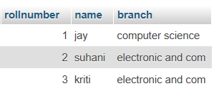

CREATE TABLE exam (rollnumber int ,s_code varchar (10),marks int , p_code varchar (10), FOREIGN key (rollnumber) REFERENCES student (rollnumber));

******************************

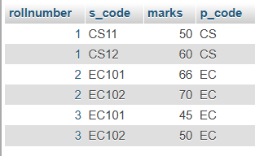

INSERT INTO `exam`(`rollnumber`, `s_code`, `marks`, `p_code`) VALUES

('1','CS11','50','CS');

('1','CS12','60','CS');

('2','EC101','66','EC');

('2','EC102','70','EC');

('3','EC101','45','EC');

 ('3','EC102','50','EC');

1. . Create table given below: Employee and IncentiveTable

* ANS

INSERT INTO `employee`(`employee_id`, `first_name`, `last_name`, `salary`, `joining_date`, `department`) VALUES

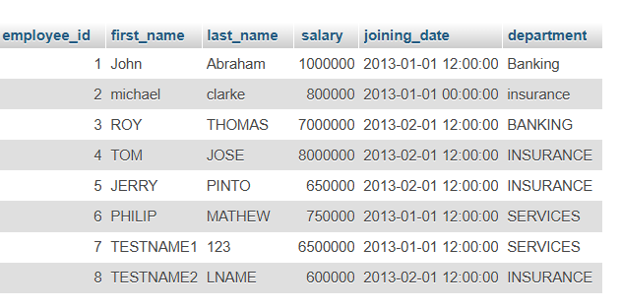

 ('1','JOHN','ABRAHAM','1000000','2013-01-01 12:00','BANKING')

 ('2','MICHAEL','CLARKE','8000000','2013-01-01 12:00','INSURANCE')

 ('3','ROY','THOMAS','700000','2013-01-01 12:00','BANKING ')

   ('4','TOM','JOSE','8000000','2013-02-01 12:00','INSURANCE')

 ('5','JERRY','PINTO','6500000','2013-02-01 12:00','INSURANCE')

 ('6','PHILIP','MATHEW','7500000','2013-01-01 12:00','SERVICES')

 ('7','TESTNAME1','123','6500000','2013-01-01 12:00','SERVICES')

 ('8','TESTNAME2''LNAME','6000000','2013-02-01 12:00','INSURANCE');

******************************

TABLE NAME : INCENTIVE

create table incentive(employee_ref_id int, incentive_date date, incentive_amount int, foreign key (employee_ref_id) REFERENCES employee (employee_id));

INSERT INTO `incentive`(`employee_ref_id`, `incentive_date`, `incentive_amount`)

VALUES

('1','2013-02-01','5000'),

('2','2013-02-01','3000'),

('3','2013-02-01','4000'),

('1','2013-01-01','4500'),

('2','2013-01-01','3500');

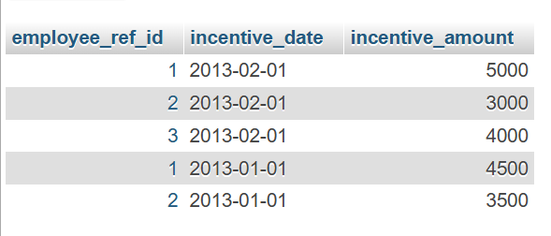

1. Get First_Name from employee table using Tom name “Employee Name”.

* Ans [SELECT](http://localhost/phpmyadmin/url.php?url=https://dev.mysql.com/doc/refman/8.0/en/select.html) `first_name` FROM `employee` WHERE first_name= 'tom';

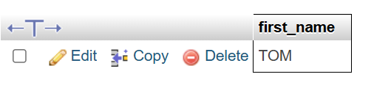

1. Get FIRST_NAME, Joining Date, and Salary from employee table.

* [SELECT](http://localhost/phpmyadmin/url.php?url=https://dev.mysql.com/doc/refman/8.0/en/select.html) `first_name`, `salary`, `joining_date` FROM `employee`;

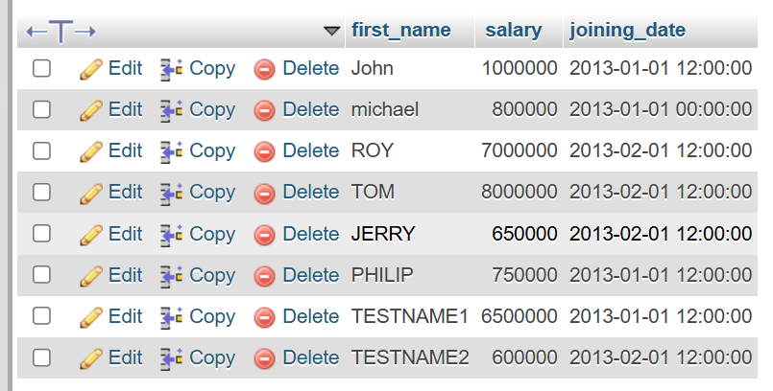

1. Get all employee details from the employee table order by First_Name

* SELECT * FROM `employee` order by first_name asc, salary desc;

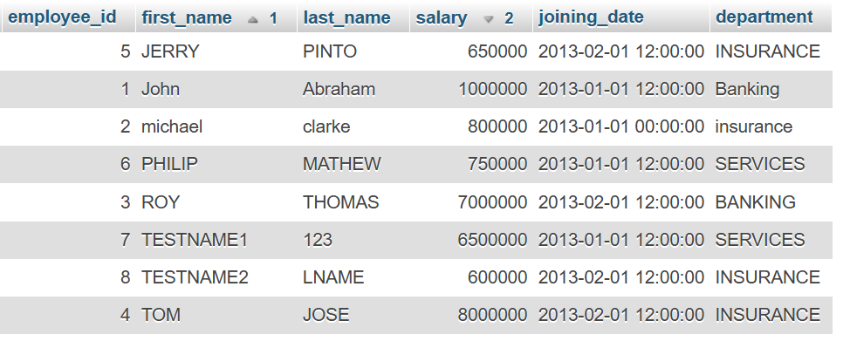

1. Get employee details from employee table whose first name contains ‘J’

* SELECT * FROM `employee` WHERE first_name like '%j%';

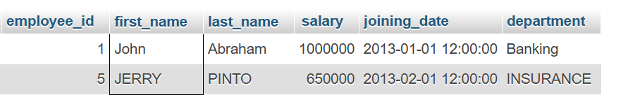

7-8.Get department wise maximum salary from employee table order by salaryascending?

* Ans [SELECT](http://localhost/phpmyadmin/url.php?url=https://dev.mysql.com/doc/refman/8.0/en/select.html) ‘department’, [MAX](http://localhost/phpmyadmin/url.php?url=https://dev.mysql.com/doc/refman/8.0/en/aggregate-functions.html%23function_max)(salary) AS max_salary FROM ‘employee’ GROUP BY department ORDER BY max_salary ASC;

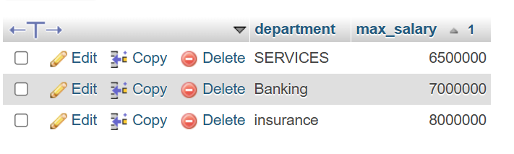

9. Select first_name, incentive amount from employee and incentives table forthose employees who have incentives and incentive amount greater than 3000

* ANS

SELECT employee.employee_id,employee.first_name, incentive.incentive_amount

from employee left join incentive on employee.employee_id=incentive.employee_ref_id;

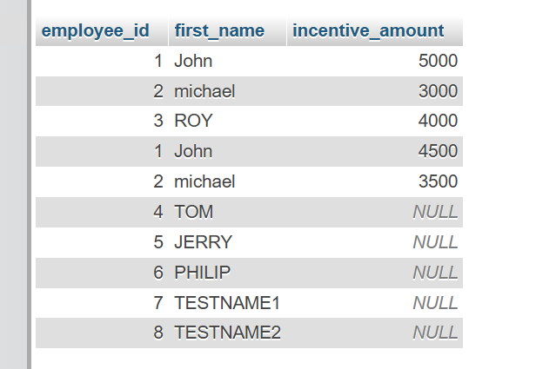

10. Create After Insert trigger on Employee table which insert records in viewtable

* Ans

CREATE TABLE ViewTable (Employee_id INT, First_name VARCHAR(100), Last_name VARCHAR(100), Inserted_at DATETIME);

DELIMITER $$

CREATE TRIGGER after_employee_insert AFTER INSERT ON Employee

FOR EACH ROW

BEGIN

INSERT INTO ViewTable (Employee_id, First_name, Last_name, Inserted_at)

VALUES (NEW.Employee_id, NEW.First_name, NEW.Last_name, NOW());

END $$

INSERT INTO Employee (Employee_id, First_name, Last_name, Salary, Joining_date, Department) VALUES

(9, 'sanket', 'devganiya', 50000, '2001-02-01', 'HR'),

(10, 'harsh', 'devganiya', 60000, '2002-02-01', 'sales');

select * from ViewTable;

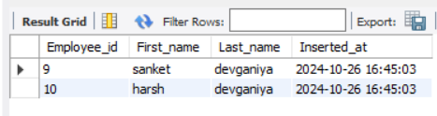

11.Create table given below: Salesperson and Customer

* Ans

create table salesperson (s_no int primary key, s_name varchar(50), city varchar(50), commision decimal(10,2));

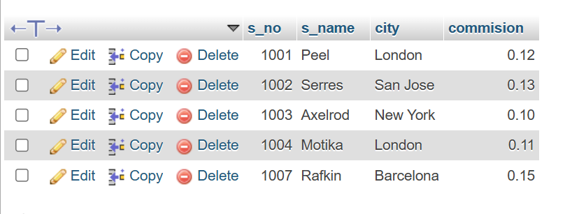

INSERT INTO salesperson(s_no, s_name, city, commision)

VALUES

('1001', 'Peel', 'London', '0.12'),

('1002', 'Serres', 'San Jose', '0.13'),

('1004', 'Motika', 'London', '0.11'),

('1007', 'Rafkin', 'Barcelona', '0.15'),

('1003', 'Axelrod', 'New York', '0.10');

* create table customer (c_nm int primary key, c_name varchar(50), city varchar(50),

rating int, s_no int, foreign key(s_no) REFERENCES salesperson(s_no));

INSERT INTO customer(c_nm, c_name, city, rating, s_no)

VALUES

('201', 'Hoffman', 'London', '100', '1001'),

('202', 'Giovanne', 'Rome', '200', '1003'),

('203', 'Liu', 'San Jose', '300', '1002'),

('204', 'Grass', 'Barcelona', '100', '1002'),

('206', 'Clemens', 'London', '300', '1007'),

('207', 'Pereira', 'Rome', '100', '1004');

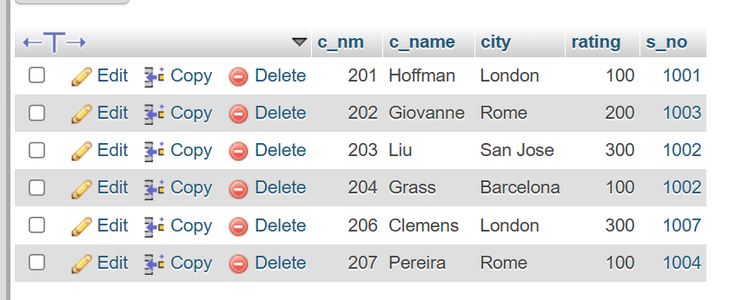

12.Retrieve the below data from above table

* Ans

Select s_name, city from salesperson where city = ‘London’ and commision > 0.12; Select s_name, city from salesperson where city = ‘London’ and commision > 0.12;

* --no output because there is no data where city is London and commission is above 0.12

13. All Customer name whose rating is more than 100

* Ans

[SELECT](http://localhost/phpmyadmin/url.php?url=https://dev.mysql.com/doc/refman/8.0/en/select.html) c_name, rating from customer where rating > 100;

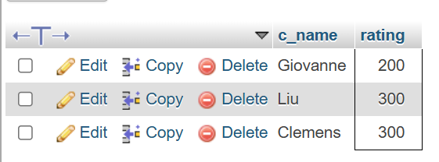

14.Names and city of all salespeople in London with commission above 0.12

* Ans

[Select](http://localhost/phpmyadmin/url.php?url=https://dev.mysql.com/doc/refman/8.0/en/select.html) s_name, city from salesperson where city = 'London' [and](http://localhost/phpmyadmin/url.php?url=https://dev.mysql.com/doc/refman/8.0/en/logical-operators.html%23operator_and) commision > 0.12;

* --no output because there is no data where city is London and commission is above 0.12

15.All salespeople either in Barcelona or in London

* Ans

[SELECT](http://localhost/phpmyadmin/url.php?url=https://dev.mysql.com/doc/refman/8.0/en/select.html) s_name,city from salesperson where city='Barcelona' [OR](http://localhost/phpmyadmin/url.php?url=https://dev.mysql.com/doc/refman/8.0/en/logical-operators.html%23operator_or) city='london';

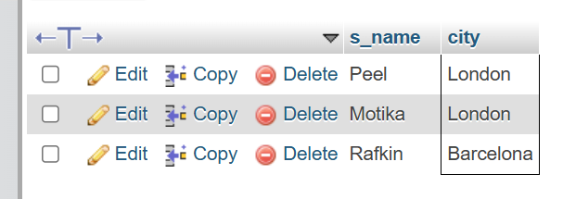

16. All salespeople with commission between 0.10 and 0.12. (Boundary valuesshould be excluded).

* Ans

[SELECT](http://localhost/phpmyadmin/url.php?url=https://dev.mysql.com/doc/refman/8.0/en/select.html) * FROM `salesperson` WHERE commision > 0.10 [and](http://localhost/phpmyadmin/url.php?url=https://dev.mysql.com/doc/refman/8.0/en/logical-operators.html%23operator_and) commision < 0.12;

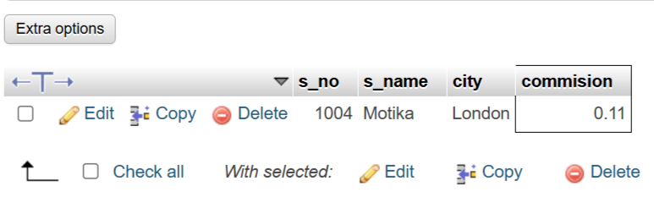

17.All customers excluding those with rating <= 100 unless they are locatedinRome

* Ans

[SELECT](http://localhost/phpmyadmin/url.php?url=https://dev.mysql.com/doc/refman/8.0/en/select.html) * FROM `customer` WHERE rating <= 100 [or](http://localhost/phpmyadmin/url.php?url=https://dev.mysql.com/doc/refman/8.0/en/logical-operators.html%23operator_or) city = 'Rome';

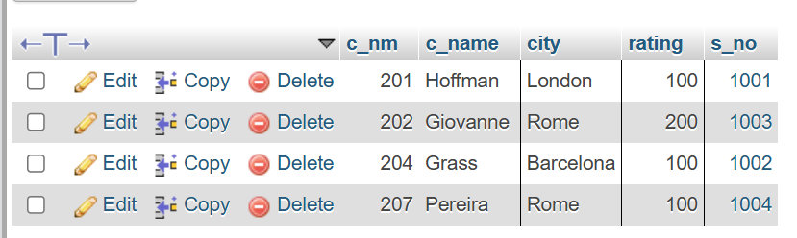

18.Write a SQL statement that displays all the information about all salespeople

* Ans

[create](http://localhost/phpmyadmin/url.php?url=https://dev.mysql.com/doc/refman/8.0/en/create-table.html) [table](http://localhost/phpmyadmin/url.php?url=https://dev.mysql.com/doc/refman/8.0/en/create-table.html) salesman (salesman_id int, name varchar(50), city varchar(50), commission decimal(4,2));

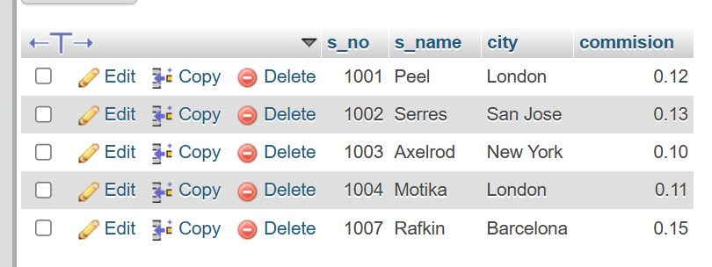

INSERT INTO salesman (salesman_id, name, city, commission)

VALUES

(5001, 'James Hoog', 'New York', 0.15),

(5002, 'Nail Knite', 'Paris', 0.13),

(5005, 'Pit Alex', 'London', 0.11),

(5006, 'Mc Lyon', 'Paris', 0.14),

(5007, 'Paul Adam', 'Rome', 0.13),

(5003, 'Lauson Hen', 'San Jose', 0.12);

19. From the following table, write a SQL query to find orders that are delivered by a salesperson with ID. 5001. Return ord_no, ord_date, purch_amt. Sample table: orders

* ANS

CREATE TABLE orders (ord_no INT, purch_amt DECIMAL(10, 2), ord_date DATE, customer_id INT, salesman_id INT);

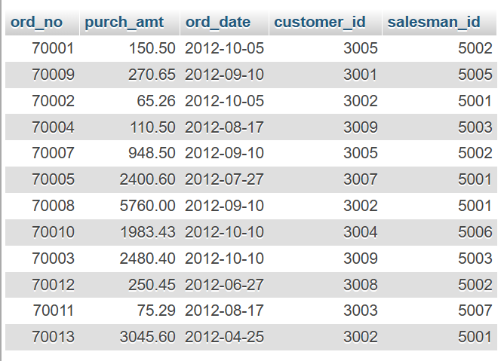

INSERT INTO orders (ord_no, purch_amt, ord_date, customer_id, salesman_id)

VALUES

(70001, 150.50, '2012-10-05', 3005, 5002),

(70009, 270.65, '2012-09-10', 3001, 5005),

(70002, 65.26, '2012-10-05', 3002, 5001),

(70004, 110.50, '2012-08-17', 3009, 5003),

(70007, 948.50, '2012-09-10', 3005, 5002),

(70005, 2400.60, '2012-07-27', 3007, 5001),

(70008, 5760.00, '2012-09-10', 3002, 5001),

(70010, 1983.43, '2012-10-10', 3004, 5006),

(70003, 2480.40, '2012-10-10', 3009, 5003),

(70012, 250.45, '2012-06-27', 3008, 5002),

(70011, 75.29, '2012-08-17', 3003, 5007),

(70013, 3045.60, '2012-04-25', 3002, 5001);

20. From the following table, write a SQL query to select a range of products whose price is in the range Rs.200 to Rs.600. Begin and end values are included. Return pro_id, pro_name, pro_price, and pro_com.

* ANS

CREATE TABLE item_mast (pro_id INT, pro_name VARCHAR(50), pro_price DECIMAL(10, 2), pro_com INT);

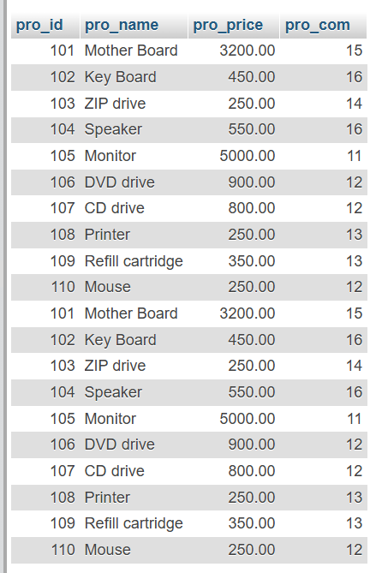

INSERT INTO item_mast (pro_id, pro_name, pro_price, pro_com)

VALUES

(101, 'Mother Board', 3200.00, 15),

(102, 'Key Board', 450.00, 16),

(103, 'ZIP drive', 250.00, 14),

(104, 'Speaker', 550.00, 16),

(105, 'Monitor', 5000.00, 11),

(106, 'DVD drive', 900.00, 12),

(107, 'CD drive', 800.00, 12),

(108, 'Printer', 250.00, 13),

(109, 'Refill cartridge', 350.00, 13),

(110, 'Mouse', 250.00, 12);

23. From the following table, write a SQL query to find the items whose prices are higher than or equal to $250. Order the result by product price in descending, then product name in ascending. Return pro_name and pro_price.

* ANS

SELECT pro_name, pro_price FROM `item_mast` WHERE pro_price >= 250 order by pro_price desc, pro_name asc;

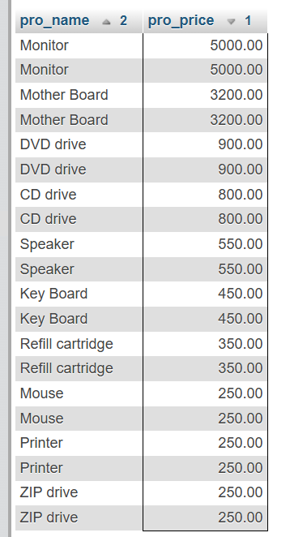

24. From the following table, write a SQL query to calculate average price of the items for each company. Return average price and companycode

* ANS

SELECT pro_com, avg(pro_price) as avg_price FROM `item_mast` group by pro_com;

