Name: Sanket H. Vanani

No: 30

Sem: IT 9th

Subject : Cloud Computing

1. Create Database in mysql through PHPMyadmin.

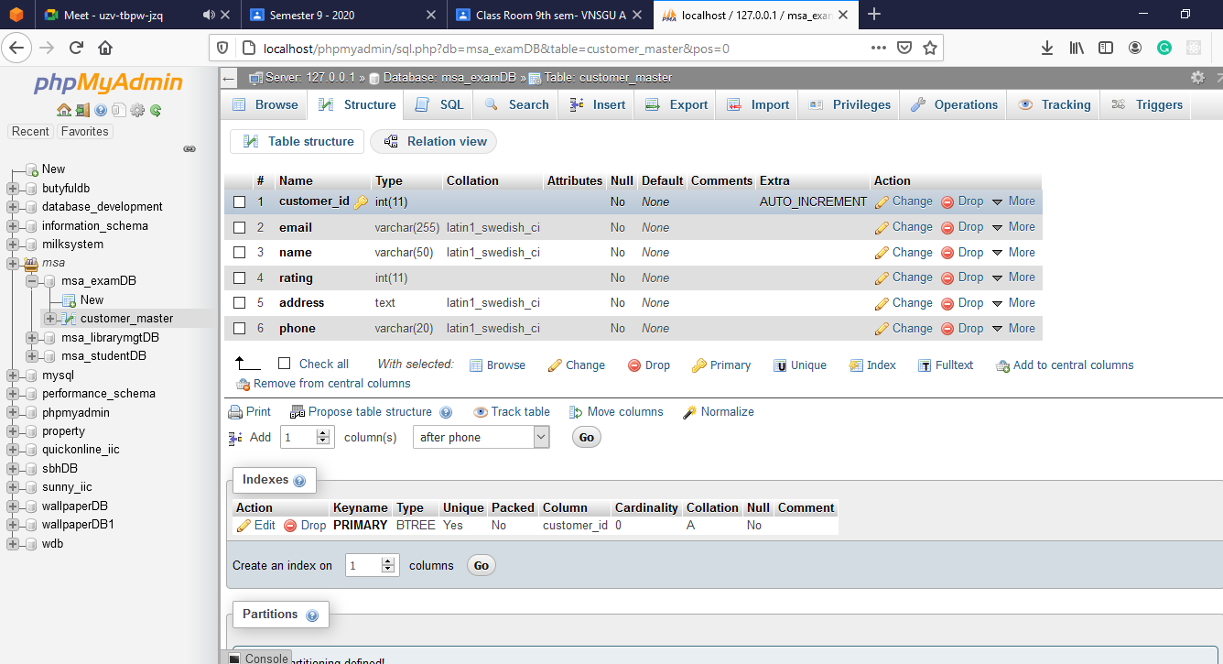

2. Add 2-3 data for testing.

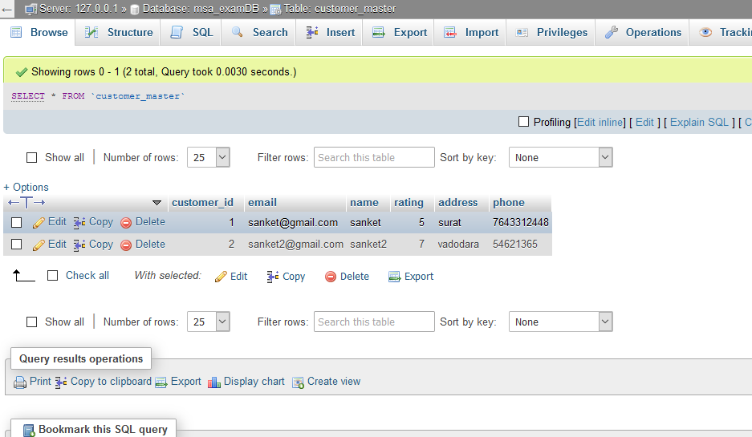

3. **For creating MSA Application we need to make Project with Archtype and I have created 2 project one called exam-client and another one is exam-service.**

4. **Then we need to create the JDBC pool and JDBC resource in Payara Server.**

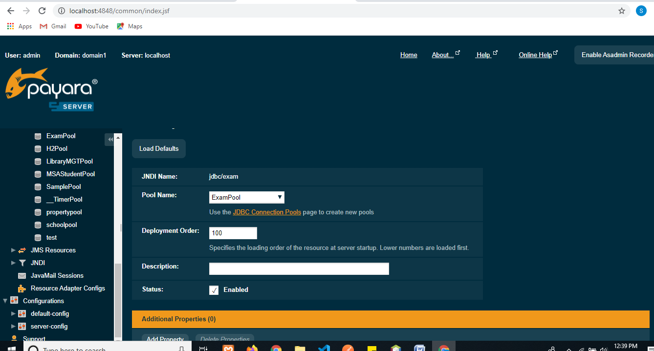

**5. Now we will create Persistence unit and Entity from the database.**

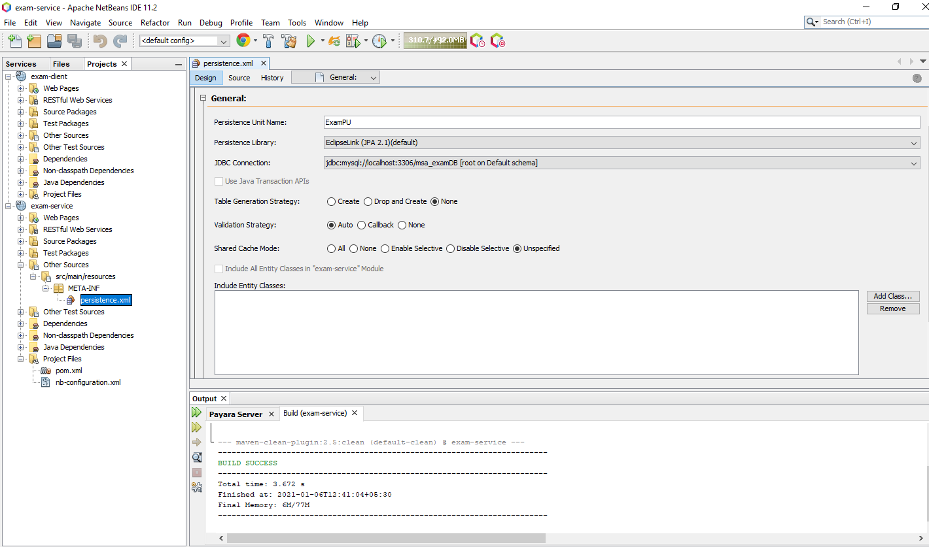

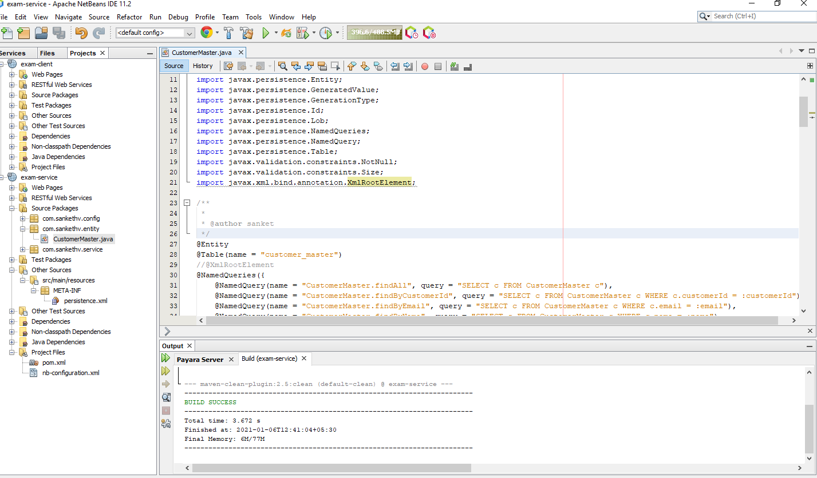

**6. Now we will create the model Customer and add query as per our requirements in Entity.**

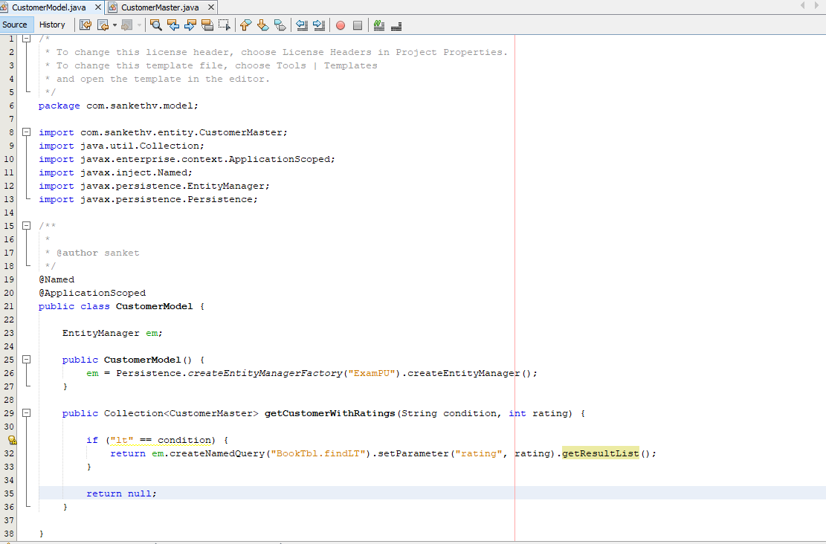

**/\***

**\* To change this license header, choose License Headers in Project Properties.**

**\* To change this template file, choose Tools | Templates**

**\* and open the template in the editor.**

**\*/**

**package com.sankethv.model;**

**import com.sankethv.entity.CustomerMaster;**

**import java.util.Collection;**

**import javax.enterprise.context.ApplicationScoped;**

**import javax.inject.Named;**

**import javax.persistence.EntityManager;**

**import javax.persistence.Persistence;**

**/\*\***

**\***

**\* @author sanket**

**\*/**

**@Named**

**@ApplicationScoped**

**public class CustomerModel {**

**EntityManager em;**

**public CustomerModel() {**

**em = Persistence.createEntityManagerFactory("ExamPU").createEntityManager();**

**}**

**public Collection<CustomerMaster> getCustomerWithRatings(String condition, int rating) {**

**if ("lt" == condition) {**

**return em.createNamedQuery("BookTbl.findLT").setParameter("rating", rating).getResultList();**

**}**

**return null;**

**}**

**}**

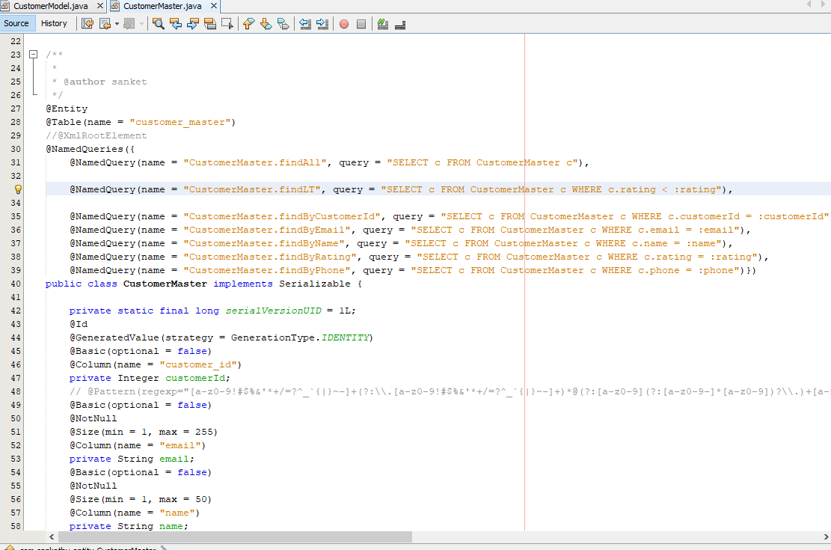

**/\***

**\* To change this license header, choose License Headers in Project Properties.**

**\* To change this template file, choose Tools | Templates**

**\* and open the template in the editor.**

**\*/**

**package com.sankethv.entity;**

**import java.io.Serializable;**

**import javax.persistence.Basic;**

**import javax.persistence.Column;**

**import javax.persistence.Entity;**

**import javax.persistence.GeneratedValue;**

**import javax.persistence.GenerationType;**

**import javax.persistence.Id;**

**import javax.persistence.Lob;**

**import javax.persistence.NamedQueries;**

**import javax.persistence.NamedQuery;**

**import javax.persistence.Table;**

**import javax.validation.constraints.NotNull;**

**import javax.validation.constraints.Size;**

**import javax.xml.bind.annotation.XmlRootElement;**

**/\*\***

**\***

**\* @author sanket**

**\*/**

**@Entity**

**@Table(name = "customer_master")**

**//@XmlRootElement**

**@NamedQueries({**

**@NamedQuery(name = "CustomerMaster.findAll", query = "SELECT c FROM CustomerMaster c"),**

**@NamedQuery(name = "CustomerMaster.findLT", query = "SELECT c FROM CustomerMaster c WHERE c.rating < :rating"),**

**@NamedQuery(name = "CustomerMaster.findByCustomerId", query = "SELECT c FROM CustomerMaster c WHERE c.customerId = :customerId"),**

**@NamedQuery(name = "CustomerMaster.findByEmail", query = "SELECT c FROM CustomerMaster c WHERE c.email = :email"),**

**@NamedQuery(name = "CustomerMaster.findByName", query = "SELECT c FROM CustomerMaster c WHERE c.name = :name"),**

**@NamedQuery(name = "CustomerMaster.findByRating", query = "SELECT c FROM CustomerMaster c WHERE c.rating = :rating"),**

**@NamedQuery(name = "CustomerMaster.findByPhone", query = "SELECT c FROM CustomerMaster c WHERE c.phone = :phone")})**

**public class CustomerMaster implements Serializable {**

**private static final long serialVersionUID = 1L;**

**@Id**

**@GeneratedValue(strategy = GenerationType.IDENTITY)**

**@Basic(optional = false)**

**@Column(name = "customer_id")**

**private Integer customerId;**

**// @Pattern(regexp="[a-z0-9!#$%&'*+/=?^_`{|}~-]+(?:\\.[a-z0-9!#$%&'*+/=?^_`{|}~-]+)*@(?:[a-z0-9](?:[a-z0-9-]*[a-z0-9])?\\.)+[a-z0-9](?:[a-z0-9-]*[a-z0-9])?", message="Invalid email")//if the field contains email address consider using this annotation to enforce field validation**

**@Basic(optional = false)**

**@NotNull**

**@Size(min = 1, max = 255)**

**@Column(name = "email")**

**private String email;**

**@Basic(optional = false)**

**@NotNull**

**@Size(min = 1, max = 50)**

**@Column(name = "name")**

**private String name;**

**@Basic(optional = false)**

**@NotNull**

**@Column(name = "rating")**

**private int rating;**

**@Basic(optional = false)**

**@NotNull**

**@Lob**

**@Size(min = 1, max = 65535)**

**@Column(name = "address")**

**private String address;**

**// @Pattern(regexp="^\\(?(\\d{3})\\)?[- ]?(\\d{3})[- ]?(\\d{4})$", message="Invalid phone/fax format, should be as xxx-xxx-xxxx")//if the field contains phone or fax number consider using this annotation to enforce field validation**

**@Basic(optional = false)**

**@NotNull**

**@Size(min = 1, max = 20)**

**@Column(name = "phone")**

**private String phone;**

**public CustomerMaster() {**

**}**

**public CustomerMaster(Integer customerId) {**

**this.customerId = customerId;**

**}**

**public CustomerMaster(Integer customerId, String email, String name, int rating, String address, String phone) {**

**this.customerId = customerId;**

**this.email = email;**

**this.name = name;**

**this.rating = rating;**

**this.address = address;**

**this.phone = phone;**

**}**

**public Integer getCustomerId() {**

**return customerId;**

**}**

**public void setCustomerId(Integer customerId) {**

**this.customerId = customerId;**

**}**

**public String getEmail() {**

**return email;**

**}**

**public void setEmail(String email) {**

**this.email = email;**

**}**

**public String getName() {**

**return name;**

**}**

**public void setName(String name) {**

**this.name = name;**

**}**

**public int getRating() {**

**return rating;**

**}**

**public void setRating(int rating) {**

**this.rating = rating;**

**}**

**public String getAddress() {**

**return address;**

**}**

**public void setAddress(String address) {**

**this.address = address;**

**}**

**public String getPhone() {**

**return phone;**

**}**

**public void setPhone(String phone) {**

**this.phone = phone;**

**}**

**@Override**

**public int hashCode() {**

**int hash = 0;**

**hash += (customerId != null ? customerId.hashCode() : 0);**

**return hash;**

**}**

**@Override**

**public boolean equals(Object object) {**

**// TODO: Warning - this method won't work in the case the id fields are not set**

**if (!(object instanceof CustomerMaster)) {**

**return false;**

**}**

**CustomerMaster other = (CustomerMaster) object;**

**if ((this.customerId == null && other.customerId != null) || (this.customerId != null && !this.customerId.equals(other.customerId))) {**

**return false;**

**}**

**return true;**

**}**

**@Override**

**public String toString() {**

**return "com.sankethv.entity.CustomerMaster[ customerId=" + customerId + " ]";**

**}**

**}**

**7. Now create the service for testing.**

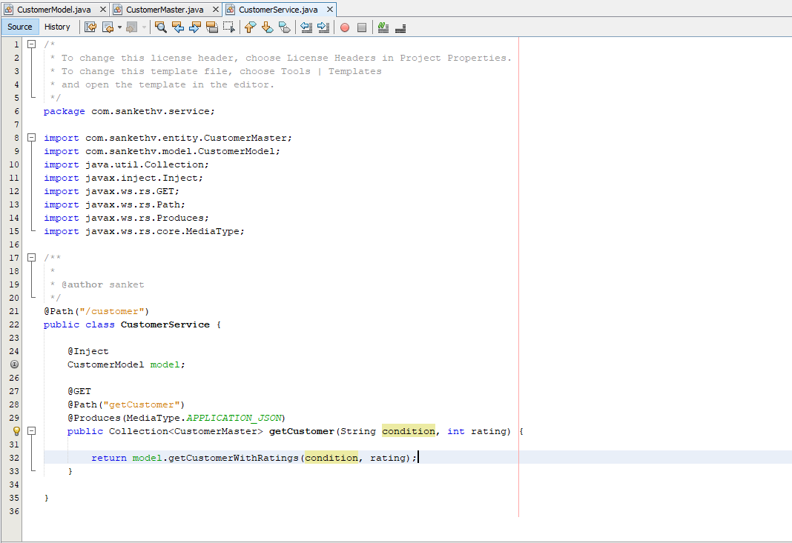

**package com.sankethv.service;**

**import com.sankethv.entity.CustomerMaster;**

**import com.sankethv.model.CustomerModel;**

**import java.util.Collection;**

**import javax.inject.Inject;**

**import javax.ws.rs.GET;**

**import javax.ws.rs.Path;**

**import javax.ws.rs.Produces;**

**import javax.ws.rs.core.MediaType;**

**/\*\***

**\***

**\* @author sanket**

**\*/**

**@Path("/customer")**

**public class CustomerService {**

**@Inject**

**CustomerModel model;**

**@POST**

**@Path("getCustomer")**

**@Produces(MediaType.APPLICATION_JSON)**

**@Consumes(MediaType.APPLICATION_JSON)**

**public Collection<CustomerMaster> getCustomer(String condition, int rating) {**

**return model.getCustomerWithRatings(condition, rating);**

**}**

**}**