**L & M Wallpaper Printing Specialist**

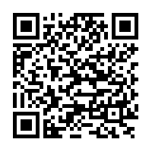

**Scan & Get our Android Application from Google playstore.**