**ASSIGNMENT-1**

Q1.) Suppose that the values for a given set of data are grouped into intervals. The intervals and corresponding frequencies are as follows:

|  |  |  |
| --- | --- | --- |
| **Age Group** | **Frequency** | **Cumulative Frequency (CF)** |
| 1-5 | 200 | 200 |
| 6-15 | 450 | 650 |
| 16-20 | 300 | 950 |
| 21-50 | 1500 | 2450 |
| 51-8 | 700 | 3150 |
| 81-110 | 44 | 3194 |

Compute an approximate median value for the data.

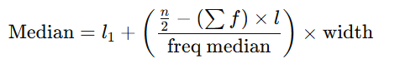

* Total Frequency (NNN) = **3194**
* Median Position = N/2 = 3194/2 =1597
* The cumulative frequency just before **1597** is **950**, and the next class is **21–50**, so this is the **median class**.
* L1= 21 (Lower boundary of the median class **21–50**)
* ∑f previous= 950
* F_median=1500
* w= 50−21= 29

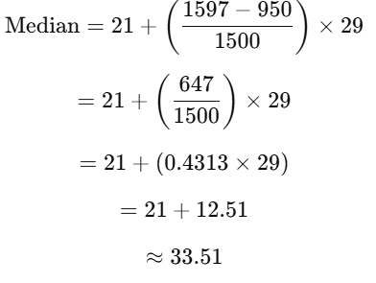

Q2.) Suppose that a hospital tested the age and body fat data for 18 randomly selected adults with the following results:

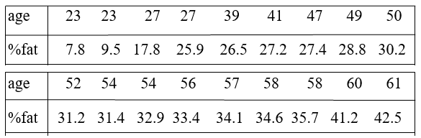

* Calculating Mean Age:

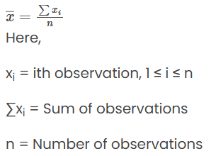

= 836

n = 18

= 836/18 = 46.44

* Calculating Median for Age:

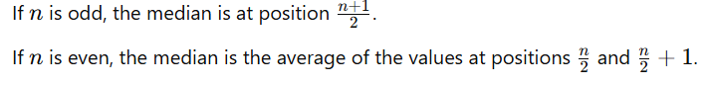





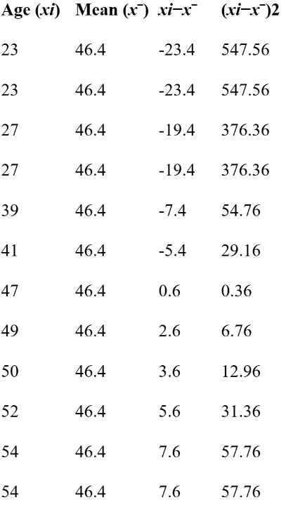

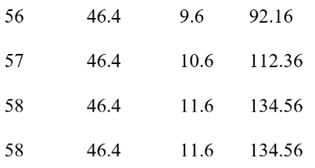

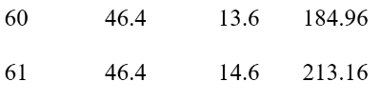

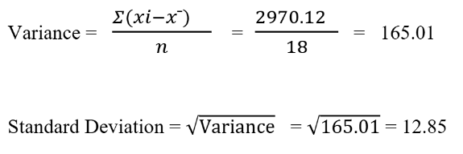

* Calculating Mean Fat:

= 518.1

n = 18

 = 518.1/18 = 28.78

* Calculating Median for Fat:



