**Module 4**

**Defect Managment**

Que – 1 what is RDBMS ?

Ans – RDBMS – Relation Database Management System (RDBMS)

* The software used to store, manage, query, and retrieve data stored in a relation database is called relation database management system (RDBMS)
* The RDBMS provides an interface between users and application and the database, as well as administrative function for managing data storage, access and performance.
* Relation Database Management System is a more advance version of a DBMS system that allow access to data in a more efficiency way. It is used to store or manage only the data that are in the form of tables.

Que – 2 what is SQL ?

Ans – SQL stand for Structure Query Language.

* SQL is a standerd language for storing, manipulating and retrieve data in database. SQL allows you to access and manipulate in database. To use SQL in: MySQL, SQL server, MS access , Oracle, Sybase, Informix, Postgeres, and other database systems.

Que – 3 Write SQL Commands .

Ans – These SQL commands are mainly categorized into five categories:-

1. DDL – Data Definition Language
2. DQL – Data Query Language
3. DML – Data Manipulation Language
4. DCL – Data Control Language
5. TCL – Transaction Control Language

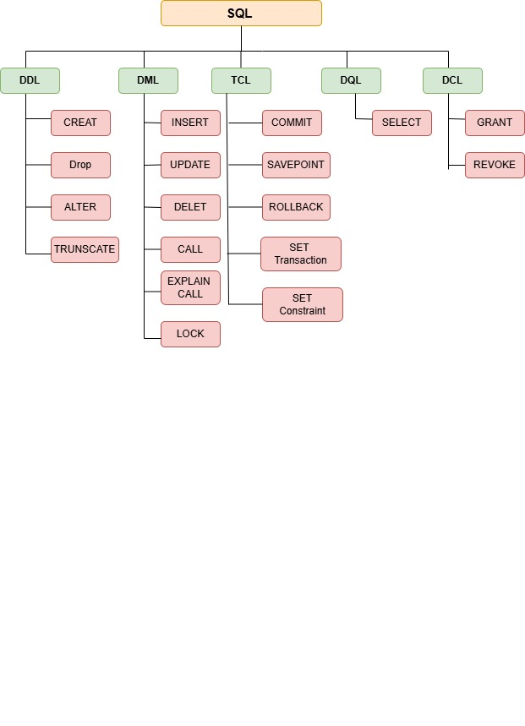

Que – 4 What is join ?

Ans – SQL Join statement is used to combine data or rows from two or more tables based on a common field between them. different types of join are as follows:

1. **INNER JOIN**
2. **LEFT JOIN**
3. **RIGHT JOIN**
4. **FULL JOIN**

Que – 5 Write types of joins.

Ans – There are four types of join

1. **INNER JOIN**
2. **LEFT JOIN**
3. **RIGHT JOIN**
4. **FULL JOIN**

**INNER JOIN -** The INNER JOIN keyword selects all rows from both the tables as long as the condition is satisfied. This keyword will create the result – set by combining all rows from both the tables where the satisfies i.e value of the common field will be the same.

**LEFT JOIN -** This join returns all the rows of the table on the left side of the join and matches rows for the table on the right side of the join. For the rows for which there is no matching row on the right side, the result – set will contain *null.* LEFT JOIN is also known as LEFT OUTER JOIN.

**RIGHT JOIN -** RIGHT JOIN is similar to LEFT JOIN. This join returns all the rows of the table on the right side of the join and matching rows for the table on the left of the join. For the rows for which there is no matching row on the left side, the result – set will contain *null.* RIGHT JOIN is also known as RIGHT OUTER JOIN.

**FULL JOIN -** FULL JOIN creates the results – set by combining results of both LEFT JOIN and RIGHT JOIN. The result set – set will contain all the rows from both tables. For the rows for which there is no matching, the result – set will contain *NULL* values.

Que – 6 How many Constrains and describe it self.

Ans – SQL constraints are used to specify rules for the data in table.

Constraints are used to limit the type of data that can go into a table. This ensures the accuracy and reliability of the data in the table. It there is any violation between the constraint and the data action, the action is aborted.

Constraints can be column level or table level. Column level constraints apply to a column, and table level constraints apply to the whole table.

The following constraints are commonly used in SQL :

1. NOT NULL – Ensure that a column cannot have a NULL value.
2. UNIQUE – Ensures that all values in a column are different
3. PRIMARY KEY – A combination of a NOT NULL and UNIQUE. Uniquely identifies each raw in a table
4. FORIEGN KEY- Prevents action that would destroy links between tables.
5. CHECK – Ensures that the values in a column satisfies a specific condition
6. DEFAULT – Sets a default value for a column if no value is specified
7. CREAT INDEX – Used to create and retrieve data from the database very quickly

Que – 7 Difference between RDBMS Vs DBMS

Ans – SQL constraints are used to specify rules for the data in table.

|  |  |
| --- | --- |
| RDBMS | BDMS |
| Data stored is in table format. | Data stored is in the file format. |
| Multiple data element are accessible together | Individual access of data elements |
| Data in the form of a table are linked together | No connection between data |
| Support distributed database | No support distributed database |
| Data is stored in large amount | Data is stored in small quality |
| RDMS supports multiple users | DBMS supports a single user |
| The software and hardware requirements are higher | The software and hardware requirements are law |
| Example :- Oracle, SQL Server. | Example :- XML, Microsoft Access. |

Que – 7 What is an SQL alias ?

Ans – SQL aliases are used to give a table, or a column in a table, a temporary name.

Aliases are often used to make column names more readable.

An alias only exists for the duration of that query.

An alias is created with AS keyword.

Que – 8 Write a query to create the table in Structured Query Language.

Ans – CREAT TABLE student (ID int, Sname varchar(30), Course text, Cost int(10));

* Creat table student

(

ID int,

Sname varchar(30),

Course text,

Cost int(10)

);

Que – 9 Write a query to Insert data into table.

Ans– insert into student VALUES(101,’Ankita’,’Python’,33000), (102,’Sanket’,’Software Testing’,53000),(103,’Bhavna’,’DA’,63000), (104,’Tushar’,’Python’,33000), (105,’Jay’,’Soft Skill’,25000), (106,’Bharat’,’Java’,56000);

Que – 10 Write a query to update data into table with validation.

Ans–

* UPDATE emp1 set salary=32000;
* UPDATE emp2 set salary=32000 where eid=3;
* UPDATE Employee SET Salary=25000 WHERE Emp_Name=’Dhara’;
* UPDATE Employee SET Salary=2500;

Que – 10 Write a query to Delete data from table with validation.

Ans–

* DELET FROM emp1;
* DELET FROM emp2 WHERE dept=’purchase’;
* DELET FROM Employee WHERE Emp_No=104;
* DELET FROM Employee;

(Delete all records from the table)

Que – 11 Write a query to Drop table and database.

Ans–

* DROP TABLE TestEmployee;

Que – 12 Write a query to find max and min value from table.

Ans–

* The MIN() function returns the smallest value of the selected column.
* SELECT MIN(Salary) “Minimum Salary Is” FROM Employee;
* The MAX() function returns the largest value of the selected column.
* SELECT MAX(Salary) “MAXIMUM Salary Is” FROM Employee;

Que – 13 What is API Testing?

Ans– API is the mediator which helps to communicate with each other. It is kind of logic written by developers using any programming language to perform something.

Testing the business logic of any application is called API. QA will test the same logic and called API testing.

API testing is a part of back end testing like database.

Que – 14 Types of API Testing.

Ans– Mainly 3 types of API Testing.

1. Open APIs :- These types of API are publicly available to use like OAuth APIs from google. It has also not given any restriction to use them. So, they also known as Public APIs.
2. Partner APIs :- Specific rights or licenses to access this type of API because they are not available to the public.
3. Internal APIs :- Internal or Private. These APIs are developed by companies to use in their internal systems. It helps you to enhance the productivity of your dreams.

Que – 15 What is Responsive Testing?

Ans– Responsive testing involves how a website or web application looks and behaves on different devices, Screen size, and resolutions. The goal of responsive testing is to ensure that the website or web application can be used effectively on various devices, including desktops, laptops, table, and smart phones.

Que – 16 Which types of tools are available for Responsive Testing.

Ans– Responsive Testing tools:-

1. LT Browser
2. Lembda Testing
3. Google Resizer
4. am I responsive
5. pixel tuner

Que – 17 What is The full form .ipa, .apk

Ans–

1. .ipa :- iOS package App, international phonetic alphabet
2. apk :- Android Application Packege

Que – 18 How to creat step for to open the developer option mode ON ?

Ans–

1. Step 1 - GO *to setting > my phone.*
2. Step 2 - *Tap software info > Build Number*
3. Step 3 – Tap *Build Number* seven times. After the first few taps, you should see the steps counting down until you unlock the developer options. you may also have to tap in your PIN for verification.
4. Step 4 – Once developer options are activated, you will see a message that reads, *you are now developer.*
5. Step 5 – Go back to the *setting* pane, where you will now find *Developer* options as an entry.
6. Step 6 – Tap it and toggle (USB debugging) the switch on if it is not already, and from there, you can proceed make adjustments to your phone.

Que – 19 Create two tables named seller and product apply foreign key in product table fetch data from both table using different joins.

Ans–

* CREAT TABLE Department

(

Did int PRIMARY KEY,

Dname text,

branch text,

city text

);

* Insert a department records

INSERT into department

VALUE (1,’purchase’, ‘xxxx’, ‘Himmatnagar’),(2,’Sales’,’yyyy’,’Gandhinagr’),(3,’Legal’,’zzzz’,’Ahmedabad’);

* CREATE TABLE employee1

(

e1id int

e1name text,

Salary int,

did int,

PRIMARY KEY (e1id),

FOREIGH KEY(did) REFERENCE department (did)

);

* Insert employee1 entry

INSERT into employee1 VALUES(101, ‘Sanket’,35000,1);

INSERT into employee1 VALUES(102, ‘Jay’,40000,2);

INSERT into employee1 VALUES(103, ‘Kartik’,34000,3);

INSERT into employee1 VALUES(104, ‘Tushar’,32000,1);