**Requirement of resources in Health sector**

1) Adequate funding: Sufficient financial resources are needed to support the development and maintenance of a robust health system.

2) Skilled health workforce: A well-trained and motivated workforce is essential to provide quality health services.

3) Medical equipment and supplies: Medical equipment such as ventilators, oxygen concentrators, and personal protective equipment (PPE) are needed to diagnose and treat illnesses.

4) Medicines and vaccines: Essential medicines and vaccines are required to prevent and treat illnesses.

5) Health infrastructure: Hospitals, clinics, and health centers are needed to provide health services.

6) Health information systems: Accurate and timely health information is needed to monitor health status and support health system decision-making.

7) Health research and development: Ongoing research is needed to identify new treatments, vaccines, and diagnostic tools.

8) Health promotion and disease prevention: Health education programs and initiatives are needed to promote healthy lifestyles and prevent illnesses.

9) Mental health services: Mental health services are required to address the growing burden of mental illness.

10) Maternal and child health services: Maternal and child health services are needed to promote healthy pregnancies and ensure healthy child development.

11) Emergency medical services: Emergency medical services are required to provide timely and appropriate care in emergency situations.

12) Rehabilitation services: Rehabilitation services are needed to help individuals recover from illness or injury.

13) Health financing: Effective health financing systems are needed to ensure that health services are accessible and affordable to all.

14) Health governance and leadership: Strong governance and leadership are essential to ensure effective and efficient health service delivery.

15) Health technology: Health technology can improve the quality and efficiency of health services.

16) Health regulation: Health regulation is needed to ensure the safety and quality of health services and products.

17) Health partnerships and collaboration: Collaboration and partnerships with other sectors and stakeholders can help to address health challenges.

18) Community participation: Community participation is needed to promote ownership and sustainability of health programs.

19) Health monitoring and evaluation: Monitoring and evaluation systems are needed to assess the effectiveness and impact of health programs.

20) Health policy and planning: Evidence-based policies and plans are needed to guide health system development and improve health outcomes.

Code:

Graph: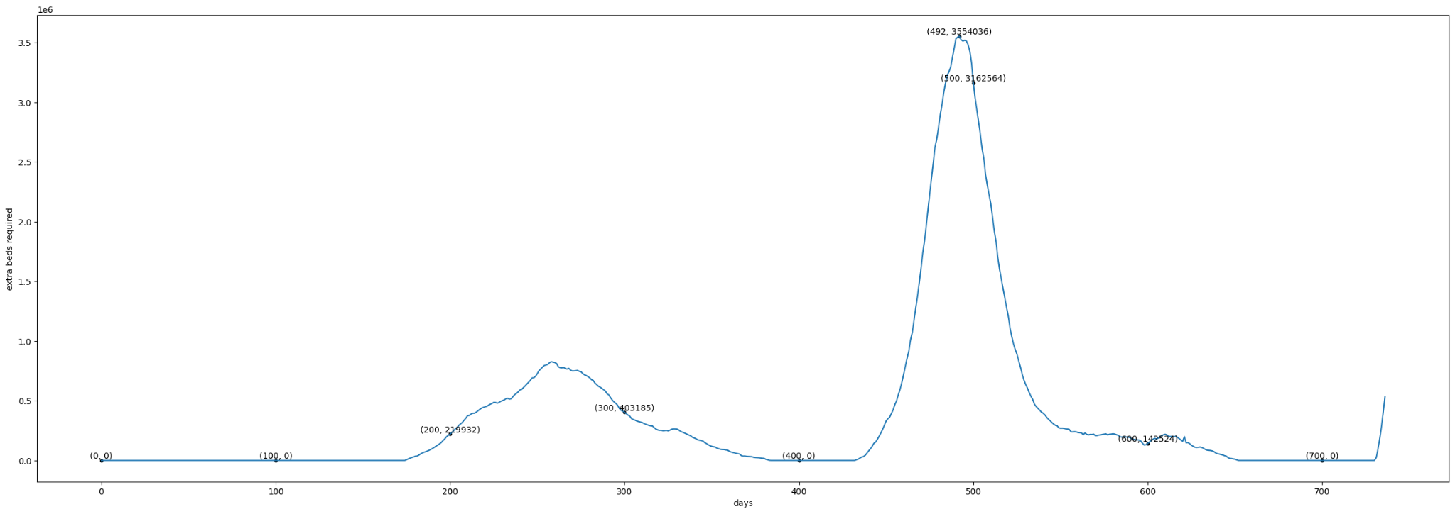

**Prediction of the disease spread risk with high range of accuracy throughout the country**

Code:



Graph:

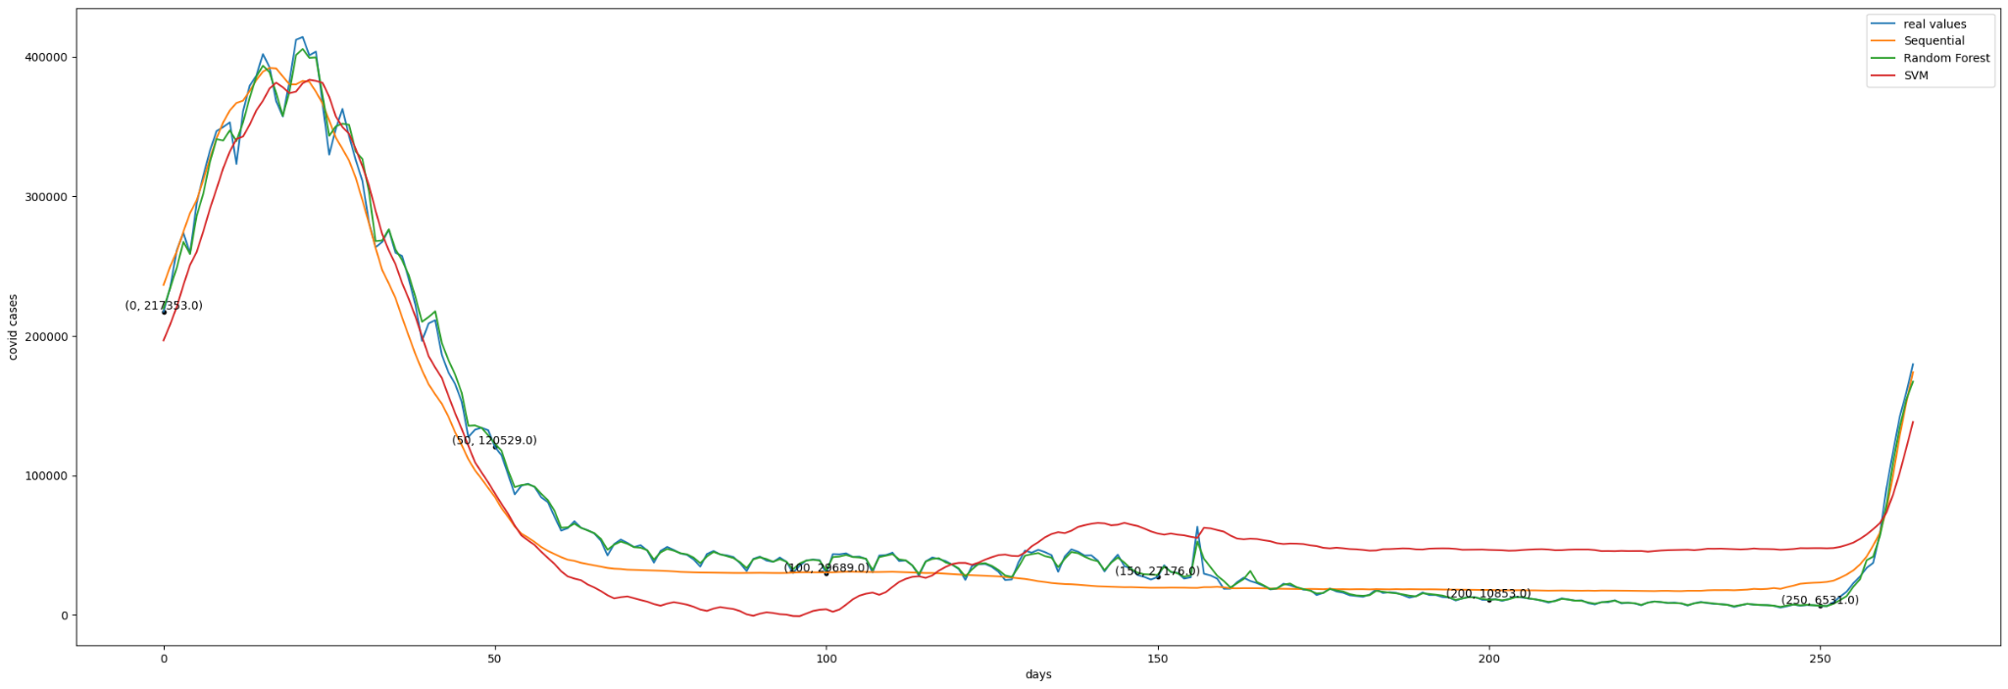

**Future prediction to provide the vaccination and treatment on right time**

Code:

Graph:

