**SPORTS MANAGEMENT AND SCHEDULING SYSTEM WITH SMS NOTIFICATION**

Presented to

The Faculty of Institute of Information Technology

CARLOS HILADO MEMORIAL STATE COLLEGE

Barangay Enclaro, Binalbagan, Negros Occidental

In Partial Fulfillment

Of the Requirements of the

Bachelor of Science in Information Technology

By:

NARDO, MELINDA

PATULADA, MARY GRACE

SUAREZ, ANGEL JUDE

November, 2019

**Chapter I**

**INTRODUCTION**

**Project context**

In the world of developing technologies, some activities were still done manually. Example of which is the hosting of sports. Others tends to ignore such issues but then these things should also be improve to increase its productivity and efficiency.

Managing sports was not just about game activities, it has also various transactions which includes evaluation of the sports matches, records of facilities and equipment and provision of schedules. In such matters, facilitators were having a hard time in managing the equipment because they were not able to produce a track of record of their transactions, which also causes a delay in starting the events. Manual way of doing these activities were unable to provide such records of equipment, schedule of the games and venues for various sports in a small period of time. It takes a lot of time in creating schedules, facilitating sport and equipment before it could be done. And there are also instances that a schedule of a game would move or cancel because of unexpected happenings, and this will cause a lot of effort and time for the facilitators to inform the participating group of players, in which also causes the delay of the program and waste of time and effort of the players for their preparation because they were not informed ahead of time.

Transactions that were done manually are not applicable nowadays. Aside from that it is not secured, tracing of these transactions were also hard for the facilitators because they lack back-ups. Issues were not just about that, informing the involved participants in various sports will also consume a lot of time and effort for the facilitators. To accomplish such things, the management would need lot of individuals to do the job. To improve such and to provide convenience to these activities, a development should be created with the use of technology.

**Purpose and Description**

The efficiency of sports management and provision of various records of the transactions, schedules and venues of each game were the main purpose of this study. Especially in managing equipment, the facilitator would need a record to keep track if the facilities needed in each match were already provided. Plotting of the schedules of each game is also essential to the facilitators and with the help of this system, plotting of time, venues an designation could be manageable because this system will save up records and schedules of all the activities with less consumption of time and effort. Also the facilitator won’t need a lot of individuals to do the facilitating because he has the basis to trace down sports/events that are played at a certain time. He will also be informed of which venues were already used. And most importantly, this system will provide notification to the facilitator if the event is about to start so that he can inform the participating schools. It is also convenient for them to announce the flow of events, revealing of the winners and other matters involved in the sports held because they had the records which is essential for hosting a sport and they can still keep control out of the unexpected incidents that may occur during that events.

**General Objectives**

To provide more efficient and productive way of managing sports event with the use of SMS notification was the main goal of this study.

**Specific Objectives**

1. To avoid the time consuming way of making schedules for each sports held in a certain hosting school as well as managing equipment and assigning of facilities needed for each sport.

2. To give the sports management the full control in case of accidental instances and emergencies with the help of the SMS notification.

3. To provide security for all of the records of every match so that the announcing of the winners will be fine and just. To produce consistent monitoring of the borrowing transactions of the equipment.

4. To evaluate the acceptability of the proposed system.

**Scope and limitation of the Study**

This will gather information of the instructors, players, and the referees to provide them notifications about the schedules of time, ranges, and venue in different/particular field of sports via SMS. This system will also be responsible for the bracketing of the matches and could give just results of the winners through accurate summation of the scores of each match. This could also secure the facilities and equipment of every sports encoded and provide inventory to it.

This study will only be applicable for the sports related events and activities and not applicable for any other transactions unrelated to sports.

**Significance of the study**

This study is significant to these individuals:

***Sports Facilitator***

This study is usable for the controlling of every events held in SCUAA and other sports related activities and could help the facilitators to lighten their jobs.

***Participating Schools***

This system will keep these individuals updated about what to do, where to go and when to do their various activities and to avoid uncertain conflict of events for better productivity of the participants involved.

***Future Researchers***

This will be a reference for them if they would like to improve this system or if this study is related to their future researches.

***Researchers***

This could be their basis in developing this study and the record of the possible and expected features of the system.

**Definition of Terms**

***Facilitator*** – Operational - are the persons who takes charge of every event in the sports activities. They are also the one’s that will manipulate this system.

Conceptual - a person or thing that makes an action or process easy or easier.

***Management****­* – Operational - the individuals who takes control on the flow of events in a certain activity and they were also responsible for the plotting of schedules which will be encoded in this system.

Conceptual - the process of dealing with or controlling things or people.

***Records*** – Operational - are used for the tracing of scores of the various matches which will be needed for the revealing of the winners of the various sports. This also refer to updating the status of the equipment listed.

Conceptual - a thing constituting a piece of evidence about the past, especially an account of an act or occurrence kept in writing or some other permanent form.

***Scheduling*** - Operational - Planning or plotting of time, events and venues for sports procedures. Scheduling will be easy with the use of this proposed system.

Conceptual - a plan for carrying out a process or procedure, giving lists of intended events and times.

***Sport*** – Operational – are activities that includes matches which should be arranged and designated to produce productivity and is essential for tournaments and for this proposed system.

Conceptual - an activity involving physical exertion and skill in which an individual or team competes against another or others for entertainment.

***Sports Equipment*** – Operational - are the materials essential for sports events which needs to be recorded for inventories and this study will provide online database for this.

Conceptual -

***System*** – Operational - a programmed system that saves and updates important data in managing and monitoring every operations happen in sports events.

Conceptual - a set of principles or procedures according to which something is done; an organized scheme or method.

**CHAPTER II**

**REVIEW OF RELATED LITERATURE AND PRIOR ARTS**

This chapter provides a brief review of related literature, studies and interrelated system from both local and foreign as proponents’ basis for the developing the of the proposed study, the Sports Management and Scheduling System with SMS Notification.

**LOCAL RELATED LITERATURE**

**The Need of Sport Management in the Philippines**

According to Erick A. Fabian (2012), the Sports Industry is a huge source of revenue and employment. I has a major social impact to the people who participate in it and support it. Apart from being a profitable industry, it is also a way of life and a culture to every individual. But in terms of Sports Management, the Philippines has still a long way to go in its act together. To acquire such things, a person who understands the way of sports management and business acumen. With those abilities, efficiency and productivity of sports management could be attainable.

The Commission on Higher Education (CHED), with the initiation of the former UP Dean of College of Human Kinetics Hercules Callanta has come up an answer to these needs. They’ve created a hybrid P.E. and Sport and Recreation curriculum (Section 6.2 and 10.2).It stated that, the sport industry currently impacts at least 55 sectors in the economy, ranging from tourism, manufacturing, infrastructure, various goods and services.

**SMS Notification Study**

The use of the SMS Notification (Claro, Libron, Songcoyauon, Masillones, 2013) creates a big help in controlling the problems and cut-downs that involve too much hardware and waste of material, time and effort. No matter where your work place is, you could reach your employees with the important corporate communication with the use of SMS notification.

SMS messages are traditional text messages that support a wider range of devices. This SMS Notification System can help the organizations disseminate information easier.

**Attendance Monitoring**

According to Casas, Ibanez, and Pilongco (2013), this is a study that tries to formulate an easy way of monitoring the attendance of students and faculty. This study includes the use of a radio frequency identification card reader and tags. With the help of this study, the reader will be able to see the flow of attendance of every Faculty and students in their respective classes.

**FOREIGN RELATED LITERATURE**

**Sports Tournament Scheduling to Determine the Required Number of Venues Subject to the Minimum Timeslots under given Format**

According to Su, Cheng and Chui, (2013) the tournaments are played in two phases: the preliminary phase and final phase. The Preliminary phase consist of the single and double elimination while in the final phase is the round robin. To determine the required number of venues and accurate dissemination of equipment subject to the least timeslots at a given format, they used the diagonal symmetric matrix to pair teams and to schedule game timeslots for the tournament. They’ve produce a procedure to find the number of division, and the number of games in each division to disseminate the total number of games and timeslots accordingly. And then they determined the number of venues required at the given timeslots. In result, a formulation of a constraint programming model was created based on the diagonal symmetric matrix and the round robin tournament.

### **Competion: the Heart and Soul of the Sports Management**

According to Shilbury (2012), understanding competition is central to the task of strategy formulation and implementation. It was argued that strategy, given its centrality to organizational phenomena and strategy research in particular, provides rich and diverse competitive context with potential to reveal some of the unique properties of the sport management. That is why competitiveness is essential in doing the sports management to improve its productivity.

**Scheduling Sports Competition on Multiple Venues**

The Sport Scheduling (Urban, and Russel, 2017), has been receiving a great attention when it comes to multiple venues. This considers the scheduling of competitions that takes place on several venues not associated with the participants. It was motivated by the conditions that creates conflicts during tournaments that causes waste of time and productivity. An integer goal program was developed to construct a schedule that satisfies the variety of conditions.

## Local Related System

## Automated Class Scheduling System

The system Automated Class scheduling System (Gayomale, Anuta, and Sayson, 2011) has features that solves the primary problems in creating schedules which is the same with the proponents system. The system was able to respond automatically in terms of speed, data handling, accuracy and stability in scheduling issues. Its features was tested and proven to be functional and helpful in producing secured data needed by the users. The only difference is that, this system is applicable for class scheduling while the proponents is for sports scheduling system.

### **Web-Based Class Scheduling**

On the other hand, in Web-Based Scheduling Management (Botangen, 2014) creation of class schedule is much easier. This Web-based scheduling was designed to develop integrated an algorithm for automated plotting of schedules and checking of every entities to avoid conflicts. This system is applicable for plotting of class schedules but the concept was the same with the sports scheduling system (proponent system).

**Athlete’s Registration and Monitoring System**

This Development of Athlete’s Registration and Monitoring System (Matillano, 2017) is a programmed software that provides computerized registration for automation and accurate producing of Athlete’s records. This system requires eligible information of the athlete for monitoring purposes. But then this system mainly focused on the developing of athlete’s registration and monitoring system of student-athlete in the P.E. department of the University of the East for UAAP. This system could provide a schedule of activities of the athletes that is the same with the proponent system. However, this system do not support other features like cloud storage, auto-print and SMS notification.

## Foreign Related System

### **Sports Tournament Automated System**

The Sports Tournament Scheduling System (Sudin, Mahrom and Che Rosli, 2018) is a programmed software which provide automation in generating the tournaments schedule. Especially in saving of records of the sports bracketing and accuracy of the summation of the scores of the sports is the same with this proponent system. This system also provides accuracy and easiness for the tournament organizer in increasing the level of reliability. But then, this STAS does not support cloud database and SMS notification.

### **Team Sports Scheduling System**

On the other hand, this team sports scheduling system (Galactic software, 2011) was created to help facilitators to create league schedules for sports organization. Its features includes multi-division scheduling, time and venues management and game rescheduling for uncertain events was the same to this proponent system. This system could provide such needed schedules in the small period of time. But then this system doesn’t have SMS Notification.

**Diamond Scheduler**

The Diamond Scheduler (Cactusware, 2019) was a system that can store data on cloud based storage. Its features was the same with the proponent system in terms of proving a schedule and tournament brackets. This system could also give accurate dissemination of venues and time management. And one of their features that’s the same with this proponent system is that they could export data in any format.

|  |  |  |  |  |  |
| --- | --- | --- | --- | --- | --- |
| RELATED PRIOR ARTS | FEATURES | | | | |
| Automated System | Automated exporting of data | Cloud Storage | SMS | Web-based |
| Automated Scheduling system | YES | YES | NO | NO | YES |
| Web-based Class Scheduling for Collaboration of Preparation for Block-based Scheduling | YES | YES | YES | NO | YES |
| Development of athlete’s Registration and Monitoring System | YES | NO | NO | NO | YES |
| Sports Tournament Automated System | YES | NO | YES | NO | YES |
| Team Sports Scheduling System | YES | NO | YES | NO | YES |
| Diamond Scheduler | YES | YES | YES | NO | YES |
| Sports Management and Scheduling System with SMS Notification | YES | YES | YES | YES | YES |

*Table 1 shows the differences of the system and studies related to the proponent’s proposed system*.

**CHAPTER III**

**METHODOLOGY**

This chapter will discuss all the methods of the proponent system as well as the step by step processes of this study.

**SYSTEM DEVELOPMENT LIFE CYCLE (SDLC)**

SDLC – System Development Life Cycle defines the process of developing a proposed system. It consist of different stages or methods which will be a guide in processing the development of a system. In addition to this, the SDLC as the structure and the development of the system will be done by the team within the software organization. The life cycle of the system development will describe the developing and maintaining processes of the proponent system and also the replacement of the specific system. The proponent system will be using the Rapid Application Development Methodology as the basis in processing the system development.

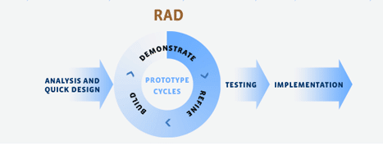**RAPID APPLICATION DEVELOPMENT METHODOLOGY**

*Figure 1: Rapid Application Development Methodology*

Figure 1: The Figure above describes the processes involved in the Rapid application Development Methodology. This methodology will be the basis for the processing of the proponent system. It will also help the researcher on how to start the processing up to finishing it. The proponents system chose to use this as the method of development because of its concept that can help in the step by step processes of the proponents. This development diagram allows the proponents to review about its steps in development through the prototype applied in RAD. All in all this methodology will help the proponents system in building a well-polished and functional system.

**Analysis and Quick Design**

During the Analysis and Quick Design phase, the proponents has conducted an interview regarding the problems in handling sports activities to gather information for the designing of the system. The proponents also discussed analysis in designing the possible features and functionalities in this phase.

**Demonstrate**

In the demonstrate phase, the proponents’ will evaluate the information gathered. They will value those information and then they will formulate a solution that will answer to the needs of the user, by this activity they will be able to initiate the finalization of the features of the proposed study.

**Refine**

In the refine phase, the proponents’ will do the refining of the study in all aspects before building it. They should make sure that every steps of the development of the proposed study was correct to avoid unnecessary events while building it. The proponents’ will now foresee the finalized features and functions of the proposed study.

**Build**

In this phase, the proponents’ will build the designed study with the use of the tools and languages that is useful and helpful for the proponents’. The proponents’ will use the Visual basic language for the developing of the proposed study for the admin side and then PHP for the website.

**Testing and Implementation**

In the Testing and implementation phase, the proponent system will have the fully finish project that will be evaluated. This will also be the time that the proponents’ let the end users manipulate the proposed system to know on how can this study help the target users. The proponents’ will also ask some questions to the users regarding the effectivity efficiency of the study. Proponents’ shall also secure and ensure the functionalities of the study before the testing and implementation. The proposed system will be tested by the I. T. faculty and sports facilitators of CHMSC Binalbagan.

**Case Study**: Sport Management and Scheduling System with SMS Notification

In this case study the task is to create a useful system that can be used to manage sports events and equipment. The name of the said system is Sports Management and Scheduling System. The administrator or host of the sports event does the scheduling of every events in sport. The schedules consist of plotting of venues and time ranges, arranging the sports events and bracketing of matches. The equipment are also designated to the sport that needs it. Facilitators gathers the participants and disseminate them in different sports areas that they want to participate. The officials are also designated according to their capability in officiating every sport. The Sports Administrator also does the computation of the scores and announcing of the winners. The management aims to use the Sports Management and Scheduling System to attain productivity and for an easier way of managing sports.

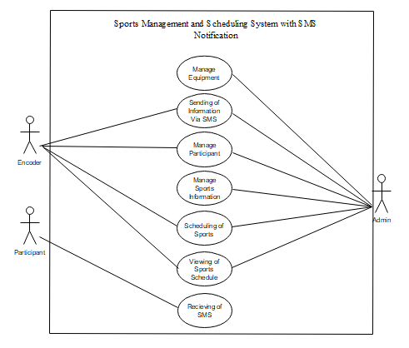

*Figure 2: Sports Management and Scheduling System with SMS Paradigm*

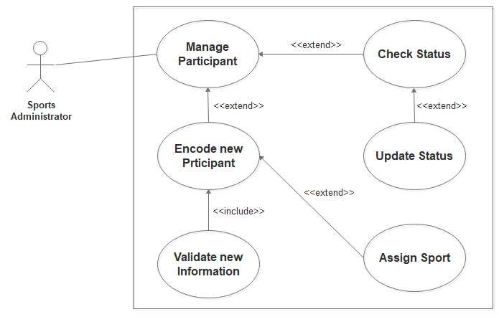 *Figure 3: Manage Participant Use Case*

|  |  |  |
| --- | --- | --- |
| **Use Case Name:** | Manage participants | |
| **Actors:** | Sports Administrator | |
| **Description:** | This use case describes on how the sports administrator manage the participating schools, assign the opponents of the participants and checks the status of the players. | |
| **Pre-conditions:** | The Sports Administrator should login to the Sports Management System. | |
| **Post-conditions:** | Sports Administrator has now the access to the system or if not , an error alert will show explaining the failure | |
| **Normal Flow:** | Actor | System |
| 1. The Sports Administrator selects Encode new Participant 2. Sports Administrator input and submit the information of the participant 3. Sports Administrator selects Assign sport 4. Sports Administrator has received an acknowledgement from the system that the assigning of sports has been designated, or if not, a message explaining the failure 5. Sports Administrator selects Check status | 1.1System invokes and shows the Add New Participant form  2.1 System validates the participant’s information  2.2 System adds the information and sends a confirmed message back to the Sports Facilitator   * 1. System shows the list of sport   3.2 Sports Administrator selects sport which the participant wants to participate   * 1. System shows participant’s status in every sports event |
| **Alternative Flows:** | * 1. Participant’s information validation failed, display an error message, and go to step 2   2. Showing list of sport failed, display an error message, and go to step 3   5.1 Showing participant’s status failed, and go to step 5 | |
| **Business Rules:** | * 1. Validation of participant’s information script/code conditions | |

*Table 2 shows the Use Description of Participants Management*

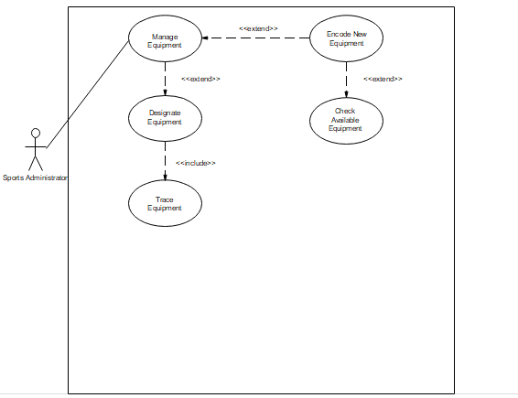

*Figure 4: Manage Equipment Use Case*

|  |  |  |
| --- | --- | --- |
| **Use Case Name:** | Manage equipment | |
| **Actors:** | Sports Administrator | |
| **Description:** | This use case describes on how the Sports Administrator manage the equipment and tracking it in every sport event. | |
| **Pre-conditions:** | The Sports Administrator should login to the Sports Management System. | |
| **Post-conditions:** | Sports facilitator has now the access to the system or if not , an error alert will show explaining the failure | |
| **Normal Flow:** | Actor | System |
| 1. The Sports administrator selects Add new equipment 2. Sports Administrator input and submit the new equipment 3. Sports Administrator selects Check available equipment 4. Sports Administrator selects Designate the equipment 5. Sports Administrator has received an acknowledgement from the system that the equipment has been designated, or if not, a message explaining the failure 6. Sports Administrator selects Trace the equipment | 1.1System invokes and shows the Add New Equipment form  2.1 System encodes the information  2.2 System adds the information and sends a confirmed message back to the Sports Administrator   * 1. System shows the available equipment   2. System shows options of sport to assign the equipment to it   3. System shows the list of equipment and names of sports where the equipment was designated |
| **Alternative Flows:** | * 1. Adding equipment failed, display an error message, and go to step 2   2. Showing of available equipment failed, display an error message, and go to step 4   6.1 Showing list of equipment and names of sports equipment was designated failed, and go to step 6 | |
| **Business Rules:** | 2.1 Encoding of equipment information script/code conditions | |

*Table 3 shows the Description of Equipment Management Use Case*

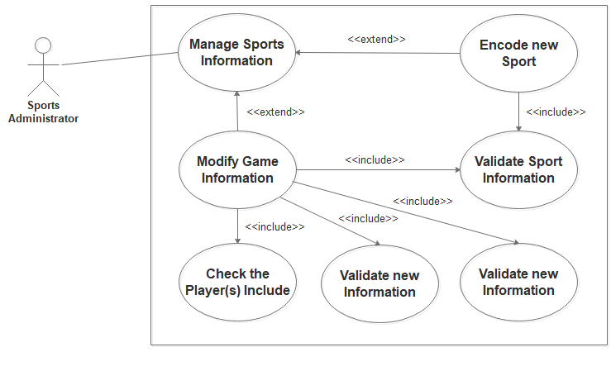

*Figure 5: Manage Sports Use Case*

|  |  |  |
| --- | --- | --- |
| **Use Case Name:** | Manage Sports Information | |
| **Actors:** | Sports Administrator | |
| **Description:** | This use case describes on how the Sports Administrator manage every event happens in sports. | |
| **Pre-conditions:** | The Sports Administrator should login to the Sports Management System. | |
| **Post-conditions:** | Sports Administrator has now the access to the system or if not , an error alert will show explaining the failure | |
| **Normal Flow:** | Actor | System |
| 1. The Sports Administrator selects Encode new Sport 2. Sports Administrator input and submit the new Sport Information 3. Sports Administrator selects Check Players involved 4. Sports Administrator selects View the officials involved 5. Sports Facilitators selects View Facilitated equipment | 1.1System invokes and shows the Add New Sport form  2.1 System encodes the information  2.2 System validates and adds the information and sends a confirmed message back to the Sports Administrator   * 1. System shows the list of players in a particular sport.   2. System shows the list of the officials officiating a particular sport   5.1 System shows the list of equipment facilitated in the particular sport |
| **Alternative Flows:** | * 1. Encoding sport failed, display an error message, and go to step 2   2. Showing list of players failed, display an error message, and go to step 3   4.1 Showing list of officials officiating the sports failed, and go to step 4  5.1 Showing list of facilitated equipment failed, display an error message and go to step 5 | |
| **Business Rules:** | * 1. Validation and adding of new Sport Information script/code conditions | |

*Table 4 shows the Sports Information Management Use Case*

*Figure 6: Scheduling of Sports Use Case*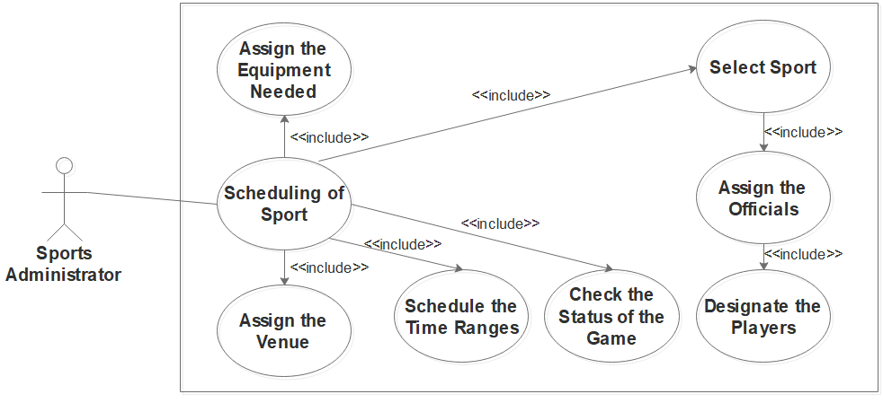

|  |  |  |
| --- | --- | --- |
| **Use Case Name:** | Scheduling of Sports | |
| **Actors:** | Sports Facilitator | |
| **Description:** | This use case describes on how the Sports Administrator plots the schedules, venues and time of every sports event. | |
| **Pre-conditions:** | The sports facilitator should login to the Sports Management System. | |
| **Post-conditions:** | Sports facilitator has now the access to the system or if not , an error alert will show explaining the failure | |
| **Normal Flow:** | Actor | System |
| 1. The Sports Administrator selects Modify Sport 2. Sports Administrator selects Assign Equipment an equipment 3. Sports Administrator has received an acknowledgement from the system that the equipment has been designated, or if not, a message explaining the failure 4. Sports Administrator selects Assign venue 5. Sports Administrator has received an acknowledgement from the system that the venue has been designated, or if not, a message explaining the failure 6. Sports Administrator declares the Time of scheduled sport 7. Sports Administrator selects Check the Status of the game | 1.1System invokes and displays the information form of the Sport  2.1 System invokes showing the list of available equipment  2.2 Sport Administrator selects the equipment needed for the sport and System adds the information  4.1 System shows the available venues for particular sport  4.2 Sport Administrator selects the venue for the sport and System adds the information  6.1 System Adds the scheduled time information and send confirmation back to the Sports Administrator  7.1 System shows the status of the game |
| **Alternative Flows:** | * 1. Showing list of available equipment failed, display an error message, and go to step 2   2. Showing of available venues for particular sports failed, display an error message, and go to step 4   6.1 Declaration of the time schedule failed, display an error message and go to step 6  7.1 Showing of Sports Status failed, display an error message and go to step 7 | |
| **Business Rules:** | * 1. Displaying of Sports information form script/code conditions | |

*Table 5 shows the Description of Scheduling of Sports Use Case*

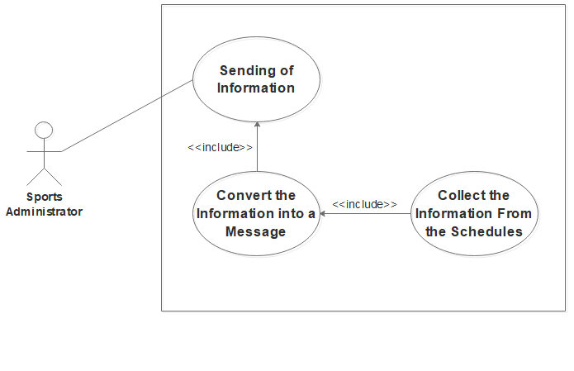

*Figure 7: Sending of information*

|  |  |  |
| --- | --- | --- |
| **Use Case Name:** | Sending of Information | |
| **Actors:** | Sports Facilitator | |
| **Description:** | This use case describes on how the Sports Administrator Send the information to the person involved in the Sport. | |
| **Pre-conditions:** | The sports facilitator should login to the Sports Management System. | |
| **Post-conditions:** | Sports facilitator has now the access to the system or if not , an error alert will show explaining the failure | |
| **Normal Flow:** | Actor | System |
| 1. The Sports Administrator selects the button to send the information 2. Sports Administrator arrange the information and converts it into a message. 3. Sports Administrator clicks the send button. | 1.1System invokes and displays the collection of Scheduled information.  3.1 System invokes showing the confirmation message.  3.2 Sport Administrator confirms and then system sends the information to its designated receivers. |
| **Alternative Flows:** | 1.1System displaying of Schedules failed, go back to step 1.  3.2 System sending of the information failed, go back to step 3. | |
| **Business Rules:** | * 1. Displaying of Scheduled information form script/code conditions | |

*Table 6 shows the Description of Sending of Information Use Case*

*Figure 8: Viewing of Sports Information* 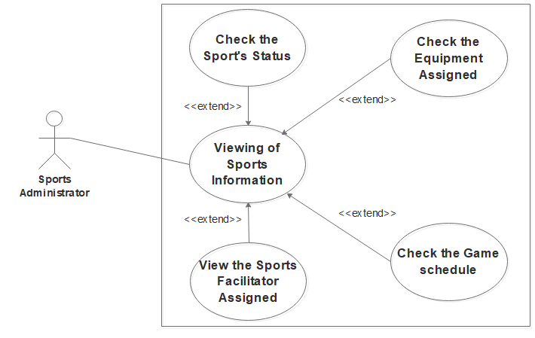

|  |  |  |
| --- | --- | --- |
| **Use Case Name:** | Viewing of Sports Information | |
| **Actors:** | Sports Facilitator | |
| **Description:** | This use case describes on how the Sports Administrator view the Sports Information | |
| **Pre-conditions:** | The sports facilitator should login to the Sports Management System. | |
| **Post-conditions:** | Sports facilitator has now the access to the system or if not , an error alert will show explaining the failure | |
| **Normal Flow:** | Actor | System |
| 1. The Sports Administrator selects the button to view the Sports Information | 1.1System invokes and displays the information of every Sport. |
| **Alternative Flows:** | 1.1System displaying of Schedules and sports information failed, go back to step 1. | |
| **Business Rules:** | * 1. Displaying of Sports Information script/code conditions | |

*Table 7 shows the Description for the Viewing of Sports Information Use Case*

**Activity Diagram**

Sport Scheduling

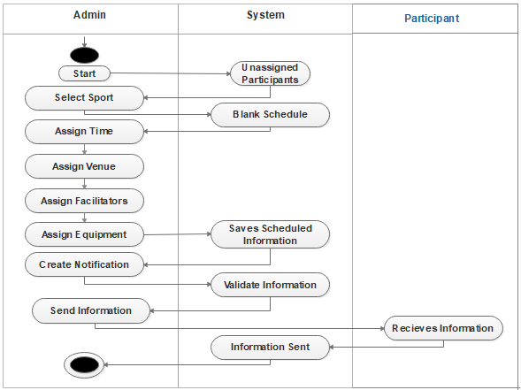

*Figure 9: Sports Scheduling Activity Diagram*

Manage Participant

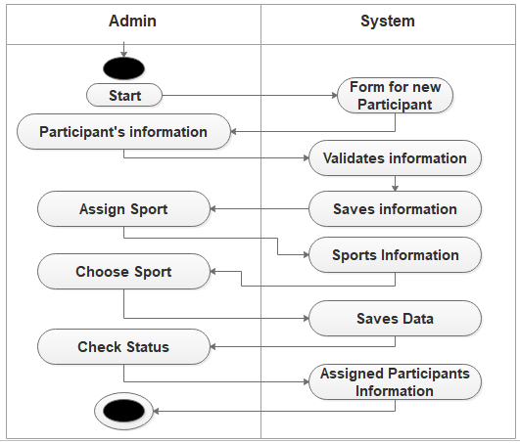

*Figure 10: Manage Participants Activity Diagram*

Manage Equipment

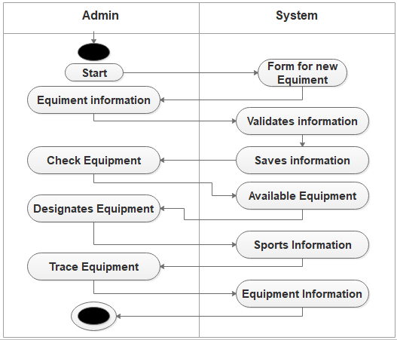

*Figure 11: Manage Equipment Activity Diagram*

Sports Management

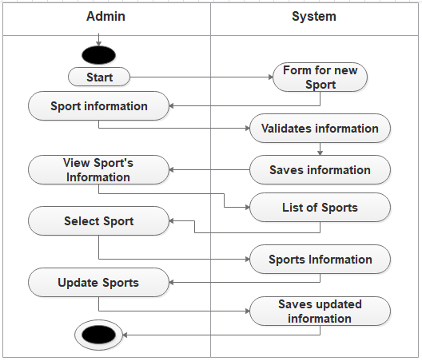

*Figure 12: Manage Sports Activity Diagram*

Context Diagram

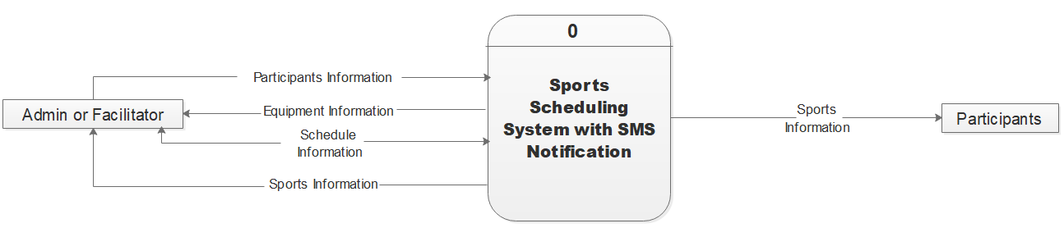

*Figure 13: Context Diagram*

Data Flow Diagram

Level 0

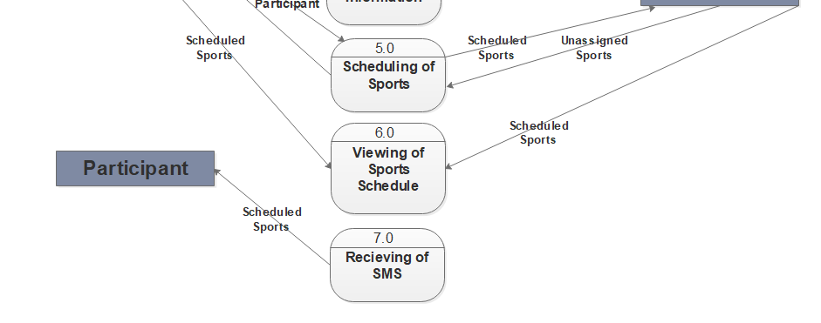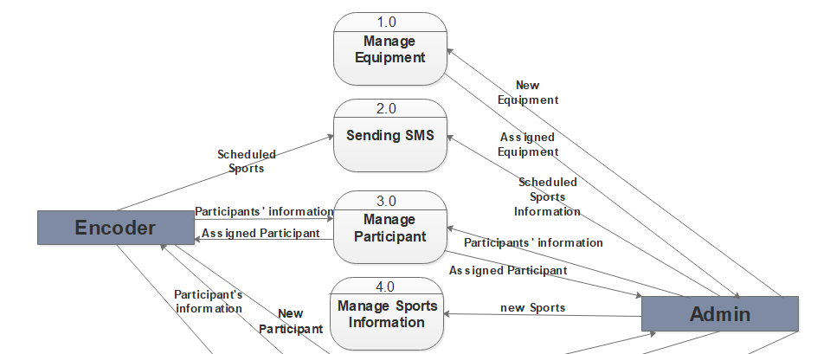

*Figure 14: Level 0 Data Flow Diagram*

Level 1

Manage Equipment

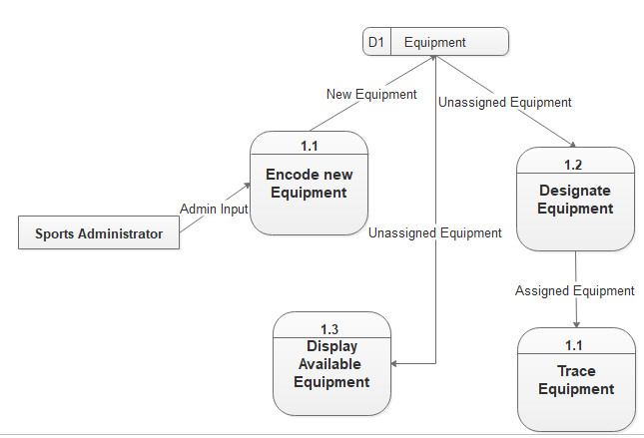

*Figure 15: Manage Equipment Level 1 Data Flow Diagram*

Manage Participants

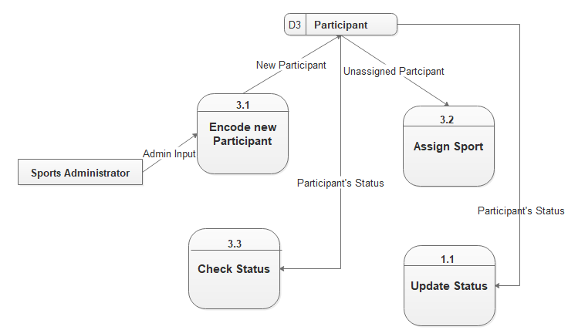

*Figure 16: Manage Participants Level 1 Data Flow Diagram*

Manage Sports Information

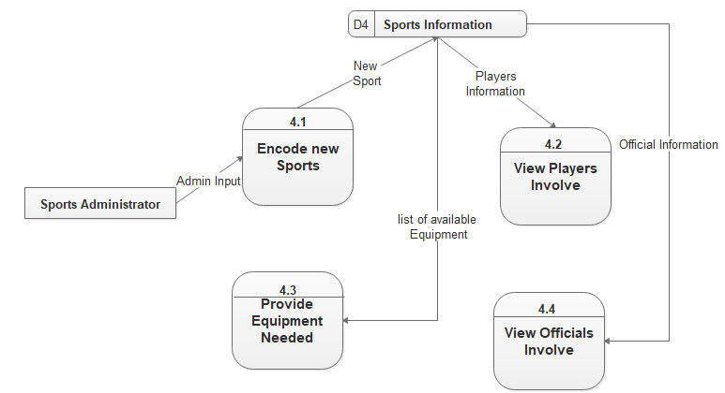

*Figure 17: Manage Sports Information Level 1 Data Flow Diagram*

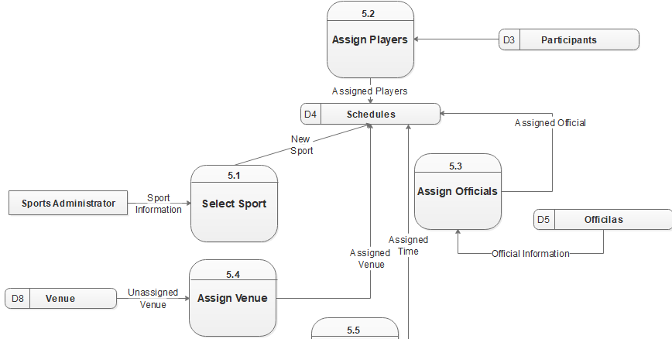Scheduling Sports



*Figure 18: Scheduling Sports Level 1 Data Flow Diagram*

*Figure 18: Scheduling of Sports Level 1 Data Flow Diagram*

**DATA DICTIONARIES**

These tables below provide the entire database tables details such as **FIELD NAME, DESCRIPTION, TYPE** and **LENGTH**

|  |  |  |  |
| --- | --- | --- | --- |
| **FIELD NAME** | **DESCRIPTION** | **TYPE** | **LENGTH** |
| sport_id | Sports id number | INT | 11 |
| sport_name | Name of sports | VARCHAR | 30 |
| game_type_code | game type code | VARCHAR | 30 |
| no_of_player | Sports number of player | INT | 11 |
| sport_code | Sports code | VARCHAR | 30 |

*Table8:**sports*

|  |  |  |  |
| --- | --- | --- | --- |
| **FIELD NAME** | **DESCRIPTION** | **TYPE** | **LENGTH** |
| equipment_id | Equipment id number | INT | 11 |
| equipment_name | Equipment name | VARCHAR | 30 |
| Quantity | Equipment quantity | INT | 11 |
| available_qty | Equipment available quantity | INT | 11 |
| quantity_out | Equipment quantity out | INT | 11 |
| equipment_code | Equipment code | VARCHAR | 30 |

*Table9:**equipments*

|  |  |  |  |
| --- | --- | --- | --- |
| **FIELD NAME** | **DESCRIPTION** | **TYPE** | **LENGTH** |
| facilitator_id | Facilitator id number | INT | 11 |
| facilitator_name | Name of facilitator | VARCHAR | 30 |
| facilitator gender | Gender of facilitator | VARCHAR | 30 |
| facilitator_address | Address of facilitator | TEXT |  |
| facilitator_contact | Contact number of facilitator | VARCHAR | 30 |
| facilitator_type | Type of facilitator | VARCHAR | 30 |
| facilitator_status | Status of facilitator | VARCHAR | 30 |
| facilitator_code | Facilitator code | VARCHAR | 30 |

*Table10: facilitator*

|  |  |  |  |
| --- | --- | --- | --- |
| **FIELD NAME** | **DESCRIPTION** | **TYPE** | **LENGTH** |
| player_id | Player id number | INT | 11 |
| player_name | Name of the player | VARCHAR | 30 |
| player_age | Age of the player | INT | 11 |
| player_course | Course of the player | VARCHAR | 30 |
| player_address | Address of the player | TEXT |  |
| player_gender | Gender of the player | VARCHAR | 30 |
| school_code | Code of school | VARCHAR | 30 |
| coach_code | Code of coach | VARCHAR | 30 |
| sport_code | Code of sports | VARCHAR | 30 |
| Contact | Contact number of the player | VARCHAR | 30 |
| player_code | Code of the player | VARCHAR | 30 |

*Table11: players*

|  |  |  |  |
| --- | --- | --- | --- |
| **FIELD NAME** | **DESCRIPTION** | **TYPE** | **LENGTH** |
| referee_id | Referee id number | INT | 11 |
| sport_code | Code of sports | VARCHAR | 30 |
| referee_name | Name of the referee | VARCHAR | 30 |
| referee_gender | Gender of the referee | VARCHAR | 30 |
| referee_address | Address of the referee | TEXT |  |
| referee_contact | Contact number of the referee | VARCHAR | 30 |
| referee_code | Code of the referee | VARCHAR | 30 |
| referee_status | Status of the referee | VARCHAR | 30 |

*Table12: referee*

|  |  |  |  |
| --- | --- | --- | --- |
| **FIELD NAME** | **DESCRIPTION** | **TYPE** | **LENGTH** |
| coach_id | coach id number | INT | 11 |
| coach_name | Name of the coach | VARCHAR | 30 |
| coach_contact | Contact number of the coach | VARCHAR | 30 |
| coach_address | Address of the coach | TEXT |  |
| school_code | Code of school | VARCHAR | 30 |
| coach_code | Code of the coach | VARCHAR | 30 |

*Table13: coaches*

|  |  |  |  |
| --- | --- | --- | --- |
| **FIELD NAME** | **DESCRIPTION** | **TYPE** | **LENGTH** |
| school_id | school id number | INT | 11 |
| school_name | Name of the school | VARCHAR | 30 |
| school_address | Address of the school | TEXT |  |
| school_code | Code of the school | VARCHAR | 30 |

*Table14: schools*

|  |  |  |  |
| --- | --- | --- | --- |
| **FIELD NAME** | **DESCRIPTION** | **TYPE** | **LENGTH** |
| game_type_id | school id number | INT | 11 |
| type_of_game | Name of the school | VARCHAR | 30 |
| game_type_code | Address of the school | VARCHAR | 30 |

*Table15: game_type*

|  |  |  |  |
| --- | --- | --- | --- |
| **FIELD NAME** | **DESCRIPTION** | **TYPE** | **LENGTH** |
| team_playerA_id | Team or player A id number | INT | 11 |
| team_playerA_name | Team or player A name | VARCHAR | 30 |
| sport_code | Code of the sport | TEXT |  |
| player_code | Code of the player | VARCHAR | 30 |
| coach_code | Code of the coach | VARCHAR | 30 |
| school_code | Code of the school | VARCHAR | 30 |
| school_name | Name of the school | VARCHAR | 30 |
| Status | Status of team or player A | VARCHAR | 30 |
| team_playerA_code | Code of team or player A | VARCHAR | 30 |

*Table16: team_player_a*

|  |  |  |  |
| --- | --- | --- | --- |
| **FIELD NAME** | **DESCRIPTION** | **TYPE** | **LENGTH** |
| team_playerB_id | Team or player B id number | INT | 11 |
| team_playerB_name | Team or player B name | VARCHAR | 30 |
| sport_code | Code of the sport | TEXT |  |
| player_code | Code of the player | VARCHAR | 30 |
| coach_code | Code of the coach | VARCHAR | 30 |
| school_code | Code of the school | VARCHAR | 30 |
| school_name | Name of the school | VARCHAR | 30 |
| Status | Status of team or player B | VARCHAR | 30 |
| team_playerB_code | Code of team or player B | VARCHAR | 30 |

*Table17: team_player_b*

|  |  |  |  |
| --- | --- | --- | --- |
| **FIELD NAME** | **DESCRIPTION** | **TYPE** | **LENGTH** |
| match_id | Game match id number | INT | 11 |
| Team_playerA_code | Code of team or player A | VARCHAR | 30 |
| Team_playerB_code | Code of team or player B | VARCHAR | 30 |
| Sport_code | Code of the sport | VARCHAR | 30 |
| referee_code | Code of the referee | VARCHAR | 30 |
| equipment_code | Code of the equipment | VARCHAR | 30 |
| Facilitator_code | Code of the facilitator | VARCHAR | 30 |
| Venue_code | Code of the venue | VARCHAR | 30 |
| Match_date | Date of the game match | TEXT |  |
| Match_time | Time of the game match | TEXT |  |
| Match_status | Status of the game match | VARCHAR | 30 |
| Match_code | Code of the game match | VARCHAR | 30 |
| school_year | Game match school year | VARCHAR | 30 |

*Table18: match_schedule*

|  |  |  |  |
| --- | --- | --- | --- |
| **FIELD NAME** | **DESCRIPTION** | **TYPE** | **LENGTH** |
| game_result_id | Result of the game id number | INT | 11 |
| match_code | Code of the game match | VARCHAR | 30 |
| sport_code | Code of the sport | VARCHAR | 30 |
| Winner | Result of the game winner | VARCHAR | 30 |
| Losser | Result of the game losser | VARCHAR | 30 |
| facilitator_code | Code of the facilitator | VARCHAR | 30 |
| referee_code | Code of the referee | VARCHAR | 30 |
| venue_code | Code of the venue | VARCHAR | 30 |
| Game_result_code | Code of the game result | VARCHAR | 30 |

*Table19: game_result*

|  |  |  |  |
| --- | --- | --- | --- |
| **FIELD NAME** | **DESCRIPTION** | **TYPE** | **LENGTH** |
| venue_id | Venue id number | INT | 11 |
| Place | Place of the venue | VARCHAR | 30 |
| venue_status | Status of the venue | VARCHAR | 30 |
| venue_code | Code of the venue | VARCHAR | 30 |

*Table20: venue*

|  |  |  |  |
| --- | --- | --- | --- |
| **FIELD NAME** | **DESCRIPTION** | **TYPE** | **LENGTH** |
| winner_id | winner id number | INT | 11 |
| match_code | Code of the game match | VARCHAR | 30 |
| final_score | Winner final score | VARCHAR | 30 |
| school_code | Code of the school | VARCHAR | 30 |
| school_name | Winner name of the school | VARCHAR | 30 |
| winner_code | Code of the winner | VARCHAR | 30 |

*Table21: winner*

|  |  |  |  |
| --- | --- | --- | --- |
| **FIELD NAME** | **DESCRIPTION** | **TYPE** | **LENGTH** |
| losser_id | Losser id number | INT | 11 |
| match_code | Code of the game match | VARCHAR | 30 |
| final_score | losser final score | VARCHAR | 30 |
| school_code | Code of the school | VARCHAR | 30 |
| school_name | name of the school of the losser | VARCHAR | 30 |
| losser_code | Code of the losser | VARCHAR | 30 |

*Table22: losser*

|  |  |  |  |
| --- | --- | --- | --- |
| **FIELD NAME** | **DESCRIPTION** | **TYPE** | **LENGTH** |
| award_id | award id number | INT | 11 |
| school_code | Code of the school | VARCHAR | 30 |
| Total_gold | Award total gold | INT | 11 |
| Total_silver | Award total silver | INT | 11 |
| Total_bronze | Award total bronze | INT | 11 |
| award_code | Code of the award | VARCHAR | 30 |

*Table23: awards*

|  |  |  |  |
| --- | --- | --- | --- |
| **FIELD NAME** | **DESCRIPTION** | **TYPE** | **LENGTH** |
| id | Message In id number | INT | 11 |
| SendTime | Message In send time | DATETIME |  |
| RecieveTime | Message In receive time | DATETIME |  |
| MessageFrom | Message In From | VARCHAR | 80 |
| MessageTo | Message In To | VARCHAR | 80 |
| SMSC | SMSC | VARCHAR | 80 |
| MessageText | Message In Text | TEXT |  |
| MessageType | Message In Type | VARCHAR | 80 |
| MessageParts | Message In Parts | INT | 11 |
| MessagePDU | Message In PDU | TEXT |  |
| Gateway | Message In Gateway | VARCHAR | 80 |
| UserId | Message In UserId | VARCHAR | 80 |

*Table24: messagein*

|  |  |  |  |
| --- | --- | --- | --- |
| **FIELD NAME** | **DESCRIPTION** | **TYPE** | **LENGTH** |
| id | Message Log id number | INT | 11 |
| SendTime | Message Log send time | DATETIME |  |
| RecieveTime | Message Log receive time | DATETIME |  |
| StatusCode | Message Log status code | INT | 11 |
| StatusText | Message Log text status | VARCHAR | 80 |
| MessageTo | Message To | VARCHAR | 80 |
| MessageFrom | Message From | VARCHAR | 80 |
| MessageText | Message Text | TEXT |  |
| MessageType | Type of message | VARCHAR | 80 |
| MessageId | Message id number | VARCHAR | 80 |
| MessageGuid | Message guid | TEXT |  |
| MessageInfo | Message information | TEXT |  |
| ErrorCode | Error code | VARCHAR | 80 |
| ErrorText | Error text | TEXT |  |
| Gateway | Message gateway | VARCHAR | 80 |
| MessageParts | Message parts | INT | 11 |
| MessagePDU | Message PDU | TEXT |  |
| Connector | Message connector | VARCHAR | 80 |
| UserId | Message UserId | VARCHAR | 80 |
| UserInfo | Message User Information | TEXT |  |

*Table25: messagelog*

|  |  |  |  |
| --- | --- | --- | --- |
| **FIELD NAME** | **DESCRIPTION** | **TYPE** | **LENGTH** |
| id | Message Out id number | INT | 11 |
| MessageTo | Message To | VARCHAR | 80 |
| MessageFrom | Message From | VARCHAR | 80 |
| MessageText | Message Text | TEXT |  |
| MessageType | Message Type | VARCHAR | 80 |
| MessageGuid | Message Guid | TEXT |  |
| MessageInfo | Message Information | TEXT |  |
| Gateway | Message Gateway | VARCHAR | 80 |
| UserId | Message User Id number | VARCHAR | 80 |
| UserInfo | Message User Information | TEXT |  |
| Priority | Message Priority | INT | 11 |
| Scheduled | Message Scheduled | DATETIME |  |
| ValidityPeriod | Message Validity | INT | 11 |
| IsSent | Message Is Sent | TINYINT | 1 |
| IsRead | Message Is Read | TINYINT | 1 |

*Table26: messagelog*

|  |  |  |  |
| --- | --- | --- | --- |
| **FIELD NAME** | **DESCRIPTION** | **TYPE** | **LENGTH** |
| user_id | User id number | INT | 11 |
| name | User Name | VARCHAR | 30 |
| username | User username | VARCHAR | 30 |
| password | User password | TEXT |  |
| user_type | User type | VARCHAR | 30 |

*Table27: user*

|  |  |  |  |
| --- | --- | --- | --- |
| **FIELD NAME** | **DESCRIPTION** | **TYPE** | **LENGTH** |
| sy_id | School Year ID number | INT | 11 |
| school_year | School year | VARCHAR | 30 |
| sy_code | School year code | VARCHAR | 30 |

*Table28: school_year*

**Architectural Framework**







**Screen Design**

Start Page



*Figure 19: Start Interface*

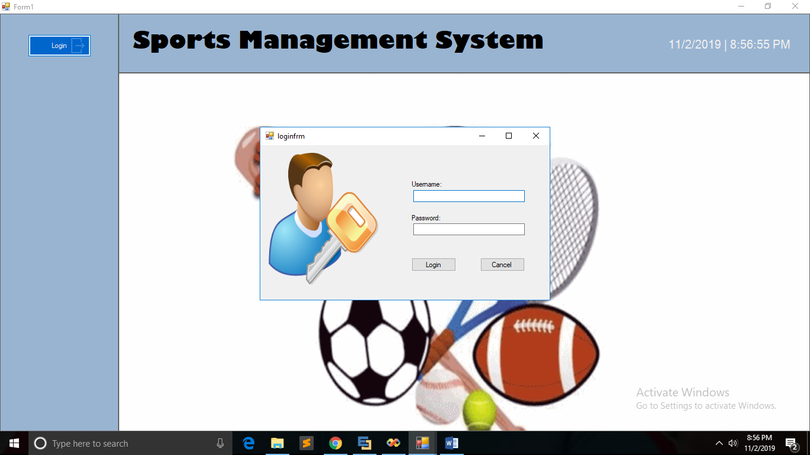Login Page

*Figure 20: Login*

Home Page (Admin side)

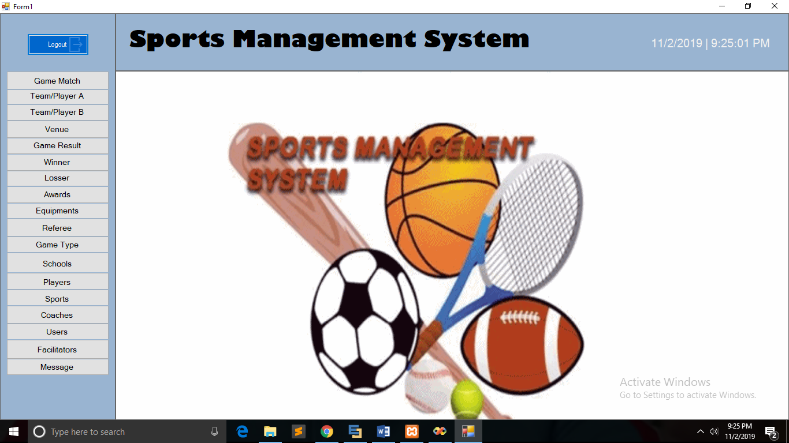

*Figure 21: Home Interface*

Game Match Page

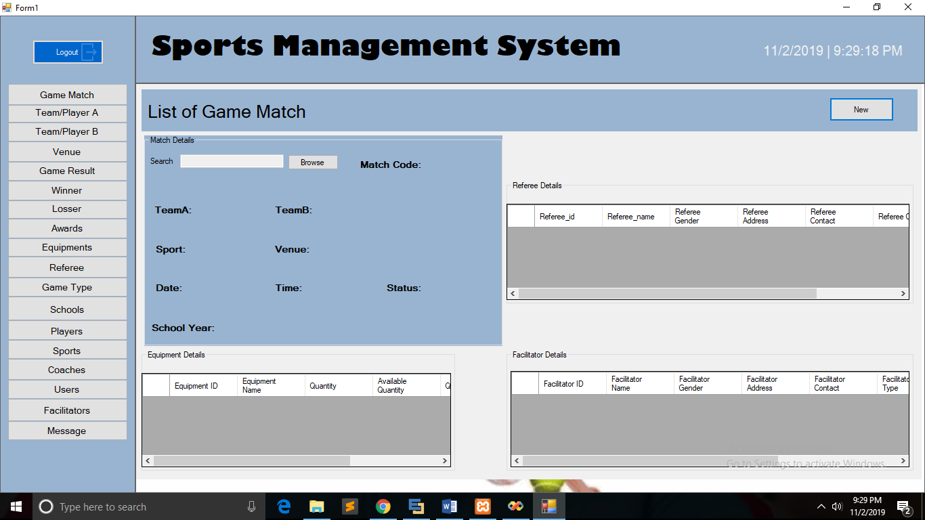

*Figure 22: Game Match Interface*

Team A Page

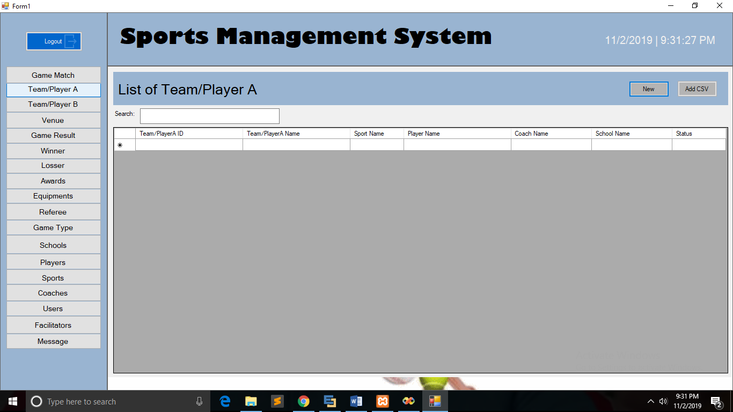

*Figure 23: Player or Team A Interface*

Team B Page

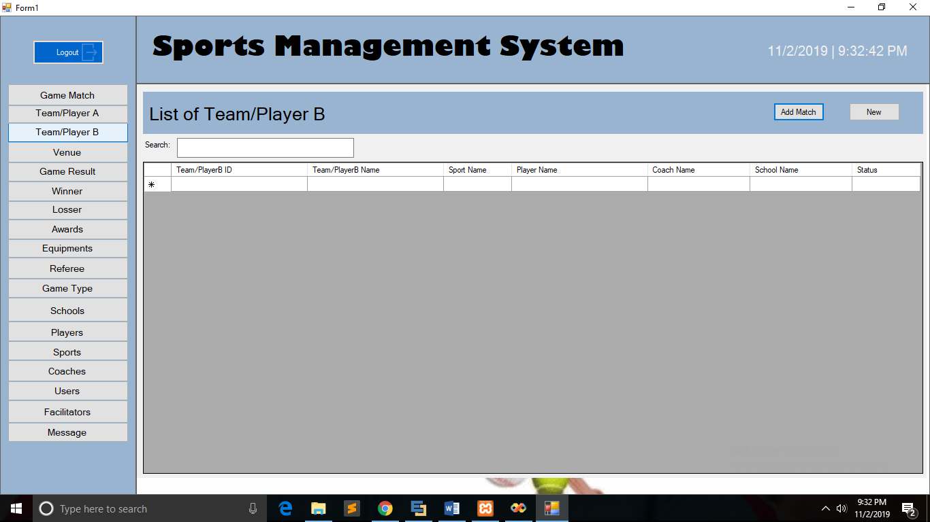

*Figure 24: Player or Team B Interface*

Venue Page

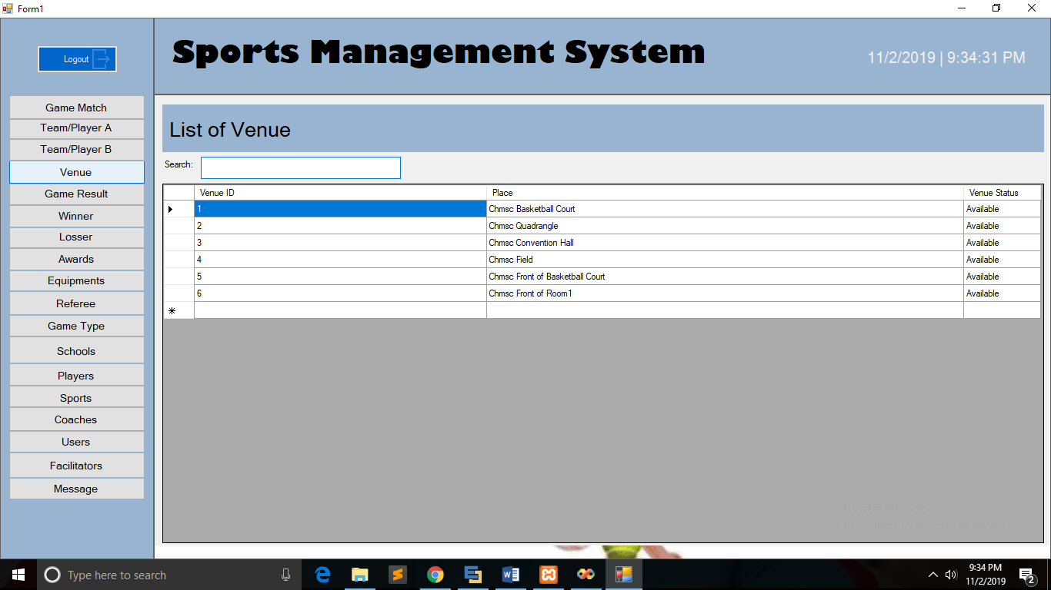

*Figure 25: Venue Interface*

Game Result Page

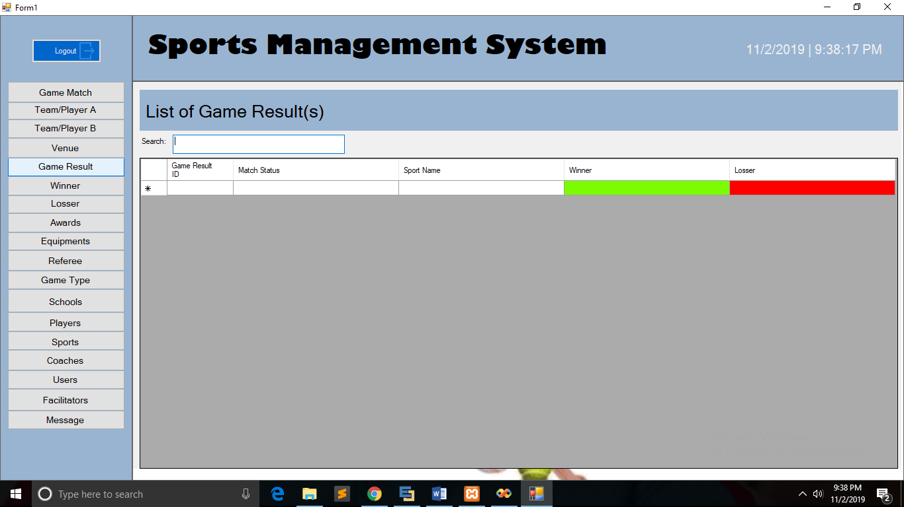

*Figure 26: Game Results Interface*

List of Winners Page

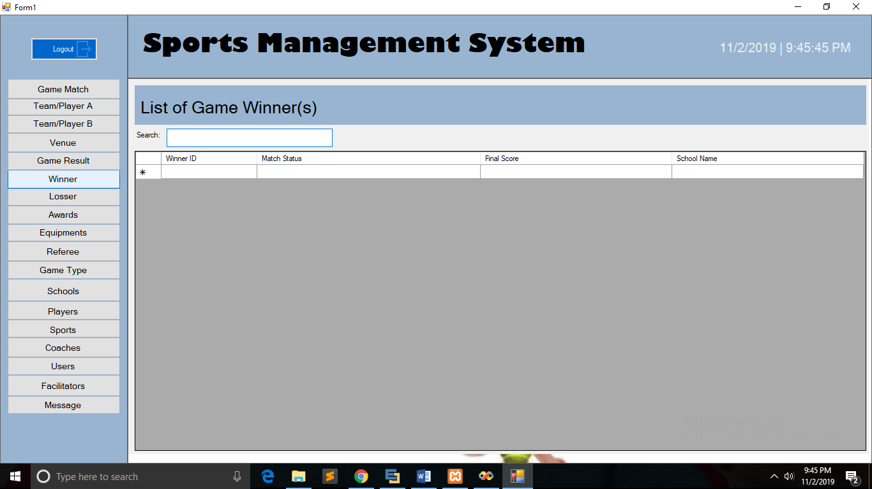

*Figure 27: Winners Interface*

List of Looser Page



*Figure 28: Loser’s Interface*

List of Awards Page

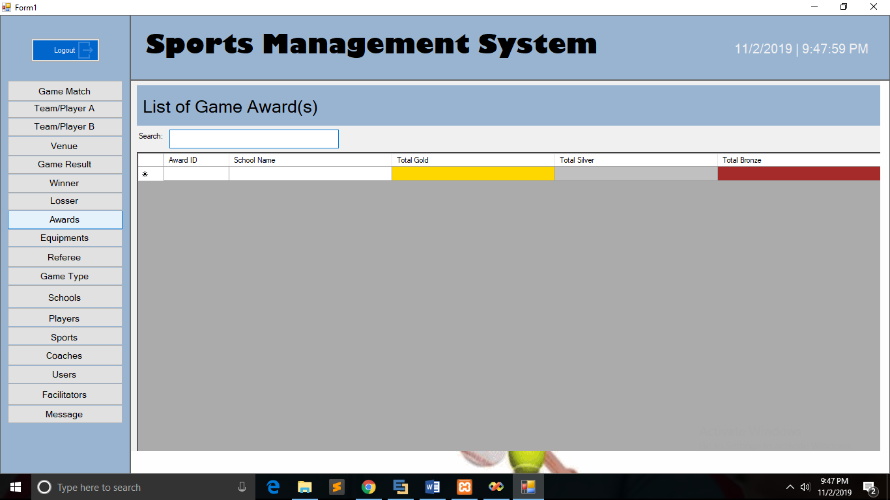

*Figure 29: Awards Interface*

List of Equipment Page

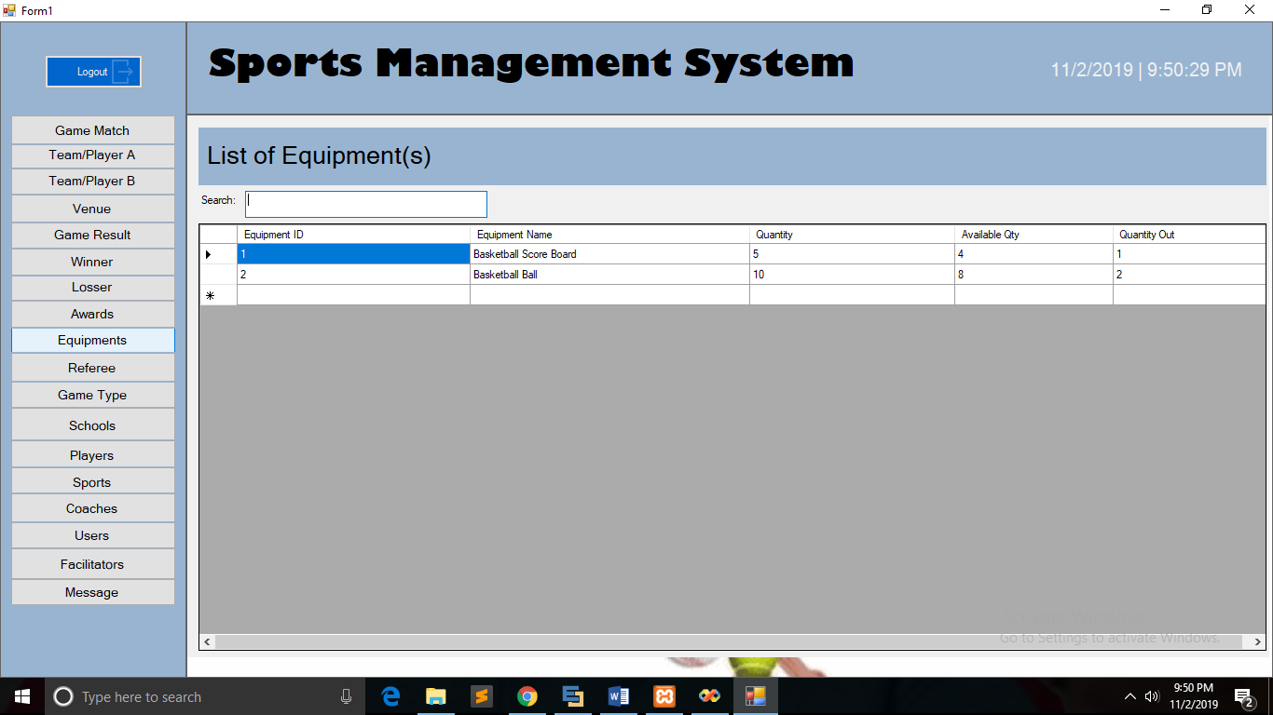

*Figure 30: Equipment Interface*

List of Referee Page

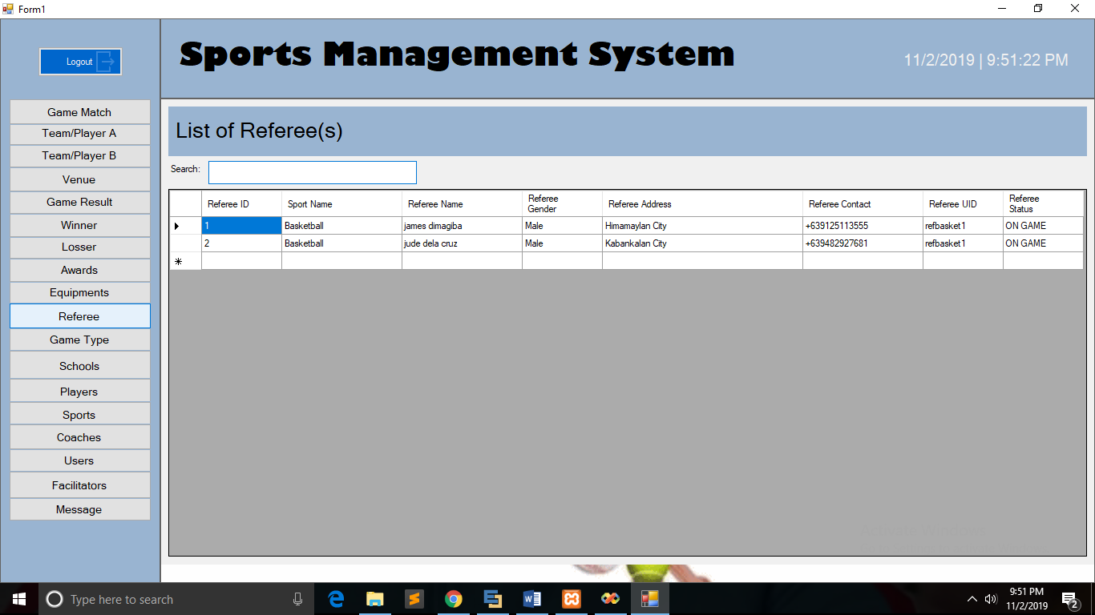

*Figure 31: Referee’s Interface*

Game Type Page

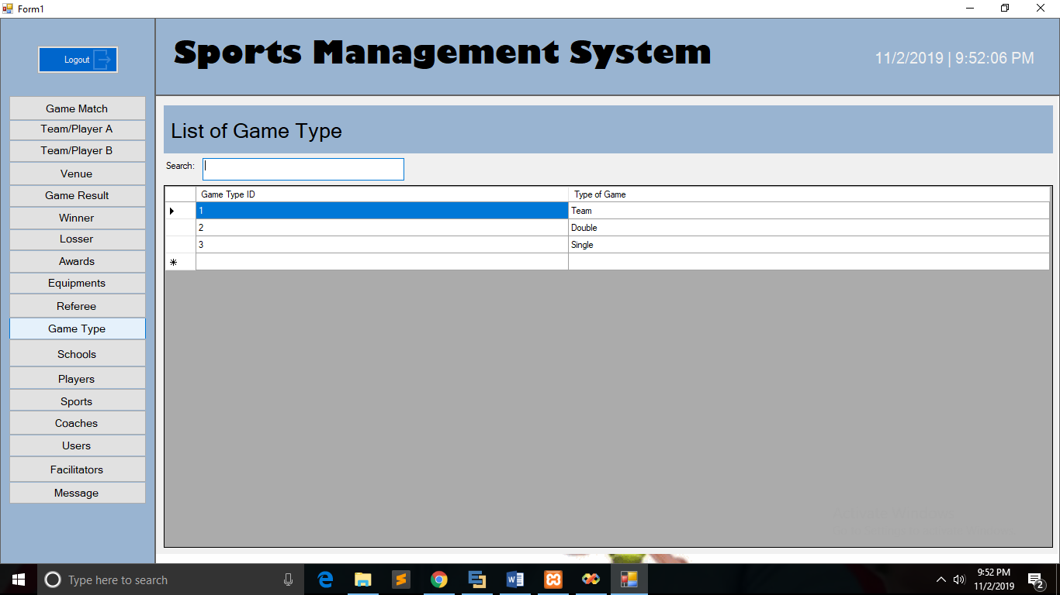

*Figure 32: Game Type Interface*

List of Schools Participated Page

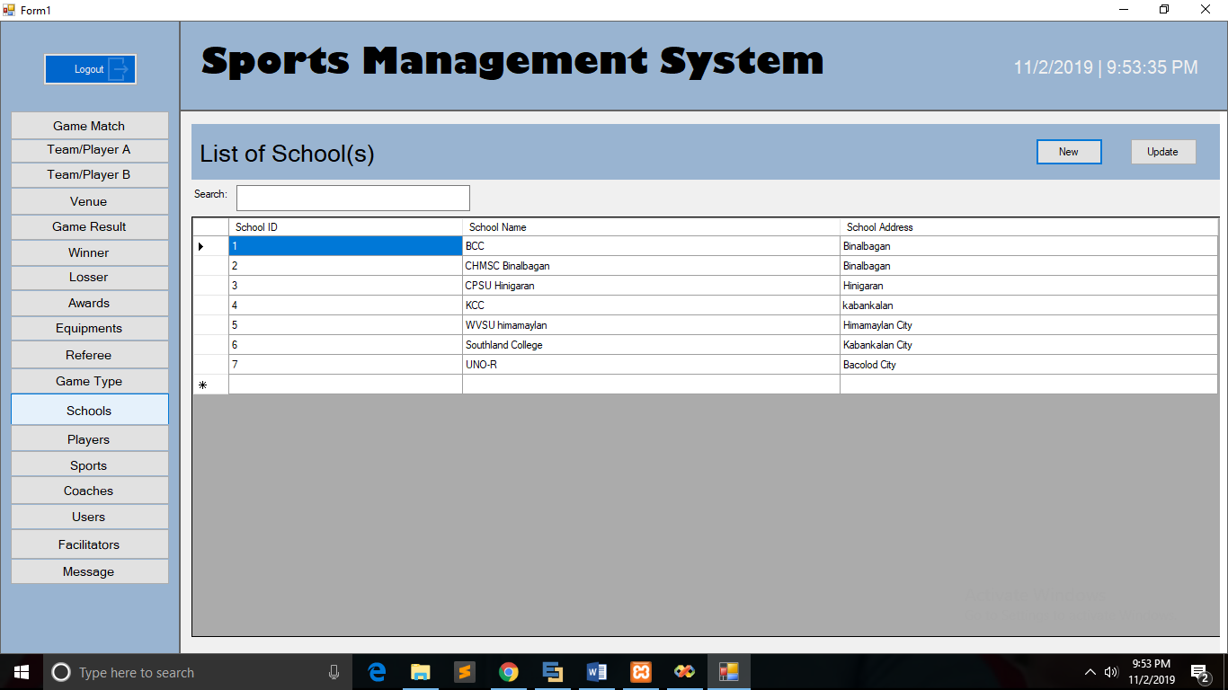

*Figure 33: List of Schools Interface*

List of Players Page

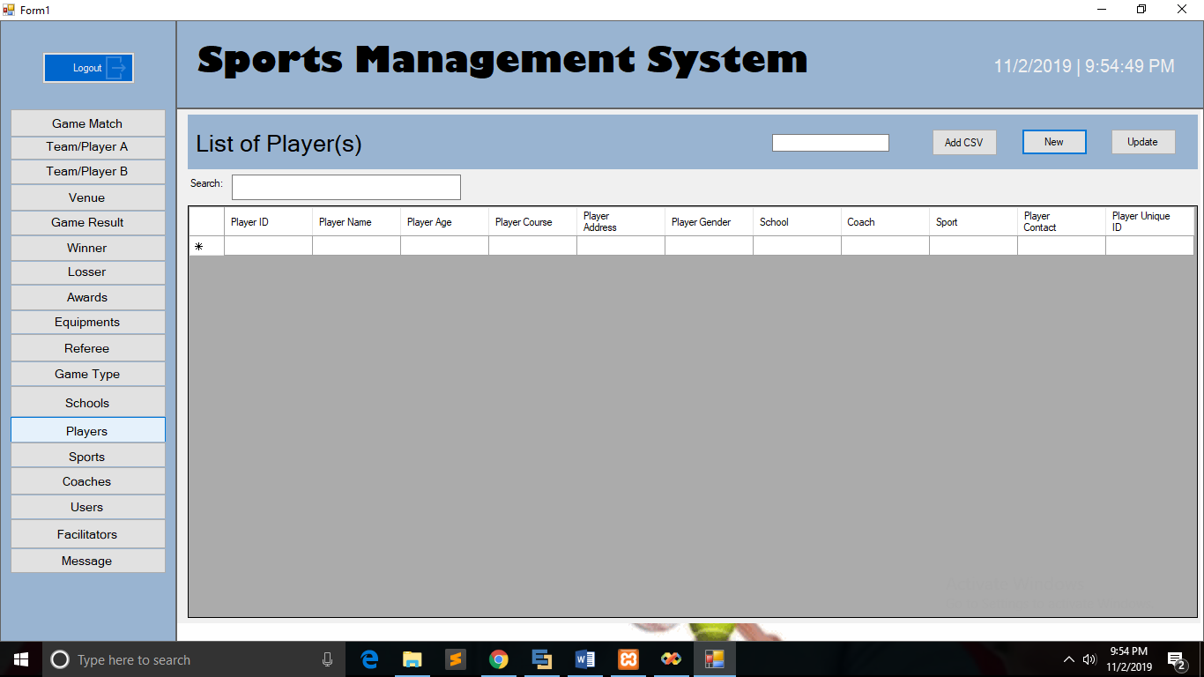

*Figure 34: List of Players Interface*

List of Sports Page

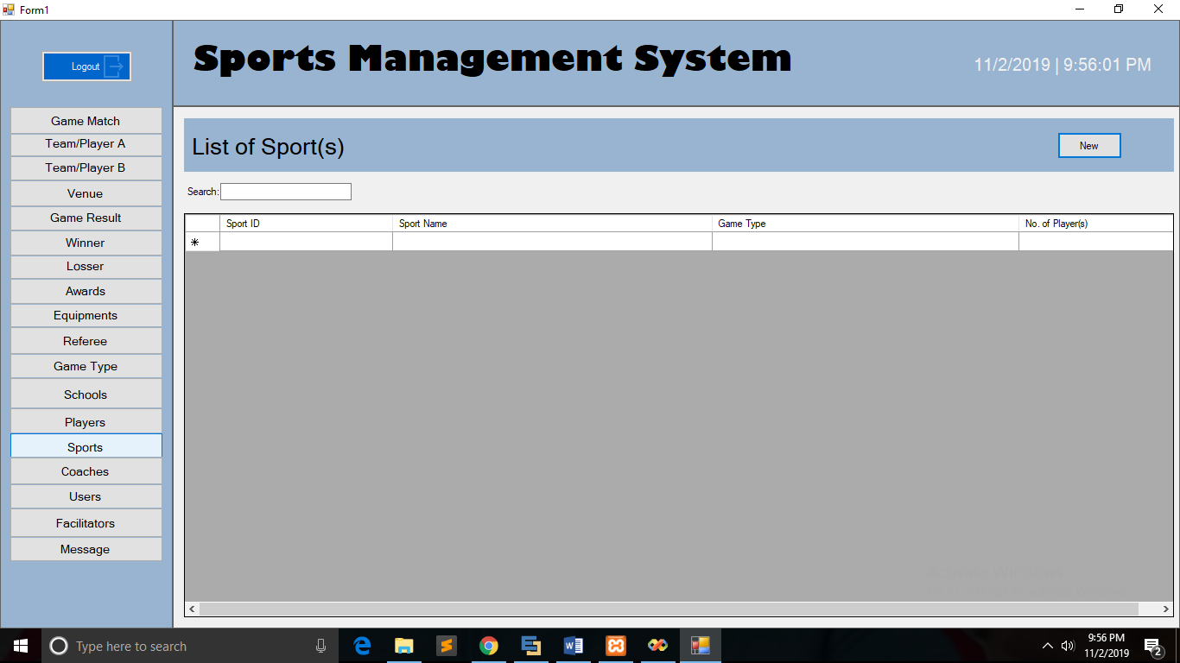

*Figure 35: List of Sports Interface*

List of Coaches Page

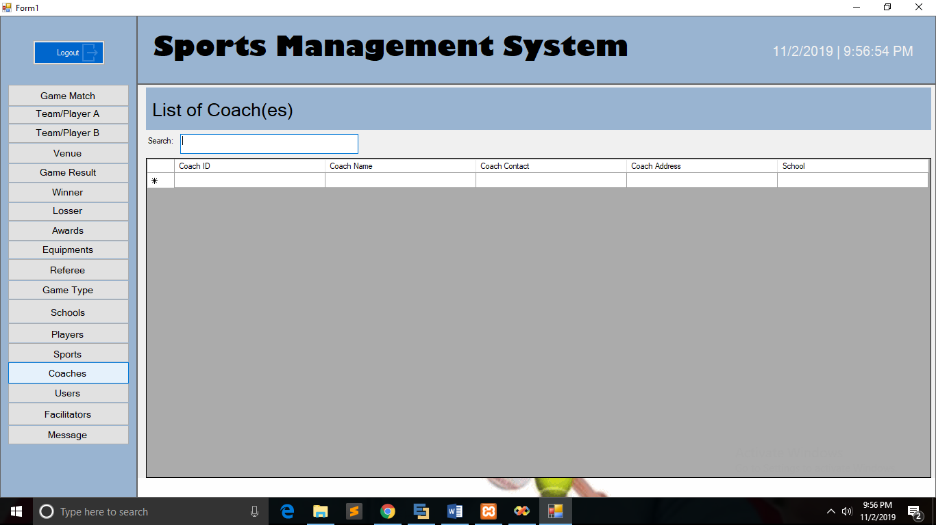

*Figure 36: List of Coaches Interface*

List of Users Page

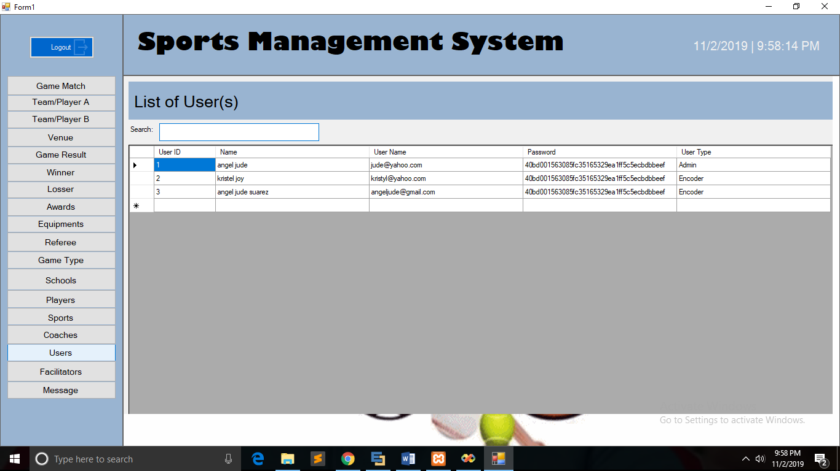

*Figure 37: List of Users Interface*

List of Facilitators Page

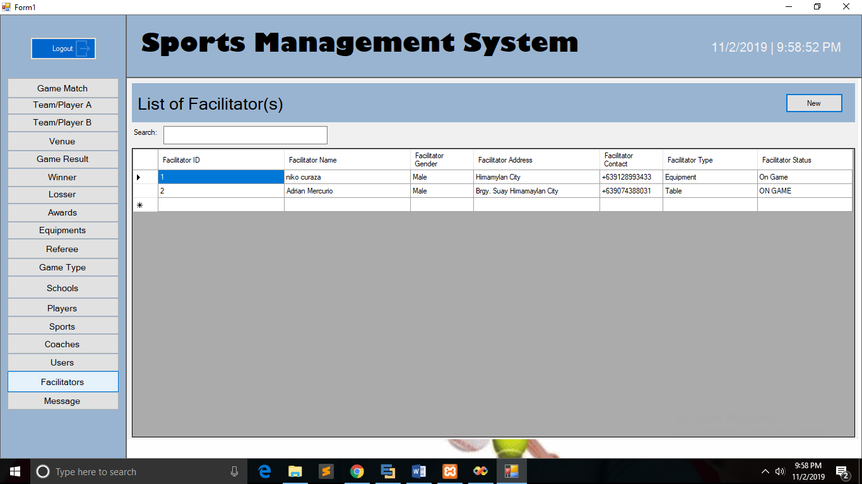

*Figure 38: List of Facilitators Interface*

**Modals**

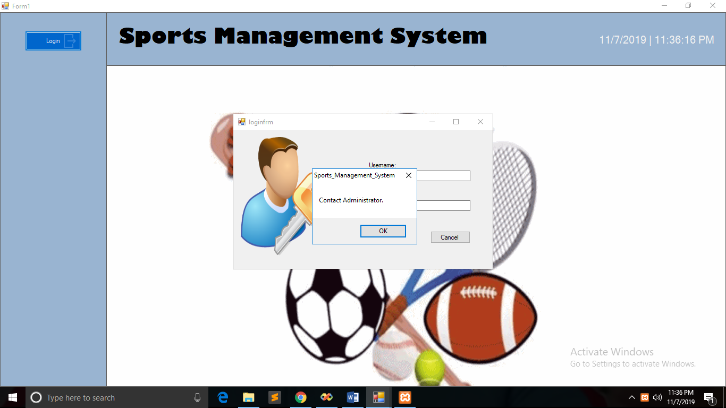Error in logging in

*Figure 39: Error Message in Logging in*

Send Message Form

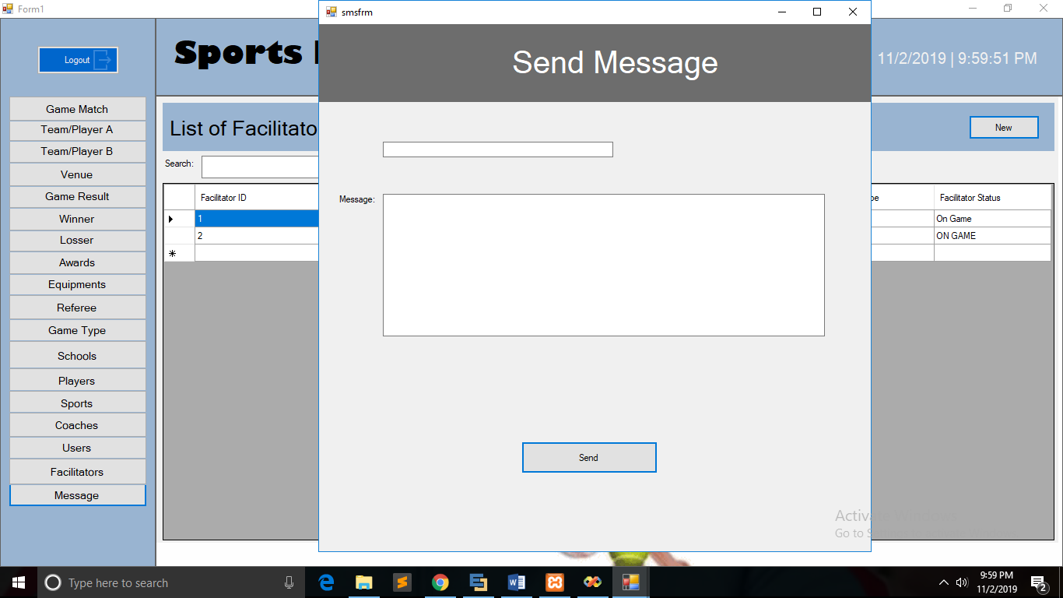

*Figure 40: Send Message Form*

Adding Game Match Modal

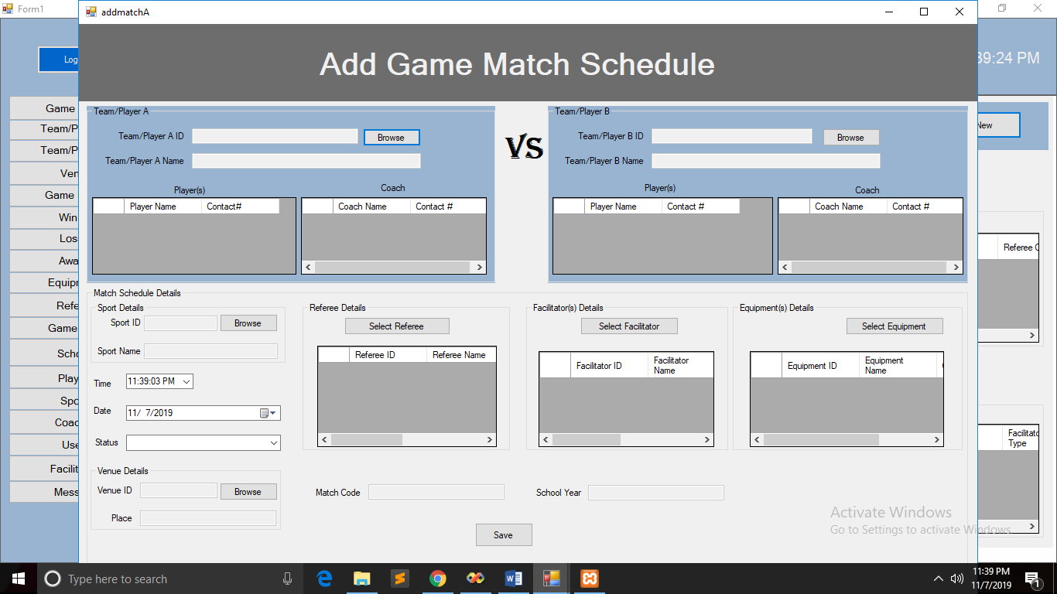

*Figure 41: Add Game Match Modal*

Add School Modal

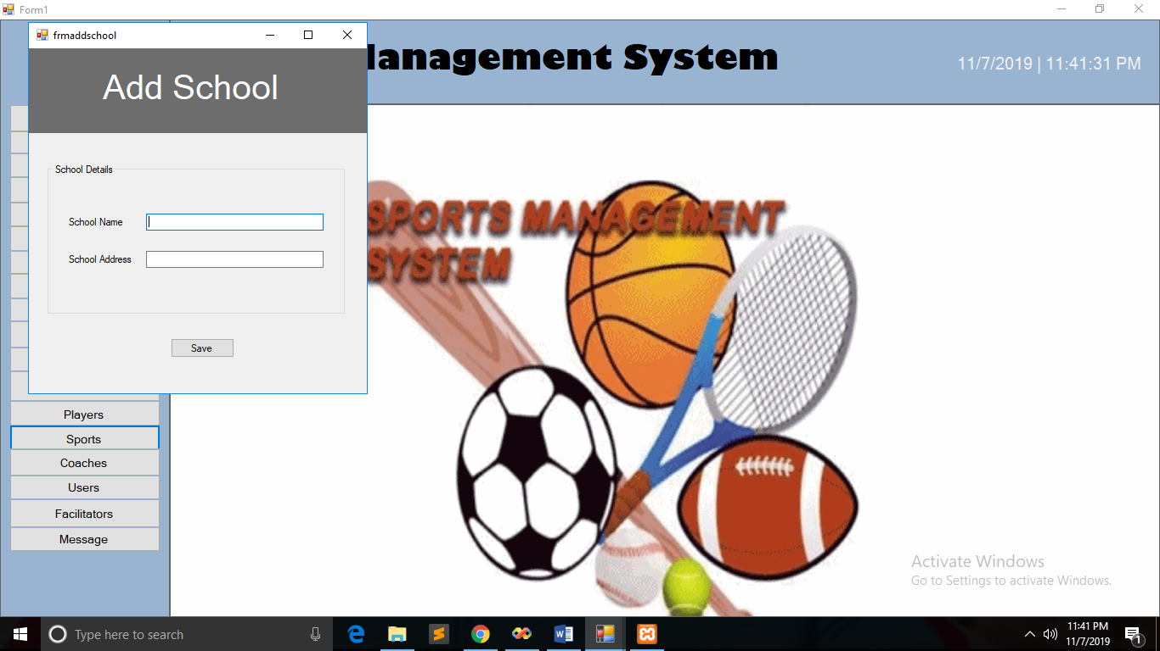

*Figure 42: Add School Modal*

Add Facilitator Modal

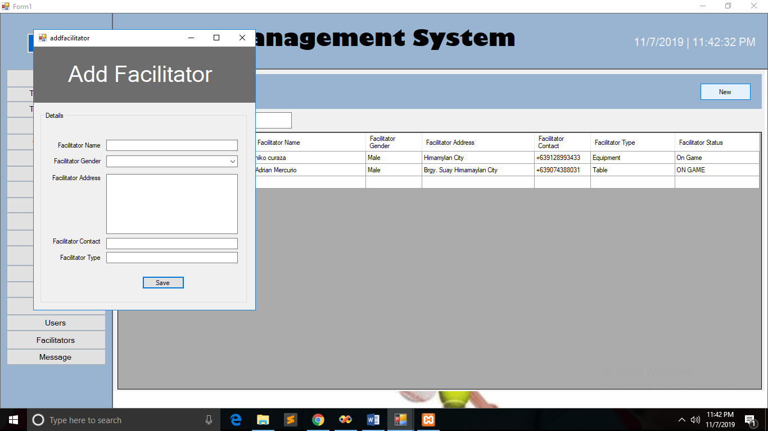

*Figure 43: Add Facilitator Modal*

**System Requirements**

* Processor: 1 gigahertz (GHz) or faster processor or SoC.
* RAM: 1 gigabyte (GB) for 32-bit or 2 GB for 64-bit.
* Hard disk space: 16 GB for 32-bit OS 20 GB for 64-bit OS.
* Graphics card: DirectX 9 or later with WDDM 1.0 driver.
* Display: 800x600.