Project 2
Introduction:
Netflix, Inc. is an American subscription streaming service and production company. Launched on August 29, 1997, it offers a film and television series library through distribution deals as well as its own productions, known as Netflix Originals.
Tasks:
- Load Excel data ,Using providing excel worksheet.
- Clean data in power Query.
- Create required relationships.
- Create measures for “total content” & “Runtime hours” formulas using DAX.
  - Runtime hours = DIVIDE(SUM(titles[runtime (in mins)]), 60, 0)
  - Total Content = DISTINCTCOUNT(titles[id])

- Create visualisation using same as below wireframe/design.
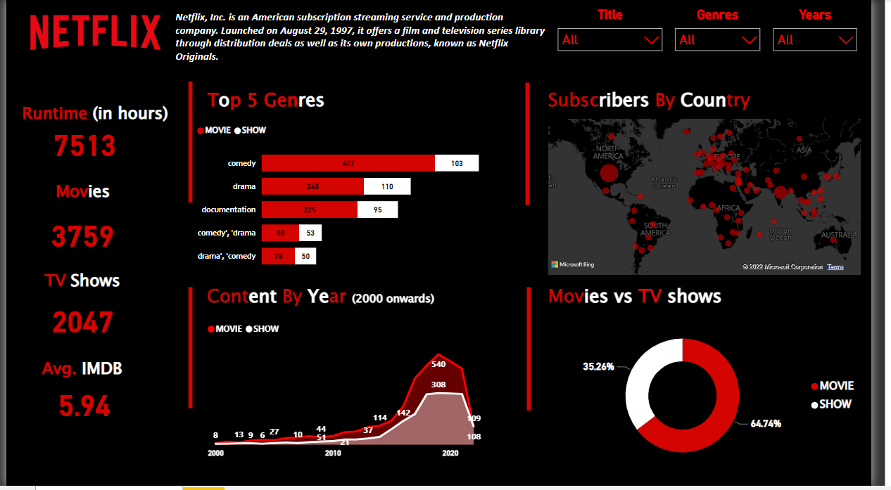
Color hex codes:
#D40400 for red
#FFFFFF for white
#000000 for black

Solution steps:
Load Excel data ,Using providing excel worksheet.
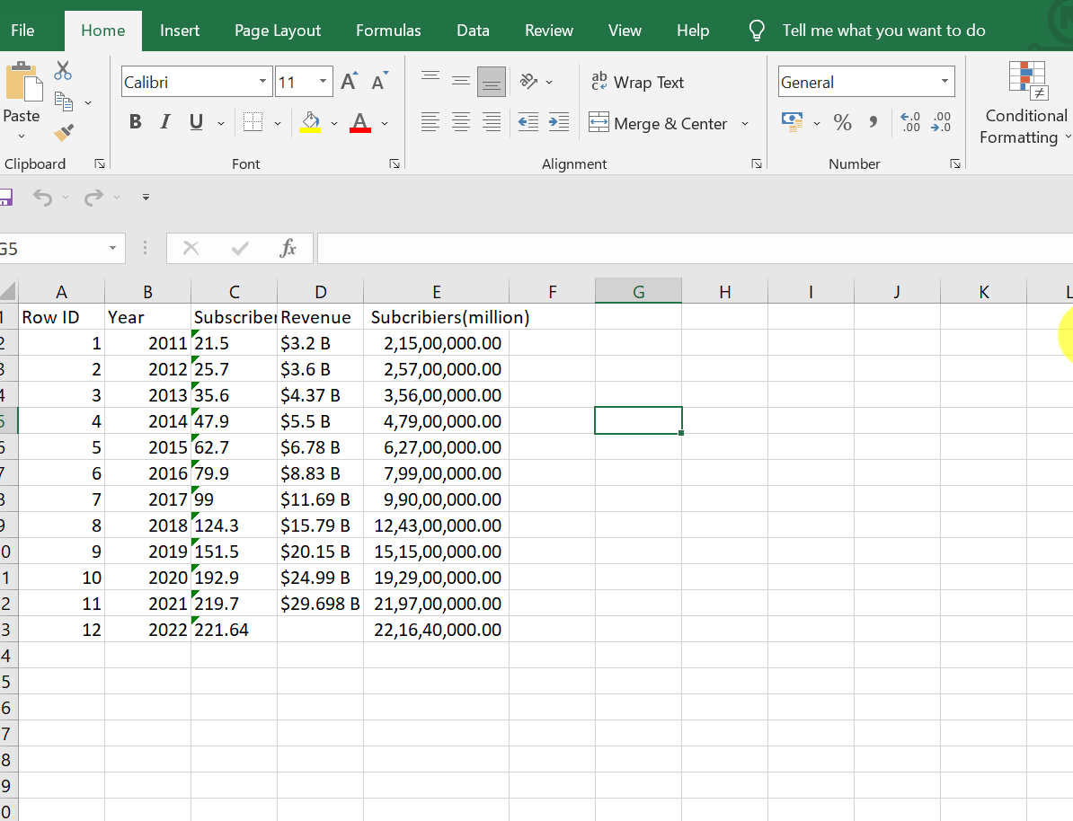
Clean data in power Query.
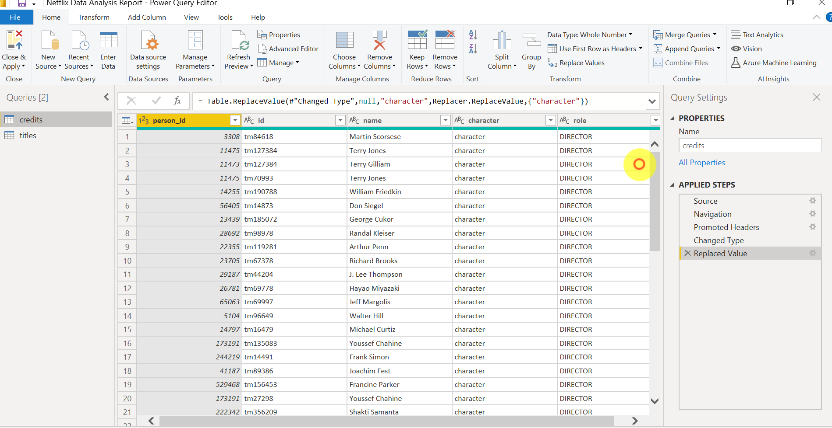

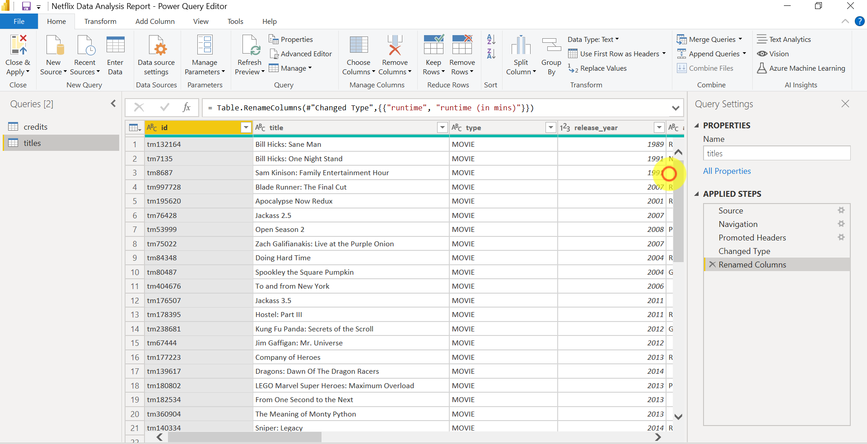
Create required relationships.
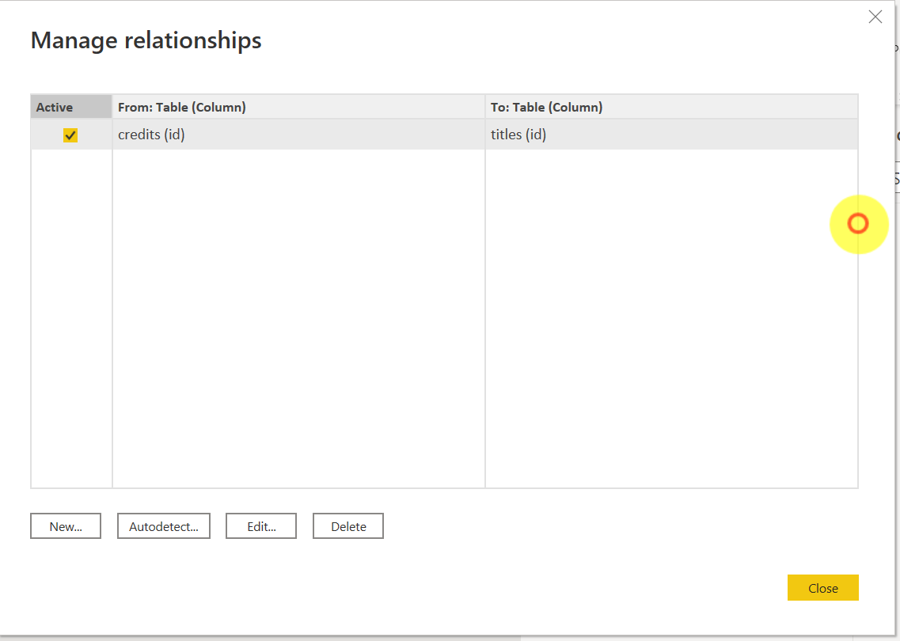

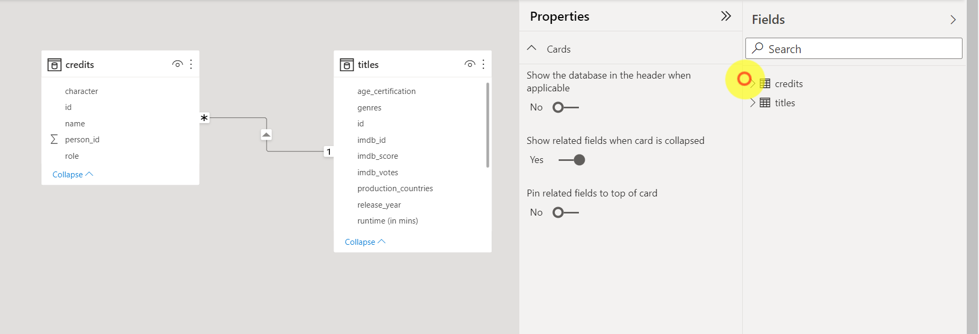
Create below formulas using DAX.

