AWS LEARNING
Assignment No. 2
AWS Root Account Creation — Step by Step
Name | Sanket Kolhe | Roll No. | ________________
Class / Division | ________________ | Subject | Cloud Computing (AWS)
Assignment No. | 02 | Date | 05 / 09 / 2026

Q.1 Enlist the steps involved in the process of AWS Root Account creation.

What is the AWS Root Account?
The root account is the very first account created when we sign up for AWS. The email address used at sign-up becomes the root user, and this identity has unrestricted access to every service, every resource and all billing information in the account. Because it has full power, AWS recommends using it only for a few special tasks and protecting it with Multi-Factor Authentication.

What you need before starting
- A valid email address — it must not already be linked to another AWS account. Prefer a company or team email rather than a personal one.
- A mobile number — used for the identity verification call or SMS.
- A credit or debit card — international transactions must be enabled. AWS places a small refundable verification charge (about $1 / ₹2) that is returned in a few days.
- Full address details — country, address, city, state and postal code.
- A strong password for the root user, and preferably an authenticator app installed on the phone for MFA.
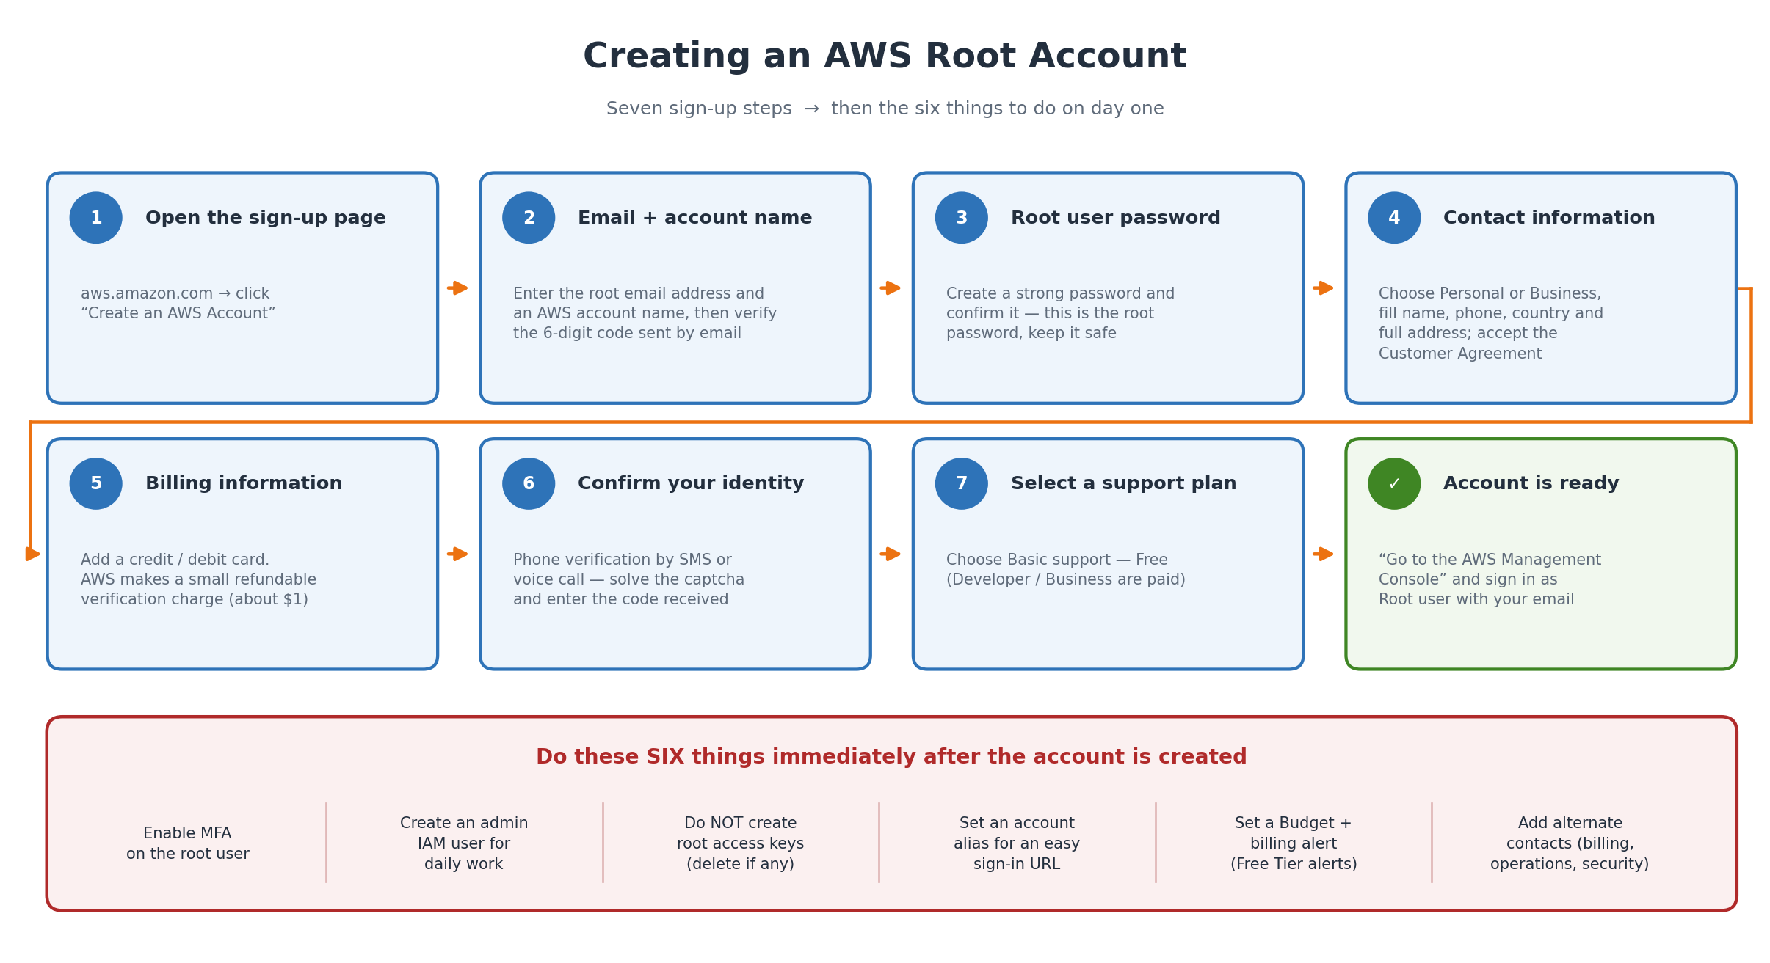
Figure 1: The seven sign-up steps, followed by the six security tasks to do on day one.

Steps to Create the AWS Root Account

Step 1 — Open the AWS sign-up page
Step 1 Open a browser and go to https://aws.amazon.com.
Step 2 Click the Create an AWS Account button on the top right (on the sign-in page the same option appears as “Create a new AWS account”).
Direct link: https://portal.aws.amazon.com/billing/signup

Step 2 — Enter the email address and account name
Step 1 Type the Root user email address. This email becomes the root user of the account.
Step 2 Type an AWS account name — for example “Sanket-Learning-Account”. It can be changed later.
Step 3 Click Verify email address.
Step 4 AWS sends a 6-digit verification code to that email. Open the inbox, copy the code, paste it and click Verify.
If the mail does not arrive, check the spam folder and then use “Resend code”.

Step 3 — Create the root user password
Step 1 Enter a Root user password and type it again in Confirm root user password.
Step 2 Click Continue.
AWS requires a minimum of 8 characters with uppercase, lowercase, a number and a symbol. Store this password safely — it protects the whole account.

Step 4 — Fill the contact information
Step 1 Choose how the account will be used: Personal or Business. (Personal is fine for learning; the features are the same.)
Step 2 Fill in the full name, phone number, country or region, address, city, state and postal code.
Step 3 Read and tick the AWS Customer Agreement checkbox, then click Continue.
The address must match the billing address of the card that will be added in the next step, otherwise verification can fail.

Step 5 — Add the billing information
Step 1 Enter the credit or debit card number, expiry date and cardholder name.
Step 2 Choose the billing address — use the contact address or enter a new one.
Step 3 Click Verify and Continue.
Important: AWS charges a small refundable amount (about $1, or ₹2 in India) only to confirm that the card is valid. It is reversed automatically within a few days. The card must allow international online transactions.

Step 6 — Confirm your identity
Step 1 Choose the verification method: Text message (SMS) or Voice call.
Step 2 Select the country code, enter the mobile number and solve the captcha shown on the screen.
Step 3 Click Send SMS (or Call me now).
Step 4 Enter the 4-digit verification code received and click Continue.

Step 7 — Select a support plan
Step 1 Choose one of the plans shown:
Plan | Cost | Choose it when
Basic support | Free | Learning, practice and personal accounts — select this one.
Developer support | Paid (from about $29/month) | Testing and development workloads.
Business support | Paid (from about $100/month) | Production workloads needing 24×7 help.

Step 2 Click Complete sign up.
The support plan can be changed later at any time from the Support Center.

Step 8 — Sign in for the first time
Step 1 A “Congratulations” page appears. Click Go to the AWS Management Console.
Step 2 On the sign-in page choose Root user, type the email address, click Next, then enter the password.
Step 3 The AWS Management Console opens — the account is now ready.
Note: Account activation is usually complete within a few minutes, but AWS may take up to 24 hours. Until then some services show an “account is being activated” message. A confirmation email is sent once activation finishes.

What to Do Immediately After Creating the Account
Creating the account is only half the job. These six tasks make the account safe and are part of the AWS security best practices.

1. Enable MFA on the root user
Step 1 Sign in as the root user and open the IAM console.
Step 2 On the dashboard find Security recommendations and click Add MFA (or go to the account menu → Security credentials).
Step 3 Under Multi-factor authentication (MFA) click Assign MFA device.
Step 4 Give the device a name and choose the type:
- Authenticator app — Google Authenticator, Microsoft Authenticator or Authy (free and most common).
- Security key — a physical device such as a YubiKey.
- Hardware TOTP token — a small key-fob device.
Step 5 Scan the QR code with the app, then enter two consecutive codes from it and click Add MFA.
From now on the root sign-in asks for the password plus the 6-digit code from the app.

2. Create an administrator IAM user for daily work
Step 1 In the IAM console go to Users → Create user.
Step 2 Give a user name, tick “Provide user access to the AWS Management Console” and set a password.
Step 3 On the permissions page create (or select) a group such as Administrators and attach the AdministratorAccess policy.
Step 4 Create the user, enable MFA for it as well, and use this user for all normal work.
Full steps for this are covered in Assignment 3 (IAM practical).

3. Do not create root access keys
Access keys for the root user are extremely dangerous — if leaked, the whole account is compromised. Never create them. If any already exist, open Account menu → Security credentials → Access keys and delete them.

4. Set an account alias
Step 1 Open IAM → Dashboard and find AWS Account → Account Alias → click Create.
Step 2 Type a short unique alias, for example sanket-aws.
The sign-in URL becomes easy to remember:
Before: https://123456789012.signin.aws.amazon.com/console
After : https://sanket-aws.signin.aws.amazon.com/console

5. Set a budget and billing alerts
Step 1 Open the Billing and Cost Management console.
Step 2 Go to Billing preferences and turn on Receive Free Tier alerts and Receive billing alerts.
Step 3 Go to Budgets → Create budget, choose Cost budget, set an amount such as $5, and add your email for the alert.
This prevents a surprise bill — the most common problem for new AWS learners.

6. Add alternate contacts
Step 1 Open Account menu → Account.
Step 2 Under Alternate contacts add a Billing, Operations and Security contact.
AWS uses these to reach the right person even if the root email is unavailable.

Important Points to Remember

Tasks that only the root user can perform
- Changing the AWS account name, root email address or root password.
- Changing the support plan.
- Closing the AWS account.
- Moving the account into (or out of) AWS Organizations.
- Restoring IAM user permissions when an administrator has locked everyone out.
- Fixing an invalid S3 bucket policy or SQS policy that denies everyone.
- Signing up for AWS GovCloud and registering as a seller in the Reserved Instance Marketplace.

AWS Free Tier
A new account automatically gets the AWS Free Tier, which has three kinds of offers:
Type | Meaning | Example
12 months free | Free for one year from the sign-up date. | 750 hours/month of t2.micro or t3.micro EC2; 5 GB of S3 standard storage.
Always free | Free for every account, with no time limit. | 1 million AWS Lambda requests per month; 25 GB of DynamoDB storage.
Trials | Free for a short period after the service is first used. | Amazon SageMaker and some other services.

Warning: Free Tier is not unlimited. Crossing the limit, or leaving an EC2 instance or an Elastic IP running, starts real charges. Always set a budget alert and stop or terminate resources after practising.

Root account vs IAM user
Point | Root user | IAM user
Created | Automatically at sign-up | Created manually inside IAM
Sign in with | Email address + password | Account ID/alias + user name + password
Permissions | Unrestricted — cannot be limited by an IAM policy | Only what its policies allow
Number | Exactly one per account | Up to 5,000 per account
Daily use | Not recommended | Recommended

Common problems during sign-up and how to fix them
Problem | Reason | Solution
“This email is already in use” | An AWS account already exists with that email. | Use a different email, or recover the password of the existing account.
Card declined / payment failed | International transactions are disabled, or the address does not match the card. | Enable international use in the bank app, check the billing address, or try another card.
Verification code not received | Wrong number, poor network, or the mail went to spam. | Use the voice-call option, check the spam folder, or click Resend.
“Your account is being activated” for a long time | AWS is still verifying the payment method. | Wait — usually a few minutes, but it can take up to 24 hours. Then contact AWS Support.
Unexpected bill after some practice | A resource was left running beyond the Free Tier. | Stop/terminate EC2, release Elastic IPs, delete unused volumes; set a budget alert.

Viva questions on this practical
Q1. What is the root account?
Ans. The first identity created when an AWS account is opened, identified by the sign-up email address, having unrestricted access to everything in that account.
Q2. Why is a card required if we only use the Free Tier?
Ans. To verify identity and to charge anything used beyond the Free Tier. AWS only takes a small refundable verification amount at sign-up.
Q3. Which support plan should a student choose?
Ans. Basic support, because it is free.
Q4. What is the first thing to do after creating the account?
Ans. Enable MFA on the root user and create an administrator IAM user for daily work.
Q5. Can the root user's permissions be restricted with an IAM policy?
Ans. No. Only a Service Control Policy in AWS Organizations can restrict the root user.
Q6. Why should root access keys never be created?
Ans. If they leak, an attacker gets complete control of the account and the permissions cannot be limited.
Q7. What is an account alias used for?
Ans. It replaces the 12-digit account ID in the sign-in URL, making it easy to remember.

Conclusion
Creating an AWS root account is a seven-step online process: open the sign-up page, verify the email, set the root password, fill the contact details, add a payment method, verify the phone number and choose a support plan. The account is ready within minutes. However, the more important part is what follows — enabling MFA on the root user, creating an administrator IAM user for everyday work, avoiding root access keys and setting a billing budget. The root account should then be kept aside and used only for the few tasks that nothing else can perform.

