**B10-Write a program using UDP sockets for wired network to implement**

**a. Peer to Peer Chat b. Multiuser Chat**

**a. Peer to Peer Chat**

**import random**

**from socket import \***

**from threading import Thread, Lock**

**def receiver(serverSocket):**

**global recv_msg**

**global name**

**while flag:**

**recv_msg,address=serverSocket.recvfrom(1024) #Receive data from using**

**recvfrom'''**

**if client_addr == str(address[0]):**

**if recv_msg == '*quit*':**

**print name+" is offline"**

**else:**

**print "\t\t"+recv_msg**

**flag = True**

**serverSocket=socket(AF_INET,SOCK_DGRAM) #Declare a socket for UDP'''**

**serverSocket.bind(('', 12000))**

**recv_msg, address = serverSocket.recvfrom(1024)**

**client_addr = str(address[0])**

**print recv_msg + " is connected from IP:"+str(address[0])+" and**

**Port:"+str(address[1])+"\n"**

**name = recv_msg**

**# Start channel receiver thread**

**recv_thread = Thread(target=receiver, args=(serverSocket,))**

**recv_thread.daemon = True**

**recv_thread.start()**

**while flag:**

**send_msg = raw_input()**

**if send_msg == '*quit*':**

**flag = False**

**serverSocket.sendto(send_msg,address)**

**'''Send data to client using sendto'''**

**B10P2P CLIENT CODE:**

**from socket import \***

**import time**

**from threading import Thread, Lock**

**def receiver(clientSocket):**

**while flag:**

**recv_msg,address=clientSocket.recvfrom(1024)**

**#Receive data from server using recvfrom'''**

**print "\t\t"+recv_msg**

**flag = True**

**clientSocket = socket(AF_INET, SOCK_DGRAM)**

**addr = ('172.168.255.121', 12000)**

**name = str(raw_input("Enter Your Name:"))**

**clientSocket.sendto(name, addr)**

**#try:**

**# Start channel receiver thread**

**recv_thread = Thread(target=receiver, args=(clientSocket,))**

**recv_thread.daemon = True**

**recv_thread.start()**

**recv_msg = 'NUll'**

**while recv_msg != '*quit*':**

**send_msg = raw_input()**

**if send_msg == '*quit*':**

**clientScoket.sendto(send_msg,addr) #Send data to client using sendto'''**

**flag = False**

**recv_thread.stop()**

**else:**

**clientSocket.sendto(send_msg,addr)#Send data to client using sendto'''**

**OUTPUT:**

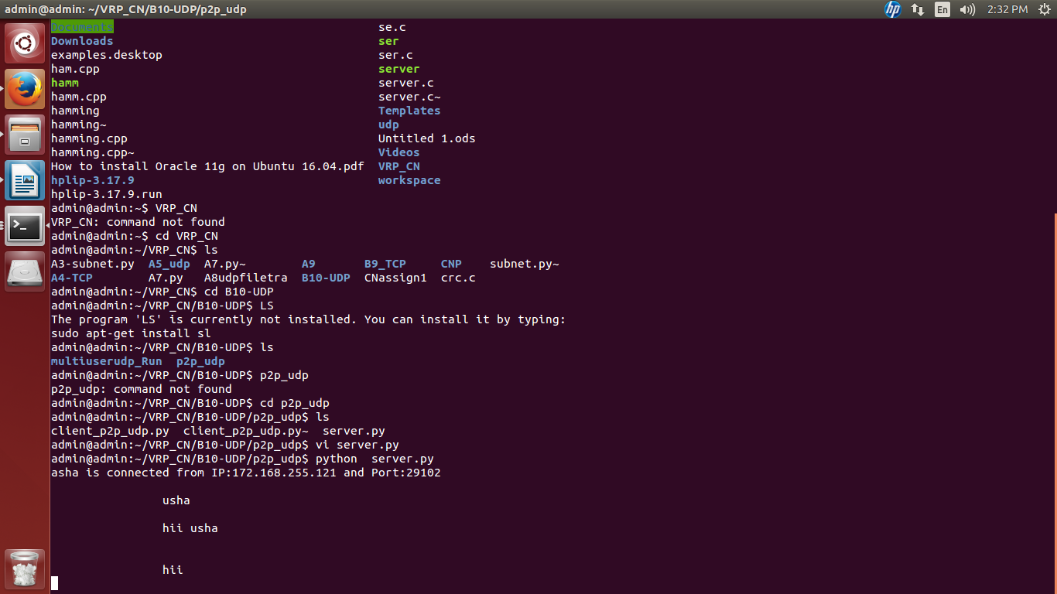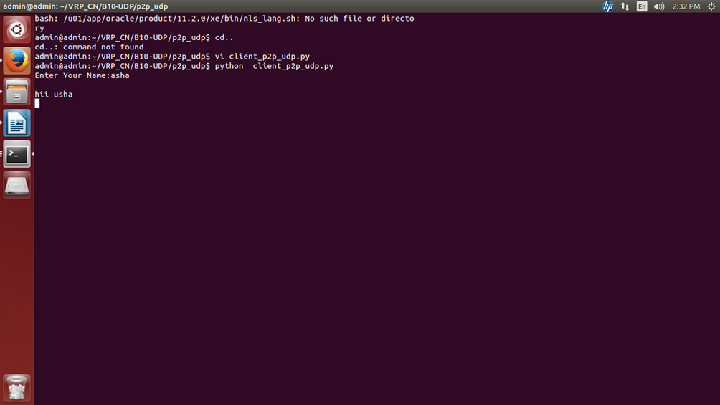

**b. Multiuser Chat**

**import random**

**from socket import \***

**from threading import Thread, Lock**

**client_info = {}**

**def listener(serverSocket):**

**global client_info**

**global recv_msg**

**global name**

**while flag:**

**#print "started"**

**recv_msg, address = serverSocket.recvfrom(1024)**

**#print bool(client_info)**

**if bool(client_info):**

**if address in client_info.keys():**

**msg = "\t\t"+client_info[address]+":"+recv_msg**

**print msg**

**for addr in client_info:**

**'''Send data using sendto to addr'''**

**serverSocket.sendto(msg,address)**

**else:**

**client_info[address] = recv_msg**

**msg = "\n"+str(client_info[address])+" is online"**

**print msg**

**for addr in client_info:**

**'''Send data using sendto to addr'''**

**serverSocket.sendto(msg,address)**

**else:**

**client_info[address] = recv_msg**

**msg = "\n"+str(client_info[address])+" is online"**

**print msg**

**multiclient udp:**

**from socket import \***

**import time**

**from threading import Thread, Lock**

**def receiver(clientSocket):**

**global recv_msg**

**while flag:**

**'''receive data from server'''**

**recv_msg,address=clientSocket.recvfrom(1024)**

**print "\t\t"+recv_msg**

**flag = True**

**clientSocket = socket(AF_INET, SOCK_DGRAM)**

**addr = ('172.168.255.121', 5500)**

**name = str(raw_input("Enter Your Name:"))**

**'''Send name to client'''**

**clientSocket.sendto(name,addr)**

**#try:**

**# Start channel receiver thread**

**recv_thread = Thread(target=receiver, args=(clientSocket,))**

**recv_thread.daemon = True**

**recv_thread.start()**

**recv_msg = 'NUll'**

**while recv_msg != '*quit*':**

**send_msg = raw_input()**

**if send_msg == '*quit*':**

**'''Send the data'''**

**clientSocket.sendto(send_msg,addr)**

**OUTPUT:**

