from pexpect import pxssh

import getpass

try:

s = pxssh.pxssh()

hostname = raw_input('hostname: ')

username = raw_input('username: ')

password = getpass.getpass('password: ')

s.login (hostname, username, password)

s.sendline ('sudo apt-get install geany -y') # run a command

s.prompt() # match the prompt

print s.before # print everything before the prompt.

s.logout()

except pxssh.ExceptionPxssh, e:

print "pxssh failed on login."

print str(e)

from pexpect import pxssh

import getpass

try:

s = pxssh.pxssh()

hostname = raw_input('hostname: ')

username = raw_input('username: ')

password = getpass.getpass('password: ')

s.login (hostname, username, password)

s.sendline ('sudo apt-get install geany -y') # run a command

s.prompt() # match the prompt

print s.before # print everything before the prompt.

s.logout(

except pxssh.ExceptionPxssh, e:

print "pxssh failed on login."

print str(e)

**Step 1**

Check your IP address Command:: ifconfig eth0

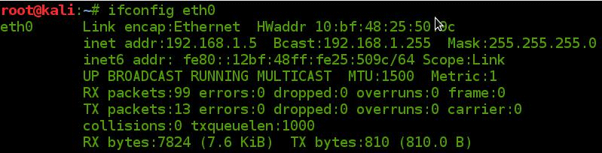

**Step 2**

First we need to install a DHCP server Software

# apt-get install isc-dhcp-server

**Step 3**

Open the DHCP server configuration FILE.

# nano /etc/dhcp/dhcpd.conf



**Step 4**

Configure the DHCP server configuration FILE as per the required Settings.

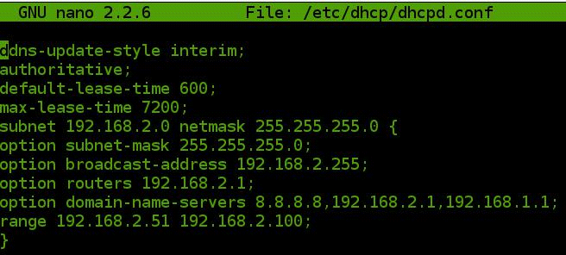

**Step 5**

Give the Interfaces on which DHCP should work.

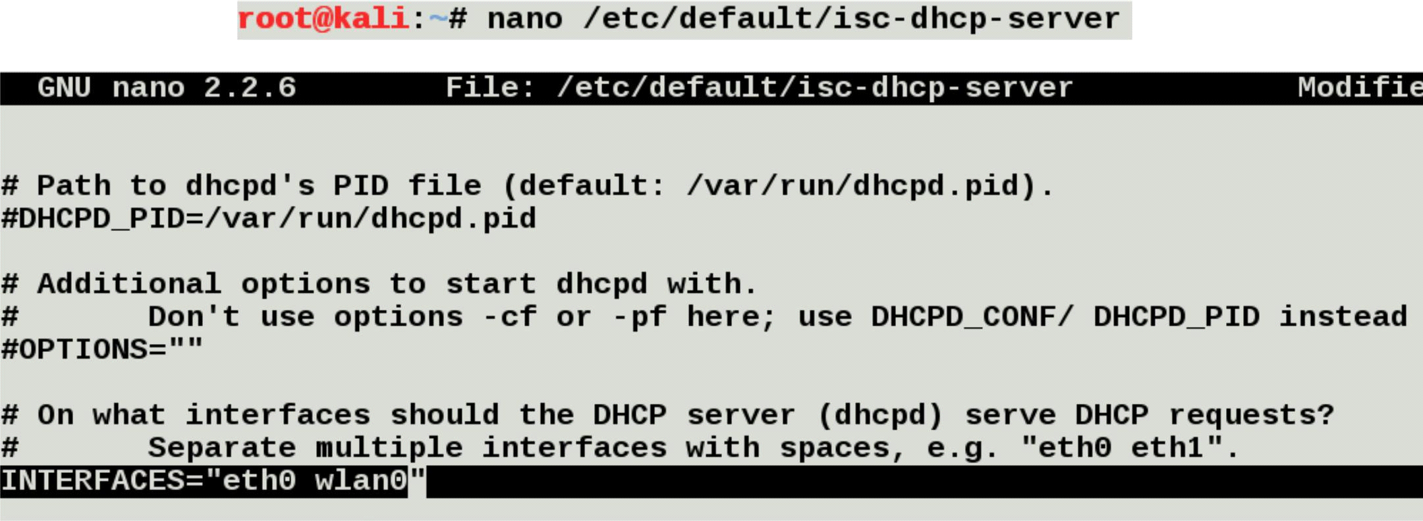

**Step 6**

Assign IP range to route the data packets

route add -net 192.168.2.0 netmask 255.255.255.0 gw 192.168.2.1

**Step 7**

dhcpd -cf /etc/dhcp/dhcpd.conf -pf /var/run/dhcpd.pid eth0

**Step 8**

Start DHCP server.

# /etc/init.d/isc-dhcp-server start