

SWE2011 – BIG DATA ANALYTICS

DIGITAL ASSIGNMENT – 1

Web Scraping (Python) and Data Exploration (Java)

GitHub : https://github.com/sanket9673/Big_Data_Analytics---DA1

Submitted by
Name: Sanket Chavhan
Register Number: 22MIS1116

1. Introduction
In modern data analytics, data is often collected from web sources and processed using various data exploration techniques. Web scraping helps in extracting structured information from websites, while data exploration allows analysts to understand, clean, and transform data before further analysis.
This assignment demonstrates a complete data analytics pipeline where data is scraped from a public website using Python and subsequently explored using Java. The project emphasizes practical implementation of web scraping, data preprocessing, and exploratory data analysis techniques.
Objectives of the assignment:
- To scrape structured data from a website using Python
- To store the scraped data in CSV format
- To perform data exploration using Java
- To generate intermediate datasets for each exploration step

2. Project Folder Structure
The project is organized into separate folders for Python scraping, Java data exploration, and report documentation.
DA1/
├── python/
│ ├── scrape_books.py
│ ├── books.csv
│ └── requirements.txt
├── java/
│ ├── src/
│ │ └── BooksEDA.java
│ ├── bin/
│ └── out/
│ ├── 01_loaded.csv
│ ├── 04_missing_handled.csv
│ ├── 05_deduplicated.csv
│ ├── 07_sorted_by_price.csv
│ ├── 08_filtered_rating_above_4.csv
│ └── 09_normalized_minmax.csv
└── report/

3. Website and Python Program

3.1 Website from Which Data Was Scraped
The data was scraped from the following publicly available website : https://books.toscrape.com
BooksToScrape is a demo website designed specifically for practicing web scraping. It provides structured information about books, including title, price, rating, and availability, making it suitable for academic assignments.
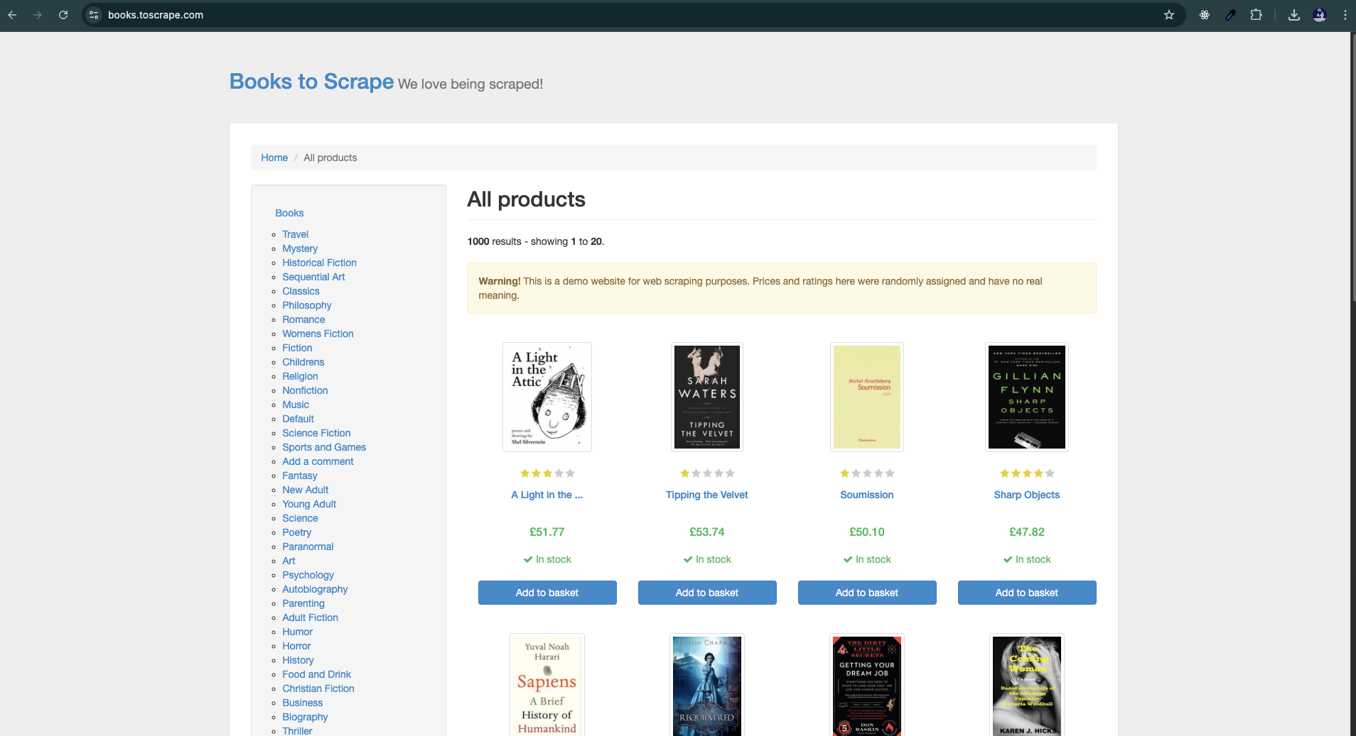

3.2 Python Libraries Used
The following Python libraries were used:
- requests – to send HTTP requests to the website
- BeautifulSoup – to parse and extract HTML content
- pandas – to store and export data into CSV format

3.3 Python Program Used for Scraping
The Python program fetches the webpage, parses the HTML, extracts relevant book information, and saves the data into a CSV file.
Attributes scraped:
- Book Title
- Price
- Rating
- Availability

import requests
from bs4 import BeautifulSoup
import pandas as pd

URL = "https://books.toscrape.com/"
response = requests.get(URL)
soup = BeautifulSoup(response.text, "lxml")

books = []
rating_map = {"One":1, "Two":2, "Three":3, "Four":4, "Five":5}

for book in soup.select("article.product_pod"):
title = book.h3.a["title"]
price_text = book.select_one("p.price_color").text
price = float("".join(c for c in price_text if c.isdigit() or c == "."))
rating = rating_map[book.p["class"][1]]
availability = book.select_one("p.instock.availability").text.strip()
books.append([title, price, rating, availability])

df = pd.DataFrame(
books,
columns=["Book Title", "Price", "Rating", "Availability"]
)

df.to_csv("books.csv", index=False, encoding="utf-8")
print("Total books scraped:", len(df))

3.4 Raw Dataset (Output of Python)
The scraped data is stored as books.csv. This dataset serves as the input for the Java-based data exploration phase.
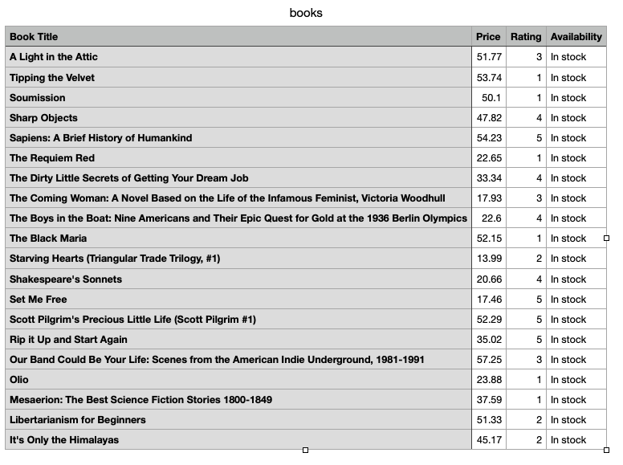

4. Data Exploration Using Java
Data exploration was implemented using Java without using any external libraries. Each step produces an intermediate CSV file, allowing easy verification of changes at every stage.

4.1 Step 1: Load CSV
The CSV file generated by Python is loaded into Java objects.
- Input: books.csv
- Output: 01_loaded.csv
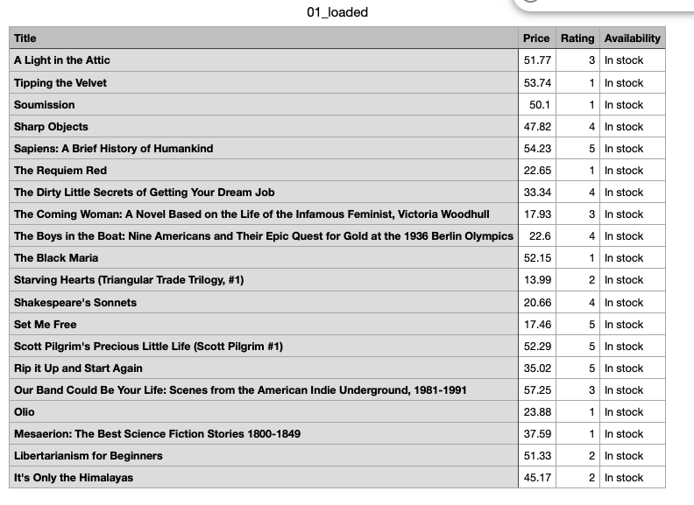

4.2 Step 2: Dataset Overview
The number of rows and columns in the dataset is displayed to understand the dataset size.

4.3 Step 3: Data Type Identification
The data types for each column are identified as follows:
- Book Title - String
- Price - Double
- Rating - Integer
- Availability - String

4.4 Step 4: Missing Value Handling
Rows with missing or invalid values were removed to maintain data quality.
- Output: 04_missing_handled.csv

4.5 Step 5: Duplicate Removal
Duplicate records were identified using book titles and removed.
- Output: 05_deduplicated.csv

4.6 Step 6: Descriptive Statistics
The average price of all books in the dataset was calculated.
Average Price: 38.0485

4.7 Step 7: Sorting
The dataset was sorted in ascending order based on book price.
- Output: 07_sorted_by_price.csv

4.8 Step 8: Filtering
Books with a rating greater than or equal to 4 were filtered.
- Output: 08_filtered_rating_above_4.csv

4.9 Step 9: Normalization
Min-Max normalization was applied to the Price attribute using the formula:
x' = (x - min) / (max - min)
- Output: 09_normalized_minmax.csv
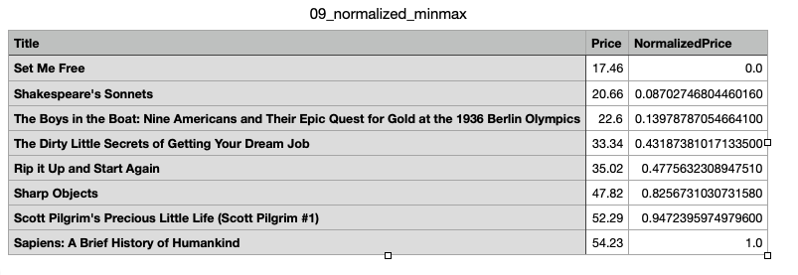

5. Java Program Used for Data Exploration
The Java program BooksEDA.java performs all data exploration steps including CSV loading, missing value handling, duplicate removal, descriptive statistics, sorting, filtering, and normalization. Intermediate CSV files are generated after each step.

6. Conclusion
This assignment successfully demonstrates a complete data analytics workflow. Python was used to scrape structured data from a public website, and Java was used to perform data exploration tasks without external libraries. The project highlights practical skills in web scraping, data preprocessing, and exploratory data analysis.
The methodology followed is systematic, reproducible, and suitable for real-world data analytics applications.

