Document name | Java Major Project
Version no. | 1.0
Release date | 23rd Nov 2020
Classification | Departmental



This document of Cybage Software Pvt. Ltd. is for restricted circulation. No part of this publication may be reproduced, stored in a retrieval system or transmitted in any form or by any means – recording, photocopying, electronic and mechanical, without prior written permission of Cybage Software Pvt. Ltd.
Java Major Project

Document History

Ver. No | Release Date | Created By / Modified By and Date | Reviewed By and Date | Approved By and Date | Remarks and Changes Made
0.1 | 23rd Nov 2020 | Dadaram Jadhav |  |  | Initial draft.

Grievance management system

Project Statement:
Develop Grievance management system for Pune Municipal Corporation

Abstract of the System:
Main goal is to develop web based system for Pune municipal corporations to improve quality of life of citizens. System manages information about property tax, registration of birth, deaths, health, water, road, etc. This Grievance Handling System allows citizens to make complain online about various problems. Complain will be auto-assigned to department selected by citizens. Department will take appropriate action and intimate to citizens. If not satisfied citizens can open complain.

System Roles:
- Admin
- Department head
- Citizen

Admin Role:
- Add/delete/update/view department
- Create login credentials for department head
- Send account details to department head through email
- Unlock accounts if locked due to 3 invalid login attempts
- Reports:- department reports, resolve complain report, pending complain report, reopen complaint report
- Can see logs of users activity
Department role:
- Login into system (credentials will be given by admin)
- View list of complains
- Take action on complain
- Transfer complain to right department if logged by mistake
- Reports:- department headwise resolve complain report, pending complain report, reopen complaint report
- Settings(change password, forget password)
- Account lock after 3 invalid login
- Remember me
Citizens Role:
- Register into system
- Login into system
- Activate account with otp(otp can be send on email or phone)
- Login with otp(otp can be send on email or phone)
- Make complain
- View complain status
- Send reminder (if complain not resolved in given time)
- view public complains(rating, like, comments, dislike)
- Settings(change password, forget password)
- remember me

Technologies to be used:

- Spring Architecture
- Spring Rest for Web Services
- Spring Data JPA
- MYSQL
- HTML5
- CSS3/SASS/ Bootstrap/RWD
- Angular
- Static code validator – Linter/Hinter
- Editors – VSCode, Eclipse, STS, etc.
- Code coverage reports – SonarQube
- Git repository
- Other DevOps tools to be implemented.

System architecture:
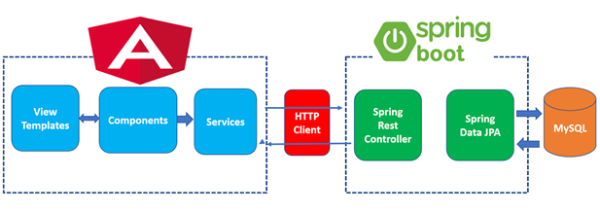

Note – Make assumptions whenever required in project

