**1.a.Source code to find Factorial of given number.**

**import** java.util.Scanner;

**public** **class** Fact {

**public** **static** **void** main(String[] args)

{ **int** n=5, fact=1;

Scanner s=**new** Scanner(System.***in***);

System.***out***.println("Enetr any Number:");

n=s.nextInt();

**for**(**int** i=1;i<=n;i++)

{

fact=fact*i;

}

System.***out***.println("factorial:"+fact);

}

}

Out Put:

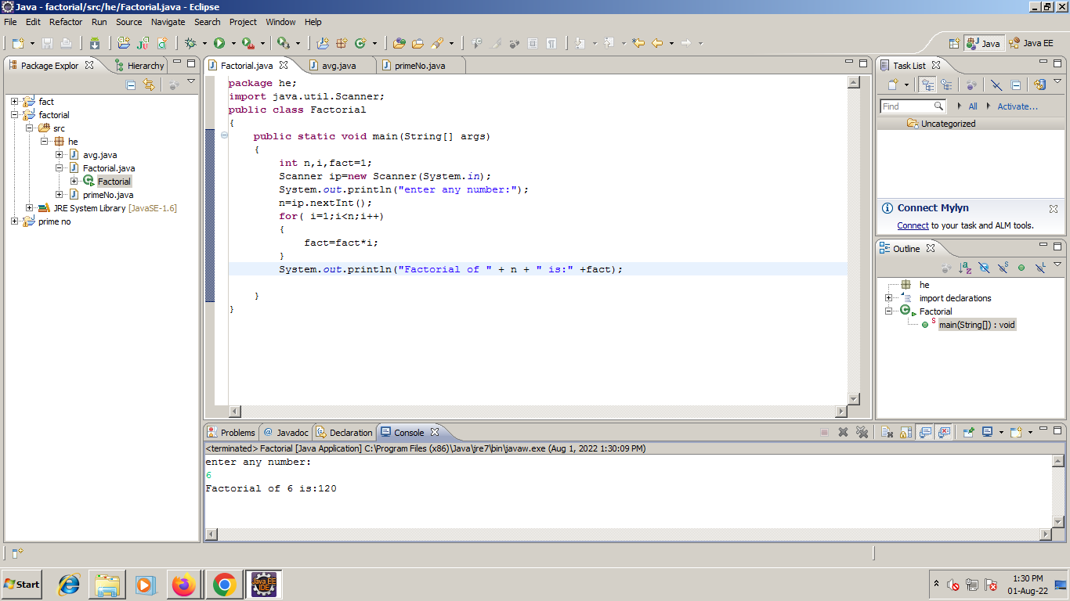

**1.b.Source code to average of given numbers.**

**import** java.util.Scanner;

**public** **class** Avg{

**public** **static** **void** main (String[] args)

{

**int** n,nos,sum=0;

Scanner s=**new** Scanner(System.***in***);

System.***out***.println("Enter How many nos:");

n=s.nextInt();

System.***out***.println("Enter the nos:");

**for**(**int** i=1;i<=n;i++)

{

nos=s.nextInt();

sum+=nos;

}

**double** average = (**double**) sum/n;

System.***out***.println("Average of " + n + " numbers = " + average);

}

}

Out Put:

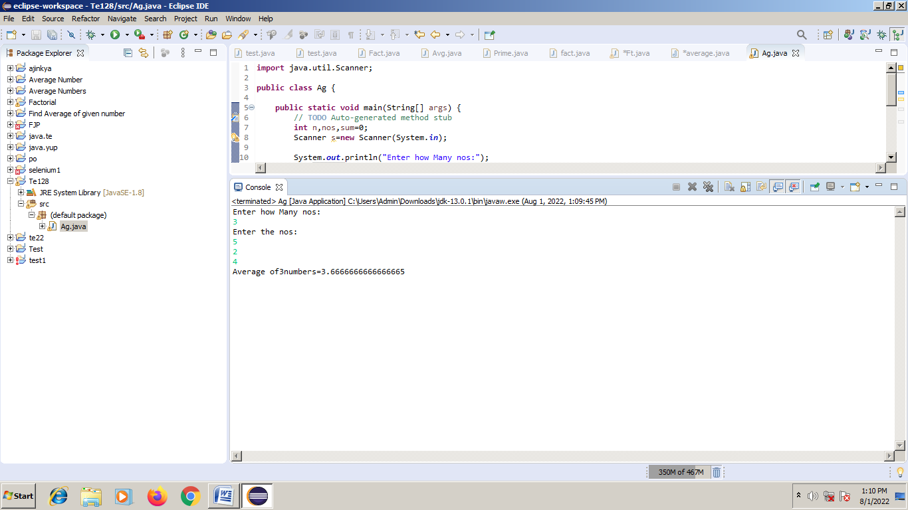

**1.c.Source code to find first 50 prime nos.**

**public** **class** Prime {

**public** **static** **void** main (String [] args)

{

**int** p=1;

**for**(**int** i=1; i<=50; i++)

{

**for** (**int** j=2; j<i; j++)

{

**if**(i%j!=0)

{

p=1;

}

**else**

{ p=0;

**break**;

}

}

**if** (p==1)

System.***out***.println(i+ " is Prime No");

}

}

}

Output:

