## SAMPLE PRINTOUT:

**Title: Simulation Study of Performance of MPSK and MQAM Name:**

**Roll No:** **Division: TE- Batch:**

### CODE:

clc;

close all;

N=input('Enter number of bits to be grouped: '); M=2^N;

x=[0:M-1]; k=1; OFF=0;

z=pskmod(x,M); scatterplot(z,k,OFF,'r+'); title('M-ary PSK') y=qammod(x,M); scatterplot(y,k,OFF,'b*'); title('M-QAM')

**OUTPUT:**

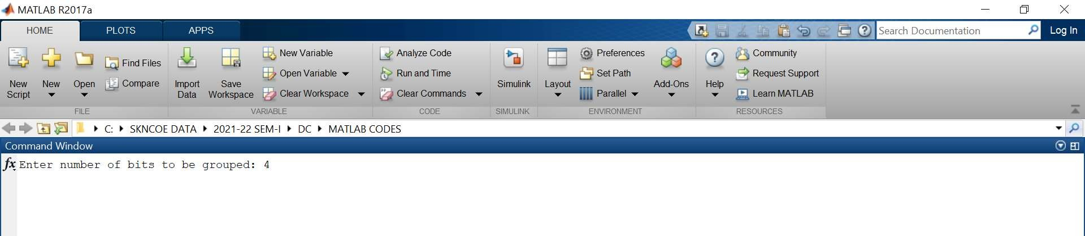

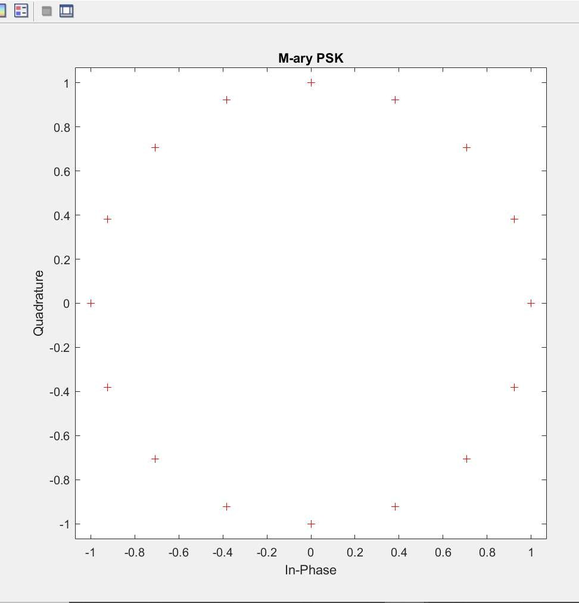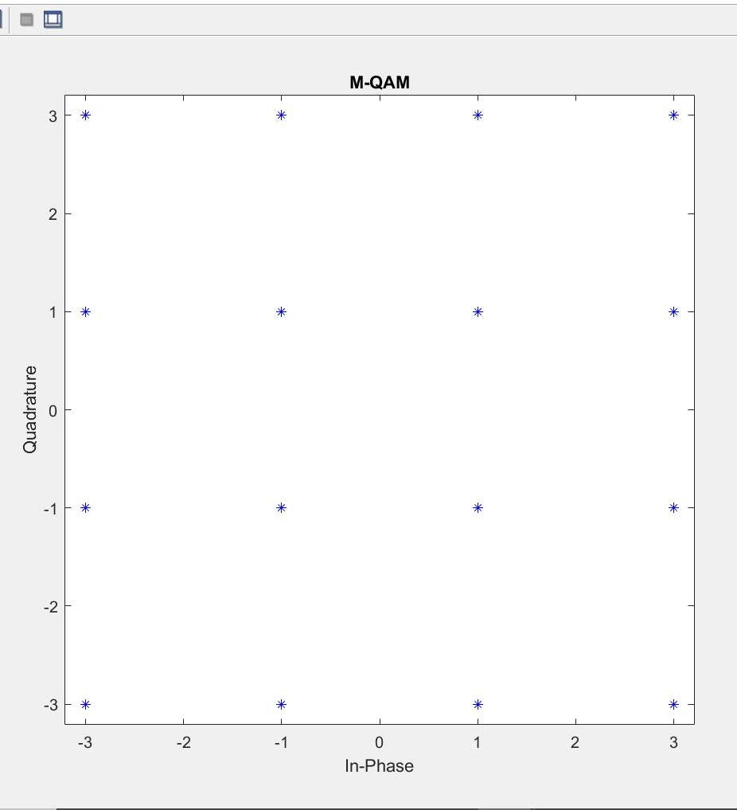

**Title:** Simulation study of random processes. Find various statistical parameters of the random process.

# Program:

clc;

clear all; close all;

load count.dat; for i = 1:3

bin_counts(i,:)= hist(count(:,i));

mu(i)= mean(count(:,i));

sigma(i)= std(count(:,i));

hist(count(:,i)); figure;

end

MeanTotal= mean(mean(count));

disp('Mean for individual column of "Count" Dataset='); mu

disp('Standard Deviation Mean for individual column of "Count" Dataset=');

sigma

disp('Overall Mean='); MeanTotal

# Output:

Mean for individual column of "Count" Dataset= mu =

32.0000 46.5417 65.5833

Standard Deviation Mean for individual column of "Count" Dataset=

sigma =

25.3703 41.4057 68.0281

Overall Mean= MeanTotal =

48.0417

## SAMPLE PRINTOUT:

**Title: Simulation Study of Performance Evaluation of BPSK Name:**

**Roll No:** **Division: TE- Batch:**

### CODE:

clc; close all;

data_bits=1000000; % no. of bits assumed

b = (randn(1, data_bits) > .5); %random 0's and 1's

s=2*b-1;%conversion of data into bipolar format for BPSK modulation SNRdB=0:9; % Assumed SNR in dB

for(k=1:length(SNRdB))%BER (error/bit) calculation for different SNR y=s+awgn(s,SNRdB(k));

error=0; for(c=1:1:data_bits)

if (y(c)>0&&s(c)==-1)||(y(c)<0&&s(c)==1)%logic according to BPSK error=error+1;

end end

BER(k)=error/data_bits; %Calculate error/bit end

figure(1); %plot start semilogy(SNRdB,BER,'r','linewidth',2); grid on;

hold on;

SNR=10.^(SNRdB/10); % conversion of SNR to Linear value BER_thBPSK=(1/2)*erfc(sqrt(SNR)); semilogy(SNRdB,BER_thBPSK,'k','linewidth',2); BER_thQPSK=erfc(sqrt(SNR)); semilogy(SNRdB,BER_thQPSK,'b','linewidth',2); legend('PR-SNR','BPSK','QPSK')

## OUTPUT:

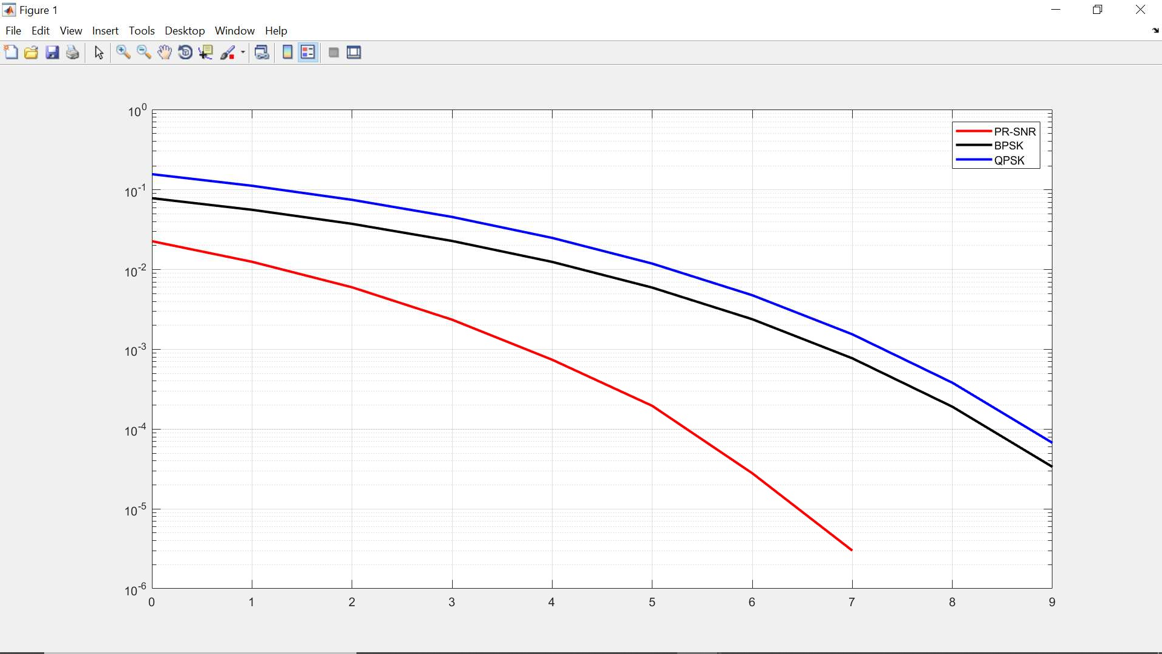

***************************************************************************** Name: Course: TE Div-

Batch: Roll No.:

Title: Simulation study of Huffman Source Coding technique.

***************************************************************************** clc;

clear all; close all;

n=input('No of symbols'); x=length(n);

p=input('Enter the probabilities'); [p,L]=sort(p,'descend');

[d,a]=huffmandict(L,p);

disp([L;p]'); disp('probability codeword'); for j=1:x

code=d{j,2}; fprintf('%f\t',L(j));

fprintf('%f\t',p(j)); disp([code]);

end;

h=sum(-p.*log2(p)); eff=(h/a)*100; red=(1-(h/a))*100;

disp('entropy'); disp(h);

disp('average length'); disp(a); disp('efficiency'); disp(eff); disp('redundancy'); disp(red);

# Program Output

No of symbols[1 2 3 4]

Enter the probabilities[0.5 0.1 0.2 0.2]

|  |  |  |  |  |
| --- | --- | --- | --- | --- |
| 1.0000 | 0.5000 | | | |
| 3.0000 | 0.2000 | | | |
| 4.0000 | 0.2000 | | | |
| 2.0000 | 0.1000 | | | |
| probability codeword | | | | |
| 1.000000 | 0.500000 | 0 |  |  |
| 3.000000 | 0.200000 | 1 | 0 | 0 |
| 4.000000 | 0.200000 | 1 | 1 |  |

2.000000 0.100000 1 0 1

entropy

1.7610

average length 1.8000

efficiency 97.8313

redundancy 2.1687

***************************************************************************** Name: Course: TE Div-

Batch: Roll No.:

Title: Simulation study of Linear Block codes.

*****************************************************************************

clc; clear all; close all;

n=input('enter the codeword length in LBC (n)'); k=input('enter the no of message bits in LBC'); p=input('enter the parity check matrix'); g=[eye(k),p];

disp('Genertor matrix'); disp(g);

%d=input('enter the combination of message bits'); d=dec2bin(0:2^k-1);

c=d*g; c=rem(c,2);

disp('all codewods'); disp(c);

for i=1:2^k

wt=0; for j=1:n

if(c(i,j)==1)

wt=wt+1;

end

end

end

disp(wt);

Hw(i,1)=wt;

y=cat(2,c,Hw);

disp('code vector with hamming weight'); disp(y);

dmin=sort(Hw(2,1)); for i=2:2^k

if(dmin>Hw(i,1))

dmin=hw(i,1);

end

end

disp('dmin'); disp(dmin); td=dmin-1; disp('td'); disp(td); tc=(dmin-1)/2; disp('tc'); disp(tc); pt=transpose(p); disp('pt'); disp(pt); H=[pt,eye(n-k)];

disp('parity check matrix');

disp(H); ht=transpose(H);

disp('transpose of parity check matrix'); disp(ht);

e=eye(n); s=e*ht;

disp(cat(2,e,s));

r=input('enter the received codeword'); synd=r*ht;

synd=rem(synd,2); disp(synd);

for i=1:1:size(ht) if(ht(i,1:n-k)==synd)

r(i)=1-r(i); disp('error location'); disp(i);

end

end

disp('corrected codeword'); disp(r);

# Program Output

enter the codeword length in LBC (n)6 enter the no of message bits in LBC3

enter the parity check matrix[1 0 1; 1 1 0; 0 0 1]

Genertor matrix

|  |  |  |  |  |  |
| --- | --- | --- | --- | --- | --- |
| 1 | 0 | 0 | 1 | 0 | 1 |
| 0 | 1 | 0 | 1 | 1 | 0 |
| 0 | 0 | 1 | 0 | 0 | 1 |
| codewods | | | | | |
| 0 | 0 | 0 | 0 | 0 | 0 |
| 0 | 0 | 1 | 0 | 0 | 1 |
| 0 | 1 | 0 | 1 | 1 | 0 |
| 0 | 1 | 1 | 1 | 1 | 1 |
| 1 | 0 | 0 | 1 | 0 | 1 |
| 1 | 0 | 1 | 1 | 0 | 0 |
| 1 | 1 | 0 | 0 | 1 | 1 |
| 1 | 1 | 1 | 0 | 1 | 0 |
| 0 |  |  |  |  |  |
| 2 |  |  |  |  |  |
| 3 |  |  |  |  |  |
| 5 |  |  |  |  |  |
| 3 |  |  |  |  |  |

all

3

4

4

code vector with hamming weight

|  |  |  |  |  |  |
| --- | --- | --- | --- | --- | --- |
| 0 0 | 0 | 0 | 0 | 0 | 0 |
| 0 0 | 1 | 0 | 0 | 1 | 2 |
| 0 1 | 0 | 1 | 1 | 0 | 3 |
| 0 1 | 1 | 1 | 1 | 1 | 5 |
| 1 0 | 0 | 1 | 0 | 1 | 3 |
| 1 0 | 1 | 1 | 0 | 0 | 3 |
| 1 1 | 0 | 0 | 1 | 1 | 4 |
| 1 1 | 1 | 0 | 1 | 0 | 4 |
| dmin  2 |  |  | | | |
| td  1 |  |
| tc  0.5000 |  |
| pt  1 1 | 0 |
| 0 1 | 0 |
| 1 0 | 1 |

parity check matrix

1 1 0 1 0 0

0 1 0 0 1 0

1 0 1 0 0 1

transpose of parity check matrix

|  |  |  |
| --- | --- | --- |
| 1 | 0 | 1 |
| 1 | 1 | 0 |
| 0 | 0 | 1 |
| 1 | 0 | 0 |
| 0 | 1 | 0 |
| 0 | 0 | 1 |

|  |  |  |  |  |  |  |  |  |
| --- | --- | --- | --- | --- | --- | --- | --- | --- |
| 1 | 0 | 0 | 0 | 0 | 0 | 1 | 0 | 1 |
| 0 | 1 | 0 | 0 | 0 | 0 | 1 | 1 | 0 |
| 0 | 0 | 1 | 0 | 0 | 0 | 0 | 0 | 1 |
| 0 | 0 | 0 | 1 | 0 | 0 | 1 | 0 | 0 |
| 0 | 0 | 0 | 0 | 1 | 0 | 0 | 1 | 0 |
| 0 | 0 | 0 | 0 | 0 | 1 | 0 | 0 | 1 |

enter the received codeword[0 0 1 0 1 1]

0 1 0

error location 5

corrected codeword

0 0 1 0 0 1

***************************************************************************** Name: Course: TE Div-

Batch: Roll No.:

Title: Simulation study of Cyclic codes.

*****************************************************************************

clc; clear all;

n=input('Enter the length of codeword : '); k=input('Enter the length of message : '); gen_coff=input('Enter the generator coefficient : '); m=input('Enter the message : ');

y2=[1];

a=zeros(1,n-k);

z1=cat(2,y2,a);

x=conv(z1,m); x1=abs(rem(x,2)); [q,r]=deconv(x1,gen_coff); r1=abs(rem(r,2)); codeword=xor(x1,r1)

rec=input('Enter the received codeword : '); [q,r]=deconv(rec,gen_coff); syn=abs(rem(r,2));

if syn==0

disp('no error'); else

disp('error');

end

if syn==0

disp('no need of correction') else

y2=zeros(1,n); e=eye(n);

for i=1:n [x2,y2(i,:)]=deconv(e(i,:),gen_coff);

end

z=abs(rem(y2,2)) for i=1:n

if syn==z(i,:) break

end

end

end corrected=xor(rec,e(i,:))

# Program Output

Enter the length of message : 4

Enter the generator coefficient : [1 0 1 1]

Enter the message : [1 1 0 0]

codeword =

1 1 0 0 0 1 0

Enter the received codeword : [1 1 0 0 1 1 0] error

z =

|  |  |  |  |  |  |  |
| --- | --- | --- | --- | --- | --- | --- |
| 0 | 0 | 0 | 0 | 1 | 0 | 1 |
| 0 | 0 | 0 | 0 | 1 | 1 | 1 |
| 0 | 0 | 0 | 0 | 1 | 1 | 0 |
| 0 | 0 | 0 | 0 | 0 | 1 | 1 |
| 0 | 0 | 0 | 0 | 1 | 0 | 0 |
| 0 | 0 | 0 | 0 | 0 | 1 | 0 |
| 0 | 0 | 0 | 0 | 0 | 0 | 1 |

corrected =

1 1 0 0 0 1 0