Assigment 1 :

Step 1 : CREATE DATABASE IF NOT EXISTS sanket_assignment COMMENT 'Hive Assignment data' WITH DBPROPERTIES('edited-by'='Sanket');

Step 2 : use sanket_assignment;

Step 3 : CREATE TABLE employee( id INT, tenure INT, designation STRING, salary BIGINT ) ROW FORMAT DELIMITED FIELDS TERMINATED BY '|' STORED AS TextFile TBLPROPERTIES( "skip.header.line.count"="1", "skip.footer.line.count"="1" );

Step 4 : LOAD DATA LOCAL INPATH '/home/march8lab23/sanket/Files/user.dat' INTO TABLE employee;

Step 5 : select *, case when tenure<2 then 20 when tenure between 2 and 10 then 30 when tenure>10 then 40 end as extra_vacation from employee;

=========================================================================================================================================================================

Assignment 2 :

Step 1 : CREATE TABLE temperature( Name STRING,state STRING,temperature array<double>) ROW FORMAT DELIMITED FIELDS TERMINATED BY '\t' COLLECTION ITEMS TERMINATED BY ':' STORED AS TextFile TBLPROPERTIES( "skip.header.line.count"="1", "skip.footer.line.count"="0" );

Step 2 : LOAD DATA LOCAL INPATH '/home/march8lab23/sanket/Files/temperature.csv.dat' INTO TABLE temperature;

Step 3 : select state,max(temp) as max_temp from temperature lateral view explode(temperature) explode_table as temp group by state;

=========================================================================================================================================================================

Assignment 3 :

Step 1 : CREATE TABLE student_marks( Name STRING, Marks Map<STRING, INT>) ROW FORMAT DELIMITED FIELDS TERMINATED BY ',' COLLECTION ITEMS

TERMINATED BY '$' MAP KEYS TERMINATED BY ':' STORED AS TextFile TBLPROPERTIES( "skip.header.line.count"="1", "skip.footer.line.count"=

"0" );

Step 2 : LOAD DATA LOCAL INPATH '/home/march8lab23/sanket/Files/student-struct-dataset.csv' INTO TABLE student_marks;

Step 3 :

1. Display NAME who have scored more than 90 in subject Maths subject

-->select name,marks_value from student_marks lateral view explode(marks) scored as subject, marks_value where subject='maths' and marks_value>90 limit 10;

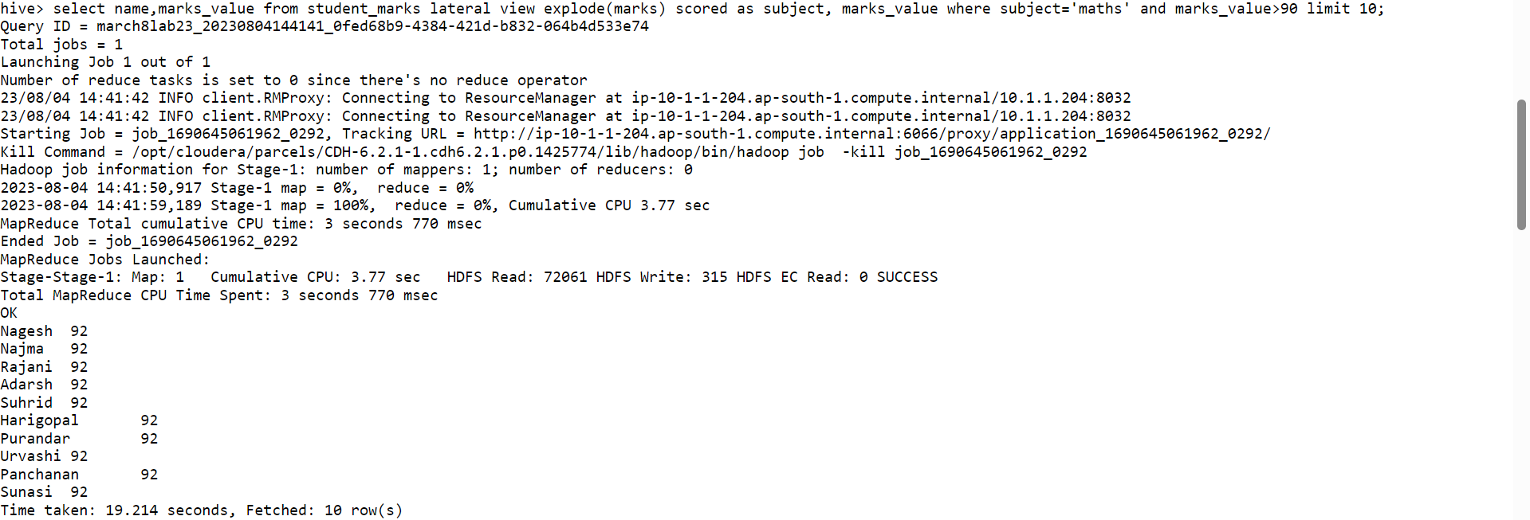

2. Display NAME and <Marks Scored in Physics subject>

-->select name,subject,max(marks_value) from student_marks lateral view explode(marks) scored as subject, marks_value where subject='physics' limit 10;

3. Display NAME, and <Maximum-Subject-Marks>

select name,max(max_marks) from (select name, map_values(marks) as subject_marks from student_marks) t1 lateral view explode(subject_marks) scored as max_marks group by name order by name limit 10;



4. Display NAME and <Average Marks Scored>

select name,avg(marks_value) from student_marks lateral view explode(marks) scored as subject, marks_value group by name limit 10;

5. Display NAME and <Percentage of Marks>

select name,map("physics",cast(marks["physics"] as double)/100,"chemistry",cast(marks["chemistry"] as double)/100,"maths",cast(marks["maths"] as double)/100,"biology",cast(marks["biology"] as double)/100)as percentage_marks from student_marks limit 10;

Assignment 4 :

Step 1 : CREATE TABLE student_info(Name STRING, Marks Map<STRING, INT>, Address Struct<doorNo: INT,Location: String,Pincode: INT>) ROW FORMAT DELIMITED FIELDS TERMINATED BY ',' COLLECTION ITEMS TERMINATED BY '$' MAP KEYS TERMINATED BY ':' STORED AS TextFile TBLPROPERTIES( "skip.header.line.count"="1", "skip.footer.line.count"= "0");

Step 2 :

LOAD DATA LOCAL INPATH '/home/march8lab23/sanket/Files/student-struct-dataset.csv' INTO TABLE student_info;

1. Display all “NAME” who is located in Banashankari

select name, address.location from student_info where address.location='Banashankari' limit 10;

1. Calculate the total count who is staying in pin code 560001

select count(*) as total_count from student_info where address.pincode=560001;

