**PROJECT REPORT**

# PROJECT NAME :- Phonebook.

**DEVELOPMENT** :- C Language.

**PROJECT BY** :- Sanket Vijaykumar Chougala

## TABLE OF CONTENTS

|  |  |  |  |  |  |  |  |
| --- | --- | --- | --- | --- | --- | --- | --- |
|  | **S No.** | |  | **Content** |  | **Page No.** |  |
|  | |  |  |  |  |
| **1.** | |  | Introduction |  | **3** |
|  | |  |  |  |  |
|  | **2.** | |  | Objective |  | **4** |  |
|  | |  |  |  |  |
|  | **3.** | |  | Requirements |  | **5** |  |
|  | |  |  |  |  |
|  | **4.** | |  | Flow chart |  | **6** |  |
|  | |  |  |  |  |
|  |  | |  |  |  |  |  |
|  | **5.** | |  | Input and output Display |  | **7** |  |
|  | |  |  |  |  |
|  | **6.** | |  | Future scope |  | **8** |  |
| **7.** | |  |  |  |  |
|  |  | Reference |  | **9** |  |
|  |  |  | | |  |

|  |
| --- |
|  |

# INTRODUCTION

The phonebook application works specifically for tracking people. The Phonebook application contains a set of basic functions for adding, searching, updating, and deleting new contacts. This mini-C phonebook design allows you to perform simple tasks in your phonebook, such as mobile phones. You can add text to the phonebook, find, edit, search, and delete. The concept of file management and data structure is often used in almost all functions in this project.  It uses functions, file management, and data structure. This application provides information on adding, viewing, modifying, receiving, and deleting data from/to files. Adding new entries, browsing them, editing and updating, searching for saved contacts, and deleting contacts in the phonebook is one of the most important services that become the main menu in the phonebook application. When you add anything to your phone book, you will be asked for personal information such as name, gender, first name, phone number, nationality, email address, and address. You can then edit, view, search, and delete this text.

Personal information such as name, sex, father’s name, phone number, citizenship number, email and address are asked while adding a record into the Phonebook. These records can then be modified, listed, searched for and removed.

**Features:**

1. Import and export contact information. A contact management system collects information from different sources—email, business cards, spreadsheets, and more—and stores it all in one database. Record notes
2. Set reminders
3. Use search and filter options.

**OBJECTIVE**

The phonebook application works specifically for tracking people. The Phonebook application contains a set of basic functions for adding, searching, updating, and deleting new contacts. This mini-C phonebook design allows you to perform simple tasks in your phonebook, such as mobile phones. You can add text to the phonebook, find, edit, search, and delete. The concept of file management and data structure is often used in almost all functions in this project.  It uses functions, file management, and data structure. This application provides information on adding, viewing, modifying, receiving, and deleting data from/to files. Adding new entries, browsing them, editing and updating, searching for saved contacts, and deleting contacts in the phonebook is one of the most important services that become the main menu in the phonebook application. When you add anything to your phone book, you will be asked for personal information such as name, gender, first name, phone number, nationality, email address, and address. You can then edit, view, search, and delete this text.

* The main objective of the C Project on Phonebook System is to manage the details of Contacts, Name, Relationship status, Address & Email id. It manages all the information about CONTACTS.
* The project is totally built at administrative end and thus only the administrator is guaranteed the access..
* Initialization of project is setup in such a way that multiple number of administrator users can access it with their special identity and password.

**REQUIREMENTS**

**Software Requirement**

* Operating System : Windows
* Application Software: Code-Blocks/Visual Studio
* Language : C-Programming

#### Hardware Requirements Specification

#### Processor : Intel core i3 or i5

#### Hard Disk : 250GB

#### Ram : 2GB

**FLOW CHART**

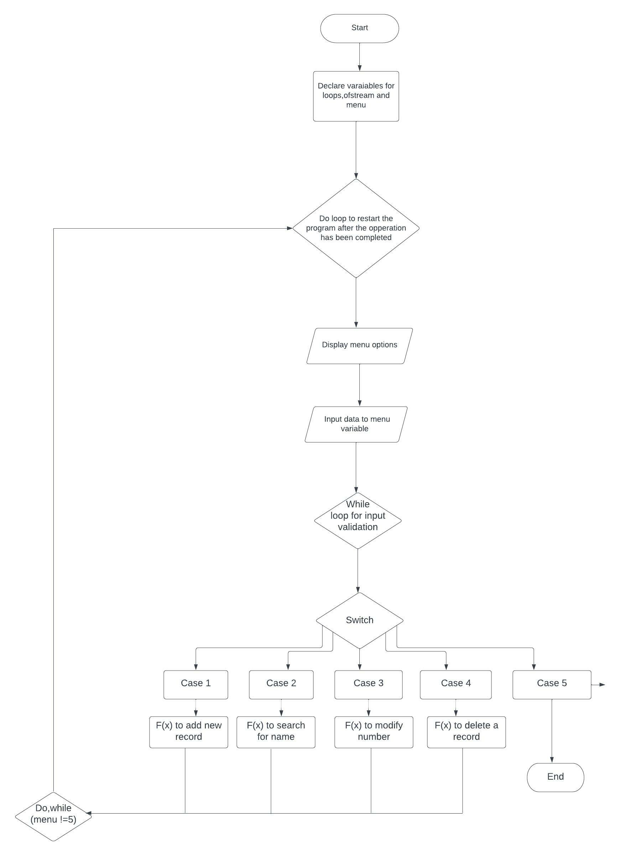

**INPUT AND OUTPUT DISPLAY**

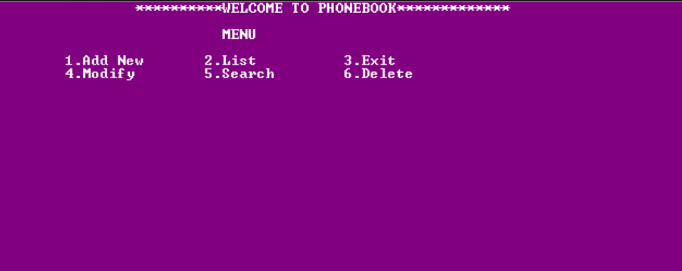

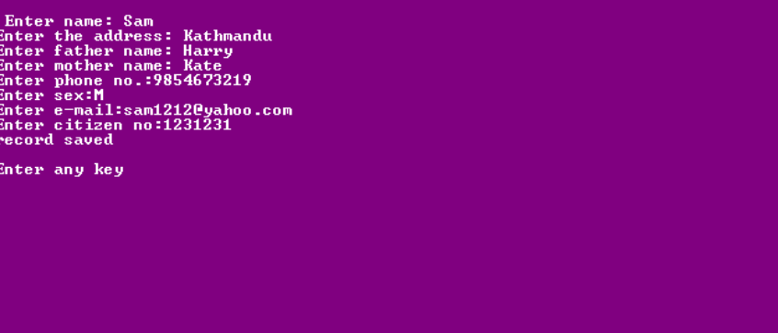

**Future Scope Of Project**

It may help collecting perfect management in details. In a very short time, the collection will be obvious, simple and sensible. It will help a person to know the management of passed year perfectly and vividly. It also helps in current all works relative to Phonebook. It also helps in current all works to phonebook system.

**Reference**

* <https://www.codewithc.com>.
* [www.youtube.com](http://www.youtube.com).