





**Adobe CQ5**

**Reusable Components High Level Specification – Country Selector**

|  |  |  |  |
| --- | --- | --- | --- |
| Date | Version | Description | Author |
| 29/01/2015 | 1.0 | Initial Draft | Ashwini Siddaiah |
|  |  |  |  |
|  |  |  |  |

|  |  |  |
| --- | --- | --- |
| Name | Organization | Date |
| Prateek Shrivastav | Accenture, IDC |  |

Approval:

|  |  |  |
| --- | --- | --- |
| Name | Organization | Date |
|  |  |  |

Table of Contents

1 Country Selector Component 4

Accenture AEM Reusable Component Library 4

Document Purpose 4

High Level Description 4

Adobe Bean Component Framework 5

1.1 Country Selector Main 5

2 Dependency 6

2.1 External Dependency: 6

2.2 Component Dependency 6

3 Installing the code 6

3.1 Steps to get the source code - TBD 6

3.2 Building the application - TBD 6

**Disclaimer**

Any sublicensing/distribution of the Asset by Accenture or any change of scope of use of the Asset, should be subject to review and clearance by legal based on the scope of new usage identified

# 1 Country Selector Component

The document describes the high level design and architecture of the Country Selector related components within Accenture AEM Reusable Component Library.

## Accenture AEM Reusable Component Library

The Reusable Component Library is a collection of AEM components that are available for reuse by projects. See <insert link to overall architecture document> for more information on the library.

## Document Purpose

This document is intended to provide a high level overview of the functionality and architectural dependencies of this component group. The goal is to provide enough information for project teams to assess the impacts of reusing these components on their project. The documents assume the reader is familiar with AEM and its technical stack.

## High Level Description

The country selector is a part of the header that refers to a country. The component is designed to display a list of country and the relevant languages of the country. The country selection will be done by selecting a country in a drop down list.

The impact of this functional focus is that components are loosely related to each other and focused more on selecting your own country and language on the web page for navigating to the relevant page. This requirement comes from Marsh project running in digital capability.

The component’s technical functionality is as follows:

1. **HTML**

This component serves as a selector for selecting different country and language pages. Component includes hover.js to generate a flyout which helps in displaying and selecting the country options.

1. **CSS and JS**

This component contains a separate css and js file for the flyout design

## Adobe Bean Component Framework

The Adobe bean component framework is used for developing the components. It is aligned with MVC architecture where in JSP is responsible for providing the interface to end users and authors in order to input values. All the provided inputs get stored in the content nodes of CQ5. The business logic that includes various operations for controlling the data between model and view are coded in controller classes (servlets). Java beans are used to capture the value of the selected request parameters (such as username), and pass it over to the other processing logics.

Maven Build is used for deploying the code in CQ5.

## Country Selector Main

The country selector is a part of the header that refers to a country. The component is designed to display a list of country and the relevant languages of the country. The country selection will be done by selecting a country in a drop down list.

User can navigate to the relevant country or language page by selecting the links in the flyout of the country or by selecting the value in the language dropdown

When user clicks on the link in the flyout, user will be redirected to the target url which will be harcoded in the html. Component look and feel is as below:

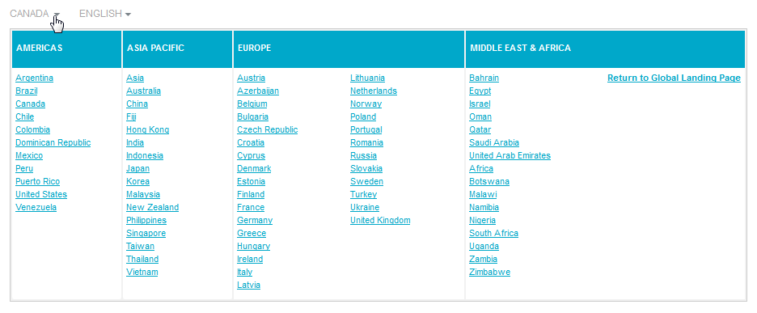

# Dependency

## **External Dependency:**

Mostly components within this group are dependent on the Accenture Adobe Bean Component framework but there are no such files required so it is independent of this. The Controller framework is a framework that supports moving all business and data logic into Java classes instead of JSPs.

## **Component Dependency**

The Country Selector component is dependent on header component.

# Installing the code

## **Steps to get the source code - TBD**

## **Building the application - TBD**