MFA Financial: Value in Levered Residential Credit

1. Overview
In this paper I will go over an attractive investment opportunity in the Mortgage Real Estate Investment Trust (mREIT) space: MFA Financial (NYSE: MFA). MFA is an mREIT with close to a 30-year history and invests across various mortgage credit instruments. MFA, like other mREITs, employs considerable leverage to enhance returns and offers an attractive yield. Because of that leverage, and the complexity of the underlying loan books, these vehicles are often misunderstood by the public.

It is worth distinguishing between the two broad strategies in the space. Agency mREITs lever quasi-government-guaranteed mortgages (agency MBS), taking essentially no credit risk but substantial rate and spread risk. Credit-focused mREITs primarily hold mortgages outside the agency wrapper (non-QM loans, business-purpose loans, re-performing loans) which offer high yields but carry genuine credit risk. MFA falls into the latter camp, with a $12.9 billion portfolio spanning non-QM ($5.5B), single-family rental ($1.2B), transitional lending ($1.1B), legacy re-performing/non-performing loans ($0.9B), and a $3.5B agency MBS book, financed with 6.3x leverage against $1.8B of equity.

2. Thesis
MFA currently trades at roughly 70% of its inherent book value, economic book value per share was $13.22 at March 31, 2026, and yields approximately 15–16%. Credit-focused mREITs typically trade between 75–90% of book in normal times, and much lower in periods of stress and panic; agency REITs typically trade at low-double-digit to single-digit premiums. So the question the market is implicitly asking is: why does MFA deserve a discount steeper than its peer group's normal range? Is something inherently broken?

My answer is no. The discount is a scar from two genuine traumas - COVID and the 2022 rate shock - but the company that earned those scars no longer exists in its old form. Management rebuilt the liability structure specifically so that the mechanism that destroyed book value in 2020 (mark-to-market margin calls forcing asset sales at the bottom) can no longer operate at scale. The stress test in Section 6 quantifies this: at the current price, the market is effectively paying you to underwrite a housing decline on the order of −15% to −20% nationally, a scenario the balance sheet now survives without forced selling, while collecting a mid-teens yield as you wait.

3. Why the Discount Exists
There are 5 main reasons, to me, why MFA trades at such a steep discount even in current times:

- Inherent risk and complexity of levered credit. A book of non-QM, transitional, and legacy NPL exposure financed 6.3x is legitimately harder to underwrite than a T-bill. Complexity discounts are real, and most investors will not read Note 6 of a 10-Q.
- Large margin calls and a steep drop in book value following COVID-19. In March 2020, mark-to-market repo lenders marked collateral down violently and demanded margin. MFA was forced into forbearance with its lenders and into asset sales into a dislocated market. Book value was permanently impaired and the market has not forgotten (roughly ~36% decline)
- The 2021–2023 interest rate back-up and mortgage spread blow-out. The steepest rate-hiking cycle in roughly 50 years took agency spreads from around 50bps to roughly 190bps - levels last seen in 1986, 1998, 2000, and 2008. Book value declined further through this period (roughly 25% decline), albeit at a considerably slower pace than during COVID, and the dividend was cut from $0.44 to $0.35.
- Strong concerns over housing affordability. With affordability near multi-decade lows, investors reasonably fear that home prices are supported by thin air, and MFA's equity is a levered claim on home prices.

Against that backdrop, the discount is easy to understand. In a span of three years the sector absorbed the two things that are inherently worst for levered mortgage: a pandemic causing forced asset sales, and the steepest rate increase in half a century. It makes sense that book value fell roughly 56% over a four-year period. But the market is pricing in the residual pain of the book value loss, not the current balance sheet.

4. The Financing Transformation
The single most important post-COVID change is that management understood the lesson of March 2020: mark-to-market funding is the kill switch on a levered credit book. Beginning in 2021, MFA aggressively termed out its liabilities through securitization and non-mark-to-market facilities; non-MTM funding grew from roughly $900 million to $3.4 billion by Q4 2021, and the securitization program has continued to compound since. More or less, they shifted their liability structure completely.

The result, as of March 31, 2026, is a liability stack of roughly $11.3 billion that breaks down as follows: $6.27 billion (56%) is securitized debt (non-recourse, term, no margin calls) where losses beyond MFA's retained equity in each deal are borne by securitization bondholders, not by MFA; $0.27 billion is non-mark-to-market facilities and senior notes (also immune to margin calls); and $4.57 billion (40%) is mark-to-market financing. Critically, $3.1 billion of that mark-to-market debt finances the agency MBS book - one of the deepest, most liquid collateral markets in the world, with modest haircuts and no credit-driven marks. The mark-to-market debt actually secured by credit-sensitive whole loans is only about $1.5 billion roughly 13% of total financing. That financing is dominated by transitional loans which are shorter in duration.

This is the structural difference between MFA in 2020 and MFA today. In 2020, a decline in loan values transmitted directly into margin calls into forced sales into realized losses. Today, a decline in loan values on 87% of the funding stack transmits into... nothing immediate. Losses on securitized collateral accrue against MFA's retained equity slice over time, or past a point, against bondholders. There is no mechanism for a lender to force MFA to sell whole loans at the bottom of a panic on that portion of the book.

5. The Portfolio Today
The asset side also does not resemble a portfolio priced for distress. Weighted-average LTV across the $8.8 billion residential whole loan book is 64%, meaning the average borrower has 36% equity in front of MFA's position. By segment: non-QM at 64% LTV with a 739 FICO and just 4.1% 60+ day delinquency; single-family rental at 66% LTV / 740 FICO / 2.6% delinquent; single-family transitional at 68% LTV; legacy RPL/NPL at 53% LTV (deep equity cushions, though a weak 646 FICO and 19% delinquency, these loans were bought as credit-impaired). The one genuinely hot spot is multifamily transitional: 83% LTV and 16.5% 60+ day delinquency on a $407 million book. This is a hotspot for most investors of MFA as they have taken losses and stopped the program for a while. However there is a deeper equity cushion here on their leverage and makes up a small portion of their credit book (~5%).

6. Stress Test: What Does It Take to Break This?
Skepticism about levered credit deserves numbers. I built a Monte Carlo model that stresses home prices and home price dispersion and traces the results through defaults, loss severities, the financing waterfall, and finally into book value per share. The mechanics: each segment's loans are simulated with a loan-level LTV distribution calibrated to the reported weighted averages (using the WA alone would understate tail losses badly); each path draws a national home price shock with 20% loan-level dispersion; any loan pushed into negative equity is assumed to eventually default, with loss severity equal to the equity shortfall plus 10% foreclosure costs; loans already 60+ days delinquent default regardless of equity. Losses on securitized collateral are capped at MFA's retained equity in those deals (non-recourse). Margin calls apply only to mark-to-market debt and are tested against ~$270 million of unrestricted cash and unencumbered securities. Two default assumptions are shown: a draconian "cliff" (100% of underwater loans default) and a more realistic ramp (default probability rising from 0% at 100 LTV to 100% at 130 LTV).

Stressed Economic Book Value per Share (reported: $13.22)

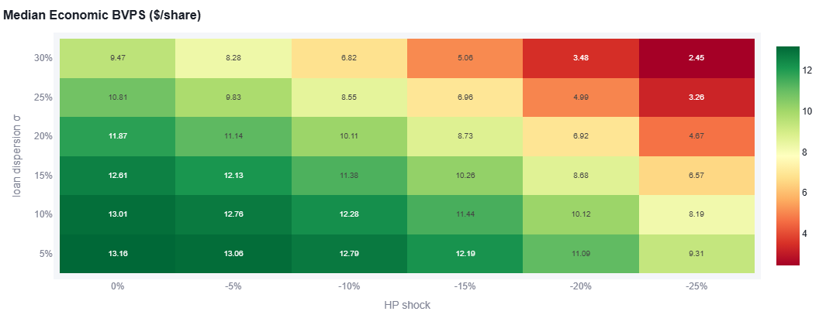

In a case of armageddon for the housing market, MFA does poorly. This is what we see in the top right corner. The GFC was roughly a peak-to-trough decline of ~25-30% based on the index and some variance around which housing market. This also took 6 years to play out, not overnight as this model assumes. Today, given the persistent housing shortage, I think a more realistic "armageddon" would be home prices down 10-20% with a variance of 10-20%. In these scenarios MFA is roughly underwritten to today’s prices!

Now, suppose we saw another 200bps rate shock? MFA would again be roughly underwritten to today’s prices.

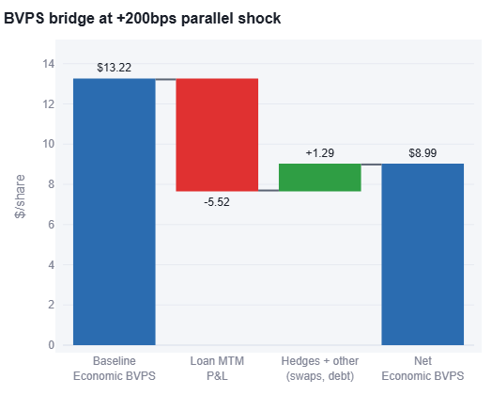

7. Return Framework
The return does not require heroics. At a 15–16% yield, the dividend alone delivers an equity-like return if book value merely holds. If housing muddles through and MFA simply re-rates to the middle of the normal credit-mREIT range, say 80–85% of book, that is 15–20% of price appreciation layered on top. The downside case, per Section 6, is that a −10% to −15% housing decline is roughly what you are already paying for. The asymmetry comes from being paid mid-teens to hold an instrument whose worst historical failure mode has been structurally disabled for ~87% of its funding.

8. Risks
The risks are real and worth stating plainly. A severe housing recession (−25% or worse nationally) impairs book value dramatically regardless of financing structure - non-recourse debt caps losses, it does not eliminate them. The multifamily transitional book (83% LTV, 30% delinquent) could produce outsized losses relative to its size. The $3.1B agency repo book carries spread and margin risk even without credit risk; a 2022-style spread blow-out would again pressure book value and liquidity. Dividend sustainability depends on net interest spread, and a cut (even a prudent one) would likely hit the stock. Finally, the discount itself can persist indefinitely; the yield is the compensation for that patience.

9. Conclusion
MFA trades like the company that took margin calls in March 2020. It is financed like a company that never intends to take them again. Fifty-six percent of the liability stack is non-recourse securitized debt, only ~13% of funding is mark-to-market against credit-sensitive collateral, borrower equity cushions average 36%, and a Monte Carlo stress of the actual portfolio shows book value surviving a GFC-scale housing decline without forced selling. At 70% of a $13.22 economic book value and a 15–16% yield, the market is paying investors handsomely to underwrite a risk that has, in large part, already been engineered out of the structure.

