**Name: Sanket Prabhu**

**Net ID: Srp140430**

**Instruction to execute program**

**Part-1**

* Compile kmeans java files using the following command:

javac kmeans.java

* Run the files using following command:

java kmeans 15 test_data.txt output.txt

You will get following command prompt window and output will get stored in output.txt file.

**Cmd:**

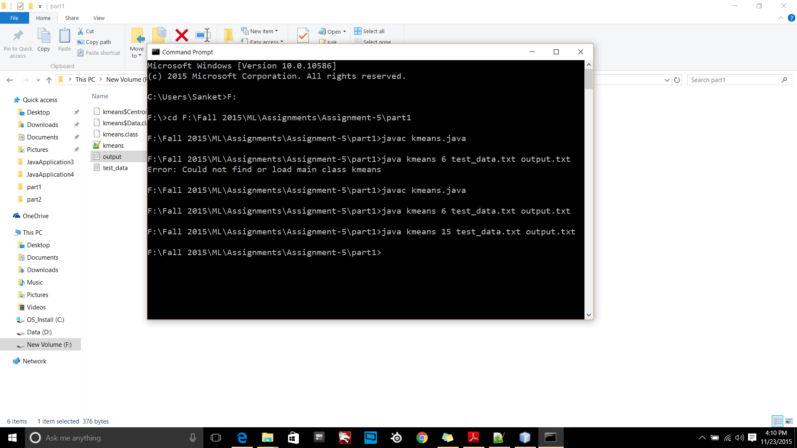

**Output.txt:**

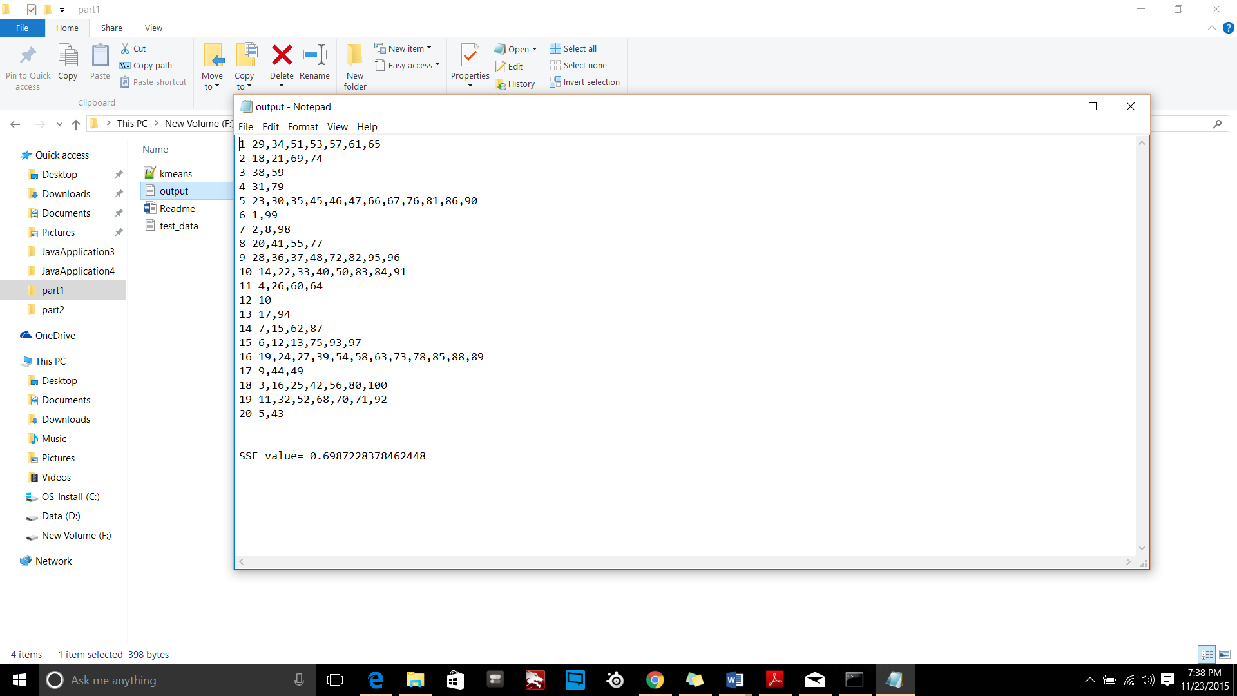

**Output SSE values:**

|  |  |
| --- | --- |
| **K Value** | **SSE** |
| 5 | 0.17059509027163662 |
| 7 | 0.24744651827282094 |
| 2 | 0.0639034296770223 |
| 16 | 0.5841540917859649 |
| 13 | 0.4119352933651585 |