**Name: Sanket Prabhu**

**Net ID: Srp140430**

**Instruction to execute program**

**Part-2**

* Compile kmeans java files using the following command:

javac KmeansTweet.java -Xlint

* Run the files using following command:

java -cp .;java-json.jar;json-simple.jar KmeansTweet 25 Tweets.json InitialSeeds.txt tweets-k-means-output.txt

Your output will get stored in tweets-k-means-output.txt file.

**Important thing to run this Program:**

**I have used two external libraries one to read json and other to throw exception. I have included those two jar files.**

**Names of jar files are:**

* **java-json**
* **json-simple**

**Proof of my working code:**

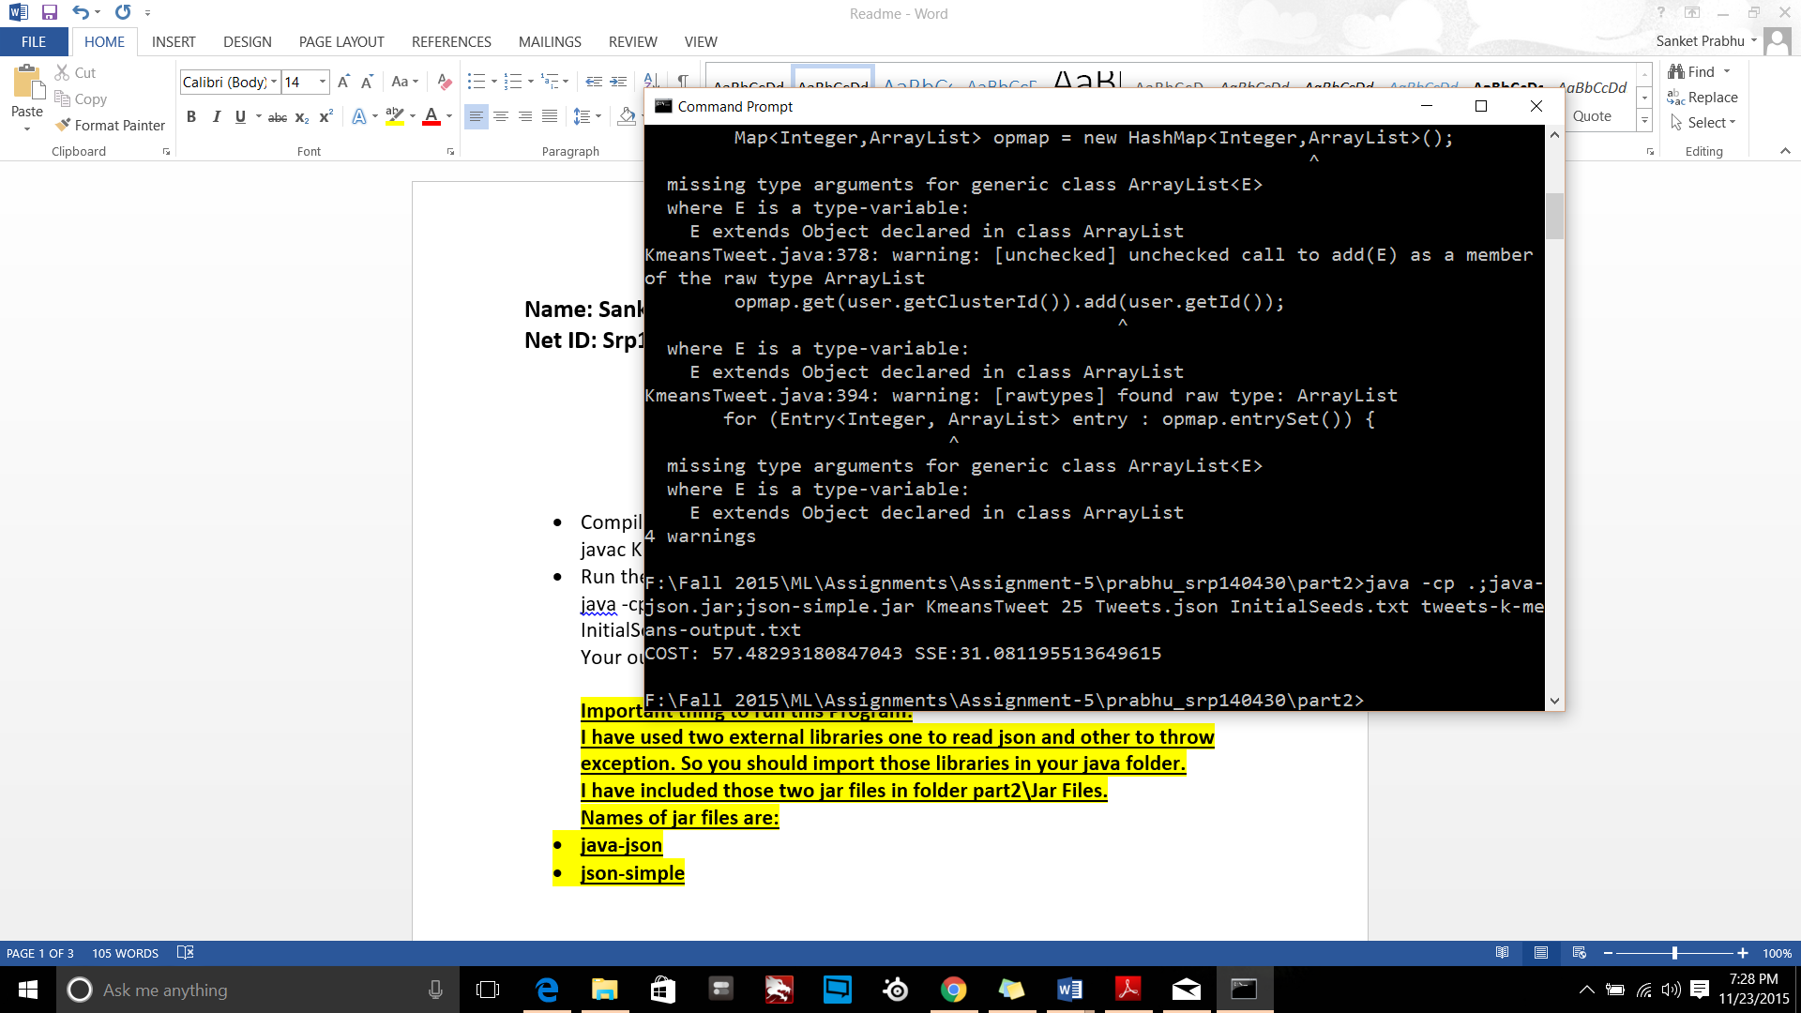

**tweets-k-means-output.txt:**

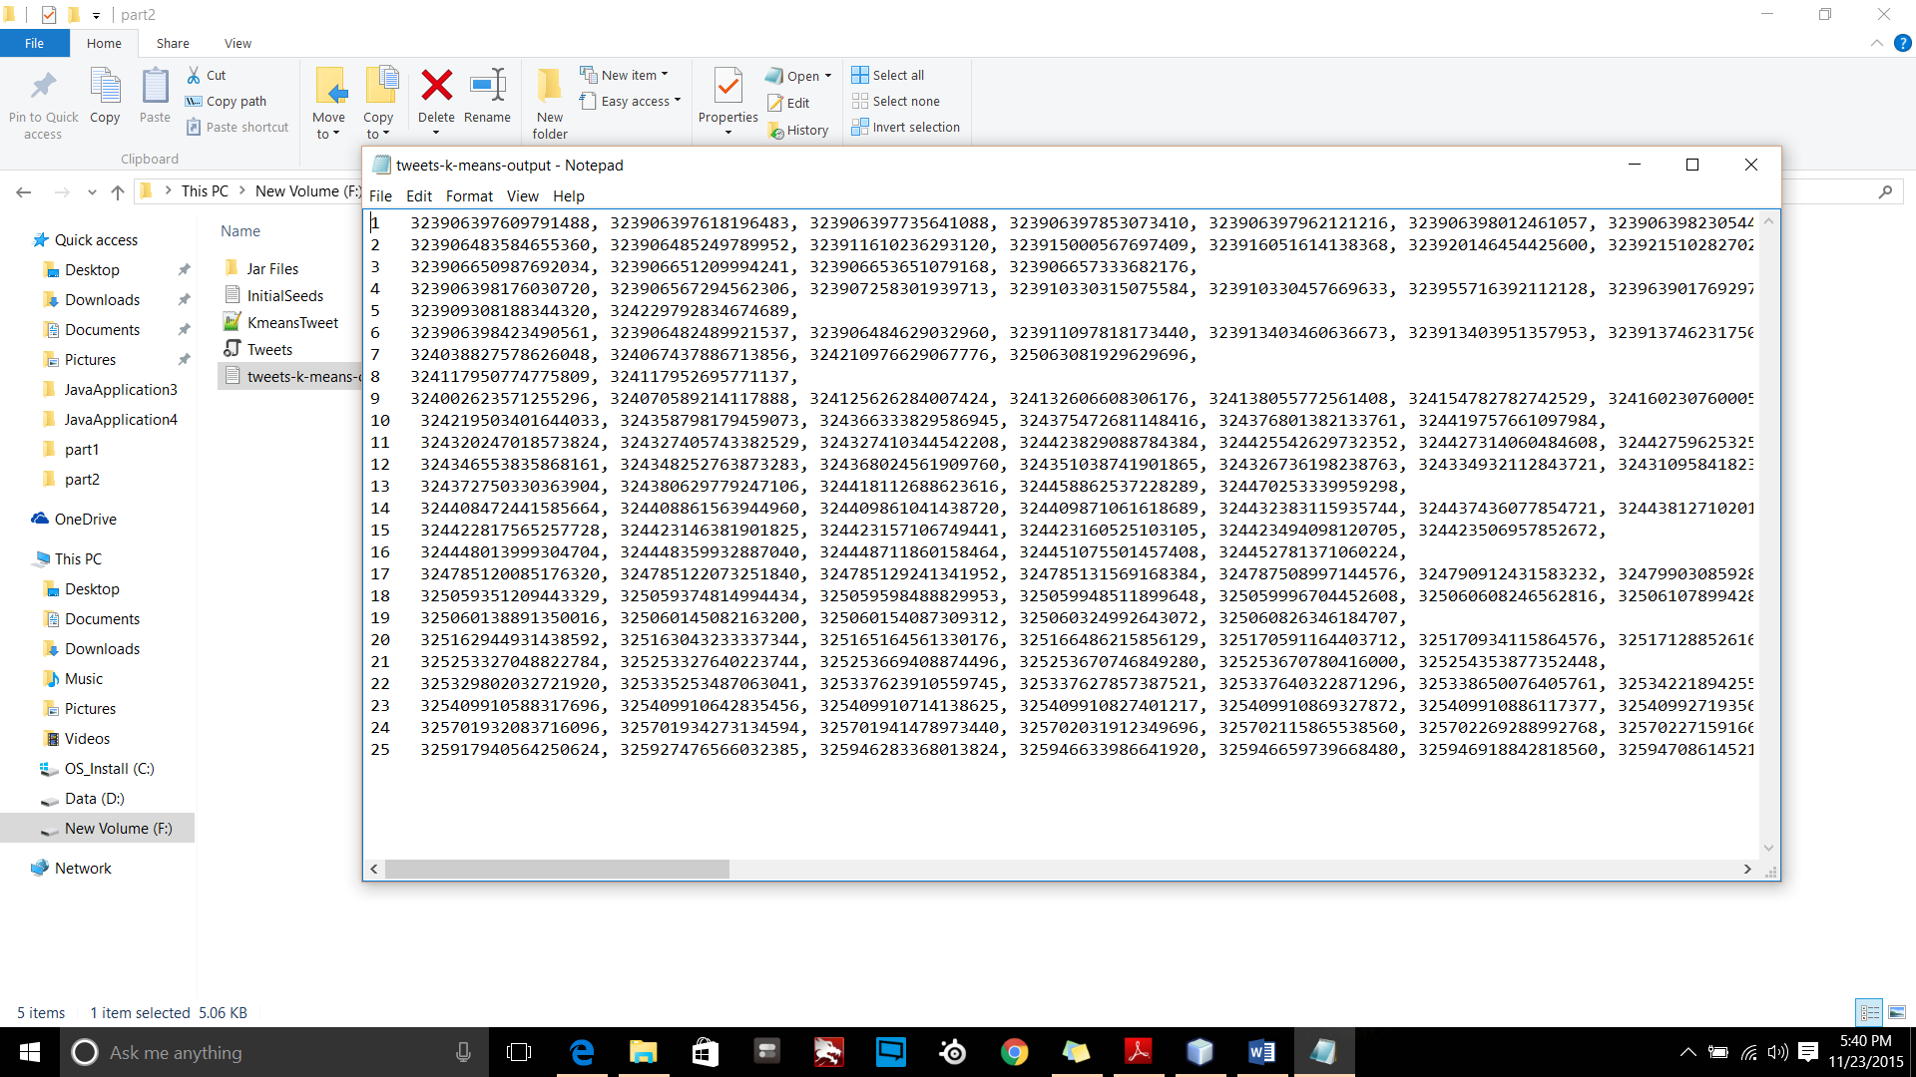

**Output:**

|  |  |
| --- | --- |
| **K value** | **SSE** |
| 25 | 31.081195513649615 |