Dear Sanket,

Museum of Goa is very happy to collaborate with you for the Goa Affordable Art Fest Website. The terms and conditions of this collaboration are mutually accepted by both parties and we look forward to a fruitful association.

Enclosed you will find terms and conditions for the said agreement along with deliverables for both parties. Acknowledge and sign the same at your earliest convenience.

We look forward to working with you.

Best Wishes,

Aditi Rakhe

Manager

Goa Affordable Art Fest

**Memorandum of Understanding**

This MoU will be signed between

**Museum of Goa (MOG), Legal Name - SUBODH CHANDRAKANT KERKAR GSTIN – 30AELPK8029C1ZU PAN No - AELPK8029C** located at #79, Pilerne Industrial Estate, Pilerne, Bardez, Goa 403511

**And**

**Mr. Sanket Shripad Gaonkar**

**Pan No: CFOPG9692D**

**Objective**

Creating the website for Goa Affordable Art Fest as per Annexure 1

**Sanket’s Deliverables**

* Sanket will work on the front and back end development for the GAAF website in collaboration with Museum of Goa (MOG)
* Sanket will give all admin rights for the GAAF website to MOG
* Sanket will arrange for an appropriate URL for the GAAF website in collaboration with MOG
* Sanket will design of the GAAF website using a GAAF design language (fonts, colour schemes etc.) in association with MOG
* Sanket will make sure the GAAF website is live by 15 July 2018
* Sanket will show a progress report to an executive from Museum of Goa (Aditi) as follows,

1. 25 June 2018

* Preliminary design and development of website

1. 2 July 2018

* Home Page
* About Page
* Involve Page
* Contact us Page
* Footer

1. 9 July 2018

* Application Page
* Art Page
* Media and Publications Page

**Notes**

* Sanket will be paid INR 12000 for the back end development and INR 8000 for the front end development of the website
* Sanket will be paid the total amount on completion of the website
* The cost for the website URL purchase will be paid by MOG to Sanket

**Annexure 1**

The GAAF Website will have it’s logo (top left corner), Navigation bar, Search bar, Social media buttons (top right corner) and Footer for all it’s web pages and all buttons when hovered over must become highlighted (similar to the MOG website).

1. HOME PAGE (Refer Appendix 1)

• Slideshow banner below the navigation bar similar to MOG website (1000x480 px), http://museumofgoa.com/

▪ Slideshow when clicked on should must open to a new page of GAAF 2017 image gallery (will be described in detail below)

• Should have LIVE social media feed for Facebook, Instagram and Twitter which should be linked to GAAF social media handles

NAVIGATION BAR:

2. ABOUT

* This page will have to split up by creating a drop-down menu on the navigation bar itself- MOG, GAAF, FOUNDER, TEAM, PARTNERS, SPONSORS (each should lead to a new page)
* MOG, GAAF, FOUNDER pages must have a banner on the top and then a text box below
* TEAM page should have an option to add image and text (Refer appendix 2)
* PARTNERS AND SPONSORS pages must have three sections with reasonable spacing

between them of the long page of which must scroll down to go through:

▪ Title Partner on the top-center of the page with a large image compared to others under it, it will have the tag Title Partner with the sponsor’s name and a text box under.

▪ Gold, Silver & Bronze Partner, having them as three in a line, consisting of image and their respective tags

▪ Partners and Sponsors, which will be two sections consisting of smaller images and their tags; with the option to add more down the row for each.

• All image & texts should have the option for us to upload & edit. (Refer appendix 3)

3. APPLICATON

* This page will have to split up by creating a drop-down menu on the navigation bar itself- APPLY, VOTES should lead to a new page)
* APPLY page should have a Rules & Regulations section, followed by an instruction guide on How to Apply and below that an application form with details such as: Name, Phone no., Email-address, No. of artworks, Picture/File upload button and three more questions with text boxes for applicants to fill in.

▪ APPLY should generate an Applicant no. for each of the artists who have completed the submissions of their applications. Application numbers should start as 0001 onwards.

VOTE page should have FB/Google login for people to cast their votes. It should also have a

voting system

* After logging in the voter comes to a new page displaying a grid view of artists with the vote button under each of them.
* When hovered over an artist image, cursor should turn from an arrow pointer into a hand pointer and a text should display with some transparency of the background with the image.
* When clicked on, a slideshow window should pop-up with the artwork images and text

4. ART

* This page will have to split up by creating a drop-down menu on the navigation bar itself- GAAF 2017, ARTISTS, BUY ART should lead to a new page)
* GAAF 2017 will be an image gallery displaying event picture and sold artworks

▪ Must have option to upload image and edit text (Refer appendix 4)

* ARTISTS page must have a grid view pictures of artists (similar to appendix 5), which when clicked on an artist, opens a new page with the option for us to edit artist image and information
* BUY ART page must have a list of the artists like in the MOG website and then have an integrated online store system similar to the buy art on MOG website (Refer appendix 5, 6, 7)

▪ Must have option to edit image and text

5. MEDIA AND PUBLICATIONS

* This page will have to split up by creating a drop-down menu on the navigation bar itself- MEDIA, PUBLICATIONS (should lead to a new page)
* Both need to have a banner
* PUBLICATIONS should have an option to add pdf documents for people to download

6. INVOLVE

* This page will have to split up by creating a drop-down menu on the navigation bar itself- INTERN, VOLUNTEER (should lead to a new page)
* Both need to have banner to upload image and then a text box below for us to edit.

7. CONTACT US

* The Contact Us tab will open a new page and must have the option for us to edit the text box.
* The page will contain texts and social media handle buttons.

8. FOOTER (must be similar to the MOG website)

* All footer buttons should open to their respective pages, except Terms & Conditions, privacy, Refund & cancellation; which will open up to a new page altogether, with the option for us to edit text
* Address, contact no. & email address will text with the option to edit; the social media buttons being embed links

EXTRAS

• Add search bar aside

* Provide options to upload documents such as PDF files
* Provide an option to edit text size, font and colours

**APPENDIX:**

1.

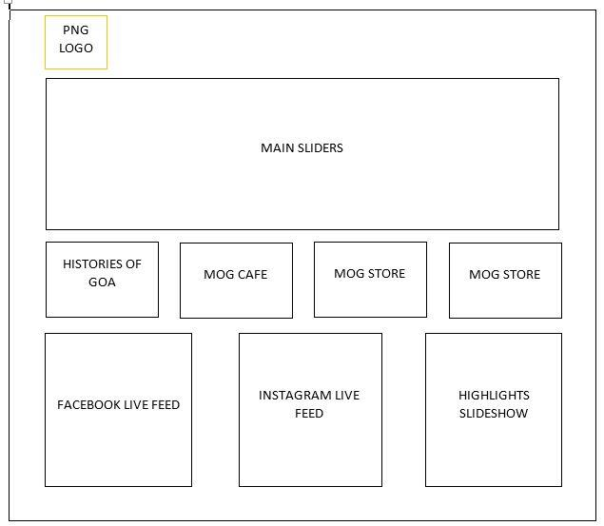

ADDRESS

CONTACT NO

EMAIL ADDRESS

SOCIAL MEDIA BUTTONS

MEDIA | PUBLICATIONS

INTERN | VOLUNTEER

TERMS & CONDITIONS, PRIVACY, REFUND & CANCELLATION

CONTACT US

HOME

MOG, GAAF │ FOUNDER │ TEAM │ PARTNERS │ SPONSORS

APPLY │ VOTE  
GAAF 2017 │ ARTISTS │ BUY ART

2. 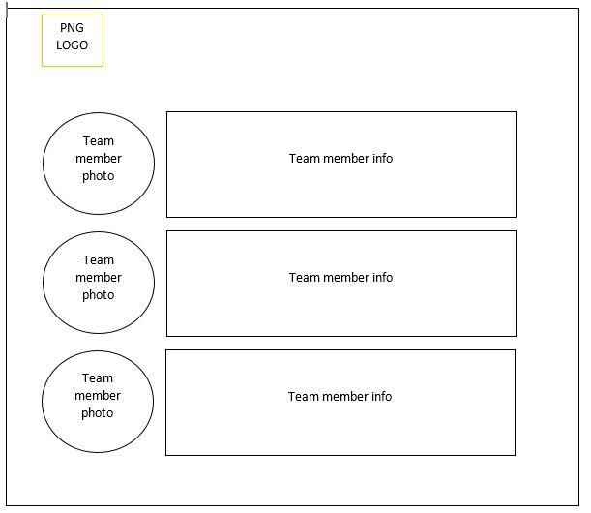

3.

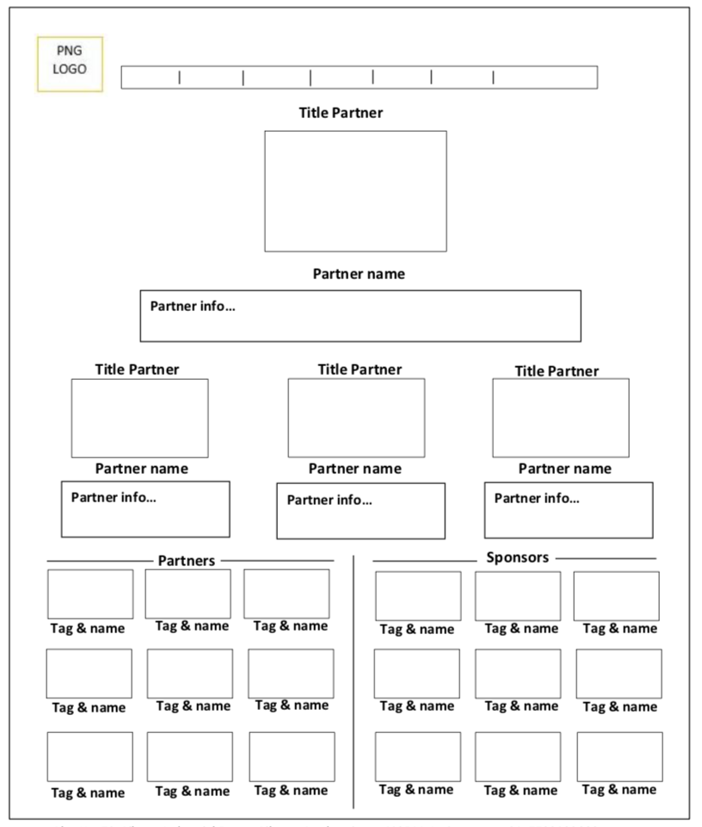

4.

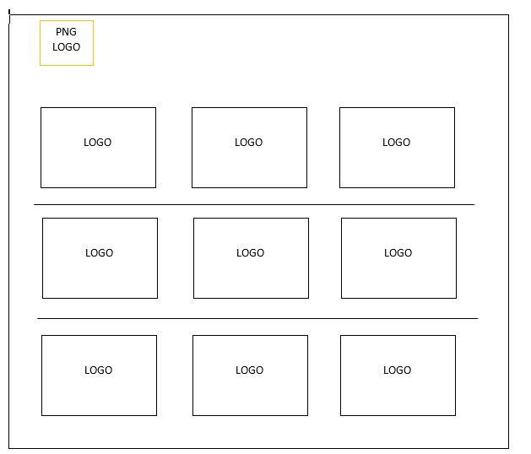

5.

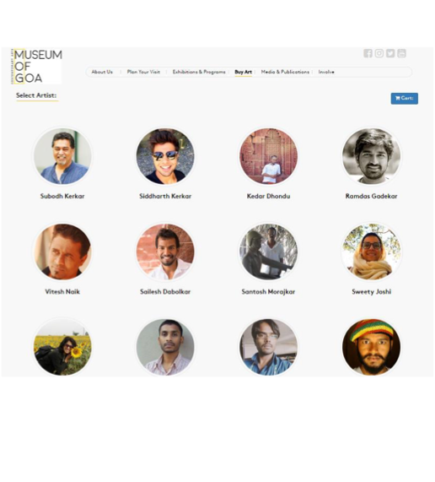

6. 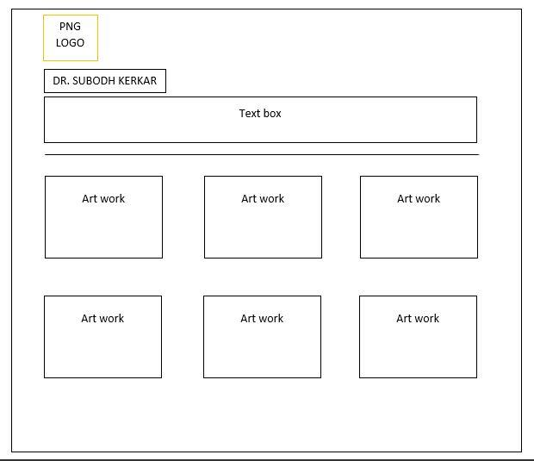

7.

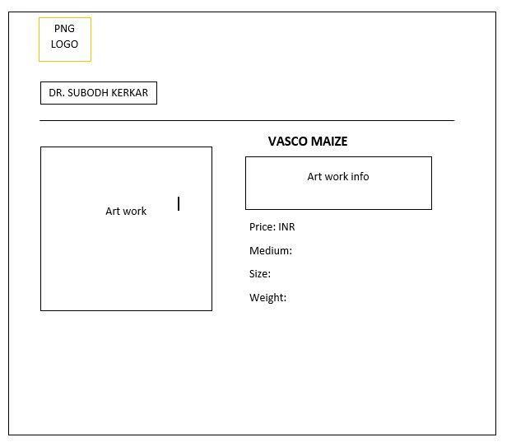

**Signatories**

**Dr. Subodh Kerker**

**Director Museum of Goa**

**Mr. Sanket Shripad Gaonkar**