A Report

On the work done during 3rd semester subject

Database Management Systems

of

B.Tech. Computer Engineering

School Management System

|  |  |
| --- | --- |
| Prepared by:  Name: Gupta Sanket Kalpeshbhai  ID: 22CEUOG043  Roll No: CE045  Computer Engineering,  Dharmsinh Desai University | Prepared by:  Name: Hadiyal Mehul Mohanbhai  ID: 22CEUBG071  Roll No: CE047  Computer Engineering,  Dharmsinh Desai University |

****

Dharmsinh Desai University

October 2023

# Table of Contents

[Table of Contents 2](#_Toc6483)

[Brief Information about the system 4](#_Toc3419)

[Introduction 4](#_Toc4314)

[Objective 4](#_Toc14925)

[Requirements of our school 4](#_Toc27152)

[ER Diagram 6](#_Toc16033)

[Schema 7](#_Toc7375)

[Normalization Comments 9](#_Toc6232)

[1NF 9](#_Toc9840)

[2NF 9](#_Toc28990)

[3NF 9](#_Toc3079)

[CRUD (DDL and DML) 1](#_Toc31423)0

[Person 1](#_Toc8014)0

[Student 1](#_Toc5546)5

[Employee 1](#_Toc9196)7

[Teacher 1](#_Toc3284)9

[Classroom 2](#_Toc8195)0

[Standard 2](#_Toc8689)0

[Subject 2](#_Toc14891)1

[Enrollment 2](#_Toc26145)3

[Lecture 2](#_Toc22594)6

[Working Day 3](#_Toc12562)9

[Attendance 3](#_Toc21390)9

[Person Mobile 49](#_Toc17944)

[Queries (DQL) 5](#_Toc29355)4

[Find number of Students 5](#_Toc27080)4

[Find lecture timings 5](#_Toc12707)4

[Find classroom 5](#_Toc10095)4

[Find classroom capacity 5](#_Toc7969)5

[Find teacher 5](#_Toc10556)5

[Find students 5](#_Toc517)5

[Find salary of employees 5](#_Toc29267)6

[Find student’s enrollent 5](#_Toc20888)6

[Find time table 5](#_Toc678)6

[Find attendance 5](#_Toc9366)7

[Find mobile number 5](#_Toc31337)8

[Find books 5](#_Toc30009)9

[References 6](#_Toc16989)0

# **Brief Information about the system**

## Introduction

Our system provides database solution for a School Management System. The solution consists of different levels of details. First of all, it is able to represent teachers, students, and various other employees of a school in the database. It is also capable of storing the data related to classrooms, standards, and subjects. After that, notion of lectures is also represented. Finally, attendance can also be stored into the system.

## Objective

The objective is to create a system capable of storing various data related to a school organization. Now, even in various school organizations, there is vast difference in their workings. Hence, it is necessary to choose some requirements of our school, and then build a database based on those requirements.

## Requirements of our school

### Requirements related to students and employees

* We wish to represent a student as well as following different employees of a school: Teacher, Watchman, Cleanliness Worker, Peon.

### Requirements related to standard and subject

* In our organization, a subject is taught in exactly one standard. This means that Mathematics of Std. 1st and Std. 2nd are different.
* Within a standard, subject names are unique.
* We need to store in which standard a student is studying in, and which past standards the student has studied in.
* Within a standard, all students have unique roll numbers.
* Each standard has a class teacher, and a teacher can be class teacher of at most one standard.
* Each standard has a classroom allocated to it. A classroom is characterized by room number, building number.

### Requirements related to lectures

* Organization needs to store data related to weekly lectures.
* A lecture is characterized by a particular subject (which is of a particular standard), and its lecture number.
* We also need to store the day, start time, end time related to a lecture.
* A lecture is conducted by exactly one teacher and one teacher has to conduct at least one lecture in a week.

### Requirements related to attendance

* Organization needs to store whether a person was present on a specific working day or not.

# ERER Diagram

# Relational_highlighted_relationsSchema

Person(Person\_ID, F\_Name, M\_Name, L\_Name, House\_No, Society\_Name, Street\_Name, Locality, Pincode, Gender, Is\_Student, DOB);

Person\_Mobile(Person\_ID, Mobile\_No, Person\_ID references Person);

Student(Student\_ID, Person\_ID, Person\_ID references Person, Person\_ID Unique);

Employee(Employee\_ID, Person\_ID, Salary, Job, Person\_ID references Person, Person\_ID Unique);

Teacher(Teacher\_ID, Employee\_ID, Employee\_ID references Employee, Employee\_ID Unique);

Classroom(Room\_No, Building\_No, Capacity);

Standard(Standard\_No, Teacher\_ID, Room\_No, Building\_No, Teacher\_ID references Teacher, (Room\_No, Building\_No) references Classroom, Teacher\_ID Unique);

Subject(Subject\_Name, Standard\_No, Book, Standard\_No references Standard);

Enrollment(Roll\_No, Standard\_No, Student\_ID, Standard\_No references Standard, Student\_ID references Student);

Lecture(Lecture\_No, Subject\_Name, Standard\_No, Teacher\_ID, Day, Start\_Time, End\_Time, (Subject\_Name, Standard\_No) references Subject, Teacher\_ID references Teacher);

Working\_Day(Day\_No, Date\_);

Attendance(Day\_No, Person\_ID, Status, Day\_No references Working\_Day, Person\_ID references Person);

# Normalization Comments

Normalization is the process of decomposing our relational schema into smaller relations, so as to remove insertion, deletion, updation, and redundancy anomalies.

One way to check if our database needs normalization is to check whether any of the anomalies are present or not. The way is to write down the Functional Dependencies, and follow the normalization procedure. If our system is already normalized, it will not change, otherwise it will be normalized.

## 1NF

The condition of the first normal form is that every attribute in our relations be atomic and there should be no multi-valued attribute. Clearly, all relations have atomic attributes (Name has been decomposed into F\_Name, M\_Name, L\_Name. Address has also been decomposed into atomic attributes). Also, no relation has any multi-valued attribute (Mobile number has a separate relation for it).

Hence, the schema is already in 1NF.

## 2NF

For a relation to be in 2NF, there should be no partial dependencies in the relation, that is, there should be no attribute that depends on part of the candidate key. In our case, there are no such attributes in any relation. Hence, all relations are already in 2NF.

Hence, the schema is already in 2NF.

## 3NF

3NF requires that no relation should have any transitive dependency, meaning that there should be no attribute that depends on a non-prime attribute. Again, no such attributes in any relation.

Hence, the schema is already in 3NF.

# CRUD (DDL and DML)

## Person

### Create

CREATE TABLE Person

(

Person\_ID varchar(10) PRIMARY KEY,

F\_Name varchar(50) not null,

M\_Name varchar(50) not null,

L\_Name varchar(50) not null,

House\_No varchar(10) not null,

society\_name varchar(50) not null,

street\_name varchar(50) not null,

locality varchar(30) not null,

pincode number(6,0) not null,

gender varchar(10) CHECK (gender IN('Male', 'Female', 'Other')),

is\_student number(1, 0) check (is\_student in(0, 1)),

dob date not null

);

### Insert

insert into person values('P0001', 'Meet', 'Ramesh', 'Patel', '101', 'Krishna Crown', 'College Road', 'Nadiad', 387001, 'Male', 1, '11-MAY-2008');

insert into person values('P0002', 'Maharshi', 'Dipak', 'Jani', '303', 'Aarav Society', 'Canal Road', 'Ghodasar', 380050, 'Male', 1, '25-SEP-2007');

insert into person values('P0003', 'Amatulla', 'Akbari', 'Gajipurwala', '205', 'Prime Society', 'Punit Road', 'Nadiad', 387002, 'Female', 1, '18-JAN-2006');

insert into person values('P0004', 'Nihar', 'Vipul', 'Rakholiya', '306', 'Aarav Society', 'Canal Road', 'Ghodasar', 380050, 'Male', 1, '10-SEP-2007');

insert into person values('P0005', 'Dev', 'Dipesh', 'Patel', '202', 'Royal Heights', 'College Road', 'Nadidad', 387001, 'Male', 1, '10-JAN-2007');

insert into person values('P0006', 'Het', 'Brijesh', 'Parikh', '54', 'Gokul Society', 'Punit Road', 'Ghodasar', 380050, 'Male', 1, '14-FEB-2009');

insert into person values('P0007', 'Nensee', 'Kishor', 'Zankat', '48', 'Baleshwar City', 'Lalgebi Road', 'Hathijan', 382445, 'Female', 1, '26-MAR-2010');

insert into person values('P0008', 'Harshpalsinh', 'Champaksinh', 'Zala', '14', 'Viratnagar Society', 'Lalbhai Road', 'Dhrangadhra', 364554, 'Male', 1, '05-NOV-2009');

insert into person values('P0009', 'Darshit', 'Dharmesh', 'Vyas', '504', 'Aarav Society', 'Canal Road', 'Ghodasar', 380050, 'Male', 1, '06-JUN-2011');

insert into person values('P0010', 'Sahil', 'Irfan', 'Vora', '202', 'Royal Heights', 'College Road', 'Nadiad', 387001, 'Male', 1, '10-OCT-2011');

insert into person values('P0011', 'Yug', 'Nipul', 'Vithani', '45', 'Baleshwar City', 'Lalgebi Road', 'Hathijan', 382445, 'Male', 1, '17-AUG-2012');

insert into person values('P0012', 'Vasu', 'Piyush', 'Vekariya', '16', 'Viratnagar Society', 'Lalbhai Road', 'Dhrangadhra', 364554, 'Male', 1, '29-NOV-2012');

insert into person values('P0013', 'Parth', 'Sandeep', 'Vasava', '26', 'Gokul Society', 'Punit Road', 'Ghodasar', 380050, 'Male', 1, '01-AUG-2016');

insert into person values('P0014', 'Jinesh', 'Vijay', 'Vamja', '17', 'Aarav Society', 'Canal Road', 'Ghodasar', 380050, 'Male', 1, '14-MAR-2016');

insert into person values('P0015', 'Manish', 'Danabhai', 'Vala', '304', 'Royal Heights', 'College Road', 'Nadiad', 387001, 'Male', 1, '19-SEP-2017');

insert into person values('P0016', 'Sohel', 'Danishbhai', 'Vahora', '47', 'Baleshwar City', 'Lalgebi Road', 'Hathijan', 382445, 'Male', 1, '04-JUL-2017');

insert into person values('P0017', 'Prince', 'Sailesh', 'Vaghasiya', '11', 'Gokul Society', 'Punit Road', 'Ghodasar', 380050, 'Male', 1, '06-APR-2016');

insert into person values('P0018', 'Shrushti', 'Rajesh', 'Vaghasiya', '204', 'Prime Society', 'Punit Road', 'Nadiad', 387002, 'Female', 1, '18-MAR-2016');

insert into person values('P0019', 'Jimesh', 'Manoj', 'Vadodariya', '404', 'Aarav Society', 'Canal Road', 'Ghodasar', 380050, 'Male', 1, '07-JAN-2017');

insert into person values('P0020', 'Akshar', 'Anand', 'Vadher', '202', 'Nexus Heights', 'College Road', 'Nadiad', 387001, 'Male', 1, '13-DEC-2016');

insert into person values('P0021', 'Milan', 'Naresh', 'Vadhel', '303', 'Krishna Crown', 'College Road', 'Nadiad', 387001, 'Male', 1, '11-JAN-2017');

insert into person values('P0022', 'Shyam', 'Dinesh', 'Vachhani', '401', 'Royal Heights', 'College Road', 'Nadiad', 387001, 'Male', 1, '16-AUG-2016');

insert into person values('P0023', 'Urvi', 'Rajesh', 'Vasava', '206', 'Prime Society', 'Punit Road', 'Nadiad', 387001, 'Female', 1, '19-JUL-2016');

insert into person values('P0024', 'Sahil', 'Sanjay', 'Undhad', '103', 'Krishna Crown', 'College Road', 'Nadiad', 387001, 'Male', 1, '30-JAN-2017');

insert into person values('P0025', 'Khushi', 'Ishwar', 'Umarvanshi', '504', 'Prime Society', 'Punit Road', 'Nadiad', 387001, 'Female', 1, '23-FEB-2017');

insert into person values('P0026','Dhamsania','Dhruvil','Arvindbhai','A1','Sahajanand','A12','Nadiad',387001,'Male',0,'29-DEC-2005');

insert into person values('P0027','Dhanani','Vaibhav','Vijaybhai','A2','Sahajanad','A123','Nadiad',387001,'Male',0,'25-jan-2005');

insert into person values('P0028','Dobariya','Meet','Manojbhai','A3','Sahajanand','A12','Nadiad',387001,'Male',0,'28-feb-2000');

insert into person values('P0029','Dobariya','Vrund','Ghanshayambhai','A4','Vidhyut','B12','Baroda',388812,'Male',0,'12-jan-1998');

insert into person values('P0030','Fadadu','Khanjan','Arvinbhai','B12','Jambuvan','A123','Baroda',388812,'Male',0,'21-dec-2003');

insert into person values('P0031','Faldu','Arpit','Kiritbhai','C12','Vidhya','C2','Nadiad',387001,'Male',0,'22-jan-2000');

insert into person values('P0032','Gabani','Kuldeep','Nareshbhai','Z12','yamuna','J12','Nadiad',387001,'Male',0,'11-nov-1999');

insert into person values('P0033','Gabani','Yash','Niteshbhai','B123','Yamata','X12','Baroda',383880,'Male',0,'01-jan-2001');

insert into person values('P0034','Gajera','Jaimin','Nileshbhai','R12','Vidhyut','C45','Surat',123456,'Male',0,'17-jan-2002');

insert into person values('P0035','Gajera','Kavan','Sanjeevbhai','Y12','Samantha','J12','Nadiad',378001,'Male',0,'12-may-2008');

insert into person values('P0036','Gajera','Rushang','Manojbhai','A2','Samantha','H12','Kheda',345678,'Male',0,'12-jan-2000');

insert into person values('P0037','Gandhi','Nitya','Vijaybhai','C123','Yamuna','H14','Vadodara',345672,'Male',0,'8-feb-2004');

insert into person values('P0038','Ganjawala','Samarth','Sanjaybhai','B12','Vishwa','M12','Nadiad',361312,'Male',0,'12-may-2005');

insert into person values('P0039','Ganvit','Nikunjkumar','Pravinbhai','C65','IPCO','V12','Anand',129023,'Male',0,'17-jan-1999');

insert into person values('P0040','Garala','Mahek','Rameshbhai','V123','Karma','B123','Nadaiad',387001,'Female',0,'1-jan-1992');

insert into person values('P0041','Garasia','Nrushans','Amrutbhai','B122','Vidhya','C90','Annad',370022,'Male',0,'22-may-1998');

insert into person values('P0042','Gohel','Akshay','Rajendrakumar','V15','Amrut','B12','Nadiad',229012,'Male',0,'24-june-1998');

insert into person values('P0043','Gohil','Nana','Gambhirbhai','C45','Krishna','J12','Neshda',387001,'Male',0,'4-jan-2005');

insert into person values('P0044','Gohil','Sumit','Jitendrakumar','Ce044','Krishan','N12','Nadiad',387001,'Male',0,'05-may-1998');

insert into person values('P0045','Gupta','Sanket','Kalpeshbhai','C12','Krishna','H45','Nadiad',387001,'Male',0,'22-feb-2000');

insert into person values ('P0046','Gurjar','Karan','Vijaybhai','V67','Ambika','L12','Kheda',389011,'Male',0,'18-feb-1999');

insert into person values ('P0047','Hadiyal','Mehul','Mohanbhai','C12','Dwarkesh','Mj12','Dwarka',361315,'Male',0,'29-jan-2005');

insert into person values ('P0048','Haraniya','Smith','Niteshkumar','G12','Kanera','K12','Kheda',453617,'Male',0,'22-feb-1998');

insert into person values ('P0049','Husain','Saif','Sahilbhai','H45','Saraswati','L12','Anand',370011,'Male',0,'15-may-1999');

insert into person values ('P0050','Jambudiya','Heet','Ketanbhai','V33','Krishna','C22','Nadiad',370001,'Male',0,'14-may-1997');

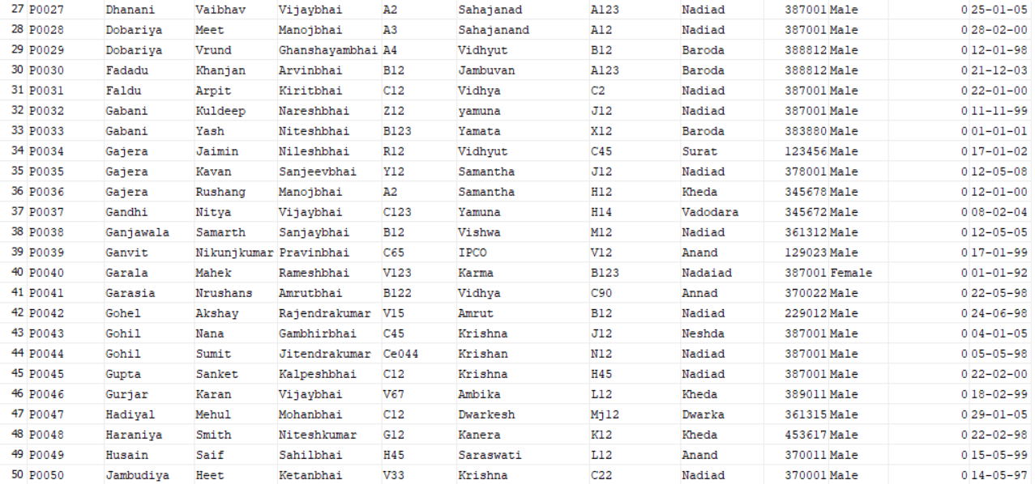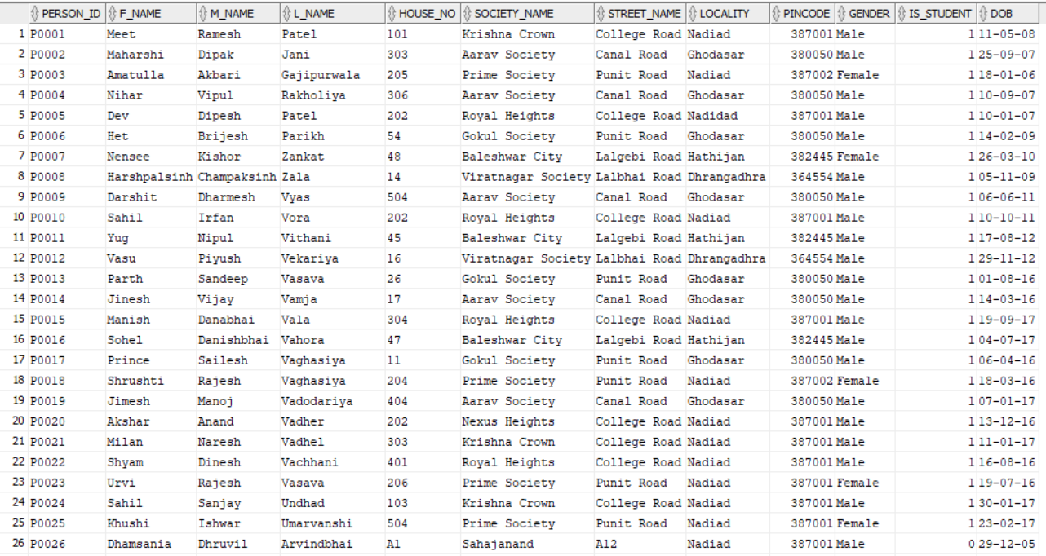

## Student

### Create

CREATE TABLE Student

(

student\_id varchar(10) PRIMARY KEY,

person\_id varchar(10),

foreign key(person\_id) REFERENCES person(person\_id)

);

### Insert

insert into student values ('S1', 'P0001');

insert into student values ('S2', 'P0002');

insert into student values ('S3', 'P0003');

insert into student values ('S4', 'P0004');

insert into student values ('S5', 'P0005');

insert into student values ('S6', 'P0006');

insert into student values ('S7', 'P0007');

insert into student values ('S8', 'P0008');

insert into student values ('S9', 'P0009');

insert into student values ('S10', 'P0010');

insert into student values ('S11', 'P0011');

insert into student values ('S12', 'P0012');

insert into student values ('S13', 'P0013');

insert into student values ('S14', 'P0014');

insert into student values ('S15', 'P0015');

insert into student values ('S16', 'P0016');

insert into student values ('S17', 'P0017');

insert into student values ('S18', 'P0018');

insert into student values ('S19', 'P0019');

insert into student values ('S20', 'P0020');

insert into student values ('S21', 'P0021');

insert into student values ('S22', 'P0022');

insert into student values ('S23', 'P0023');

insert into student values ('S24', 'P0024');

insert into student values ('S25', 'P0025');

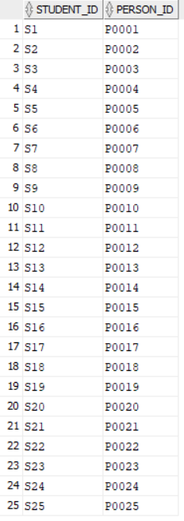

## Employee

### Create

CREATE TABLE Employee

(

employee\_id varchar(10) PRIMARY KEY,

person\_id varchar(10),

salary number(6, 0) not null,

job varchar(30) check (job in('Teacher', 'Watchman', 'Cleanliness Worker', 'Peon')),

foreign key (person\_id) REFERENCES person(person\_id)

);

### Insert

insert into employee values ('E1', 'P0026', '10000', 'Peon');

insert into employee values ('E2', 'P0027', '10000', 'Peon');

insert into employee values ('E3', 'P0028', '10000', 'Cleanliness Worker');

insert into employee values ('E4', 'P0029', '10000', 'Peon');

insert into employee values ('E5', 'P0030', '10000', 'Watchman');

insert into employee values ('E6', 'P0031', '10000', 'Peon');

insert into employee values ('E7', 'P0032', '10000', 'Peon');

insert into employee values ('E8', 'P0033', '10000', 'Cleanliness Worker');

insert into employee values ('E9', 'P0034', '10000', 'Peon');

insert into employee values ('E10', 'P0035', '10000', 'Watchman');

insert into employee values ('E11', 'P0036', '10000', 'Peon');

insert into employee values ('E12', 'P0037', '10000', 'Cleanliness Worker');

insert into employee values ('E13', 'P0038', '40000', 'Teacher');

insert into employee values ('E14', 'P0039', '10000', 'Peon');

insert into employee values ('E15', 'P0040', '10000', 'Peon');

insert into employee values ('E16', 'P0041', '40000', 'Teacher');

insert into employee values ('E17', 'P0042', '40000', 'Teacher');

insert into employee values ('E18', 'P0043', '40000', 'Teacher');

insert into employee values ('E19', 'P0044', '40000', 'Teacher');

insert into employee values ('E20', 'P0045', '10000', 'Watchman');

insert into employee values ('E21', 'P0046', '10000', 'Watchman');

insert into employee values ('E22', 'P0047', '10000', 'Cleanliness Worker');

insert into employee values ('E23', 'P0048', '10000', 'Peon');

insert into employee values ('E24', 'P0049', '10000', 'Watchman');

insert into employee values ('E25', 'P0050', '40000', 'Teacher');

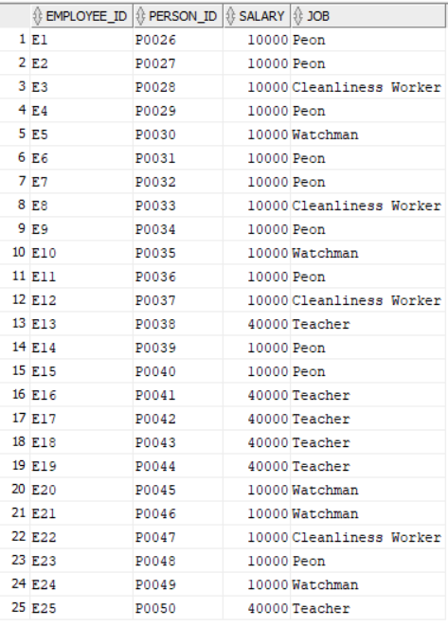

## Teacher

### Create

CREATE TABLE Teacher

(

teacher\_id varchar(10) PRIMARY KEY,

employee\_id varchar(10),

foreign key (employee\_id) REFERENCES employee(employee\_id)

);

### Insert

insert into teacher values ('T1', 'E13');

insert into teacher values ('T2', 'E16');

insert into teacher values ('T3', 'E17');

insert into teacher values ('T4', 'E18');

insert into teacher values ('T5', 'E19');

insert into teacher values ('T6', 'E25');

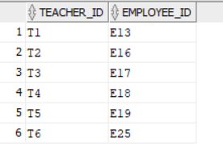

## Classroom

### Create

CREATE TABLE classroom(

room\_no number(3, 0),

building\_no number(3, 0),

capacity number(3, 0),

primary key(room\_no, building\_no)

);

### Insert

insert into classroom values (1, 1, 50);

insert into classroom values (2, 1, 40);

insert into classroom values (3, 1, 30);

insert into classroom values (1, 2, 40);

insert into classroom values (2, 2, 50);

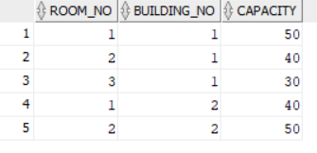

## Standard

### Create

CREATE TABLE standard

(

standard\_no number(2, 0) PRIMARY KEY,

teacher\_id varchar(10),

room\_no number(3, 0),

building\_no number(3, 0),

foreign key(teacher\_id) REFERENCES teacher(teacher\_id),

foreign key(room\_no, building\_no) references classroom

);

### Insert

insert into standard values (1, 'T1', 1, 1);

insert into standard values (2, 'T2', 2, 1);

insert into standard values (3, 'T3', 3, 1);

insert into standard values (4, 'T6', 1, 2);

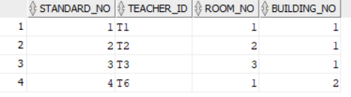

## Subject

### Create

create table subject

(

subject\_name varchar(30) not null,

standard\_no number(3),

book varchar(40) not null,

foreign key(standard\_no) references standard(standard\_no),

primary key(subject\_name, standard\_no)

);

### Insert

insert into subject values ('Mathematics', 1, 'Mathematics, Std. 1, GCERT');

insert into subject values ('Hindi', 1, 'Hindi language, Std. 1, GCERT');

insert into subject values ('Gujarati', 1, 'Gujarati, Std. 1, GCERT');

insert into subject values ('English', 1, 'English, Std. 1, GCERT');

insert into subject values ('Science', 1, 'Science for beginners, GCERT');

insert into subject values ('Mathematics', 2, 'Mathematics, Std. 2, GCERT');

insert into subject values ('Hindi', 2, 'Hindi language, Std. 2, GCERT');

insert into subject values ('Gujarati', 2, 'Gujarati, Std. 2, GCERT');

insert into subject values ('English', 2, 'English, Std. 2, GCERT');

insert into subject values ('Science', 2, 'Science for beginners, GCERT');

insert into subject values ('Mathematics', 3, 'Mathematics, Std. 3, GCERT');

insert into subject values ('Hindi', 3, 'Hindi language, Std. 3, GCERT');

insert into subject values ('Gujarati', 3, 'Gujarati, Std. 3, GCERT');

insert into subject values ('English', 3, 'English, Std. 3, GCERT');

insert into subject values ('Science', 3, 'Science for beginners, GCERT');

insert into subject values ('Social Science', 3, 'Social Science, Std. 3, GCERT');

insert into subject values ('Mathematics', 4, 'Mathematics, Std. 4, GCERT');

insert into subject values ('Hindi', 4, 'Hindi language, Std. 4, GCERT');

insert into subject values ('Gujarati', 4, 'Gujarati, Std. 4, GCERT');

insert into subject values ('English', 4, 'English, Std. 4, GCERT');

insert into subject values ('Science and Technology', 4, 'Science for intermediates, GCERT');

insert into subject values ('Social Science', 4, 'Social Science, Std. 4, GCERT');

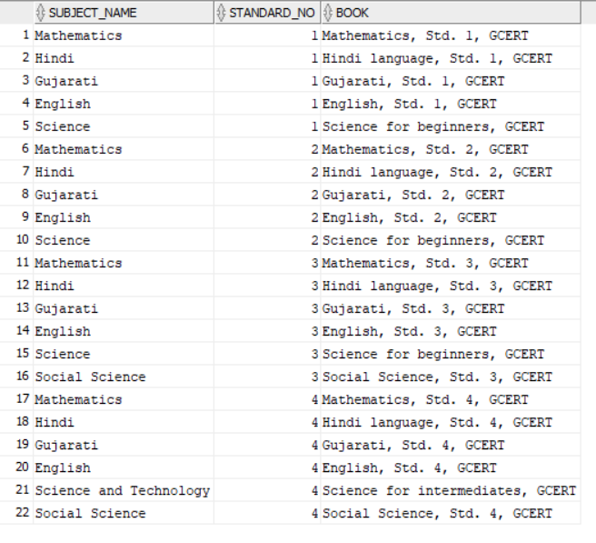

## Enrollment

### Create

create table enrollment

(

roll\_no number(3),

standard\_no number(3),

student\_id varchar(10) not null,

enrolled\_date date not null,

foreign key(standard\_no) references standard,

foreign key(student\_id) references student,

primary key(roll\_no, standard\_no)

);

### Insert

insert into enrollment values (1, 1, 'S1', '6-MAY-2023');

insert into enrollment values (2, 1, 'S2', '6-MAY-2023');

insert into enrollment values (3, 1, 'S3', '6-MAY-2023');

insert into enrollment values (4, 1, 'S4', '6-MAY-2023');

insert into enrollment values (5, 1, 'S5', '6-MAY-2023');

insert into enrollment values (6, 1, 'S6', '6-MAY-2023');

insert into enrollment values (1, 2, 'S7', '8-MAY-2023');

insert into enrollment values (2, 2, 'S8', '8-MAY-2023');

insert into enrollment values (3, 2, 'S9', '8-MAY-2023');

insert into enrollment values (4, 2, 'S10', '8-MAY-2023');

insert into enrollment values (5, 2, 'S11', '8-MAY-2023');

insert into enrollment values (6, 2, 'S12', '8-MAY-2023');

insert into enrollment values (1, 3, 'S13', '9-MAY-2023');

insert into enrollment values (2, 3, 'S14', '9-MAY-2023');

insert into enrollment values (3, 3, 'S15', '9-MAY-2023');

insert into enrollment values (4, 3, 'S16', '9-MAY-2023');

insert into enrollment values (5, 3, 'S17', '9-MAY-2023');

insert into enrollment values (1, 4, 'S18', '11-MAY-2023');

insert into enrollment values (2, 4, 'S19', '11-MAY-2023');

insert into enrollment values (3, 4, 'S20', '11-MAY-2023');

insert into enrollment values (4, 4, 'S21', '11-MAY-2023');

insert into enrollment values (5, 4, 'S22', '11-MAY-2023');

insert into enrollment values (6, 4, 'S23', '11-MAY-2023');

insert into enrollment values (7, 4, 'S24', '11-MAY-2023');

insert into enrollment values (8, 4, 'S25', '11-MAY-2023');

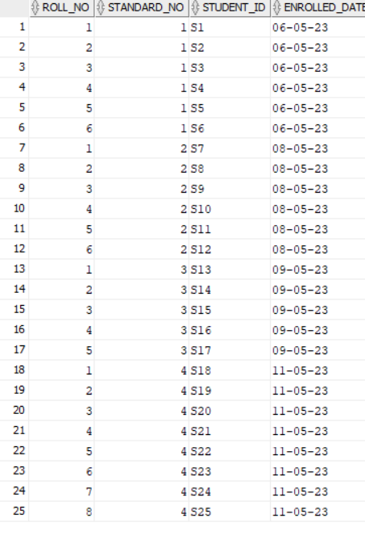

## Lecture

### Create

create table lecture

(

lecture\_no number(2),

subject\_name varchar(30),

standard\_no number(3),

teacher\_id varchar(10),

day varchar(14) check (day in('Monday', 'Tuesday', 'Wednesday', 'Thursday', 'Friday', 'Saturday')),

start\_time varchar(10) not null,

end\_time varchar(10) not null,

primary key(standard\_no, subject\_name, lecture\_no),

foreign key(subject\_name, standard\_no) references subject,

foreign key(teacher\_id) references teacher

);

### Insert

insert into lecture values(1, 'Mathematics', 1, 'T1', 'Monday', '07:30', '08:00');

insert into lecture values(2, 'Mathematics', 1, 'T1', 'Monday', '08:00', '08:30');

insert into lecture values(1, 'Hindi', 1, 'T3', 'Monday', '08:30', '09:00');

insert into lecture values(1, 'Gujarati', 1, 'T2', 'Monday', '09:00', '09:30');

insert into lecture values(1, 'English', 1, 'T4', 'Monday', '10:00', '10:30');

insert into lecture values(1, 'Science', 1, 'T1', 'Monday', '10:30', '11:00');

insert into lecture values(2, 'Science', 1, 'T1', 'Monday', '11:00', '11:30');

insert into lecture values(2, 'English', 1, 'T4', 'Monday', '11:30', '12:00');

insert into lecture values(3, 'Mathematics', 1, 'T1', 'Tuesday', '07:30', '08:00');

insert into lecture values(4, 'Mathematics', 1, 'T1', 'Tuesday', '08:00', '08:30');

insert into lecture values(2, 'Hindi', 1, 'T3', 'Tuesday', '08:30', '09:00');

insert into lecture values(2, 'Gujarati', 1, 'T2', 'Tuesday', '09:00', '09:30');

insert into lecture values(3, 'English', 1, 'T4', 'Tuesday', '10:00', '10:30');

insert into lecture values(3, 'Science', 1, 'T1', 'Tuesday', '10:30', '11:00');

insert into lecture values(4, 'Science', 1, 'T1', 'Tuesday', '11:00', '11:30');

insert into lecture values(4, 'English', 1, 'T4', 'Tuesday', '11:30', '12:00');

insert into lecture values(5, 'Mathematics', 1, 'T1', 'Wednesday', '07:30', '08:00');

insert into lecture values(6, 'Mathematics', 1, 'T1', 'Wednesday', '08:00', '08:30');

insert into lecture values(3, 'Hindi', 1, 'T3', 'Wednesday', '08:30', '09:00');

insert into lecture values(3, 'Gujarati', 1, 'T2', 'Wednesday', '09:00', '09:30');

insert into lecture values(5, 'English', 1, 'T4', 'Wednesday', '10:00', '10:30');

insert into lecture values(5, 'Science', 1, 'T1', 'Wednesday', '10:30', '11:00');

insert into lecture values(6, 'Science', 1, 'T1', 'Wednesday', '11:00', '11:30');

insert into lecture values(6, 'English', 1, 'T4', 'Wednesday', '11:30', '12:00');

insert into lecture values(7, 'Mathematics', 1, 'T1', 'Thursday', '07:30', '08:00');

insert into lecture values(8, 'Mathematics', 1, 'T1', 'Thursday', '08:00', '08:30');

insert into lecture values(4, 'Hindi', 1, 'T3', 'Thursday', '08:30', '09:00');

insert into lecture values(4, 'Gujarati', 1, 'T2', 'Thursday', '09:00', '09:30');

insert into lecture values(7, 'English', 1, 'T4', 'Thursday', '10:00', '10:30');

insert into lecture values(7, 'Science', 1, 'T1', 'Thursday', '10:30', '11:00');

insert into lecture values(8, 'Science', 1, 'T1', 'Thursday', '11:00', '11:30');

insert into lecture values(8, 'English', 1, 'T4', 'Thursday', '11:30', '12:00');

insert into lecture values(9, 'Mathematics', 1, 'T1', 'Friday', '07:30', '08:00');

insert into lecture values(10, 'Mathematics', 1, 'T1', 'Friday', '08:00', '08:30');

insert into lecture values(5, 'Hindi', 1, 'T3', 'Friday', '08:30', '09:00');

insert into lecture values(5, 'Gujarati', 1, 'T2', 'Friday', '09:00', '09:30');

insert into lecture values(9, 'English', 1, 'T4', 'Friday', '10:00', '10:30');

insert into lecture values(9, 'Science', 1, 'T1', 'Friday', '10:30', '11:00');

insert into lecture values(10, 'Science', 1, 'T1', 'Friday', '11:00', '11:30');

insert into lecture values(10, 'English', 1, 'T4', 'Friday', '11:30', '12:00');

insert into lecture values(1, 'Mathematics', 2, 'T6', 'Monday', '07:30', '08:00');

insert into lecture values(2, 'Mathematics', 2, 'T6', 'Monday', '08:00', '08:30');

insert into lecture values(1, 'Gujarati', 2, 'T2', 'Monday', '08:30', '09:00');

insert into lecture values(1, 'Hindi', 2, 'T3', 'Monday', '09:00', '09:30');

insert into lecture values(1, 'Science', 2, 'T6', 'Monday', '10:00', '10:30');

insert into lecture values(1, 'English', 2, 'T4', 'Monday', '10:30', '11:00');

insert into lecture values(2, 'English', 2, 'T4', 'Monday', '11:00', '11:30');

insert into lecture values(2, 'Science', 2, 'T6', 'Monday', '11:30', '12:00');

insert into lecture values(3, 'Mathematics', 2, 'T6', 'Tuesday', '07:30', '08:00');

insert into lecture values(4, 'Mathematics', 2, 'T6', 'Tuesday', '08:00', '08:30');

insert into lecture values(2, 'Gujarati', 2, 'T2', 'Tuesday', '08:30', '09:00');

insert into lecture values(2, 'Hindi', 2, 'T3', 'Tuesday', '09:00', '09:30');

insert into lecture values(3, 'Science', 2, 'T6', 'Tuesday', '10:00', '10:30');

insert into lecture values(3, 'English', 2, 'T4', 'Tuesday', '10:30', '11:00');

insert into lecture values(4, 'English', 2, 'T4', 'Tuesday', '11:00', '11:30');

insert into lecture values(4, 'Science', 2, 'T6', 'Tuesday', '11:30', '12:00');

insert into lecture values(5, 'Mathematics', 2, 'T6', 'Wednesday', '07:30', '08:00');

insert into lecture values(6, 'Mathematics', 2, 'T6', 'Wednesday', '08:00', '08:30');

insert into lecture values(3, 'Gujarati', 2, 'T2', 'Wednesday', '08:30', '09:00');

insert into lecture values(3, 'Hindi', 2, 'T3', 'Wednesday', '09:00', '09:30');

insert into lecture values(5, 'Science', 2, 'T6', 'Wednesday', '10:00', '10:30');

insert into lecture values(5, 'English', 2, 'T4', 'Wednesday', '10:30', '11:00');

insert into lecture values(6, 'English', 2, 'T4', 'Wednesday', '11:00', '11:30');

insert into lecture values(6, 'Science', 2, 'T6', 'Wednesday', '11:30', '12:00');

insert into lecture values(7, 'Mathematics', 2, 'T6', 'Thursday', '07:30', '08:00');

insert into lecture values(8, 'Mathematics', 2, 'T6', 'Thursday', '08:00', '08:30');

insert into lecture values(4, 'Gujarati', 2, 'T2', 'Thursday', '08:30', '09:00');

insert into lecture values(4, 'Hindi', 2, 'T3', 'Thursday', '09:00', '09:30');

insert into lecture values(7, 'Science', 2, 'T6', 'Thursday', '10:00', '10:30');

insert into lecture values(7, 'English', 2, 'T4', 'Thursday', '10:30', '11:00');

insert into lecture values(8, 'English', 2, 'T4', 'Thursday', '11:00', '11:30');

insert into lecture values(8, 'Science', 2, 'T6', 'Thursday', '11:30', '12:00');

insert into lecture values(9, 'Mathematics', 2, 'T6', 'Friday', '07:30', '08:00');

insert into lecture values(10, 'Mathematics', 2, 'T6', 'Friday', '08:00', '08:30');

insert into lecture values(5, 'Gujarati', 2, 'T2', 'Friday', '08:30', '09:00');

insert into lecture values(5, 'Hindi', 2, 'T3', 'Friday', '09:00', '09:30');

insert into lecture values(9, 'Science', 2, 'T6', 'Friday', '10:00', '10:30');

insert into lecture values(9, 'English', 2, 'T4', 'Friday', '10:30', '11:00');

insert into lecture values(10, 'English', 2, 'T4', 'Friday', '11:00', '11:30');

insert into lecture values(10, 'Science', 2, 'T6', 'Friday', '11:30', '12:00');

insert into lecture values(1, 'Hindi', 3, 'T3', 'Monday', '07:30', '08:00');

insert into lecture values(1, 'Gujarati', 3, 'T2', 'Monday', '08:00', '08:30');

insert into lecture values(1, 'Social Science', 3, 'T4', 'Monday', '08:30', '09:00');

insert into lecture values(1, 'English', 3, 'T4', 'Monday', '09:00', '09:30');

insert into lecture values(1, 'Mathematics', 3, 'T1', 'Monday', '10:00', '10:30');

insert into lecture values(2, 'Mathematics', 3, 'T6', 'Monday', '10:30', '11:00');

insert into lecture values(1, 'Science', 3, 'T5', 'Monday', '11:00', '11:30');

insert into lecture values(2, 'Science', 3, 'T5', 'Monday', '11:30', '12:00');

insert into lecture values(2, 'Hindi', 3, 'T3', 'Tuesday', '07:30', '08:00');

insert into lecture values(2, 'Gujarati', 3, 'T2', 'Tuesday', '08:00', '08:30');

insert into lecture values(2, 'Social Science', 3, 'T4', 'Tuesday', '08:30', '09:00');

insert into lecture values(2, 'English', 3, 'T4', 'Tuesday', '09:00', '09:30');

insert into lecture values(3, 'Mathematics', 3, 'T1', 'Tuesday', '10:00', '10:30');

insert into lecture values(4, 'Mathematics', 3, 'T6', 'Tuesday', '10:30', '11:00');

insert into lecture values(3, 'Science', 3, 'T5', 'Tuesday', '11:00', '11:30');

insert into lecture values(4, 'Science', 3, 'T5', 'Tuesday', '11:30', '12:00');

insert into lecture values(3, 'Hindi', 3, 'T3', 'Wednesday', '07:30', '08:00');

insert into lecture values(3, 'Gujarati', 3, 'T2', 'Wednesday', '08:00', '08:30');

insert into lecture values(3, 'Social Science', 3, 'T4', 'Wednesday', '08:30', '09:00');

insert into lecture values(3, 'English', 3, 'T4', 'Wednesday', '09:00', '09:30');

insert into lecture values(5, 'Mathematics', 3, 'T1', 'Wednesday', '10:00', '10:30');

insert into lecture values(6, 'Mathematics', 3, 'T6', 'Wednesday', '10:30', '11:00');

insert into lecture values(5, 'Science', 3, 'T5', 'Wednesday', '11:00', '11:30');

insert into lecture values(6, 'Science', 3, 'T5', 'Wednesday', '11:30', '12:00');

insert into lecture values(4, 'Hindi', 3, 'T3', 'Thursday', '07:30', '08:00');

insert into lecture values(4, 'Gujarati', 3, 'T2', 'Thursday', '08:00', '08:30');

insert into lecture values(4, 'Social Science', 3, 'T4', 'Thursday', '08:30', '09:00');

insert into lecture values(4, 'English', 3, 'T4', 'Thursday', '09:00', '09:30');

insert into lecture values(7, 'Mathematics', 3, 'T1', 'Thursday', '10:00', '10:30');

insert into lecture values(8, 'Mathematics', 3, 'T6', 'Thursday', '10:30', '11:00');

insert into lecture values(7, 'Science', 3, 'T5', 'Thursday', '11:00', '11:30');

insert into lecture values(8, 'Science', 3, 'T5', 'Thursday', '11:30', '12:00');

insert into lecture values(5, 'Hindi', 3, 'T3', 'Friday', '07:30', '08:00');

insert into lecture values(5, 'Gujarati', 3, 'T2', 'Friday', '08:00', '08:30');

insert into lecture values(5, 'Social Science', 3, 'T4', 'Friday', '08:30', '09:00');

insert into lecture values(5, 'English', 3, 'T4', 'Friday', '09:00', '09:30');

insert into lecture values(9, 'Mathematics', 3, 'T1', 'Friday', '10:00', '10:30');

insert into lecture values(10, 'Mathematics', 3, 'T6', 'Friday', '10:30', '11:00');

insert into lecture values(9, 'Science', 3, 'T5', 'Friday', '11:00', '11:30');

insert into lecture values(10, 'Science', 3, 'T5', 'Friday', '11:30', '12:00');

insert into lecture values(1, 'Hindi', 4, 'T2', 'Monday', '07:30', '08:00');

insert into lecture values(1, 'Gujarati', 4, 'T3', 'Monday', '08:00', '08:30');

insert into lecture values(1, 'Social Science', 4, 'T5', 'Monday', '08:30', '09:00');

insert into lecture values(1, 'English', 4, 'T5', 'Monday', '09:00', '09:30');

insert into lecture values(1, 'Mathematics', 4, 'T2', 'Monday', '10:00', '10:30');

insert into lecture values(2, 'Mathematics', 4, 'T2', 'Monday', '10:30', '11:00');

insert into lecture values(1, 'Science and Technology', 4, 'T4', 'Monday', '11:00', '11:30');

insert into lecture values(2, 'Science and Technology', 4, 'T6', 'Monday', '11:30', '12:00');

insert into lecture values(2, 'Hindi', 4, 'T2', 'Tuesday', '07:30', '08:00');

insert into lecture values(2, 'Gujarati', 4, 'T3', 'Tuesday', '08:00', '08:30');

insert into lecture values(2, 'Social Science', 4, 'T5', 'Tuesday', '08:30', '09:00');

insert into lecture values(2, 'English', 4, 'T5', 'Tuesday', '09:00', '09:30');

insert into lecture values(3, 'Mathematics', 4, 'T2', 'Tuesday', '10:00', '10:30');

insert into lecture values(4, 'Mathematics', 4, 'T2', 'Tuesday', '10:30', '11:00');

insert into lecture values(3, 'Science and Technology', 4, 'T4', 'Tuesday', '11:00', '11:30');

insert into lecture values(4, 'Science and Technology', 4, 'T6', 'Tuesday', '11:30', '12:00');

insert into lecture values(3, 'Hindi', 4, 'T2', 'Wednesday', '07:30', '08:00');

insert into lecture values(3, 'Gujarati', 4, 'T3', 'Wednesday', '08:00', '08:30');

insert into lecture values(3, 'Social Science', 4, 'T5', 'Wednesday', '08:30', '09:00');

insert into lecture values(3, 'English', 4, 'T5', 'Wednesday', '09:00', '09:30');

insert into lecture values(5, 'Mathematics', 4, 'T2', 'Wednesday', '10:00', '10:30');

insert into lecture values(6, 'Mathematics', 4, 'T2', 'Wednesday', '10:30', '11:00');

insert into lecture values(5, 'Science and Technology', 4, 'T4', 'Wednesday', '11:00', '11:30');

insert into lecture values(6, 'Science and Technology', 4, 'T6', 'Wednesday', '11:30', '12:00');

insert into lecture values(4, 'Hindi', 4, 'T2', 'Thursday', '07:30', '08:00');

insert into lecture values(4, 'Gujarati', 4, 'T3', 'Thursday', '08:00', '08:30');

insert into lecture values(4, 'Social Science', 4, 'T5', 'Thursday', '08:30', '09:00');

insert into lecture values(4, 'English', 4, 'T5', 'Thursday', '09:00', '09:30');

insert into lecture values(7, 'Mathematics', 4, 'T2', 'Thursday', '10:00', '10:30');

insert into lecture values(8, 'Mathematics', 4, 'T2', 'Thursday', '10:30', '11:00');

insert into lecture values(7, 'Science and Technology', 4, 'T4', 'Thursday', '11:00', '11:30');

insert into lecture values(8, 'Science and Technology', 4, 'T6', 'Thursday', '11:30', '12:00');

insert into lecture values(5, 'Hindi', 4, 'T2', 'Friday', '07:30', '08:00');

insert into lecture values(5, 'Gujarati', 4, 'T3', 'Friday', '08:00', '08:30');

insert into lecture values(5, 'Social Science', 4, 'T5', 'Friday', '08:30', '09:00');

insert into lecture values(5, 'English', 4, 'T5', 'Friday', '09:00', '09:30');

insert into lecture values(9, 'Mathematics', 4, 'T2', 'Friday', '10:00', '10:30');

insert into lecture values(10, 'Mathematics', 4, 'T3', 'Friday', '10:30', '11:00');

insert into lecture values(9, 'Science and Technology', 4, 'T4', 'Friday', '11:00', '11:30');

insert into lecture values(10, 'Science and Technology', 4, 'T6', 'Friday', '11:30', '12:00');

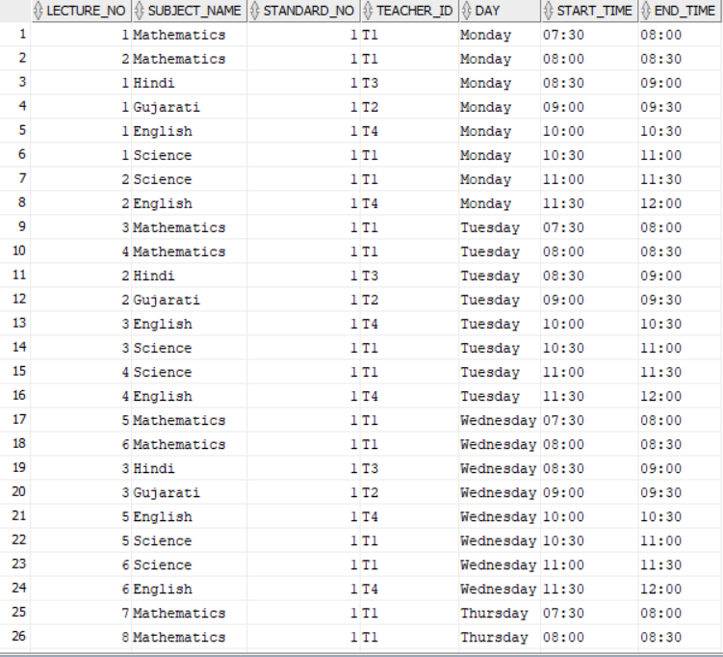

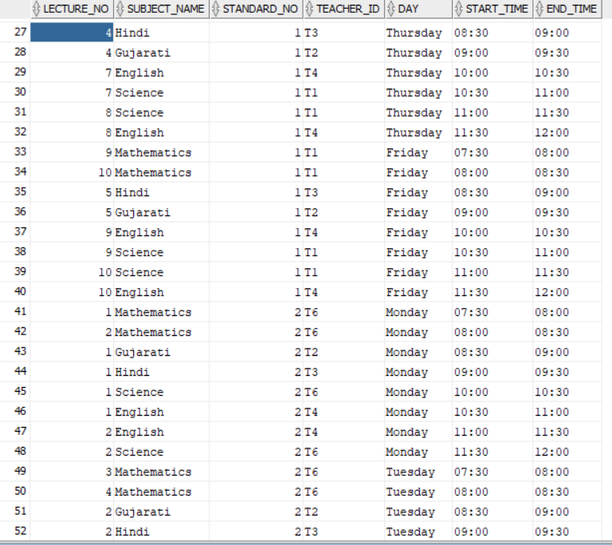

## 

## 

## 

## 

## 

## Working Day

### Create

create table working\_day

(

day\_no number(3),

date\_ date not null unique,

primary key(day\_no)

);

### Insert

insert into working\_day values(1,'01-jun-2019');

insert into working\_day values(2,'02-jun-2019');

insert into working\_day values(3,'03-jun-2019');

insert into working\_day values(4,'04-jun-2019');

insert into working\_day values(5,'05-jun-2019');

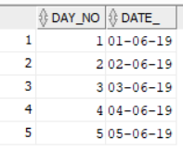

## Attendance

### Create

create table attendance

(

day\_no number(3),

person\_id varchar(10),

status varchar(15) check (status in('Present', 'Absent')),

primary key(day\_no, person\_id),

foreign key(day\_no) references working\_day,

foreign key(person\_id) references person

);

### Insert

Insert into ATTENDANCE (DAY\_NO,PERSON\_ID,STATUS) values (1,'P0001','Present');

Insert into ATTENDANCE (DAY\_NO,PERSON\_ID,STATUS) values (1,'P0002','Absent');

Insert into ATTENDANCE (DAY\_NO,PERSON\_ID,STATUS) values (1,'P0003','Present');

Insert into ATTENDANCE (DAY\_NO,PERSON\_ID,STATUS) values (1,'P0004','Absent');

Insert into ATTENDANCE (DAY\_NO,PERSON\_ID,STATUS) values (1,'P0005','Present');

Insert into ATTENDANCE (DAY\_NO,PERSON\_ID,STATUS) values (1,'P0006','Present');

Insert into ATTENDANCE (DAY\_NO,PERSON\_ID,STATUS) values (1,'P0007','Present');

Insert into ATTENDANCE (DAY\_NO,PERSON\_ID,STATUS) values (1,'P0008','Absent');

Insert into ATTENDANCE (DAY\_NO,PERSON\_ID,STATUS) values (1,'P0009','Present');

Insert into ATTENDANCE (DAY\_NO,PERSON\_ID,STATUS) values (1,'P0010','Present');

Insert into ATTENDANCE (DAY\_NO,PERSON\_ID,STATUS) values (1,'P0011','Present');

Insert into ATTENDANCE (DAY\_NO,PERSON\_ID,STATUS) values (1,'P0012','Absent');

Insert into ATTENDANCE (DAY\_NO,PERSON\_ID,STATUS) values (1,'P0013','Absent');

Insert into ATTENDANCE (DAY\_NO,PERSON\_ID,STATUS) values (1,'P0014','Present');

Insert into ATTENDANCE (DAY\_NO,PERSON\_ID,STATUS) values (1,'P0015','Absent');

Insert into ATTENDANCE (DAY\_NO,PERSON\_ID,STATUS) values (1,'P0016','Present');

Insert into ATTENDANCE (DAY\_NO,PERSON\_ID,STATUS) values (1,'P0017','Present');

Insert into ATTENDANCE (DAY\_NO,PERSON\_ID,STATUS) values (1,'P0018','Absent');

Insert into ATTENDANCE (DAY\_NO,PERSON\_ID,STATUS) values (1,'P0019','Present');

Insert into ATTENDANCE (DAY\_NO,PERSON\_ID,STATUS) values (1,'P0020','Present');

Insert into ATTENDANCE (DAY\_NO,PERSON\_ID,STATUS) values (1,'P0021','Present');

Insert into ATTENDANCE (DAY\_NO,PERSON\_ID,STATUS) values (1,'P0022','Present');

Insert into ATTENDANCE (DAY\_NO,PERSON\_ID,STATUS) values (1,'P0023','Present');

Insert into ATTENDANCE (DAY\_NO,PERSON\_ID,STATUS) values (1,'P0024','Absent');

Insert into ATTENDANCE (DAY\_NO,PERSON\_ID,STATUS) values (1,'P0025','Absent');

Insert into ATTENDANCE (DAY\_NO,PERSON\_ID,STATUS) values (1,'P0026','Present');

Insert into ATTENDANCE (DAY\_NO,PERSON\_ID,STATUS) values (1,'P0027','Absent');

Insert into ATTENDANCE (DAY\_NO,PERSON\_ID,STATUS) values (1,'P0028','Present');

Insert into ATTENDANCE (DAY\_NO,PERSON\_ID,STATUS) values (1,'P0029','Absent');

Insert into ATTENDANCE (DAY\_NO,PERSON\_ID,STATUS) values (1,'P0030','Present');

Insert into ATTENDANCE (DAY\_NO,PERSON\_ID,STATUS) values (1,'P0031','Present');

Insert into ATTENDANCE (DAY\_NO,PERSON\_ID,STATUS) values (1,'P0032','Present');

Insert into ATTENDANCE (DAY\_NO,PERSON\_ID,STATUS) values (1,'P0033','Present');

Insert into ATTENDANCE (DAY\_NO,PERSON\_ID,STATUS) values (1,'P0034','Absent');

Insert into ATTENDANCE (DAY\_NO,PERSON\_ID,STATUS) values (1,'P0035','Present');

Insert into ATTENDANCE (DAY\_NO,PERSON\_ID,STATUS) values (1,'P0036','Present');

Insert into ATTENDANCE (DAY\_NO,PERSON\_ID,STATUS) values (1,'P0037','Present');

Insert into ATTENDANCE (DAY\_NO,PERSON\_ID,STATUS) values (1,'P0038','Present');

Insert into ATTENDANCE (DAY\_NO,PERSON\_ID,STATUS) values (1,'P0039','Present');

Insert into ATTENDANCE (DAY\_NO,PERSON\_ID,STATUS) values (1,'P0040','Absent');

Insert into ATTENDANCE (DAY\_NO,PERSON\_ID,STATUS) values (1,'P0041','Present');

Insert into ATTENDANCE (DAY\_NO,PERSON\_ID,STATUS) values (1,'P0042','Present');

Insert into ATTENDANCE (DAY\_NO,PERSON\_ID,STATUS) values (1,'P0043','Present');

Insert into ATTENDANCE (DAY\_NO,PERSON\_ID,STATUS) values (1,'P0044','Present');

Insert into ATTENDANCE (DAY\_NO,PERSON\_ID,STATUS) values (1,'P0045','Present');

Insert into ATTENDANCE (DAY\_NO,PERSON\_ID,STATUS) values (1,'P0046','Present');

Insert into ATTENDANCE (DAY\_NO,PERSON\_ID,STATUS) values (1,'P0047','Present');

Insert into ATTENDANCE (DAY\_NO,PERSON\_ID,STATUS) values (1,'P0048','Present');

Insert into ATTENDANCE (DAY\_NO,PERSON\_ID,STATUS) values (1,'P0049','Present');

Insert into ATTENDANCE (DAY\_NO,PERSON\_ID,STATUS) values (1,'P0050','Present');

Insert into ATTENDANCE (DAY\_NO,PERSON\_ID,STATUS) values (2,'P0001','Present');

Insert into ATTENDANCE (DAY\_NO,PERSON\_ID,STATUS) values (2,'P0002','Present');

Insert into ATTENDANCE (DAY\_NO,PERSON\_ID,STATUS) values (2,'P0003','Present');

Insert into ATTENDANCE (DAY\_NO,PERSON\_ID,STATUS) values (2,'P0004','Present');

Insert into ATTENDANCE (DAY\_NO,PERSON\_ID,STATUS) values (2,'P0005','Absent');

Insert into ATTENDANCE (DAY\_NO,PERSON\_ID,STATUS) values (2,'P0006','Present');

Insert into ATTENDANCE (DAY\_NO,PERSON\_ID,STATUS) values (2,'P0007','Absent');

Insert into ATTENDANCE (DAY\_NO,PERSON\_ID,STATUS) values (2,'P0008','Present');

Insert into ATTENDANCE (DAY\_NO,PERSON\_ID,STATUS) values (2,'P0009','Present');

Insert into ATTENDANCE (DAY\_NO,PERSON\_ID,STATUS) values (2,'P0010','Present');

Insert into ATTENDANCE (DAY\_NO,PERSON\_ID,STATUS) values (2,'P0011','Absent');

Insert into ATTENDANCE (DAY\_NO,PERSON\_ID,STATUS) values (2,'P0012','Present');

Insert into ATTENDANCE (DAY\_NO,PERSON\_ID,STATUS) values (2,'P0013','Present');

Insert into ATTENDANCE (DAY\_NO,PERSON\_ID,STATUS) values (2,'P0014','Present');

Insert into ATTENDANCE (DAY\_NO,PERSON\_ID,STATUS) values (2,'P0015','Present');

Insert into ATTENDANCE (DAY\_NO,PERSON\_ID,STATUS) values (2,'P0016','Present');

Insert into ATTENDANCE (DAY\_NO,PERSON\_ID,STATUS) values (2,'P0017','Absent');

Insert into ATTENDANCE (DAY\_NO,PERSON\_ID,STATUS) values (2,'P0018','Present');

Insert into ATTENDANCE (DAY\_NO,PERSON\_ID,STATUS) values (2,'P0019','Present');

Insert into ATTENDANCE (DAY\_NO,PERSON\_ID,STATUS) values (2,'P0020','Present');

Insert into ATTENDANCE (DAY\_NO,PERSON\_ID,STATUS) values (2,'P0021','Present');

Insert into ATTENDANCE (DAY\_NO,PERSON\_ID,STATUS) values (2,'P0022','Absent');

Insert into ATTENDANCE (DAY\_NO,PERSON\_ID,STATUS) values (2,'P0023','Present');

Insert into ATTENDANCE (DAY\_NO,PERSON\_ID,STATUS) values (2,'P0024','Present');

Insert into ATTENDANCE (DAY\_NO,PERSON\_ID,STATUS) values (2,'P0025','Absent');

Insert into ATTENDANCE (DAY\_NO,PERSON\_ID,STATUS) values (2,'P0026','Absent');

Insert into ATTENDANCE (DAY\_NO,PERSON\_ID,STATUS) values (2,'P0027','Absent');

Insert into ATTENDANCE (DAY\_NO,PERSON\_ID,STATUS) values (2,'P0028','Absent');

Insert into ATTENDANCE (DAY\_NO,PERSON\_ID,STATUS) values (2,'P0029','Present');

Insert into ATTENDANCE (DAY\_NO,PERSON\_ID,STATUS) values (2,'P0030','Present');

Insert into ATTENDANCE (DAY\_NO,PERSON\_ID,STATUS) values (2,'P0031','Present');

Insert into ATTENDANCE (DAY\_NO,PERSON\_ID,STATUS) values (2,'P0032','Absent');

Insert into ATTENDANCE (DAY\_NO,PERSON\_ID,STATUS) values (2,'P0033','Present');

Insert into ATTENDANCE (DAY\_NO,PERSON\_ID,STATUS) values (2,'P0034','Present');

Insert into ATTENDANCE (DAY\_NO,PERSON\_ID,STATUS) values (2,'P0035','Present');

Insert into ATTENDANCE (DAY\_NO,PERSON\_ID,STATUS) values (2,'P0036','Present');

Insert into ATTENDANCE (DAY\_NO,PERSON\_ID,STATUS) values (2,'P0037','Present');

Insert into ATTENDANCE (DAY\_NO,PERSON\_ID,STATUS) values (2,'P0038','Present');

Insert into ATTENDANCE (DAY\_NO,PERSON\_ID,STATUS) values (2,'P0039','Present');

Insert into ATTENDANCE (DAY\_NO,PERSON\_ID,STATUS) values (2,'P0040','Present');

Insert into ATTENDANCE (DAY\_NO,PERSON\_ID,STATUS) values (2,'P0041','Present');

Insert into ATTENDANCE (DAY\_NO,PERSON\_ID,STATUS) values (2,'P0042','Present');

Insert into ATTENDANCE (DAY\_NO,PERSON\_ID,STATUS) values (2,'P0043','Present');

Insert into ATTENDANCE (DAY\_NO,PERSON\_ID,STATUS) values (2,'P0044','Absent');

Insert into ATTENDANCE (DAY\_NO,PERSON\_ID,STATUS) values (2,'P0045','Present');

Insert into ATTENDANCE (DAY\_NO,PERSON\_ID,STATUS) values (2,'P0046','Present');

Insert into ATTENDANCE (DAY\_NO,PERSON\_ID,STATUS) values (2,'P0047','Present');

Insert into ATTENDANCE (DAY\_NO,PERSON\_ID,STATUS) values (2,'P0048','Present');

Insert into ATTENDANCE (DAY\_NO,PERSON\_ID,STATUS) values (2,'P0049','Absent');

Insert into ATTENDANCE (DAY\_NO,PERSON\_ID,STATUS) values (2,'P0050','Absent');

Insert into ATTENDANCE (DAY\_NO,PERSON\_ID,STATUS) values (3,'P0001','Present');

Insert into ATTENDANCE (DAY\_NO,PERSON\_ID,STATUS) values (3,'P0002','Absent');

Insert into ATTENDANCE (DAY\_NO,PERSON\_ID,STATUS) values (3,'P0003','Present');

Insert into ATTENDANCE (DAY\_NO,PERSON\_ID,STATUS) values (3,'P0004','Present');

Insert into ATTENDANCE (DAY\_NO,PERSON\_ID,STATUS) values (3,'P0005','Present');

Insert into ATTENDANCE (DAY\_NO,PERSON\_ID,STATUS) values (3,'P0006','Absent');

Insert into ATTENDANCE (DAY\_NO,PERSON\_ID,STATUS) values (3,'P0007','Present');

Insert into ATTENDANCE (DAY\_NO,PERSON\_ID,STATUS) values (3,'P0008','Absent');

Insert into ATTENDANCE (DAY\_NO,PERSON\_ID,STATUS) values (3,'P0009','Present');

Insert into ATTENDANCE (DAY\_NO,PERSON\_ID,STATUS) values (3,'P0010','Absent');

Insert into ATTENDANCE (DAY\_NO,PERSON\_ID,STATUS) values (3,'P0011','Present');

Insert into ATTENDANCE (DAY\_NO,PERSON\_ID,STATUS) values (3,'P0012','Present');

Insert into ATTENDANCE (DAY\_NO,PERSON\_ID,STATUS) values (3,'P0013','Present');

Insert into ATTENDANCE (DAY\_NO,PERSON\_ID,STATUS) values (3,'P0014','Present');

Insert into ATTENDANCE (DAY\_NO,PERSON\_ID,STATUS) values (3,'P0015','Present');

Insert into ATTENDANCE (DAY\_NO,PERSON\_ID,STATUS) values (3,'P0016','Present');

Insert into ATTENDANCE (DAY\_NO,PERSON\_ID,STATUS) values (3,'P0017','Present');

Insert into ATTENDANCE (DAY\_NO,PERSON\_ID,STATUS) values (3,'P0018','Absent');

Insert into ATTENDANCE (DAY\_NO,PERSON\_ID,STATUS) values (3,'P0019','Present');

Insert into ATTENDANCE (DAY\_NO,PERSON\_ID,STATUS) values (3,'P0020','Present');

Insert into ATTENDANCE (DAY\_NO,PERSON\_ID,STATUS) values (3,'P0021','Present');

Insert into ATTENDANCE (DAY\_NO,PERSON\_ID,STATUS) values (3,'P0022','Present');

Insert into ATTENDANCE (DAY\_NO,PERSON\_ID,STATUS) values (3,'P0023','Present');

Insert into ATTENDANCE (DAY\_NO,PERSON\_ID,STATUS) values (3,'P0024','Absent');

Insert into ATTENDANCE (DAY\_NO,PERSON\_ID,STATUS) values (3,'P0025','Present');

Insert into ATTENDANCE (DAY\_NO,PERSON\_ID,STATUS) values (3,'P0026','Present');

Insert into ATTENDANCE (DAY\_NO,PERSON\_ID,STATUS) values (3,'P0027','Absent');

Insert into ATTENDANCE (DAY\_NO,PERSON\_ID,STATUS) values (3,'P0028','Absent');

Insert into ATTENDANCE (DAY\_NO,PERSON\_ID,STATUS) values (3,'P0029','Present');

Insert into ATTENDANCE (DAY\_NO,PERSON\_ID,STATUS) values (3,'P0030','Present');

Insert into ATTENDANCE (DAY\_NO,PERSON\_ID,STATUS) values (3,'P0031','Absent');

Insert into ATTENDANCE (DAY\_NO,PERSON\_ID,STATUS) values (3,'P0032','Present');

Insert into ATTENDANCE (DAY\_NO,PERSON\_ID,STATUS) values (3,'P0033','Present');

Insert into ATTENDANCE (DAY\_NO,PERSON\_ID,STATUS) values (3,'P0034','Present');

Insert into ATTENDANCE (DAY\_NO,PERSON\_ID,STATUS) values (3,'P0035','Absent');

Insert into ATTENDANCE (DAY\_NO,PERSON\_ID,STATUS) values (3,'P0036','Present');

Insert into ATTENDANCE (DAY\_NO,PERSON\_ID,STATUS) values (3,'P0037','Present');

Insert into ATTENDANCE (DAY\_NO,PERSON\_ID,STATUS) values (3,'P0038','Absent');

Insert into ATTENDANCE (DAY\_NO,PERSON\_ID,STATUS) values (3,'P0039','Absent');

Insert into ATTENDANCE (DAY\_NO,PERSON\_ID,STATUS) values (3,'P0040','Absent');

Insert into ATTENDANCE (DAY\_NO,PERSON\_ID,STATUS) values (3,'P0041','Present');

Insert into ATTENDANCE (DAY\_NO,PERSON\_ID,STATUS) values (3,'P0042','Absent');

Insert into ATTENDANCE (DAY\_NO,PERSON\_ID,STATUS) values (3,'P0043','Present');

Insert into ATTENDANCE (DAY\_NO,PERSON\_ID,STATUS) values (3,'P0044','Present');

Insert into ATTENDANCE (DAY\_NO,PERSON\_ID,STATUS) values (3,'P0045','Present');

Insert into ATTENDANCE (DAY\_NO,PERSON\_ID,STATUS) values (3,'P0046','Present');

Insert into ATTENDANCE (DAY\_NO,PERSON\_ID,STATUS) values (3,'P0047','Present');

Insert into ATTENDANCE (DAY\_NO,PERSON\_ID,STATUS) values (3,'P0048','Present');

Insert into ATTENDANCE (DAY\_NO,PERSON\_ID,STATUS) values (3,'P0049','Absent');

Insert into ATTENDANCE (DAY\_NO,PERSON\_ID,STATUS) values (3,'P0050','Absent');

Insert into ATTENDANCE (DAY\_NO,PERSON\_ID,STATUS) values (4,'P0001','Present');

Insert into ATTENDANCE (DAY\_NO,PERSON\_ID,STATUS) values (4,'P0002','Present');

Insert into ATTENDANCE (DAY\_NO,PERSON\_ID,STATUS) values (4,'P0003','Present');

Insert into ATTENDANCE (DAY\_NO,PERSON\_ID,STATUS) values (4,'P0004','Present');

Insert into ATTENDANCE (DAY\_NO,PERSON\_ID,STATUS) values (4,'P0005','Present');

Insert into ATTENDANCE (DAY\_NO,PERSON\_ID,STATUS) values (4,'P0006','Present');

Insert into ATTENDANCE (DAY\_NO,PERSON\_ID,STATUS) values (4,'P0007','Present');

Insert into ATTENDANCE (DAY\_NO,PERSON\_ID,STATUS) values (4,'P0008','Present');

Insert into ATTENDANCE (DAY\_NO,PERSON\_ID,STATUS) values (4,'P0009','Present');

Insert into ATTENDANCE (DAY\_NO,PERSON\_ID,STATUS) values (4,'P0010','Present');

Insert into ATTENDANCE (DAY\_NO,PERSON\_ID,STATUS) values (4,'P0011','Present');

Insert into ATTENDANCE (DAY\_NO,PERSON\_ID,STATUS) values (4,'P0012','Present');

Insert into ATTENDANCE (DAY\_NO,PERSON\_ID,STATUS) values (4,'P0013','Present');

Insert into ATTENDANCE (DAY\_NO,PERSON\_ID,STATUS) values (4,'P0014','Absent');

Insert into ATTENDANCE (DAY\_NO,PERSON\_ID,STATUS) values (4,'P0015','Absent');

Insert into ATTENDANCE (DAY\_NO,PERSON\_ID,STATUS) values (4,'P0016','Present');

Insert into ATTENDANCE (DAY\_NO,PERSON\_ID,STATUS) values (4,'P0017','Absent');

Insert into ATTENDANCE (DAY\_NO,PERSON\_ID,STATUS) values (4,'P0018','Present');

Insert into ATTENDANCE (DAY\_NO,PERSON\_ID,STATUS) values (4,'P0019','Present');

Insert into ATTENDANCE (DAY\_NO,PERSON\_ID,STATUS) values (4,'P0020','Present');

Insert into ATTENDANCE (DAY\_NO,PERSON\_ID,STATUS) values (4,'P0021','Present');

Insert into ATTENDANCE (DAY\_NO,PERSON\_ID,STATUS) values (4,'P0022','Absent');

Insert into ATTENDANCE (DAY\_NO,PERSON\_ID,STATUS) values (4,'P0023','Absent');

Insert into ATTENDANCE (DAY\_NO,PERSON\_ID,STATUS) values (4,'P0024','Present');

Insert into ATTENDANCE (DAY\_NO,PERSON\_ID,STATUS) values (4,'P0025','Present');

Insert into ATTENDANCE (DAY\_NO,PERSON\_ID,STATUS) values (4,'P0026','Present');

Insert into ATTENDANCE (DAY\_NO,PERSON\_ID,STATUS) values (4,'P0027','Present');

Insert into ATTENDANCE (DAY\_NO,PERSON\_ID,STATUS) values (4,'P0028','Present');

Insert into ATTENDANCE (DAY\_NO,PERSON\_ID,STATUS) values (4,'P0029','Absent');

Insert into ATTENDANCE (DAY\_NO,PERSON\_ID,STATUS) values (4,'P0030','Present');

Insert into ATTENDANCE (DAY\_NO,PERSON\_ID,STATUS) values (4,'P0031','Present');

Insert into ATTENDANCE (DAY\_NO,PERSON\_ID,STATUS) values (4,'P0032','Present');

Insert into ATTENDANCE (DAY\_NO,PERSON\_ID,STATUS) values (4,'P0033','Present');

Insert into ATTENDANCE (DAY\_NO,PERSON\_ID,STATUS) values (4,'P0034','Present');

Insert into ATTENDANCE (DAY\_NO,PERSON\_ID,STATUS) values (4,'P0035','Present');

Insert into ATTENDANCE (DAY\_NO,PERSON\_ID,STATUS) values (4,'P0036','Present');

Insert into ATTENDANCE (DAY\_NO,PERSON\_ID,STATUS) values (4,'P0037','Present');

Insert into ATTENDANCE (DAY\_NO,PERSON\_ID,STATUS) values (4,'P0038','Present');

Insert into ATTENDANCE (DAY\_NO,PERSON\_ID,STATUS) values (4,'P0039','Present');

Insert into ATTENDANCE (DAY\_NO,PERSON\_ID,STATUS) values (4,'P0040','Present');

Insert into ATTENDANCE (DAY\_NO,PERSON\_ID,STATUS) values (4,'P0041','Present');

Insert into ATTENDANCE (DAY\_NO,PERSON\_ID,STATUS) values (4,'P0042','Present');

Insert into ATTENDANCE (DAY\_NO,PERSON\_ID,STATUS) values (4,'P0043','Absent');

Insert into ATTENDANCE (DAY\_NO,PERSON\_ID,STATUS) values (4,'P0044','Present');

Insert into ATTENDANCE (DAY\_NO,PERSON\_ID,STATUS) values (4,'P0045','Present');

Insert into ATTENDANCE (DAY\_NO,PERSON\_ID,STATUS) values (4,'P0046','Present');

Insert into ATTENDANCE (DAY\_NO,PERSON\_ID,STATUS) values (4,'P0047','Present');

Insert into ATTENDANCE (DAY\_NO,PERSON\_ID,STATUS) values (4,'P0048','Absent');

Insert into ATTENDANCE (DAY\_NO,PERSON\_ID,STATUS) values (4,'P0049','Present');

Insert into ATTENDANCE (DAY\_NO,PERSON\_ID,STATUS) values (4,'P0050','Present');

Insert into ATTENDANCE (DAY\_NO,PERSON\_ID,STATUS) values (5,'P0001','Present');

Insert into ATTENDANCE (DAY\_NO,PERSON\_ID,STATUS) values (5,'P0002','Present');

Insert into ATTENDANCE (DAY\_NO,PERSON\_ID,STATUS) values (5,'P0003','Present');

Insert into ATTENDANCE (DAY\_NO,PERSON\_ID,STATUS) values (5,'P0004','Present');

Insert into ATTENDANCE (DAY\_NO,PERSON\_ID,STATUS) values (5,'P0005','Present');

Insert into ATTENDANCE (DAY\_NO,PERSON\_ID,STATUS) values (5,'P0006','Present');

Insert into ATTENDANCE (DAY\_NO,PERSON\_ID,STATUS) values (5,'P0007','Present');

Insert into ATTENDANCE (DAY\_NO,PERSON\_ID,STATUS) values (5,'P0008','Absent');

Insert into ATTENDANCE (DAY\_NO,PERSON\_ID,STATUS) values (5,'P0009','Present');

Insert into ATTENDANCE (DAY\_NO,PERSON\_ID,STATUS) values (5,'P0010','Present');

Insert into ATTENDANCE (DAY\_NO,PERSON\_ID,STATUS) values (5,'P0011','Present');

Insert into ATTENDANCE (DAY\_NO,PERSON\_ID,STATUS) values (5,'P0012','Present');

Insert into ATTENDANCE (DAY\_NO,PERSON\_ID,STATUS) values (5,'P0013','Present');

Insert into ATTENDANCE (DAY\_NO,PERSON\_ID,STATUS) values (5,'P0014','Present');

Insert into ATTENDANCE (DAY\_NO,PERSON\_ID,STATUS) values (5,'P0015','Present');

Insert into ATTENDANCE (DAY\_NO,PERSON\_ID,STATUS) values (5,'P0016','Absent');

Insert into ATTENDANCE (DAY\_NO,PERSON\_ID,STATUS) values (5,'P0017','Present');

Insert into ATTENDANCE (DAY\_NO,PERSON\_ID,STATUS) values (5,'P0018','Absent');

Insert into ATTENDANCE (DAY\_NO,PERSON\_ID,STATUS) values (5,'P0019','Present');

Insert into ATTENDANCE (DAY\_NO,PERSON\_ID,STATUS) values (5,'P0020','Present');

Insert into ATTENDANCE (DAY\_NO,PERSON\_ID,STATUS) values (5,'P0021','Present');

Insert into ATTENDANCE (DAY\_NO,PERSON\_ID,STATUS) values (5,'P0022','Present');

Insert into ATTENDANCE (DAY\_NO,PERSON\_ID,STATUS) values (5,'P0023','Present');

Insert into ATTENDANCE (DAY\_NO,PERSON\_ID,STATUS) values (5,'P0024','Present');

Insert into ATTENDANCE (DAY\_NO,PERSON\_ID,STATUS) values (5,'P0025','Present');

Insert into ATTENDANCE (DAY\_NO,PERSON\_ID,STATUS) values (5,'P0026','Present');

Insert into ATTENDANCE (DAY\_NO,PERSON\_ID,STATUS) values (5,'P0027','Present');

Insert into ATTENDANCE (DAY\_NO,PERSON\_ID,STATUS) values (5,'P0028','Absent');

Insert into ATTENDANCE (DAY\_NO,PERSON\_ID,STATUS) values (5,'P0029','Present');

Insert into ATTENDANCE (DAY\_NO,PERSON\_ID,STATUS) values (5,'P0030','Present');

Insert into ATTENDANCE (DAY\_NO,PERSON\_ID,STATUS) values (5,'P0031','Present');

Insert into ATTENDANCE (DAY\_NO,PERSON\_ID,STATUS) values (5,'P0032','Present');

Insert into ATTENDANCE (DAY\_NO,PERSON\_ID,STATUS) values (5,'P0033','Present');

Insert into ATTENDANCE (DAY\_NO,PERSON\_ID,STATUS) values (5,'P0034','Present');

Insert into ATTENDANCE (DAY\_NO,PERSON\_ID,STATUS) values (5,'P0035','Present');

Insert into ATTENDANCE (DAY\_NO,PERSON\_ID,STATUS) values (5,'P0036','Present');

Insert into ATTENDANCE (DAY\_NO,PERSON\_ID,STATUS) values (5,'P0037','Present');

Insert into ATTENDANCE (DAY\_NO,PERSON\_ID,STATUS) values (5,'P0038','Present');

Insert into ATTENDANCE (DAY\_NO,PERSON\_ID,STATUS) values (5,'P0039','Present');

Insert into ATTENDANCE (DAY\_NO,PERSON\_ID,STATUS) values (5,'P0040','Present');

Insert into ATTENDANCE (DAY\_NO,PERSON\_ID,STATUS) values (5,'P0041','Absent');

Insert into ATTENDANCE (DAY\_NO,PERSON\_ID,STATUS) values (5,'P0042','Present');

Insert into ATTENDANCE (DAY\_NO,PERSON\_ID,STATUS) values (5,'P0043','Present');

Insert into ATTENDANCE (DAY\_NO,PERSON\_ID,STATUS) values (5,'P0044','Present');

Insert into ATTENDANCE (DAY\_NO,PERSON\_ID,STATUS) values (5,'P0045','Present');

Insert into ATTENDANCE (DAY\_NO,PERSON\_ID,STATUS) values (5,'P0046','Absent');

Insert into ATTENDANCE (DAY\_NO,PERSON\_ID,STATUS) values (5,'P0047','Present');

Insert into ATTENDANCE (DAY\_NO,PERSON\_ID,STATUS) values (5,'P0048','Present');

Insert into ATTENDANCE (DAY\_NO,PERSON\_ID,STATUS) values (5,'P0049','Absent');

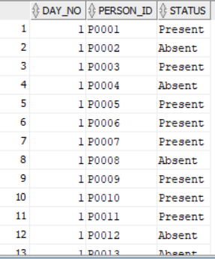Insert into ATTENDANCE (DAY\_NO,PERSON\_ID,STATUS) values (5,'P0050','Absent');

## Person Mobile

### Create

CREATE TABLE person\_mobile(

person\_id varchar(10),

mobile\_no number(10, 0) not null,

foreign key(person\_id) REFERENCES person(person\_id),

primary key(person\_id, mobile\_no)

);

### Insert

Insert into PERSON\_MOBILE (PERSON\_ID,MOBILE\_NO) values ('P0001',9553074646);

Insert into PERSON\_MOBILE (PERSON\_ID,MOBILE\_NO) values ('P0002',9638057031);

Insert into PERSON\_MOBILE (PERSON\_ID,MOBILE\_NO) values ('P0003',8138736952);

Insert into PERSON\_MOBILE (PERSON\_ID,MOBILE\_NO) values ('P0004',8531197969);

Insert into PERSON\_MOBILE (PERSON\_ID,MOBILE\_NO) values ('P0005',9583812584);

Insert into PERSON\_MOBILE (PERSON\_ID,MOBILE\_NO) values ('P0006',9011249400);

Insert into PERSON\_MOBILE (PERSON\_ID,MOBILE\_NO) values ('P0007',6710889329);

Insert into PERSON\_MOBILE (PERSON\_ID,MOBILE\_NO) values ('P0008',9680047496);

Insert into PERSON\_MOBILE (PERSON\_ID,MOBILE\_NO) values ('P0009',8962702365);

Insert into PERSON\_MOBILE (PERSON\_ID,MOBILE\_NO) values ('P0010',9106369704);

Insert into PERSON\_MOBILE (PERSON\_ID,MOBILE\_NO) values ('P0011',7762432744);

Insert into PERSON\_MOBILE (PERSON\_ID,MOBILE\_NO) values ('P0012',7123005087);

Insert into PERSON\_MOBILE (PERSON\_ID,MOBILE\_NO) values ('P0013',7849154999);

Insert into PERSON\_MOBILE (PERSON\_ID,MOBILE\_NO) values ('P0014',9458602193);

Insert into PERSON\_MOBILE (PERSON\_ID,MOBILE\_NO) values ('P0015',7207543413);

Insert into PERSON\_MOBILE (PERSON\_ID,MOBILE\_NO) values ('P0016',8816679981);

Insert into PERSON\_MOBILE (PERSON\_ID,MOBILE\_NO) values ('P0017',8371513326);

Insert into PERSON\_MOBILE (PERSON\_ID,MOBILE\_NO) values ('P0018',9099882181);

Insert into PERSON\_MOBILE (PERSON\_ID,MOBILE\_NO) values ('P0019',7519945390);

Insert into PERSON\_MOBILE (PERSON\_ID,MOBILE\_NO) values ('P0020',9878700428);

Insert into PERSON\_MOBILE (PERSON\_ID,MOBILE\_NO) values ('P0021',6916927805);

Insert into PERSON\_MOBILE (PERSON\_ID,MOBILE\_NO) values ('P0022',7709588290);

Insert into PERSON\_MOBILE (PERSON\_ID,MOBILE\_NO) values ('P0023',8640412081);

Insert into PERSON\_MOBILE (PERSON\_ID,MOBILE\_NO) values ('P0024',8761085515);

Insert into PERSON\_MOBILE (PERSON\_ID,MOBILE\_NO) values ('P0025',7650690731);

Insert into PERSON\_MOBILE (PERSON\_ID,MOBILE\_NO) values ('P0026',8273103938);

Insert into PERSON\_MOBILE (PERSON\_ID,MOBILE\_NO) values ('P0027',8792601171);

Insert into PERSON\_MOBILE (PERSON\_ID,MOBILE\_NO) values ('P0028',9451081179);

Insert into PERSON\_MOBILE (PERSON\_ID,MOBILE\_NO) values ('P0029',7477337500);

Insert into PERSON\_MOBILE (PERSON\_ID,MOBILE\_NO) values ('P0030',7127920824);

Insert into PERSON\_MOBILE (PERSON\_ID,MOBILE\_NO) values ('P0031',9519015364);

Insert into PERSON\_MOBILE (PERSON\_ID,MOBILE\_NO) values ('P0032',7260811259);

Insert into PERSON\_MOBILE (PERSON\_ID,MOBILE\_NO) values ('P0033',9846259640);

Insert into PERSON\_MOBILE (PERSON\_ID,MOBILE\_NO) values ('P0034',7435568897);

Insert into PERSON\_MOBILE (PERSON\_ID,MOBILE\_NO) values ('P0035',7016575585);

Insert into PERSON\_MOBILE (PERSON\_ID,MOBILE\_NO) values ('P0036',8566385570);

Insert into PERSON\_MOBILE (PERSON\_ID,MOBILE\_NO) values ('P0037',9170270463);

Insert into PERSON\_MOBILE (PERSON\_ID,MOBILE\_NO) values ('P0038',9944874306);

Insert into PERSON\_MOBILE (PERSON\_ID,MOBILE\_NO) values ('P0039',7368225643);

Insert into PERSON\_MOBILE (PERSON\_ID,MOBILE\_NO) values ('P0040',7833172416);

Insert into PERSON\_MOBILE (PERSON\_ID,MOBILE\_NO) values ('P0041',9785101199);

Insert into PERSON\_MOBILE (PERSON\_ID,MOBILE\_NO) values ('P0042',7646152078);

Insert into PERSON\_MOBILE (PERSON\_ID,MOBILE\_NO) values ('P0043',6880614712);

Insert into PERSON\_MOBILE (PERSON\_ID,MOBILE\_NO) values ('P0044',9748023586);

Insert into PERSON\_MOBILE (PERSON\_ID,MOBILE\_NO) values ('P0045',8267619643);

Insert into PERSON\_MOBILE (PERSON\_ID,MOBILE\_NO) values ('P0046',7065129100);

Insert into PERSON\_MOBILE (PERSON\_ID,MOBILE\_NO) values ('P0047',8978934949);

Insert into PERSON\_MOBILE (PERSON\_ID,MOBILE\_NO) values ('P0048',8469578542);

Insert into PERSON\_MOBILE (PERSON\_ID,MOBILE\_NO) values ('P0049',7209797377);

Insert into PERSON\_MOBILE (PERSON\_ID,MOBILE\_NO) values ('P0050',7933879323);

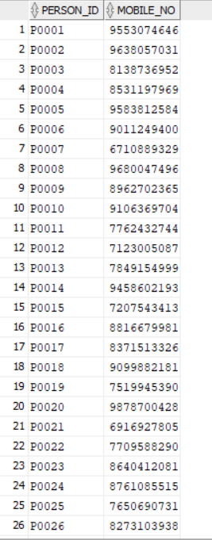

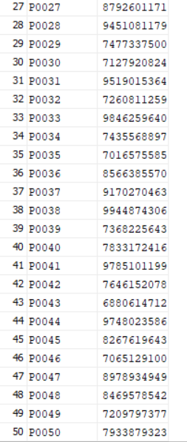

# Queries (DQL)

## Find number of Students

### Eg: Find number of students of standard 3rd.

select count(\*) as student\_in\_standard1 from (student natural join enrollment) where standard\_no=1;

## Find lecture timings

### Eg. 1: Find when is the second mathematics lecture of the week in standard 2nd.

select day, start\_time, end\_time from lecture where lecture\_no =2 and subject\_name='Mathematics' and standard\_no=2;

### Eg. 2: Find start time and end time of Hindi lecture in standard 2nd on Tuesday.

select start\_time,end\_time from lecture where subject\_name='Hindi' and standard\_no=2 and day='Tuesday';

## Find classroom

### Eg: Find the classroom allocated to standard 3rd.

select room\_no,building\_no from standard where standard\_no=3;

## Find classroom capacity

### Eg: Find the capacity of classroom in which standard 3rd studies.

select capacity from (standard natural join classroom) where standard\_no =3;



## Find teacher

### Eg: Find the name of teachers who teach Hindi in standard 2nd.

select distinct F\_name||' '||M\_name||' '||L\_name as Hindi\_Std2\_Teacher from (lecture natural join teacher natural join employee natural join person) where subject\_name='Hindi' and standard\_no=2;

## Find students

### Eg: Find names of students who study in standard 1st.

select F\_name||' '||M\_name||' '||L\_name as Student\_Std1 from (person natural join student natural join enrollment) where standard\_no=1;

## Find salary of employees

### Eg: Find salary of all teachers with their names.

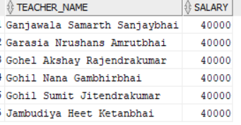select F\_name||' '||M\_name||' '||L\_name as Teacher\_Name, Salary from (person natural join employee natural join teacher);

## Find student’s enrollent

### Eg: Find the enrollment of student with student ID: S12.

select enrolled\_date, standard\_no, roll\_no from (enrollment) where student\_id='S12';

## Find time table

### Eg: Find time table of standard 1st on Monday.

select lecture\_no,subject\_name,standard\_no,start\_time,end\_time from lecture where standard\_no = 1 and day='Monday';

## Find attendance

### Eg. 1: Find whether Student with student id S4 was present on 3rd June, 2019 or not.

select status from (student natural join person natural join attendance) where day\_no=(select day\_no from working\_day where date\_='03-JUN-2019') and student\_id='S4';

### Eg. 2: Find whether roll number 3 of standard 2nd was present on 3rd June, 2019 or not.

select status from attendance where person\_id=

(

select person\_id from student where student\_id=

(

select student\_id from enrollment where roll\_no=3 and standard\_no=2

)

) and day\_no=

(

select day\_no from working\_day where date\_='03-JUN-2019'

);

## Find mobile number

### Eg: Find mobile number of student of standard 2nd with roll number 5.

Subquery method:

select mobile\_no from person\_mobile where person\_id=

(

select person\_id from student where student\_id=

(

select student\_id from enrollment where roll\_no=5 and standard\_no=2

)

);

Natural join method:

select mobile\_no from enrollment natural join student natural join person natural join person\_mobile where standard\_no=2 and roll\_no=5;



## Find books

### Find books of standard 3rd.

select book from subject where standard\_no = 3;

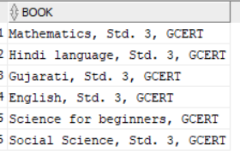

# References

* Database System Concepts by Silberschatz, Korth and Sudarshan, Sixth Edition.
* Database Management System, Part I, course on Infosys Springboard (for concepts of normalization). <https://infyspringboard.onwingspan.com/web/en/app/toc/lex_auth_01275806667282022456_shared/overview>
* Oracle Database Express Edition (as a database service), and Oracle SQL Developer (as an SQL IDE).
* GitMind (for ER Diagram creation): <https://gitmind.com/>
* DBDiagram (for relational schema creation): <https://dbdiagram.io/>