**B.N.M. Institute of Technology**

**An Autonomous Institution under VTU**

**Approved by AICTE, Accredited as Grade A Institution by NAAC till 31.12.2026.**

**All Eligible UG branches – CSE, ECE, EEE, ISE & Mech. Engg. Accredited by NBA till 30.06.2025**

**Post box no. 7087, 27th cross, 12th Main, Banashankari 2nd Stage, Bengaluru- 560070, INDIA**

**Ph: 91-80- 26711780/81/82   Email:**[**principal@bnmit.in**](mailto:principal@bnmit.in)**,** [**www.bnmit.org**](http://www.bnmit.org)



**PROBLEM SOLVING THROUGH C- 22PSC125**

**PROJECT REPORT**

**ON**

# **“MOVIE TICKET BOOKING SYSTEM”**

**by**

**H L SANKETH** **1BG22CS052**

**AMAN SOUDAGAR** **1BG22CS014**

Under the guidance of

RAGHAVENDRA C K

Dept. of CSE

BNMIT

**CHAPTER 1**

**INTRODUCTION**

The "Movie Ticket Booking System" project implemented in the C programming language offers a convenient and interactive solution for users seeking a streamlined way to book movie tickets. This project aims to provide a user-friendly console-based interface that allows individuals to choose from a selection of movies and showtimes, visualize seating arrangements, reserve seats, and manage seat data through file handling.

By employing fundamental programming concepts such as functions, arrays, loops, and file I/O, this system efficiently simulates the process of booking movie tickets, demonstrating the practical application of programming skills in a real-world context. Through its clear interface and functionalities, this project offers users a glimpse into the world of software development and showcases the essential aspects of building interactive applications.

**CHAPTER 2**

**PROBLEM STATEMENT AND OBJECTIVES**

**PROBLEM STATEMENT:**

**Movie ticket booking system**

In traditional movie theatres, ticket booking processes often required patrons to visit physical counters, leading to long queues and potential inconvenience. As technology evolved, online ticket booking systems emerged, enabling users to book seats from the comfort of their homes.

The proposed project seeks to replicate this convenience within a simplified console application, offering users a platform to explore available movies, showtimes, and reserve seats seamlessly. The project gives real life understanding of online movie ticket booking system and activities performed by various roles in the supply chain.

**OBJECTIVES:**

* Design a user-friendly interface for movie selection, seat reservation, and interaction.
* Implement the seat reservation mechanism, preventing multiple reservations for the same seat.
* Develop functions to save and load seat reservation data to and from files.
* To provide a simplified version of a movie ticket booking system, focusing on providing users with an interactive console-based interface to select movies, showtimes, reserve seats, and manage seat data using the C programming language.

**CHAPTER 3**

**METHODOLOGY**

* The user is prompted to select a movie from the available options. The loop ensures the input is within the valid range of movie options.
* Similarly, the user is prompted to select a showtime within the valid range of showtime options.
* The loadDataFromFile() function is called to load the seat data for the selected movie and showtime from the associated file.
* The inner loop displays the current seat layout using the displaySeats() function and presents options for seat reservation or exiting.
* Users can choose to reserve a seat or exit the reservation process.
* If the user chooses to reserve a seat, they are prompted to enter the seat location in a format like "A1" or "F12".
* The reserveSeat() function is called to check if the selected seat is available and to perform the reservation if possible.
* The selected seat location is converted to row and column indices, and checks are performed to ensure the selection is within valid ranges.
* After completing the reservation process for a movie and showtime, the user is asked whether they want to book another movie or showtime.
* The do-while loop allows users to repeatedly book movies or showtimes.
* Once the user is done booking movies and showtimes, a thank you message is displayed, and the program ends.

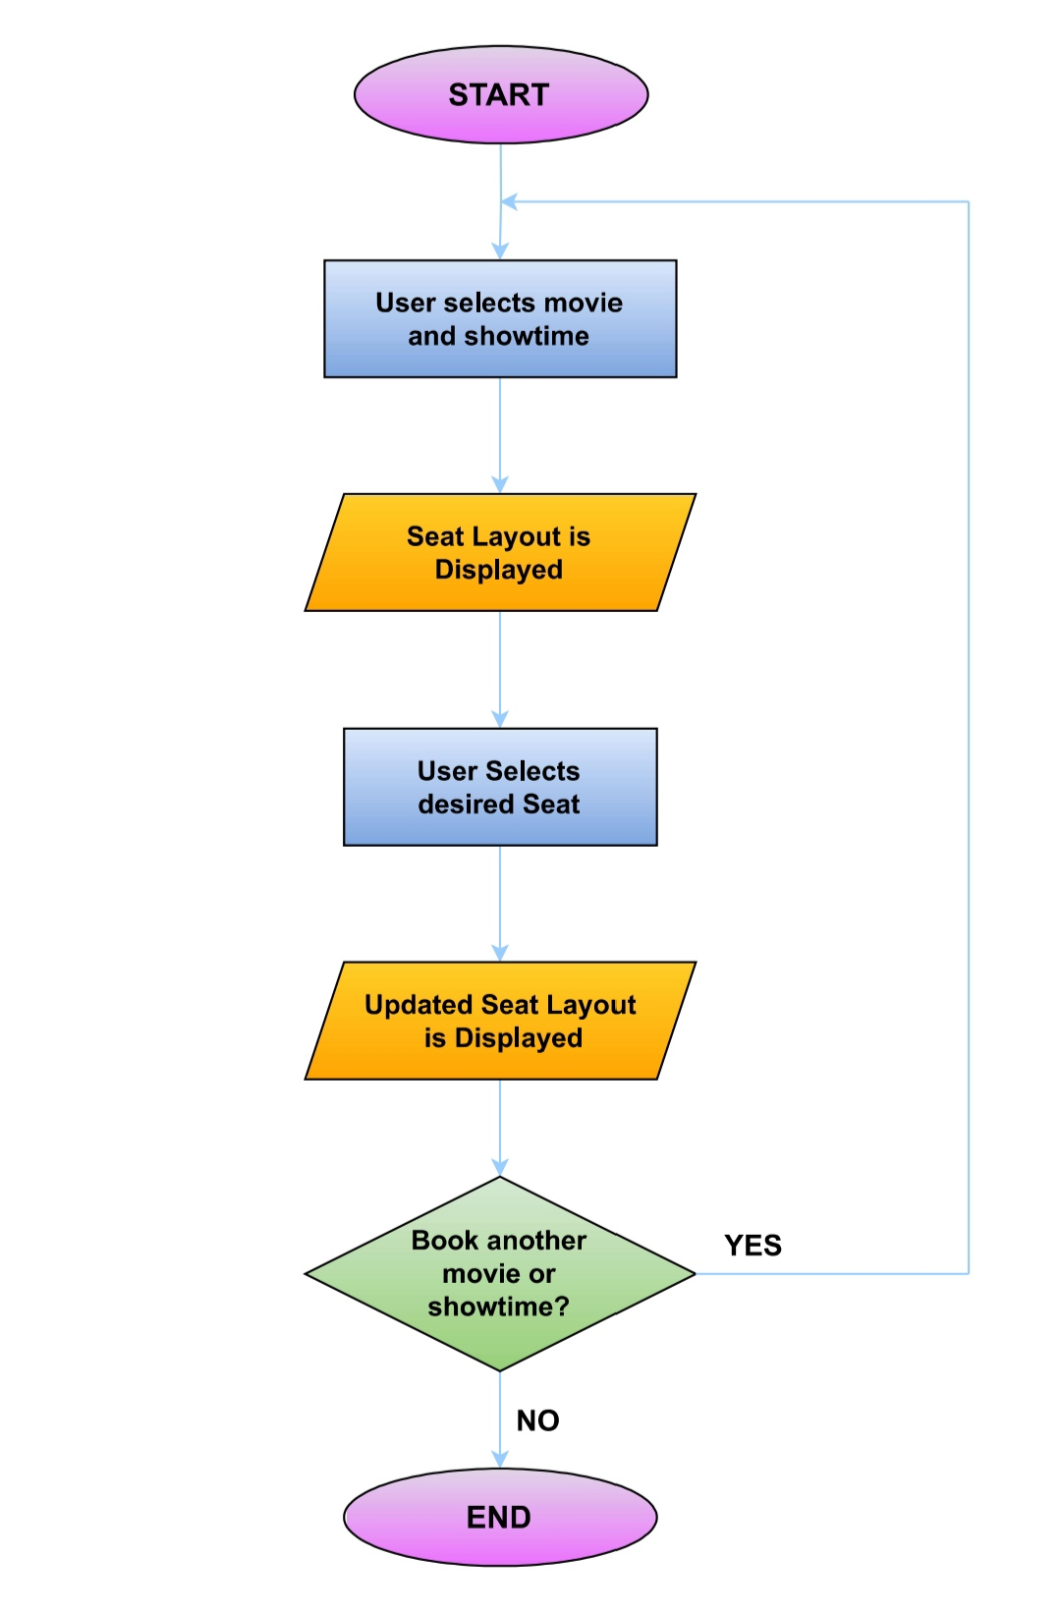**FLOWCHARTCHAPTER 4**

**Figure – 3.1**

**IMPLEMENTATION**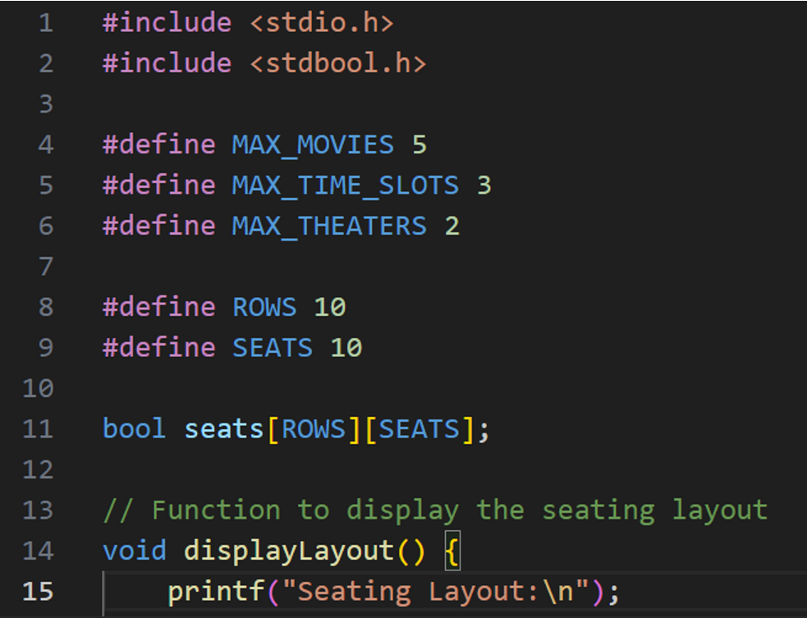

**Figure – 4.1**

This code snippet sets up a simple reservation system for movie theatre seats. It defines constants and arrays to represent movie names, showtimes, and seat availability. It also prepares file handles for data storage and manipulation. The code focuses on managing a grid of seats for different movies and showtimes. The "movies" array holds the names of different movies, the "showtimes" array contains different show times, and the "seats" array stores the availability status of each seat for different movie-show combinations. The code initializes various variables and arrays for this purpose.

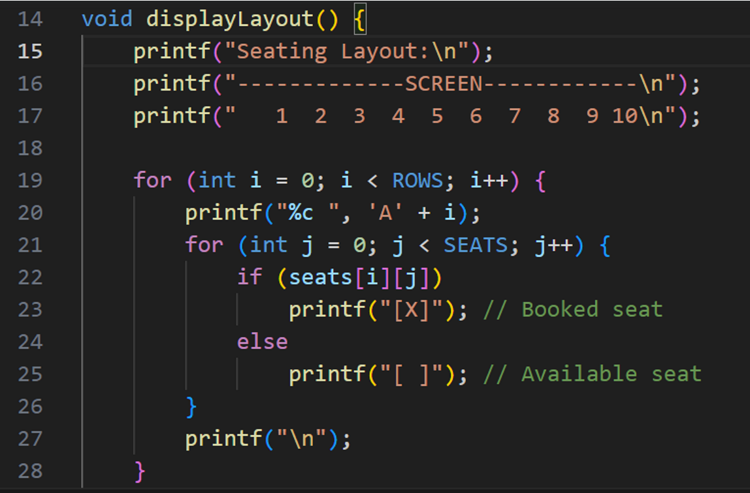

**Figure – 4.2**

This code defines a function displaylayout() that prints the layout of movie theatre seats. It generates a visual representation of the seats using row and column labels, displaying seat availability using characters within brackets[ ], and marking the position of the screen. The function enhances the user experience by providing a clear visualization of the seat arrangement.

z

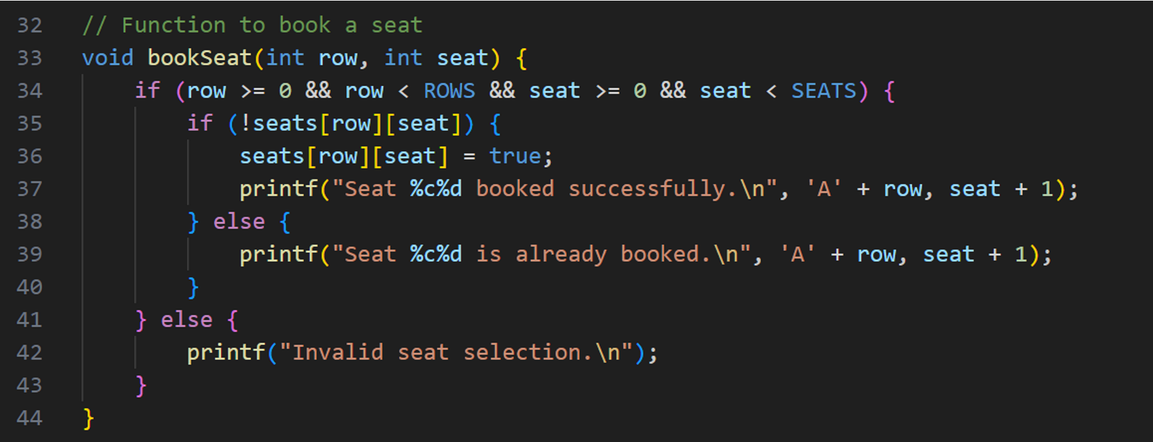

**Figure – 4.3**

This code defines a function **bookSeat** that is used to book seats in a hypothetical seating arrangement. The seating arrangement is represented as a 2D array **seats**, where each element of the array corresponds to a seat. The function takes two parameters: **row** and **seat**, representing the row number and seat number respectively. this code defines a function that allows users to book seats in a seating arrangement represented by a 2D array. It performs various checks to ensure that the seat can be booked, and provides appropriate feedback to the user based on the outcome of these checks.

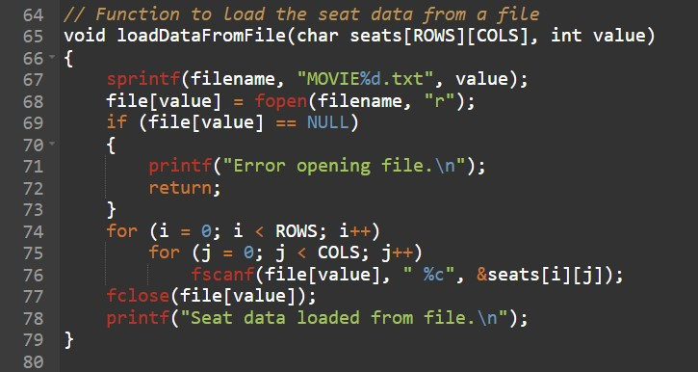

This code defines a function loadDataFromFile() that reads seat layout data from a file associated with the given integer value. It constructs the filename using that value, opens the corresponding file for reading, and then reads characters representing seat availability into the seats array. After reading, the file is closed, and a message is printed to confirm that the seat data has been loaded from the file. This function is responsible for retrieving previously saved seat reservation data from a file for a specific movie-show combination.

**Figure – 4.4**

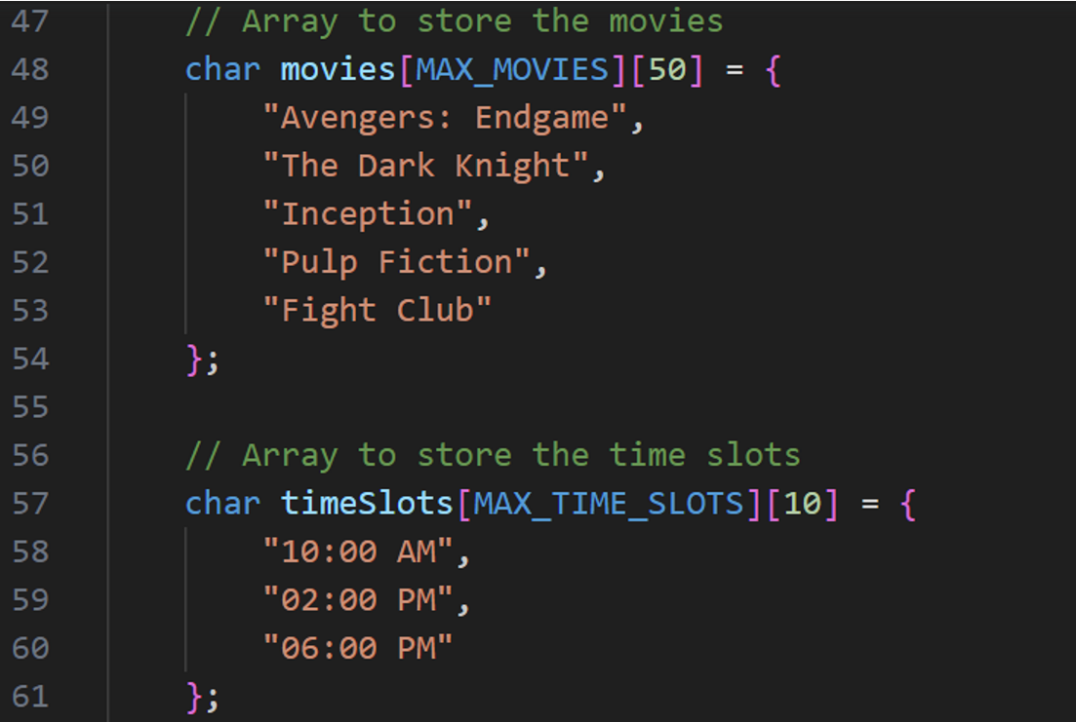

1. This code snippet defines two arrays: one to store movie titles and another to store time slots. The **char movies[MAX_MOVIES][50]** array is defined to store movie titles. This array has a maximum capacity of **MAX_MOVIES** movies, and each movie title can have up to 50 characters.
2. Inside the curly braces **{}**, the movie titles are provided as strings. In this example, there are five movie titles listed: "Avengers: Endgame", "The Dark Knight", "Inception", "Pulp Fiction", and "Fight Club". These titles are represented as strings using double quotes.
3. Similarly, the **char timeslots[MAX_TIME_SLOTS][10]** array is defined to store time slot information. This array has a maximum capacity of **MAX_TIME_SLOTS** time slots, and each time slot can have up to 10 characters.
4. Inside the curly braces **{}**, the time slot strings are provided. In this example, there are three time slots listed: "10:00 AM", "02:00 PM", and "06:00 PM".

Top of Form

**Figure – 4.5**

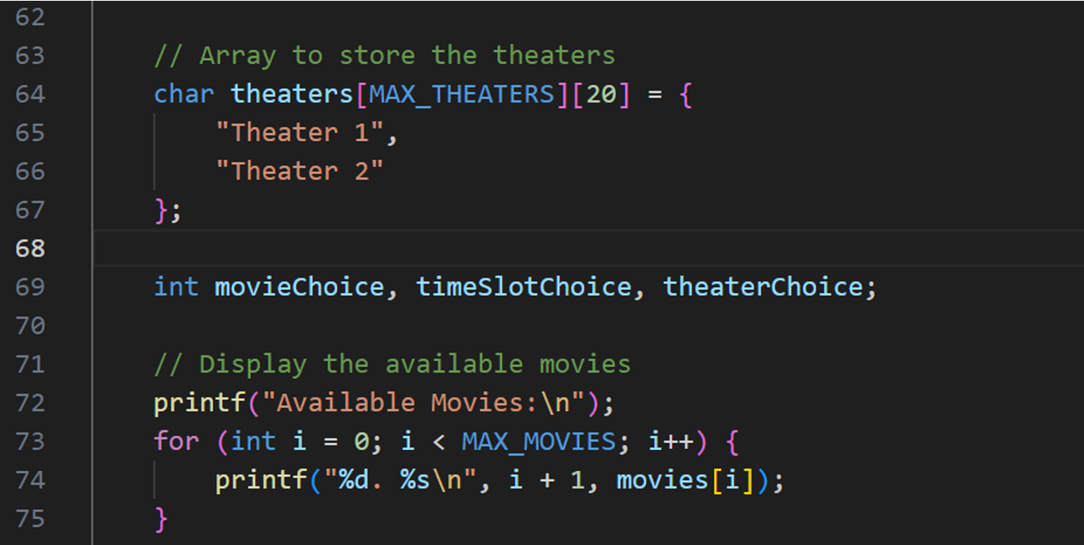

**Figure – 4.6**

This part of the code initializes an array to store theatre names and then displays a list of available movies to the user along with their corresponding indices. The indices can be used by the user to select a movie for booking. This code is likely part of a larger program that would involve user interactions for selecting movies, time slots, and theatre’s for booking movie tickets.

**CHAPTER 5**

**RESULT**

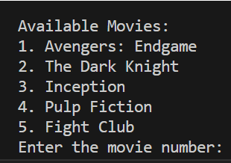

**Figure – 5.1**

**User selects movie**

**Figure – 5.2**

**The seat layout is displayed from which the user reserves the desired seat.**

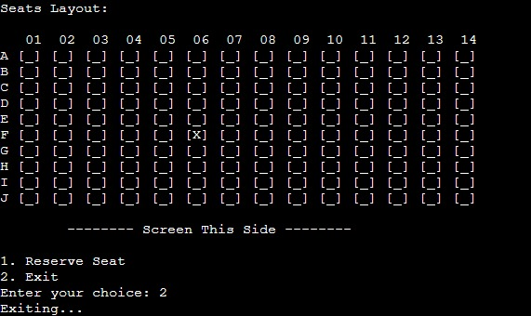

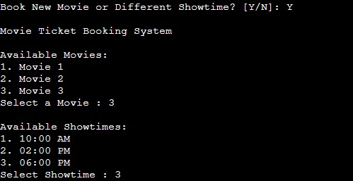

**The updated seat layout is displayed.**

**Figure – 5.3**

**Same process is repeated.**

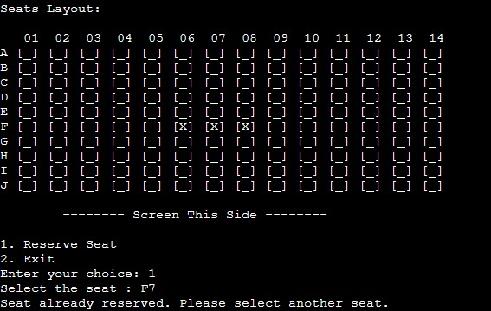

**Figure – 5.4**

**The console notifies that the seat is already reserved when the user attempts to book the seat which is already reserved**



**Figure – 5.5**

**The program is terminated with a thank you message.**

**CHAPTER 6**

**CONCLUSION**

In conclusion, the development of the "Movie Ticket Booking System" using the C programming language has been a rewarding endeavour that underscores the significance of technology in simplifying and enhancing various aspects of our lives. Through this project, we have successfully demonstrated the feasibility and functionality of an efficient platform that facilitates the seamless booking of movie tickets.

The system's design, coding, and implementation processes have provided invaluable insights into the world of software development, honing our problem-solving skills and fostering a deeper understanding of programming principles. By creating an intuitive user interface, incorporating features like seat selection, showtime options, we have catered to the modern-day expectations of convenience and user experience.

Furthermore, this project emphasizes the importance of collaboration and teamwork, as the amalgamation of creative ideas and technical expertise was essential for its successful execution. Going forward, the project can serve as a foundation for future enhancements, such as integrating additional services like concessions or introducing mobile applications for broader accessibility.

In conclusion, the "Movie Ticket Booking System" project not only showcases the power of the C language in software development but also highlights the broader impact of technology on improving everyday processes. As the digital landscape continues to evolve, projects like these pave the way for innovation and efficiency in the realm of entertainment and beyond.

**CHAPTER 7**

**REFERENCES**

* Programming in ANSI C (Eight edition) by E. Balaguruswamy
* Programming in C by Reema Thareja
* Class notes given by Raghavendra C K
* SOURCE CODE & PROJECTS

<https://code-projects.org/c/languages/project/cprojects/>

* Interview Bit

<https://www.interviewbit.com/blog/c-projects/>