PyShop: (Python Shop) Using Djongo framework

1)http://127.0.0.1:8000/products/#

Website to list all the products which are available for customer to buy the product

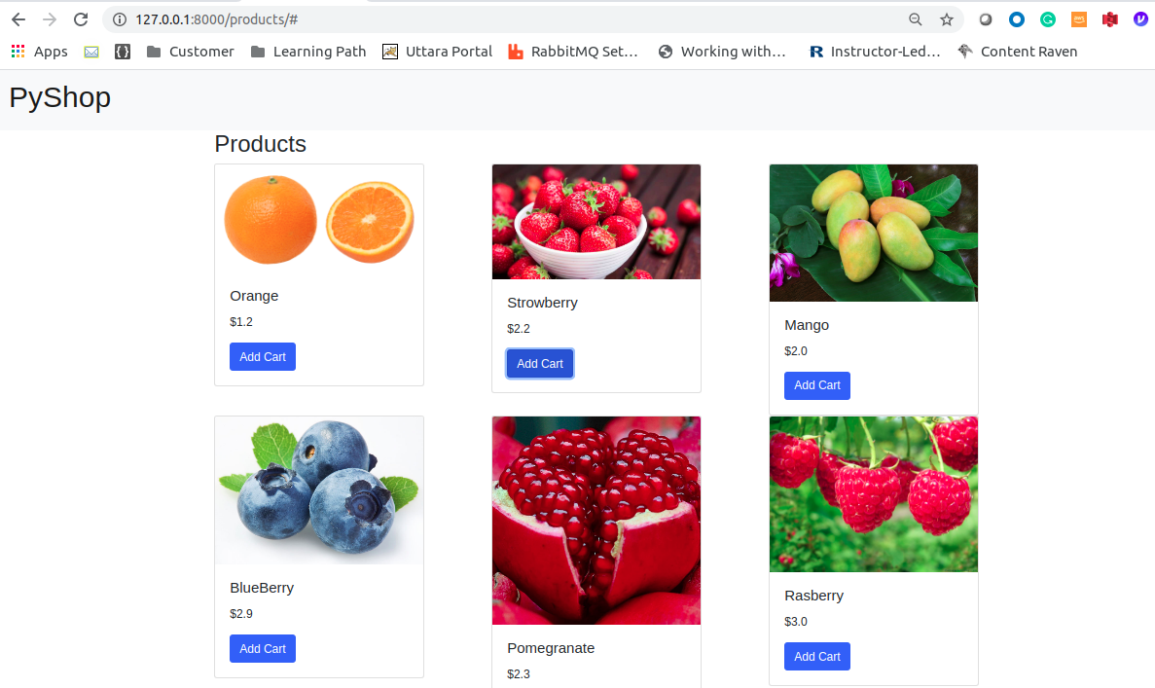
2)http://127.0.0.1:8000/admin/
Admin page to add or remove product/offer.
Manage user and groups

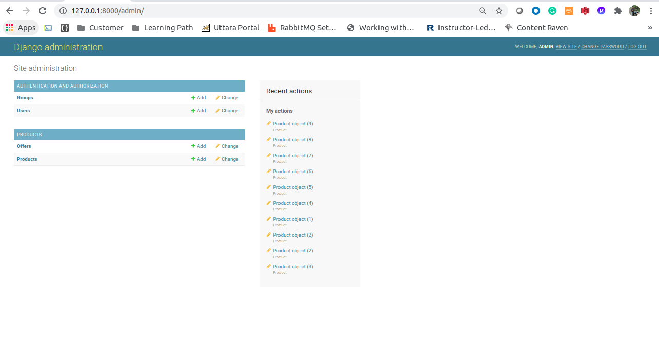
3) http://127.0.0.1:8000/admin/products/product/
Product to add and remove

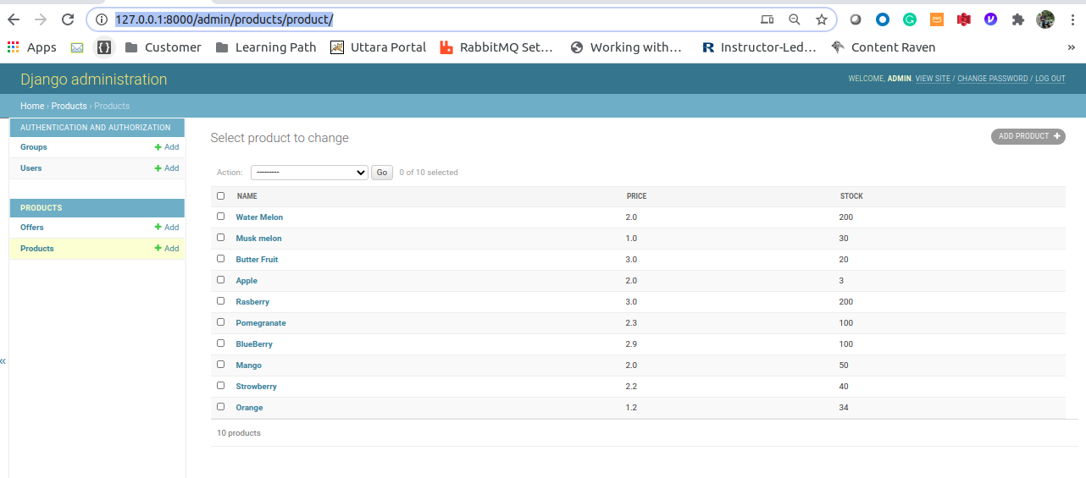

4)http://127.0.0.1:8000/admin/products/product/add/

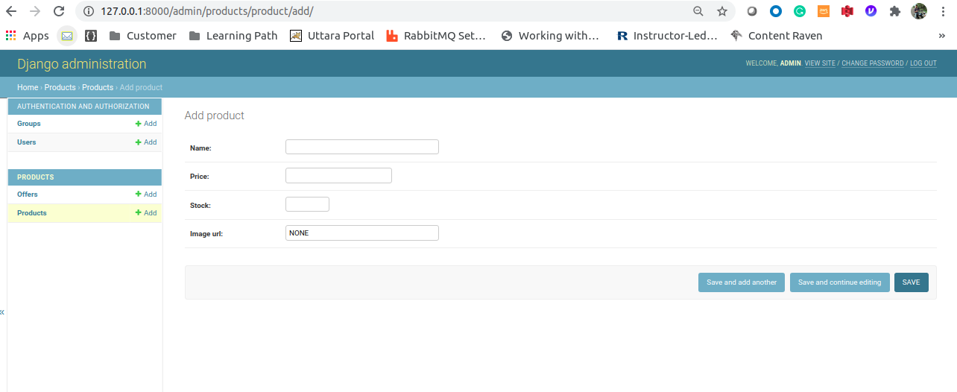
5)http://127.0.0.1:8000/admin/products/offer/add/

