## **CAREER OBJECTIVE**

To learn more about the industry and gain first-hand experience about the responsibilities and requirements of the company. Being a quick learner, I wish to develop a more rounded skill-set and improve my job capabilities.

## **ACADEMIC PROFILE**

SANKET HONASHETTI

[sankethonashetti1008@gmail.com](mailto:sankethonashetti1008@gmail.com)

+919008847628

# Main Road, Akkol, Tq: Chikodi, Dist:Belgaum, Karnataka - 591211.

sanket-honashetti-46504717a

## **TECHNICAL SKILLS**

**LANGUAGES:** C, JAVA, Python and SQL.

**Operating Systems:** Windows xp/7 Ultimate/ windows10, Linux, Ubuntu.

**Software Packages:** MS-Office, Xamp, Wamp

**Others:** Basic Web Programming, DBMS

# **PERSONAL SKILLS**

**Leadership Team Work Flexibility Critical Thinking**

**Positive Attitude Self - Motivated**

# **PERSONAL DETAILS**

**Date of Birth:** 18-June-1998

**Nationality:** Indian

**Sex:** Male

**Marital Status:** Single

**Languages:** Kannada, English, Hindi and Marathi.

# **HOBBIES**

**S. G. Balekundri Institute of Technology, Belgaum**

BE (CSE) | 2020 I CGPA: 8.1325 (73.825%)

1. **L. Science PU College, Belgaum**

PUC | 2016 I Score: 68.33%

1. **R. S. High School, Akkol**

SSLC | 2014 I Score: 89.28%

## **PROJECTS**

**Online Car Rental Management System:** Developed the system using SQL & Java at the back end, for the growing travel industry in Belgaum.

**FIFA Player Management System:** Developed the said system using Php & MySQL for backend. The said system can be an effective solution for numerous football clubs in Belgaum & Kolhapur cities in managing their players.

**Secure File Storage on Cloud Using Hybrid Cryptography**

## **INTERNSHIP**

**Tech Fortune Technologies, Belgaum "Machine Learning with Python"**

Was provided with an in-depth understanding of Machine Learning using Python in tandem with industry applications.

## **ACHIEVEMENTS**

Served as the Kho-Kho team Captain of S. G. Balekundri Institute

of Technology, Belgaum.

I was instrumental in fetching 2 University level inter college wins in Kho-Kho Tournament.

Member of CSI, LEAD and NSS,

Participated in quiz competition and young entrepreneur event in SGBIT orgnized by CSI.

## **CERTIFICATION**

"SQL for Data Science" from University of California in 2020 "Python Foundation course" from Apponix certified association in 2020

"Complete Responsive Web Development" in 2020

"Complete SQL Bootstrap with MySQL, PHP & Python" in 2020 Published a Research Paper - "Development of secure file storage on cloud using hybrid cryptography" in International Journal of Innovative Research in Science, Engineering and Technology

Travelling & exploring new places

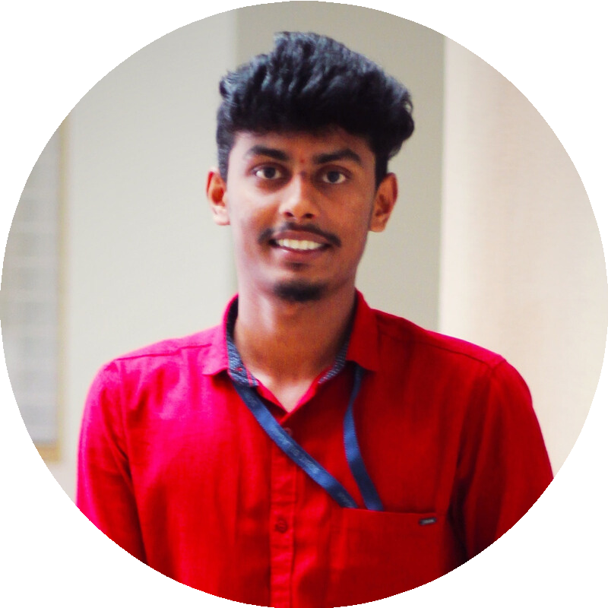

Sports

Listening to Music

(IJIRSET), April 2020.