**1.Create two linux instances,Use the first free linux AMI.**

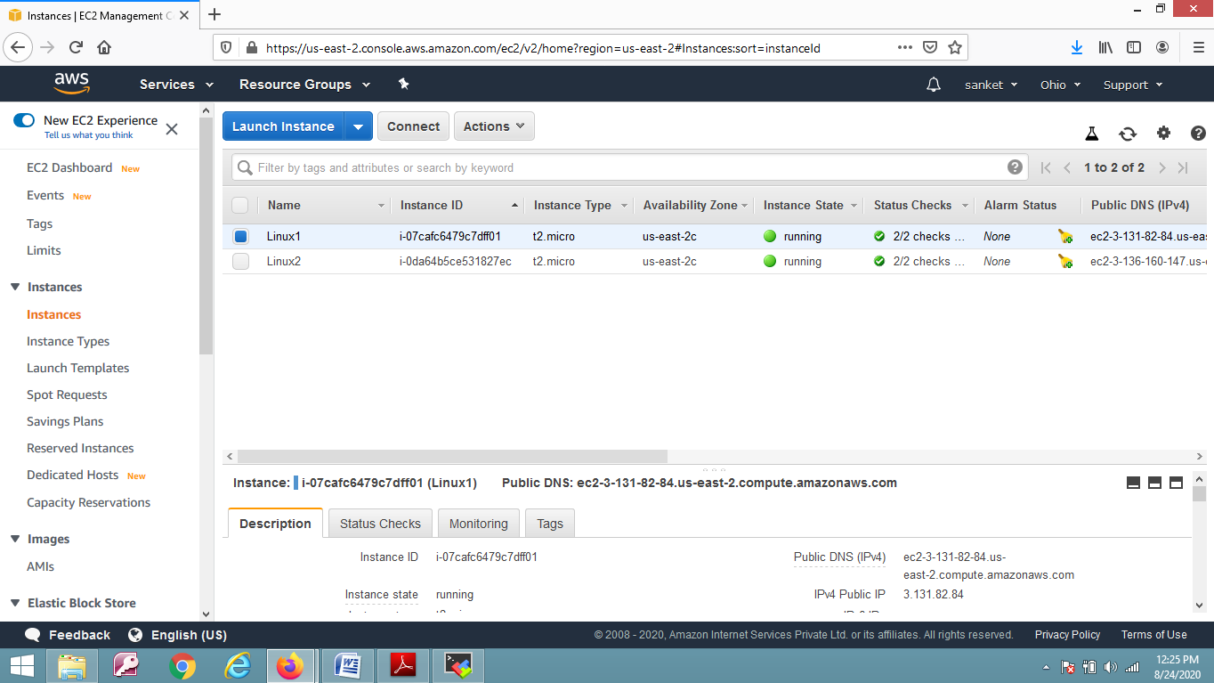

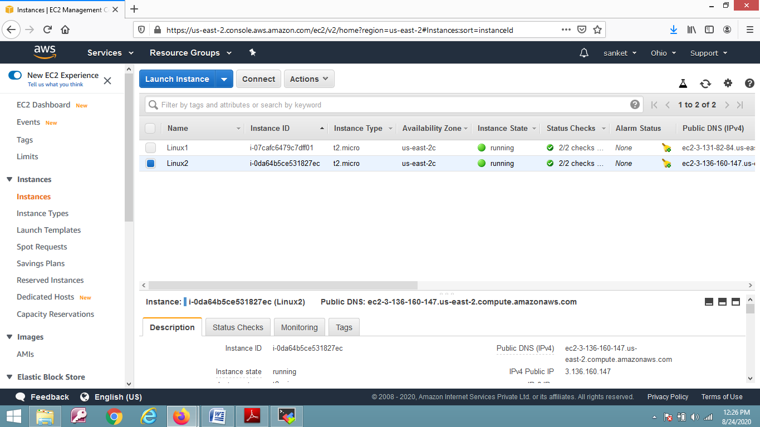

**2. application is deployed on both servers.**

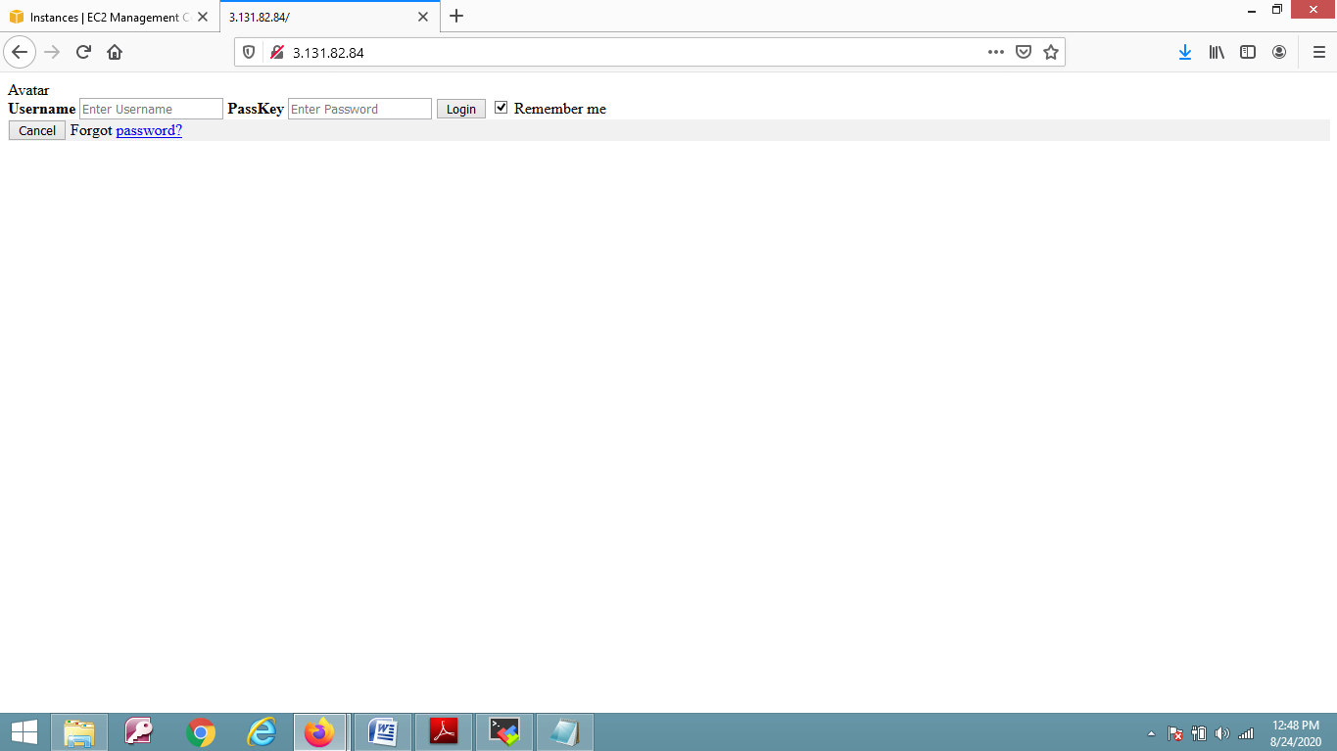

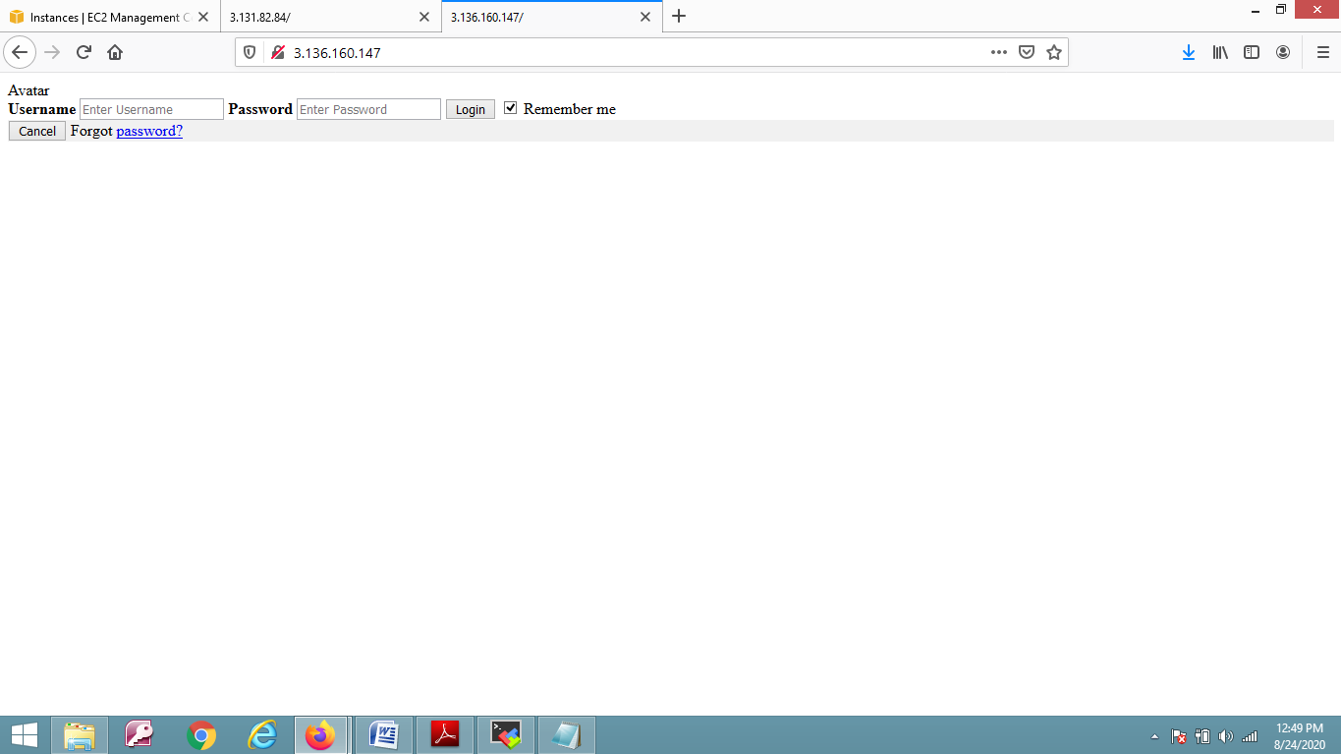

**3.Creation of Load Balancer.**

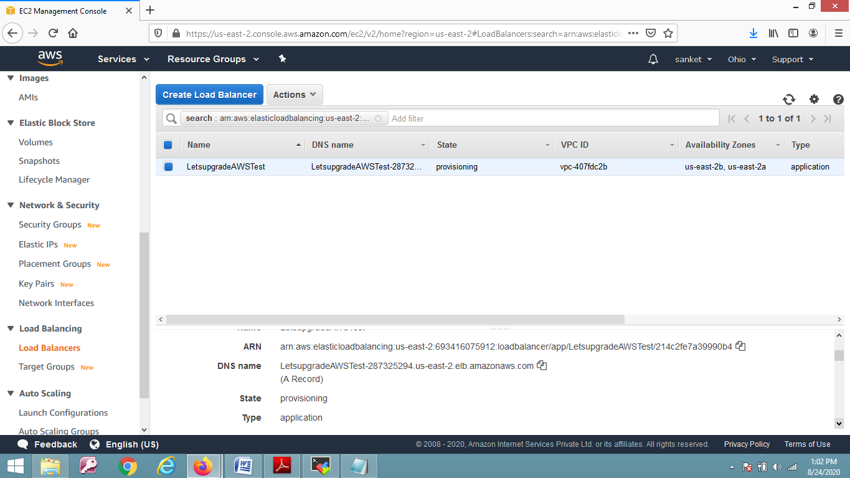

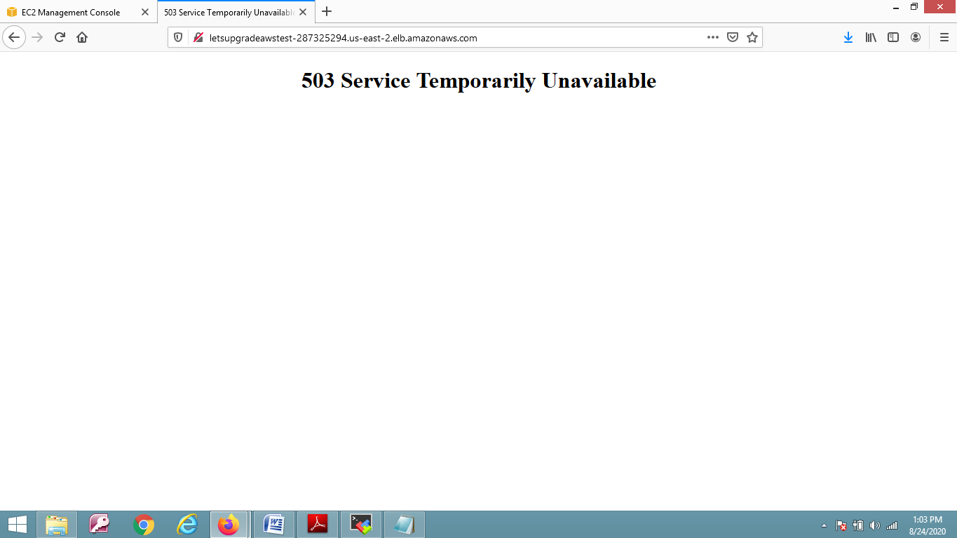

**Note:-**

As submission has to be done till today 5 PM. the last load balancer working screenshot is unable to provide as it takes time to configure(More Than 24 hours).