**Launching Ubuntu Instance**

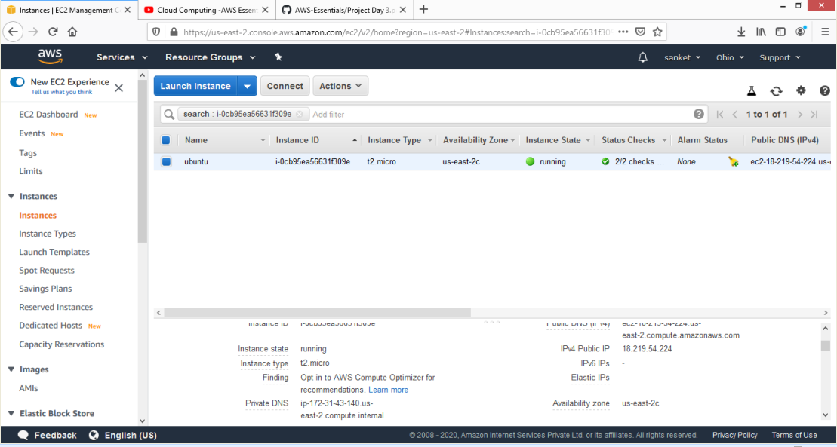

**Connecting Ubuntu instance using MobaXterm:-**

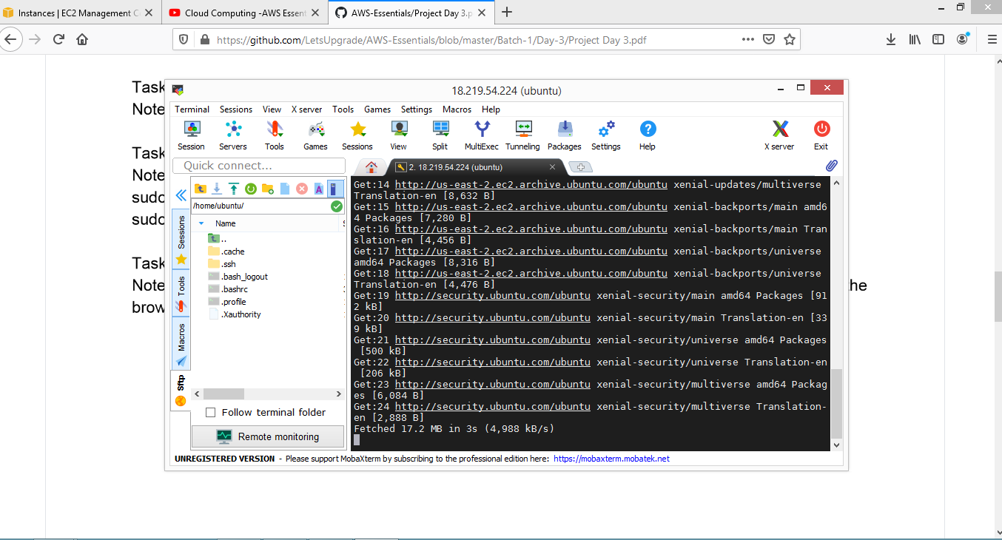

**After installing nginx server:-**

