OS
Performance Analysis
Analysing the performance of Linux DC ++ in regular,CPU intensive and IO intensive environments
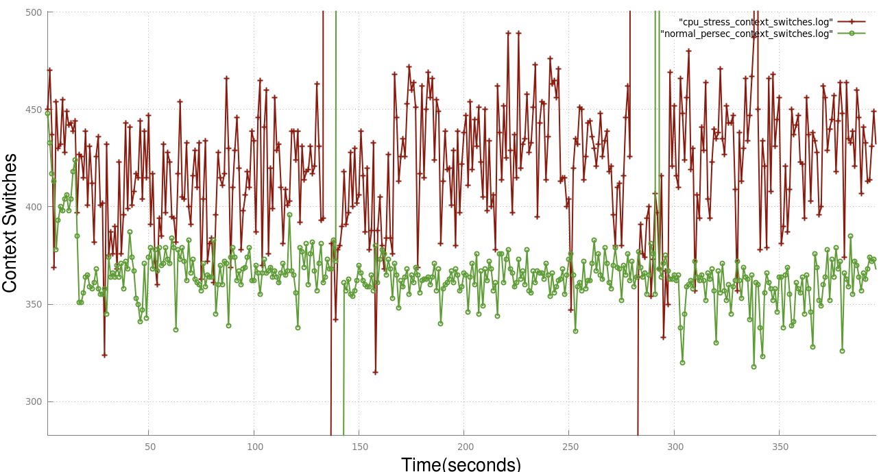

Setup
In our regular case we run Linux DC ++ on Ubuntu and we do not run any CPU or I/O intensive tasks in this case.We profile the application by executing perf stat after every 15 sec for about 3 hours and collect the data in a log file.
In our CPU intensive case we run Linux Dc ++ under heavy CPU intensive stress.This heavy CPU stress is simulated by the stress utility. Using this stress utility we were able to generate 40 CPU stressors.Each CPU stressor is nothing but a process spinning on an sqrt().
In our I/O intensive case we run Linux DC ++ under heavy I/O stress which again was simulated using stress utility.
After obtaining the data we extract and clean the data which is relevant to us(context switches and CPU utilization) using grep and sed commands , in this report we plot a graph of CPU usage vs time and Context-switches vs time using gnuplot
In both the cases (CPU usage and Context switches)for the starting half of the time period we download some file from some peer pc and for the latter half we keep the Linux DC ++ idle i.e. we don’t download any file.

Regular environment vs CPU intensive environment
Context Switches
Red - CPU Intensive Green - Regular
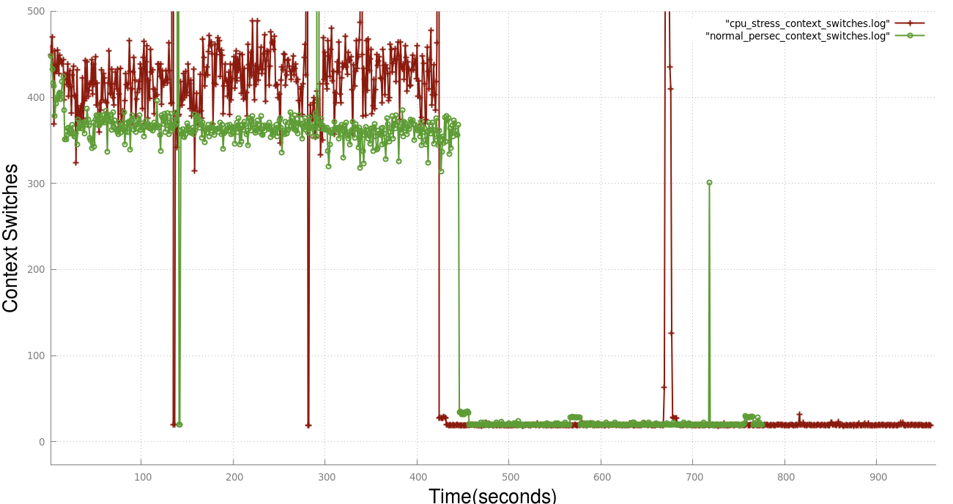

During starting half of the time period ,i.e the time period in which we download some files using Linux DC ++ the number of context switches in CPU intensive case is consistently higher as compared to normal case.
When DC++ lies idle the number of context switches is more or less same.
Deductions:
Graph zoomed showing context switches while a file is being downloaded/uploaded.
Since in the CPU intensive cases there are around 40 more process' which hog the CPU we have to context switch each of them in and out inorder to run the 40 process' + Linux DCpp fairly resulting in greater context switches.

Graph zoomed showing context switches when Linux DC ++ is ide
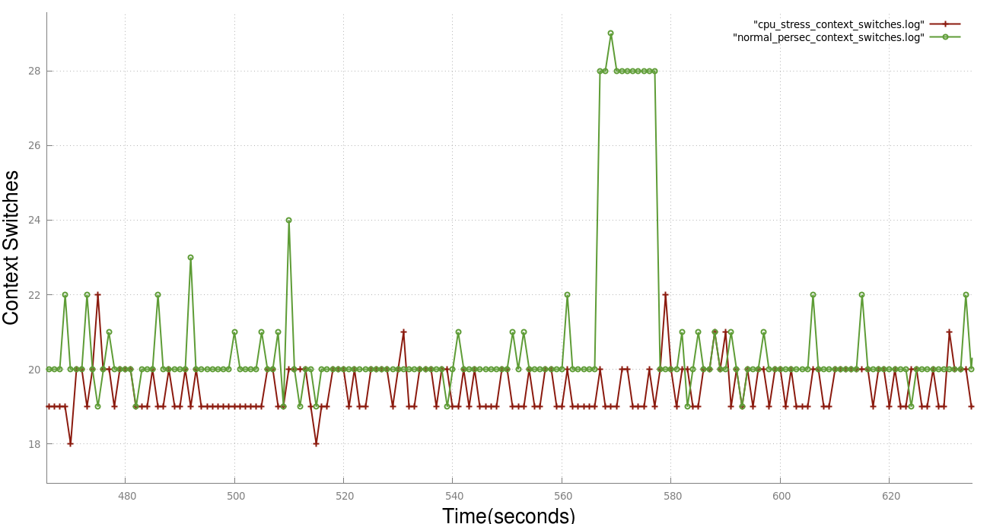
In the latter half when no downloading is happening the result is more or less same because only those many programs of Linux DC ++ are executing which are required to keep the system up and running.Since less programs of Linux Dc ++ are running when it is idle the no. of context switches is lesser as compared to former case.
CPU Utilization
Red - CPU Intensive Green - Regular
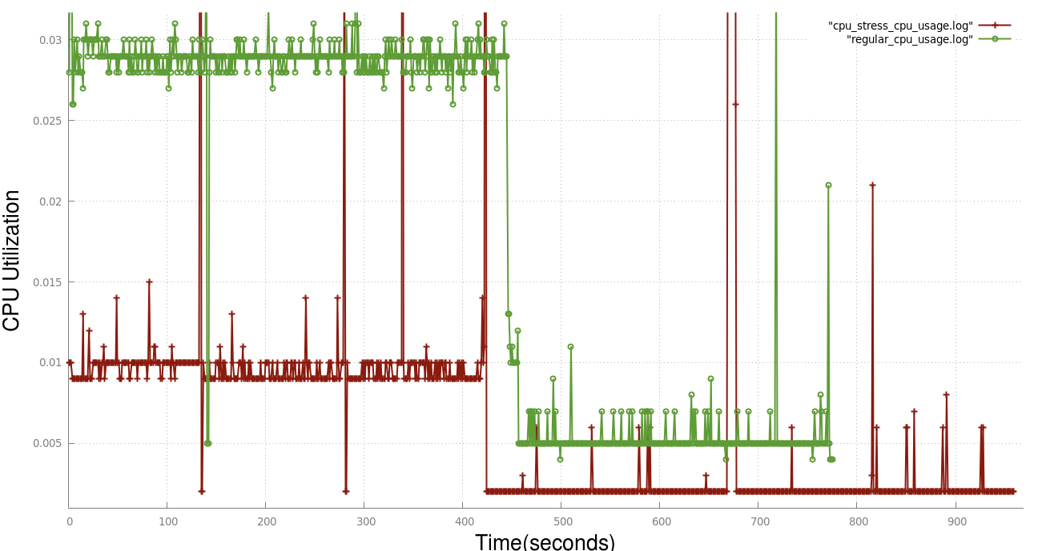
In the starting half the CPU utilization in regular case is consistently higher as compared to CPU intensive case.Here eved when in the latter half when Linux DC++ is idel the CPU utilization in regular case is higher as compared to CPU intensive case.
Deductions
Graph zoomed showing CPU Utilizations when some file is being downloaded or uploaded
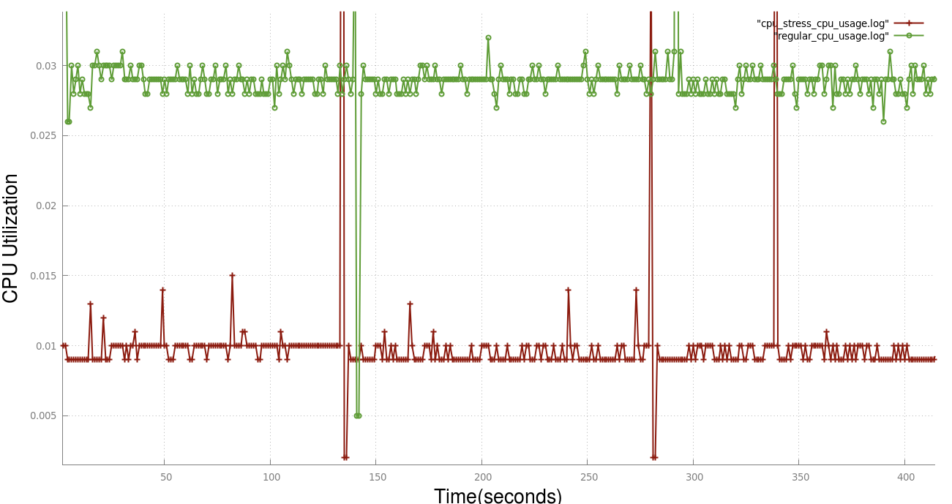
In the former half the CPU utilization in regular case is much higher s compared to CPU intensive.It is because in the CPU intensive case due to 40 extra CPU intensive process the CPU time is divided into those 40 process' + Linux DC ++ resulting in a lesser overall CPU utilization.
In the latter case half also the CPU utilization is higher because of the same fact.

Graph zoomed showing CPU Utilizations when linux DC ++ is idle
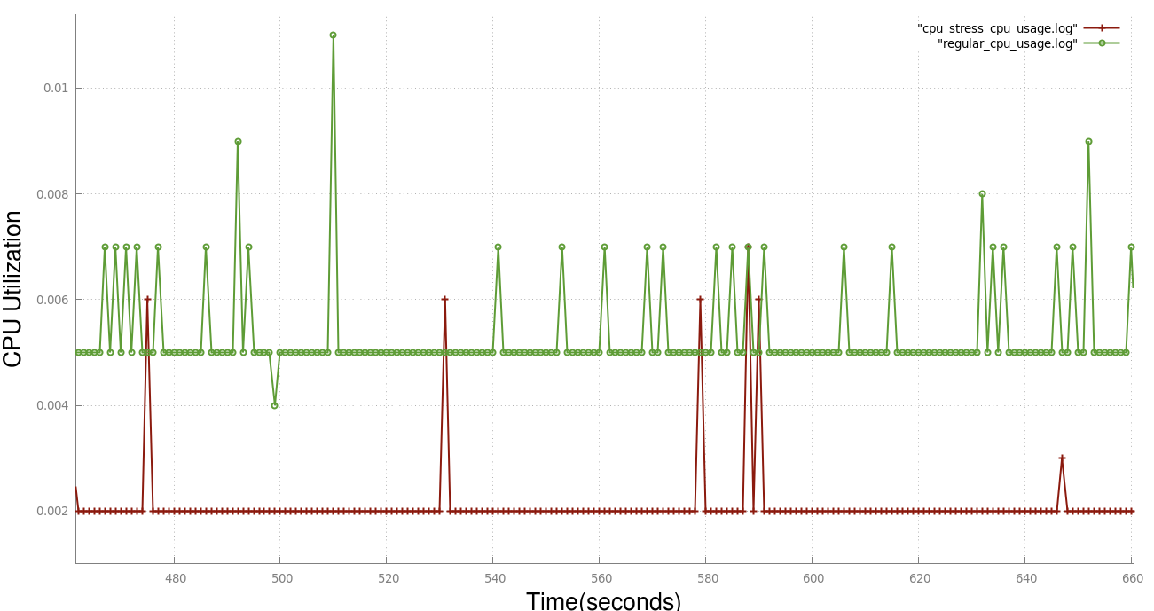

Regular environment vs I/O intensive environment
Context Switches
In the starting half of the time period during which a file is download/uploaded using Linux DC ++ the number of context switches in I/O intensive environments are abnormally high as compared to regular environment.
In the latter half during which Linux DC ++ is idle and no file is downloaded/uploaded using it the number of context switches in both the environments are more or less same.
Before deducing anything from the generated data we must first make a note as to how I/O load is generated on the system.The stress utility which is used to generate I/O load uses the sync() system call to repeatedly copy buffered data in memory onto the disk.We are using 20 process which are running their own instances of sync() so as to generate I/O intensive environment.

Blue - I/O Intensive Green - Regular
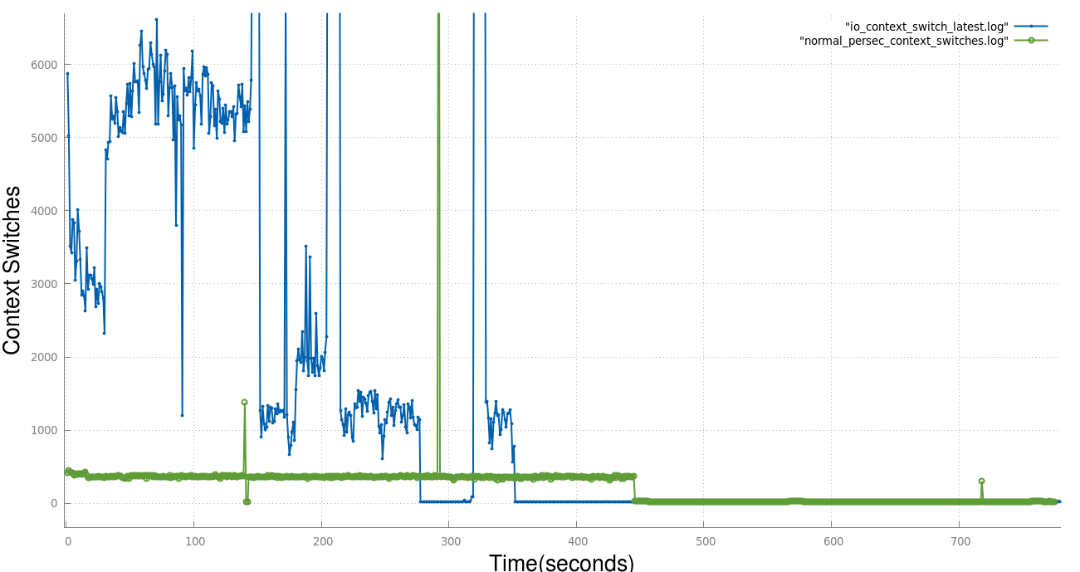
Deductions
In the earlier half,during which a file is downloaded/uploaded the number of context switches in I/O intensive case is approximately 10 times higher as compared to regular case. One of actions due to which a context switch is triggered is when a process makes itself unrunnable due to a memory-disc synchronization operation.Since we have 20 such process which are performing such sync operations the number of context switch operations automatically goes high.
In the latter half when no downloading is happening the result is more or less same because only those many programs of Linux DC ++ are executing which are required to keep the system up and running.Since less programs of Linux Dc ++ are running when it is idle the no. of context switches is lesser as compared to former case.

Graph zoomed showing context switches while a file is being downloaded/uploaded.

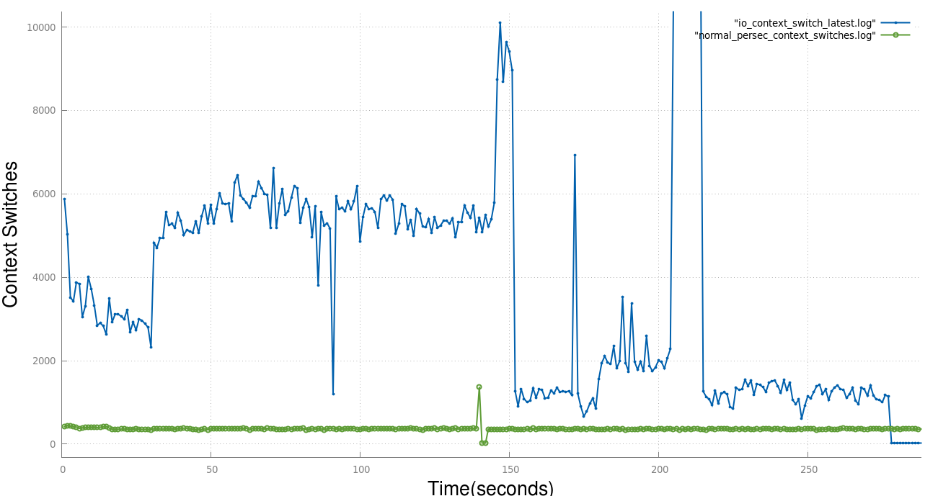
Graph zoomed showing context switches while Linux DC ++ is idle.
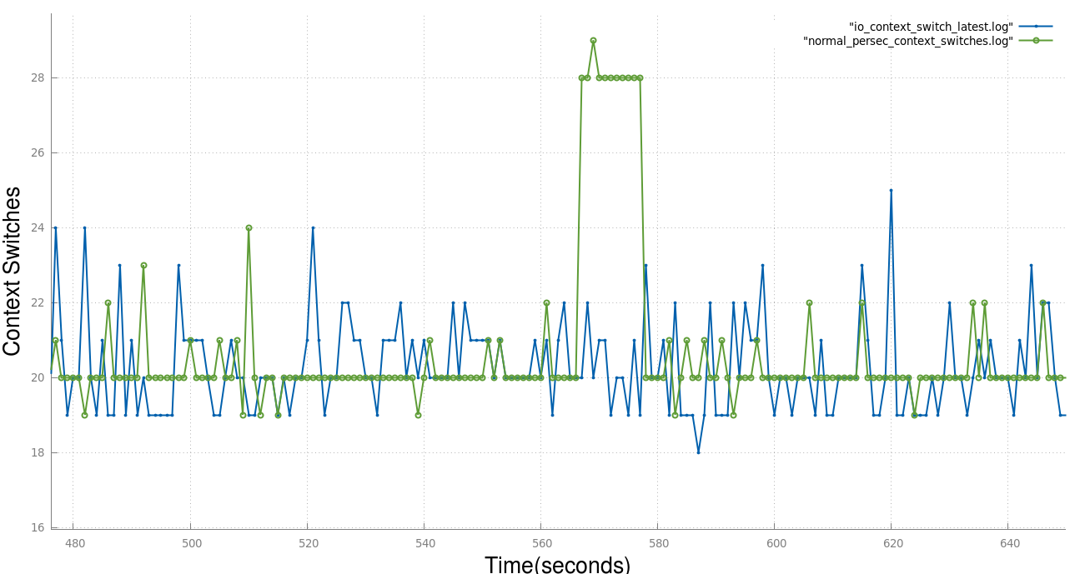.
CPU Utilization
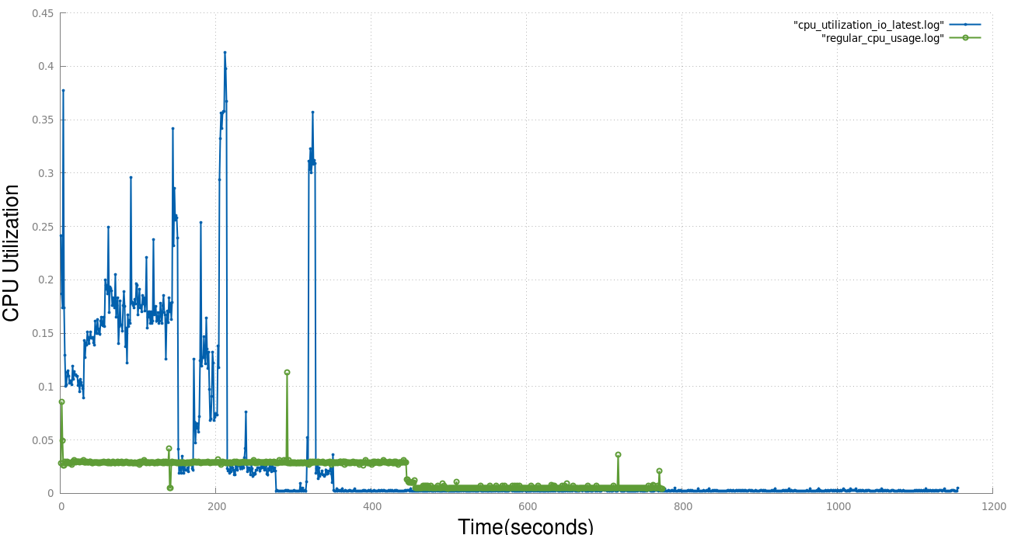
In the earlier half of the time period during which we either upload/download a file through Linux DC++ the CPU utilization is abnormally high in I/O intensive case whereas in the latter case where Linux DC ++ is idle the CPU utilization is very slightly better in regular case.
Deductions
In the earlier half the CPU utilization in I/O intensive case is much higher as compared to regular case because in I/O intensive case the 40 process which are used for increasing the I/O load of the system are not CPU intensive and are dumping buffered data from memory onto disc.Thus most of the CPU time is available to Linux DC ++ resulting in greater CPU utilization.
In the latter case ,as shown in previous cases due to Linux DC ++ being idle it does not use much of the CPU time resulting in a more or less the same result in both the cases.

Graph zoomed showing CPU Utilization while a file is being downloaded/uploaded.
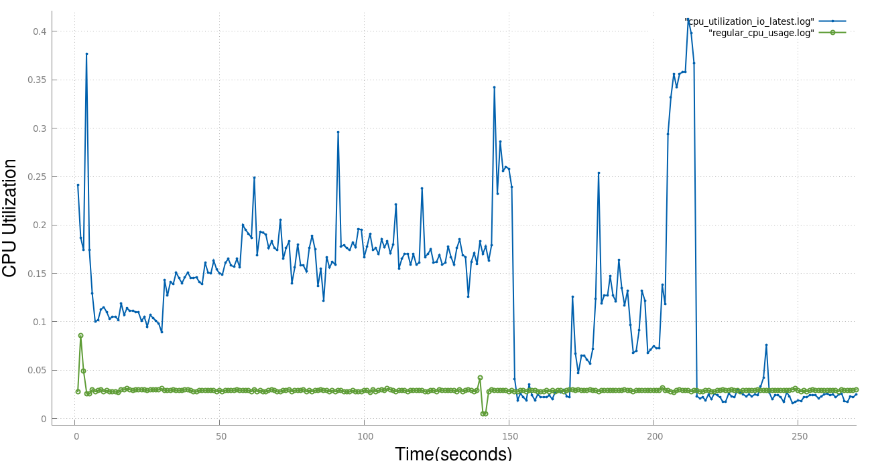
Graph zoomed showing CPU Utilization while Linux DC++ is idle
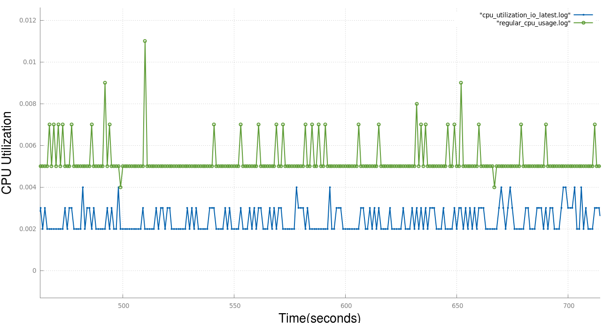
Performance Analysis
Bash command sort on various thresholds
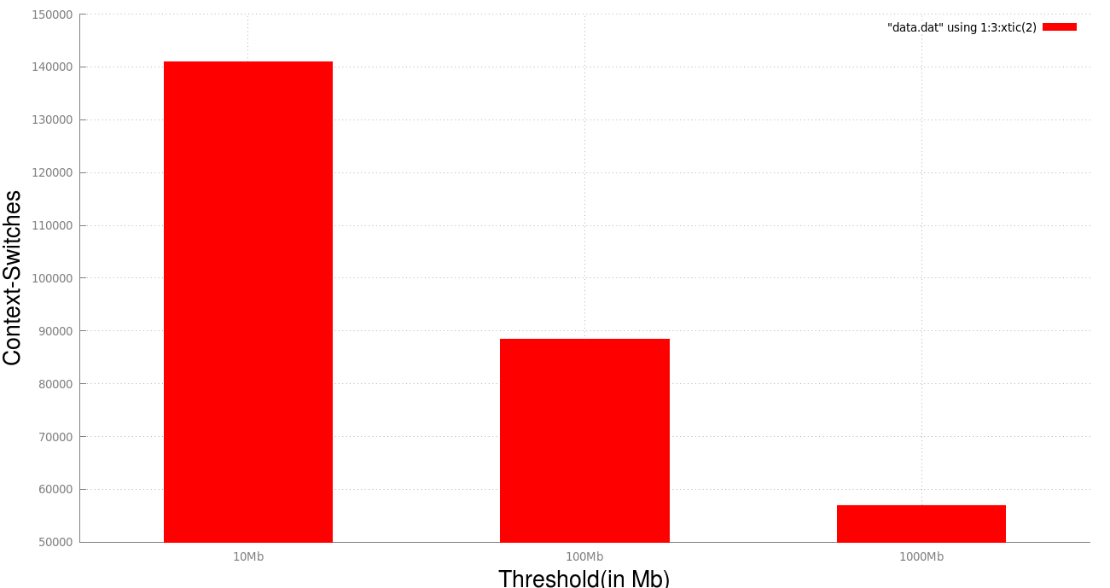

Performance analysis of bash sort command when used on a > 1Gb file
We apply the regular bash sort command to sort a 1.2Gb file.On profiling the above process we get the following results.

Performance counter stats for 'sort -n -T /media/droftware/New Volume1 numbers_gb.txt':

356534.263565 task-clock (msec) # 1.022 CPUs utilized
10,69,564 context-switches # 0.003 M/sec
16,796 cpu-migrations # 0.047 K/sec
1,23,773 page-faults # 0.347 K/sec
8,62,15,02,85,831 cycles # 2.418 GHz
5,04,83,53,09,185 stalled-cycles-frontend # 58.56% frontend cycles idle
<not supported> stalled-cycles-backend
11,47,33,81,40,845 instructions # 1.33 insns per cycle
# 0.44 stalled cycles per insn
2,44,87,09,65,782 branches # 686.809 M/sec
3,65,14,97,154 branch-misses # 1.49% of all branches

348.956544192 seconds time elapsed

Now we write a custom script which sorts the file recursively using merge sort.We split the file into two halves and sort the files recursively.Whenever the size of the file is below a specified threshold we sort the file directly using the bash sort command.
We run this script to sort a 1.2Gb file of random numbers and profile the process using perf stat.We ran the script on the same file for three different thresholds – 10Mb , 100Mb, 1000Mb.When we increase the threshold, we are indirectly decreasing the number of splits.

Performance:
We find that as we increase the threshold(i.e we decrease the number of splits) we get a gain in performance and the time taken to sort the numbers become smaller.
Why does this happen?
There are four parameters which are majorly responsible for the above consequence.
1.) Context Switches:

On profiling the three process for the same script having different threshold we find that as we decrease the threshold(i.e. we decrease the splitting) the number of context switches happening increases.This happens because as we decrease the threshold more number of process' are created by the shell so as to sort the files ,more number of process results in more number of context switches.Hence the cost incurred due to too much context switches adds to the total time resulting in a perfromace drop.

2.) CPU Migrations

As explained above as we decrease the threshold the number of process increases.This increase in the number of process' results in a greater number of hoppings from 1 CPU to another resulting in an increased overhead eventually leading to poor performance.
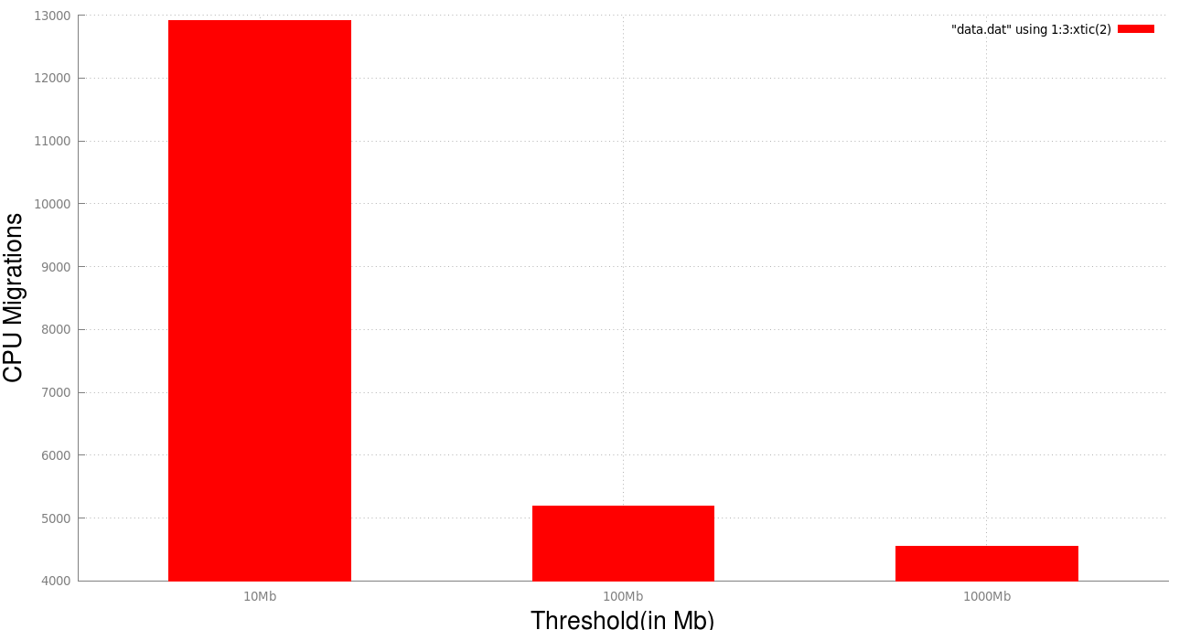

3.) Page faults
Here also due to an increase in number of process' the number of page faults increases leading to poor performance.

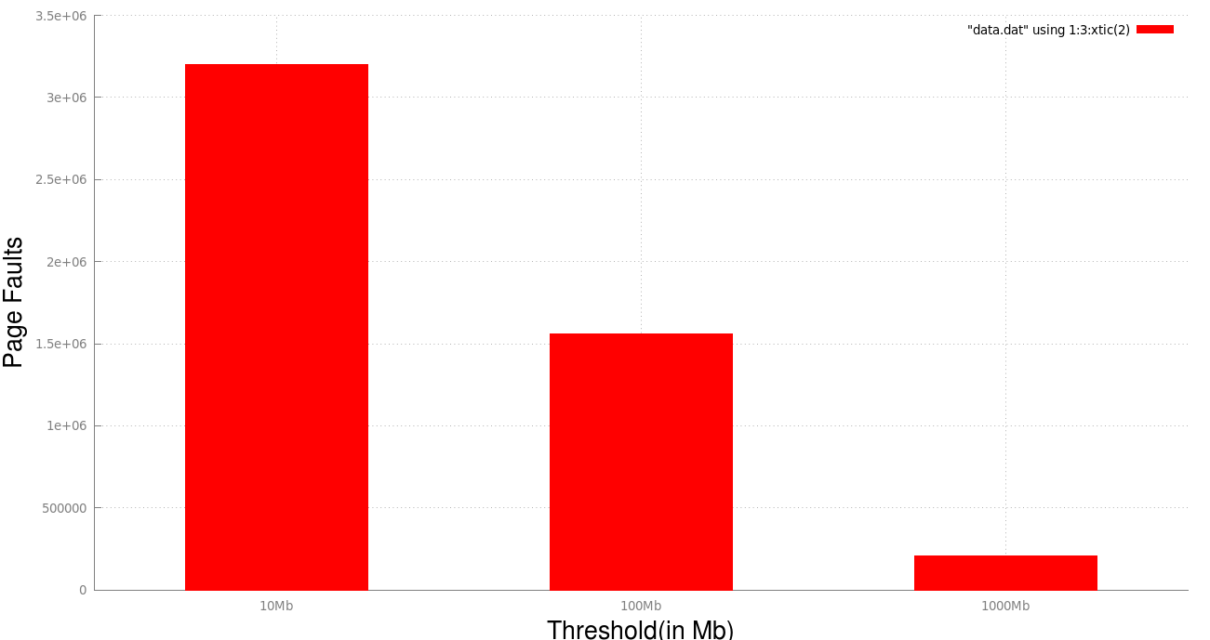

4.) CPU Utilization
Now one question arises that if we are getting a better performance with decreasing threshold we should get the best performance with the regular sort.However it is not the case and we find that in our scenario our merge script with 1000Mb threshold outperforms the regular sort command.
Why does this happen ?
When our threshold is 1000Mb the overall number of splits made by the script is two.Hence our script sorts the file using two separate process running there own instances of sort command.Since the test computer has two cores ,this results in a better CPU utilization and hence a better performance in case of merge sort script with two splits as compared to regular bash sort command.

Following are the profiling results on three different thresholds.
1.) Threshold = 10Mb

Performance counter stats for 'python sort_script.py numbers_gb.txt':

364861.478436 task-clock (msec) # 0.788 CPUs utilized
1,40,924 context-switches # 0.386 K/sec
12,906 cpu-migrations # 0.035 K/sec
32,01,964 page-faults # 0.009 M/sec
8,83,08,36,11,222 cycles # 2.420 GHz
4,75,57,23,31,747 stalled-cycles-frontend # 53.85% frontend cycles idle
<not supported> stalled-cycles-backend
12,92,87,75,15,538 instructions # 1.46 insns per cycle
# 0.37 stalled cycles per insn
2,73,97,11,19,231 branches # 750.891 M/sec
3,37,29,64,177 branch-misses # 1.23% of all branches

462.940604203 seconds time elapsed

2.) Threshold = 100Mb
Performance counter stats for 'python sort_script.py numbers_gb.txt':

358875.087959 task-clock (msec) # 0.796 CPUs utilized
88,369 context-switches # 0.246 K/sec
5,192 cpu-migrations # 0.014 K/sec
15,59,639 page-faults # 0.004 M/sec
8,78,12,55,63,877 cycles # 2.447 GHz
4,91,07,00,35,835 stalled-cycles-frontend # 55.92% frontend cycles idle
<not supported> stalled-cycles-backend
12,30,86,74,48,285 instructions # 1.40 insns per cycle
# 0.40 stalled cycles per insn
2,61,30,14,95,703 branches # 728.113 M/sec
3,37,76,80,444 branch-misses # 1.29% of all branches
451.042212274 seconds time elapsed

3.) Threshold = 1000Mb
Performance counter stats for 'python sort_script.py numbers_gb.txt':

334904.626228 task-clock (msec) # 1.165 CPUs utilized
56,999 context-switches # 0.170 K/sec
4,555 cpu-migrations # 0.014 K/sec
2,09,322 page-faults # 0.625 K/sec
8,10,38,00,88,908 cycles # 2.420 GHz
4,56,33,06,70,256 stalled-cycles-frontend # 56.31% frontend cycles idle
<not supported> stalled-cycles-backend
11,30,74,96,48,667 instructions # 1.40 insns per cycle
# 0.40 stalled cycles per insn
2,41,04,78,83,837 branches # 719.751 M/sec
3,49,95,96,521 branch-misses # 1.45% of all branches

287.392998282 seconds time elapsed

OS
Performance Comparison
Concurrent merge sort and Regular merge sort
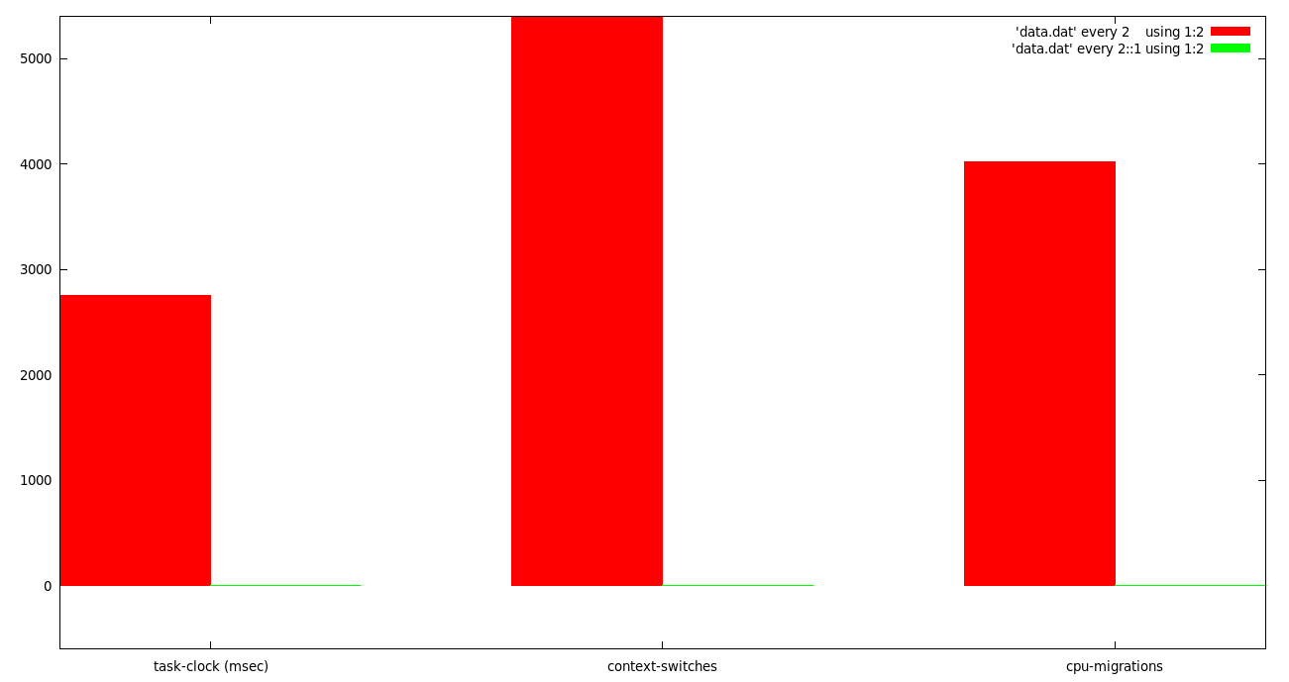
Red: Concurrent merge sort Green: Regular merge sort (Notice the green lines,these are actually bars showing task-clock,context-switches and cpu-migration of the regular merge sort as compared to concurrent merge sort which is shown by red.The difference is in the magnitude of thousands resulting in a huge overhead incurred by concurrent merge sort.)
Concurrent merge sort using shared memory
This version of quick sort recursively sorts the array of numbers.At each call it splits the array of numbers into two sub arrays ,it recursively sorts these two subarray using two separate forked child process' and then merges the two subarrays.If the array has less than 5 numbers it sorts using selection sort.

Results of profiling using perf stat(when sorting 1000 numbers)

2748.490601 task-clock (msec) # 2.266 CPUs utilized
5,562 context-switches # 0.002 M/sec
4,019 cpu-migrations # 0.001 M/sec
1,62,754 page-faults # 0.059 M/sec
6,79,49,19,746 cycles # 2.472 GHz
5,78,34,02,263 stalled-cycles-frontend # 85.11% frontend cycles idle
<not supported> stalled-cycles-backend
2,16,71,27,783 instructions # 0.32 insns per cycle
# 2.67 stalled cycles per insn
45,87,41,823 branches # 166.907 M/sec
1,02,06,064 branch-misses # 2.22% of all branches
1.213050419 seconds time elapsed

Regular Merge Sort
It sorts numbers using regular merge sort algorithm.
Results of profiling using perf stat(when sorting 1000 numbers)

Performance counter stats for './regular_merge_sort':
0.565447 task-clock (msec) # 0.716 CPUs utilized
2 context-switches # 0.004 M/sec
0 cpu-migrations # 0.000 K/sec
52 page-faults # 0.092 M/sec
13,96,489 cycles # 2.470 GHz
6,87,166 stalled-cycles-frontend # 49.21% frontend cycles idle
<not supported> stalled-cycles-backend
16,32,410 instructions # 1.17 insns per cycle
# 0.42 stalled cycles per insn
2,70,789 branches # 478.894 M/sec
12,669 branch-misses # 4.68% of all branches
0.000789566 seconds time elapsed

Deductions
I had the intuition that the concurrent-shared memory mergesort sort will overperform the regular merge sort but the results have shown that its just the reverse which is true. The profiling results clearly show that our plain old regular quick sort has overperformed the concurrent-shared quick sort by a vast margin.
The concurrent-shared memory mergesort sort was using recursively creating two process and was sorting the subarray using these created process with the hope of getting performance gains due to multitasking.Also it was using selection sorting so as avoid overhead due to recursions when the numbers were less.In Spite of all such tweaks and modifications the concurrent version performs underperforms the regular merge sort by a magnitude of a few thousands.
The reason for this is that the tweaks which were applied so as improve performance actually backfired.At each recursive call 2 new child process were created due to which a great many process were made overall for sorting the numbers.Such a large number of process resulted in a large number of context switches,cpu migrations,page faults which overshadowed any little performance gain which might have been obtained due to multiprocessing.In contrast, the regular merge sort which inspite of not benefitting from any multiprocessing had literally no overhead due to context switches,cpu migrations,page faults all these were nearly non existant due to a single process doing the sorting work.
Notice that the overhead incurred by concurrent merge sort was very huge(in the magnitude of thousands) as compared to rgsular merge sort resulting a terrible performance.

