**Final Year B.Tech. (CSE) – I : [ 2022-23 ]**

**5CS462 : PE5 Data Mining Lab**

**PRN/ Roll No: 2019BTECS00113**

**Full name: Sanket Rajaram Mote**

**Batch: B8**

**Assignment No. 1**

**Title: Data Analysis Tool (GUI)**

**Objective:**

1. To Calculate and show the measures of central tendency for uploaded data : mean ,median , mode , midrange , variance and standard deviation

2. To Calculate and show the dispersion of data : range , quartiles , interquartile range, five-number summary

3. To Graphical display of above calculated statistical description of data (provide the facility - UI form to choose different attributes from uploaded data set) : a. Quantile plot b. Quantile-quantile (q-q) plot c. Histogram d. Scatter plot e. Boxplot

**Introduction & Theory:**

**Measures of Central Tendency :   
1. Mean :** add up the values in the data set and then divide

by the number of values that you added.

**2. Median** : list the values of the data set in numerical order and

identify which value appears in the middle of the list. To find the

mode, identify which value in the data set occurs most often.

**3. Mode :** To identify which value in the data set occurs most often

**4. Midrange :** the number that is exactly halfway between the minimum and maximum numbers in a set of data.

**5. Variance** : It is a measure of dispersion that takes into account the spread of all data points in a data set.

**6. standard deviation** : It Is providing a measure of variability in a

sample or population.

**Procedure / Experiment:**

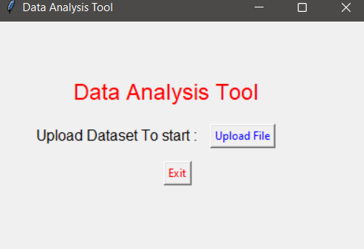

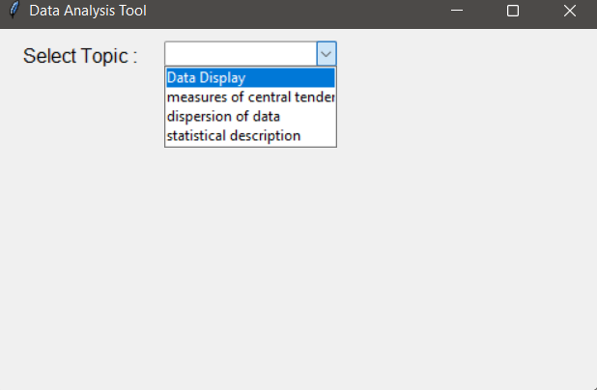

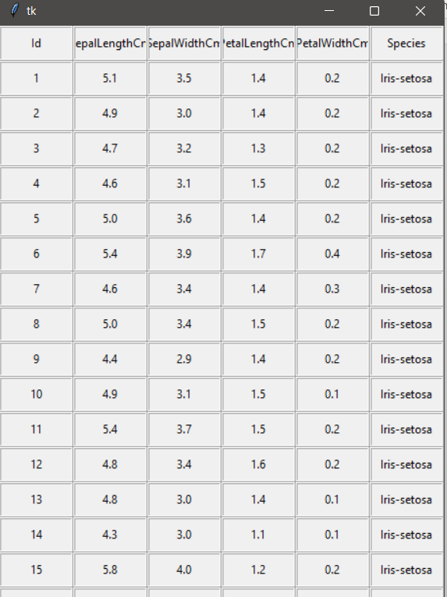

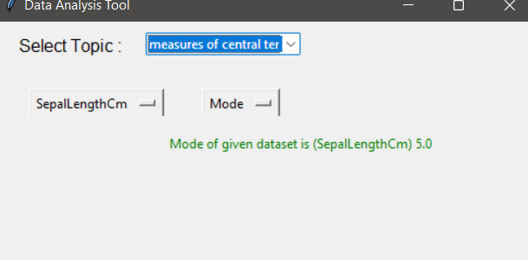

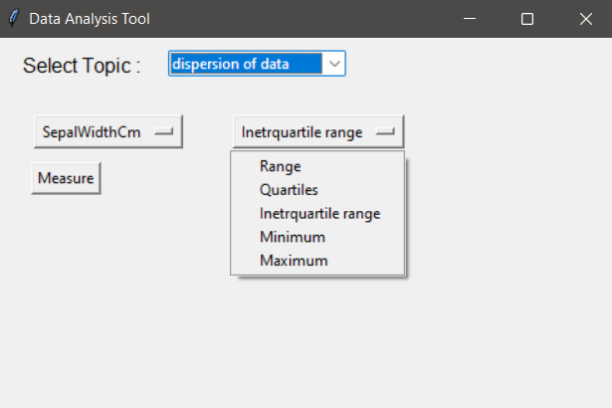

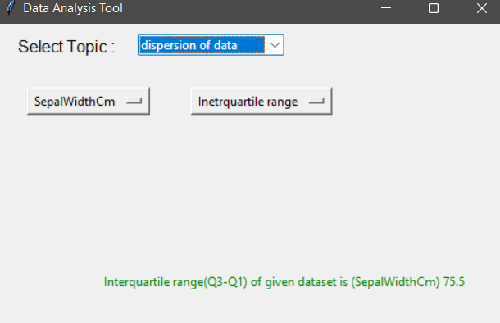

**Conclusion:**

Successfully Calculated and show the measures of central

tendency for uploaded data : mean ,median , mode ,

midrange , variance and standard deviation and displayed

using GUI

**References:**

[**https://www.analyticsvidhya.com/blog/2021/04/dispersion-of-data-range-iqr-variance-standard-deviation/**](https://www.analyticsvidhya.com/blog/2021/04/dispersion-of-data-range-iqr-variance-standard-deviation/)

**Dataset:**

[**https://archive.ics.uci.edu/ml/datasets/Iris**](https://archive.ics.uci.edu/ml/datasets/Iris)