**Walchand College of Engineering, Sangli**

**Department of Computer Science and Engineering**

**Third Year – Programming Laboratory-3 (2021-22)**

**PRN: 2019BTECS00113.**

**NAME: Sanket Mote.**

**Practical No. 3 To study web browser and its Developer Tools option.**

1. **Problem Statement 1:**

**Install different web browsers on your machine. Go through the Developer Tools option of the browser.**

**Ans -**

1. Chrome –

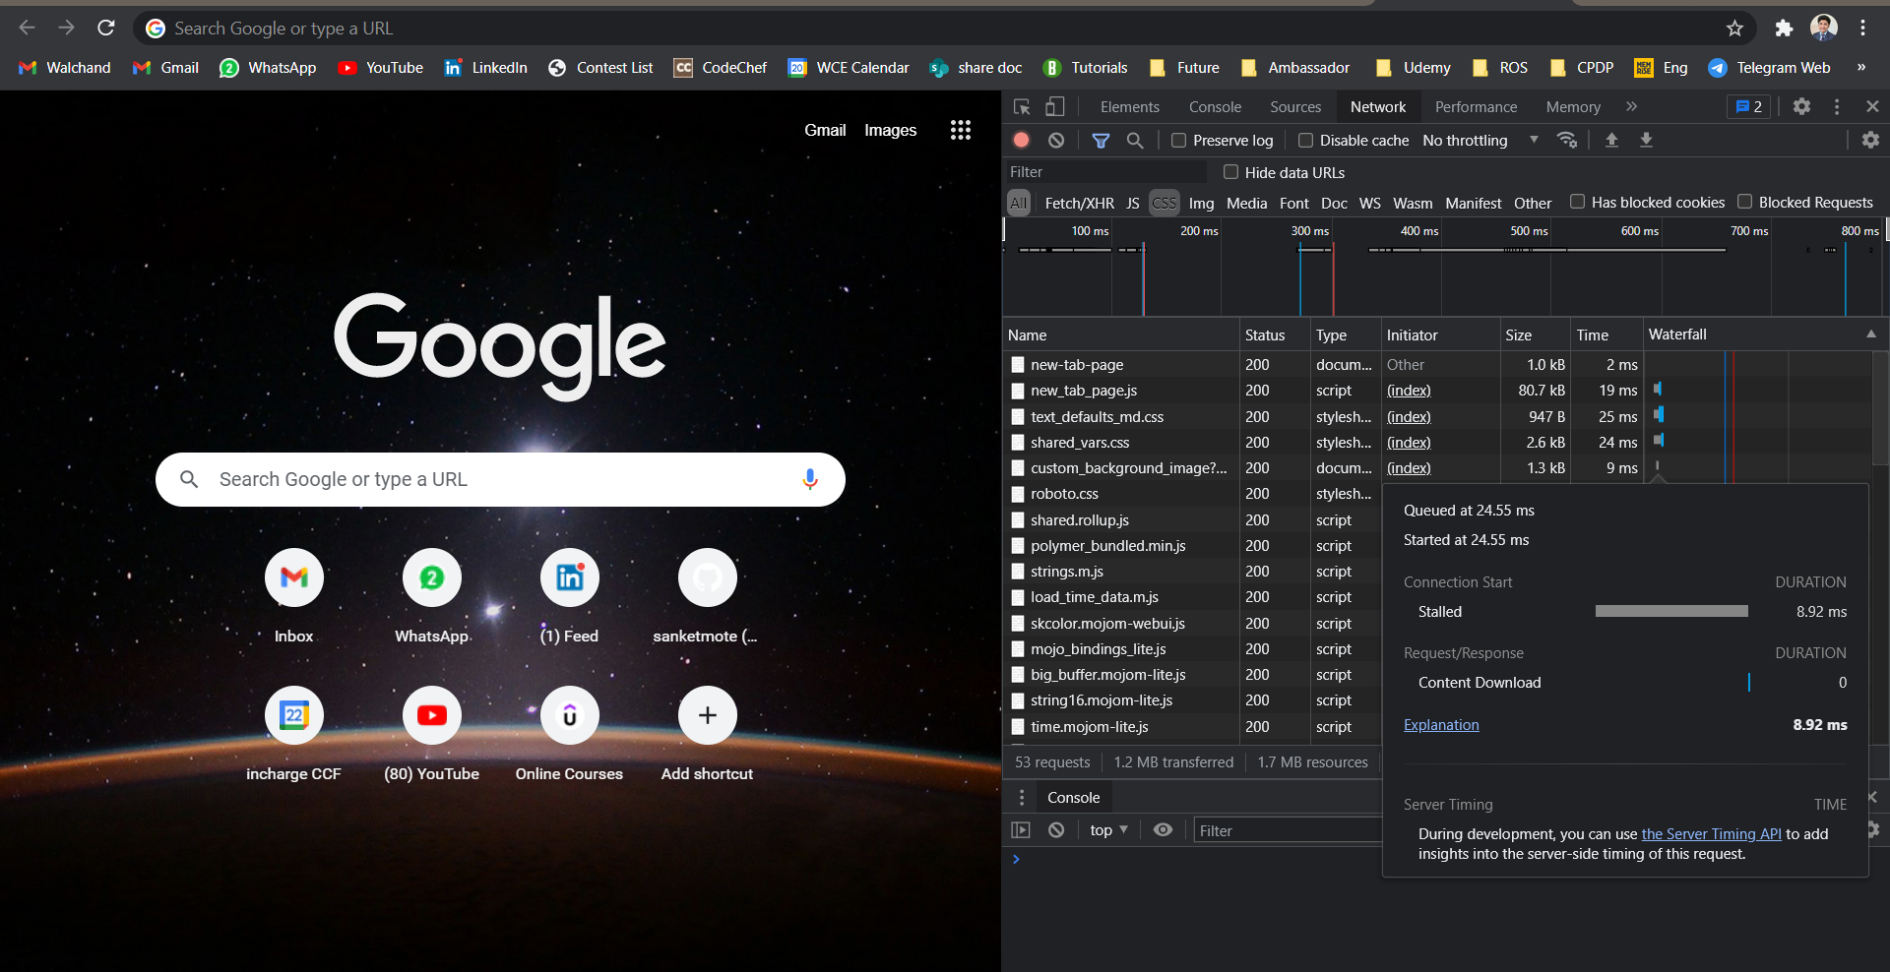

1. Brave –

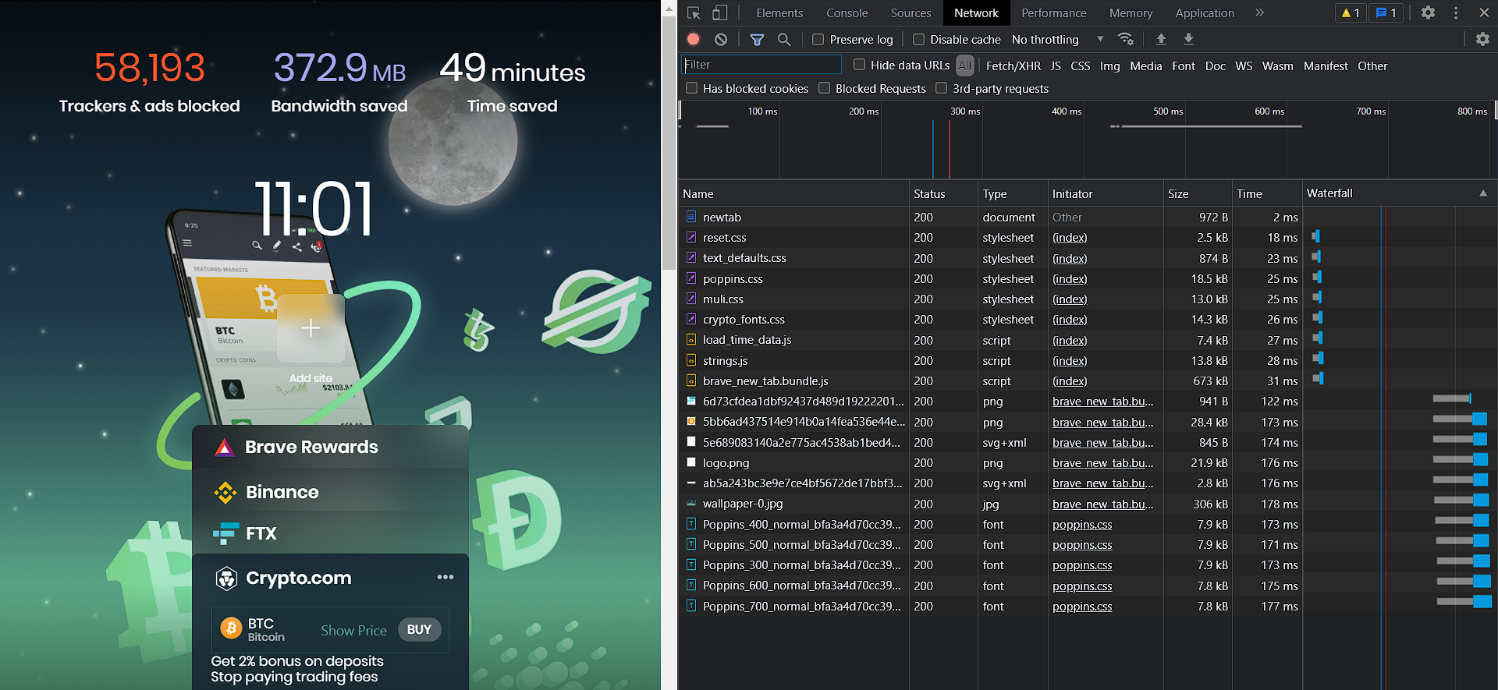

1. Edge –

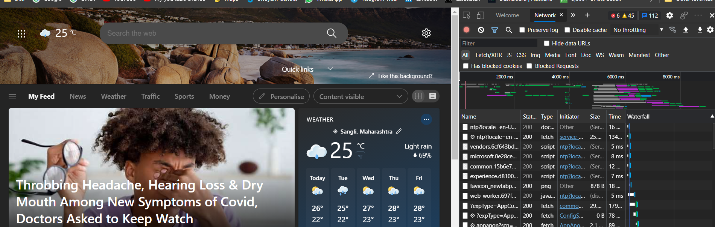

1. **Problem Statement 2:**
2. **Visit https://en.wikipedia.org/wiki/Computer_science on various browsers.**
   1. **On Chrome –**

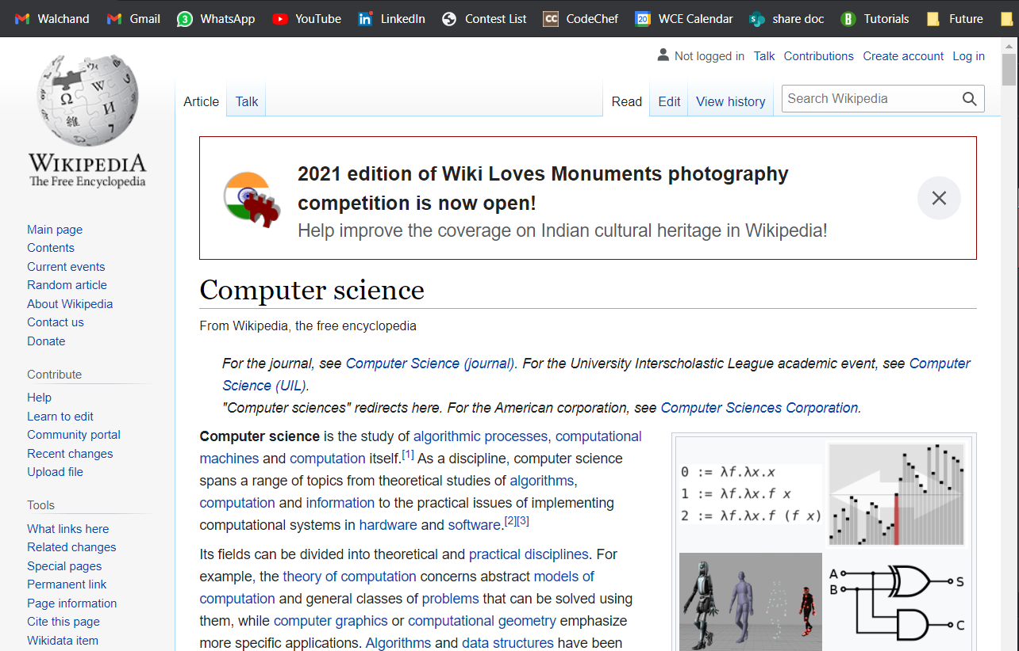

* 1. **On Brave –**

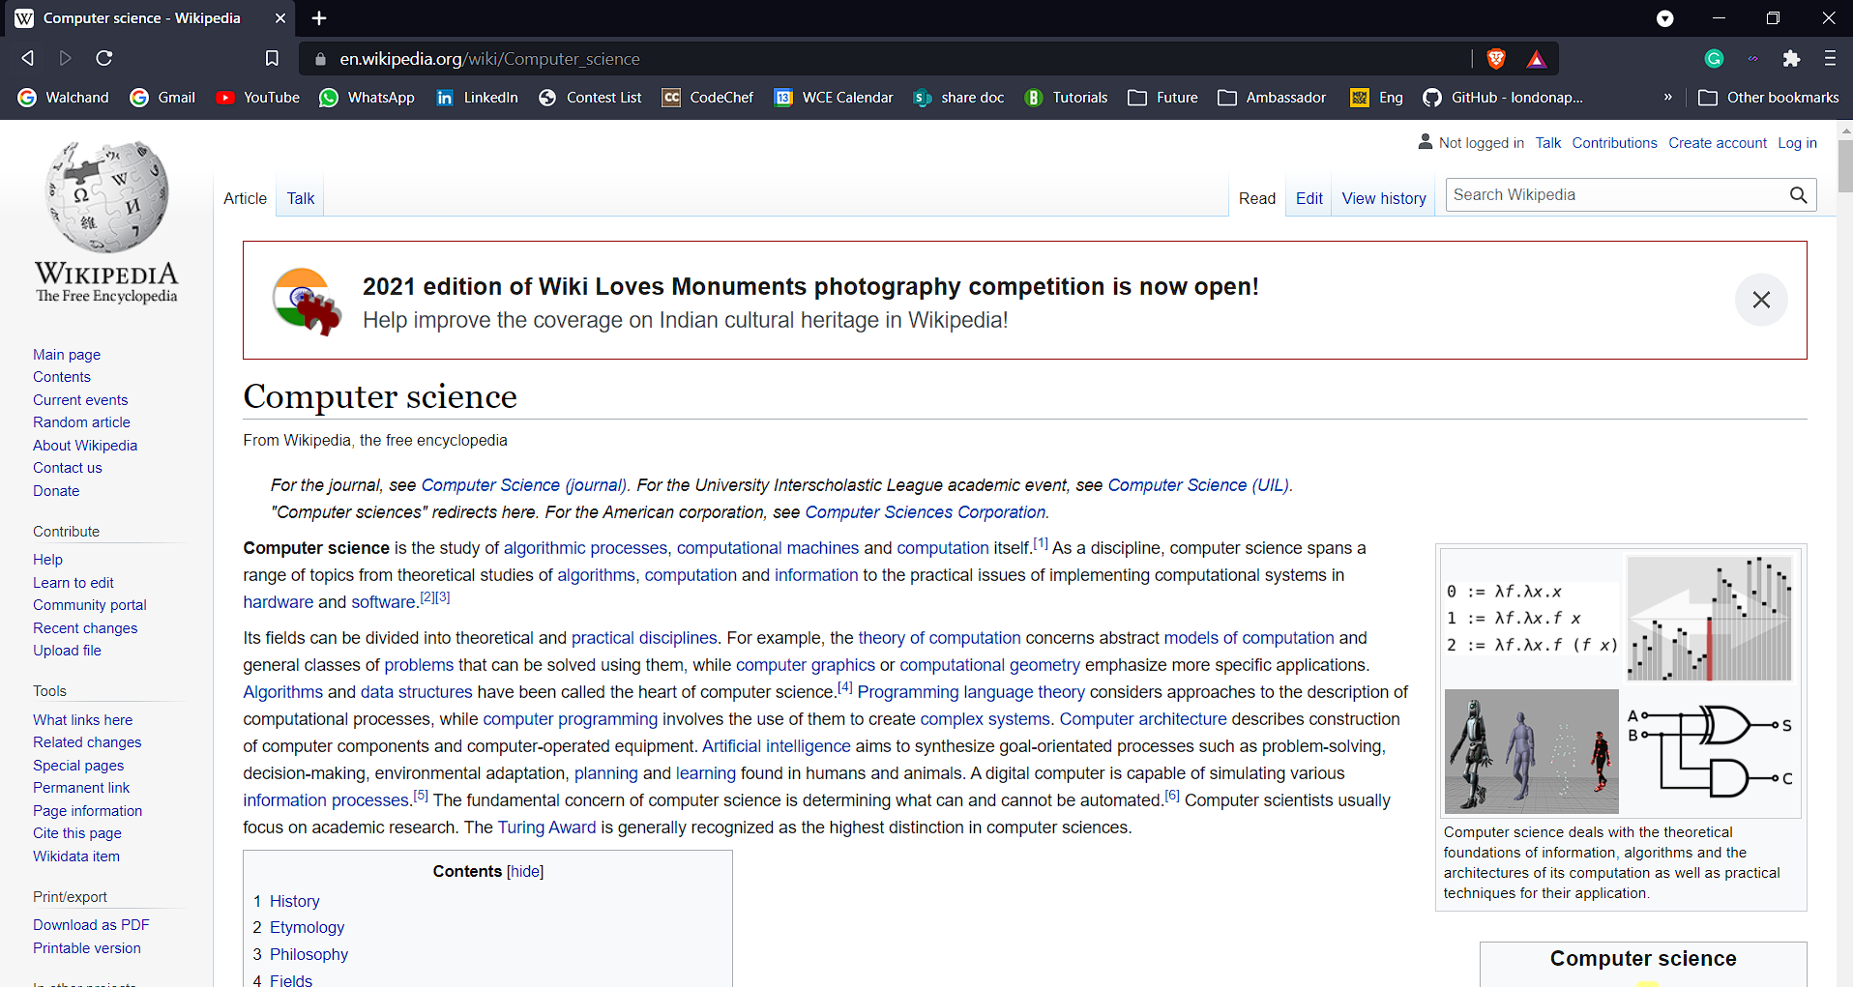

* 1. **On Edge –**

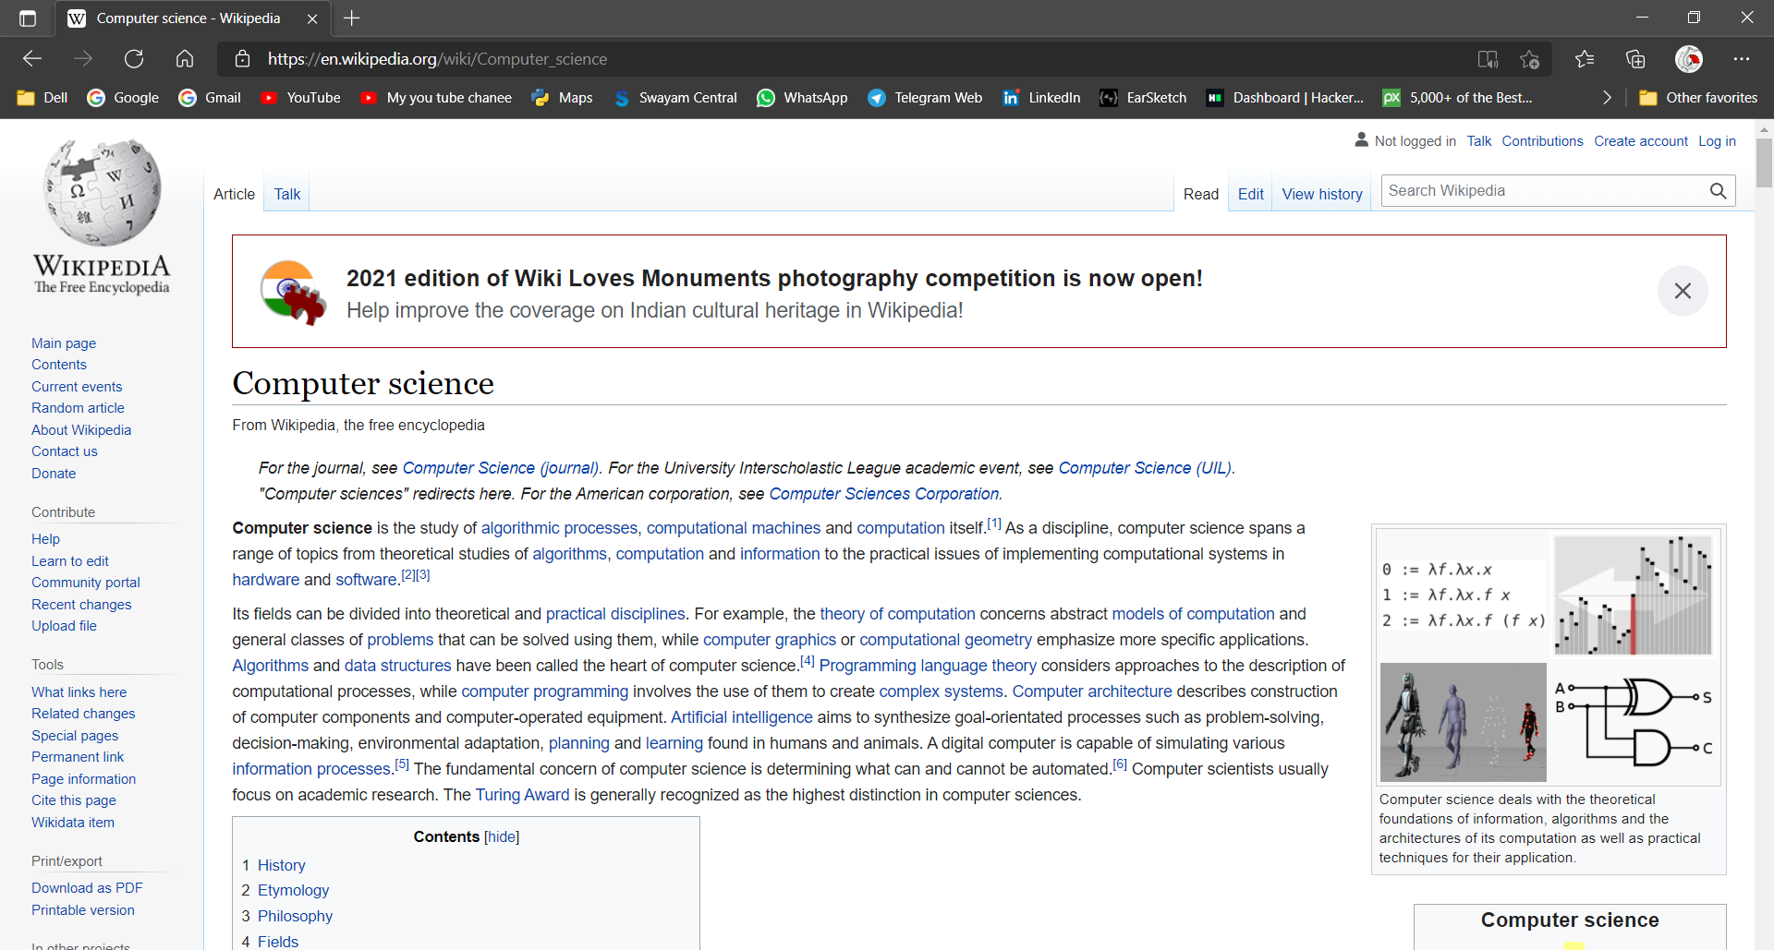

1. **Using browser’s Developer Tools option find out how many requests-response cycles are needed to load the page fully on your machine?**

**Ans:**

Total **116** requests-response cycles are needed to load the page fully on Chrome.

Total **263** requests-response cycles are needed to load the page fully on Brave.

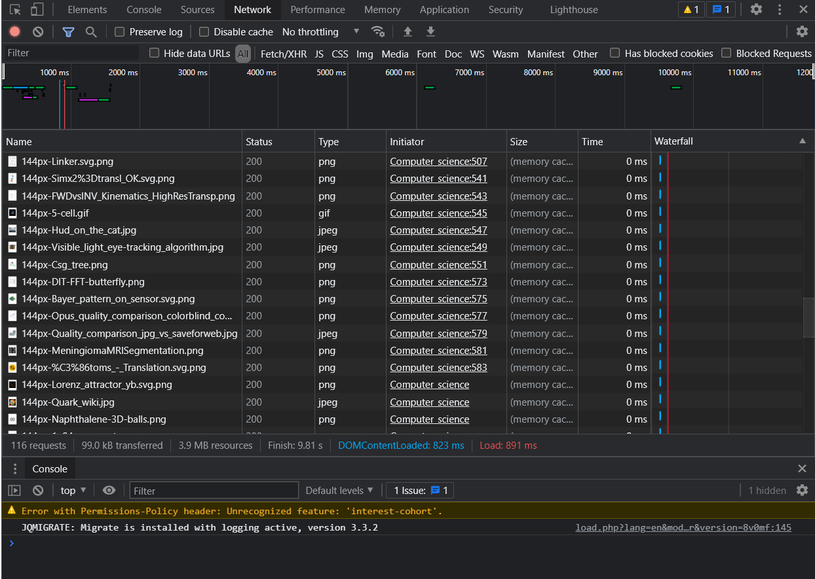

1. **Using browser’s Developer Tools option get the header information of the page.**

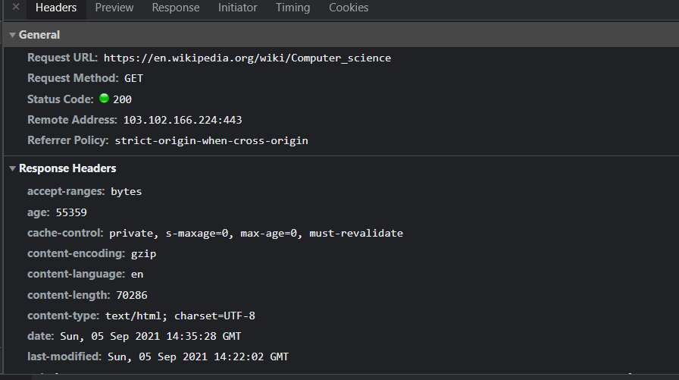

1. **Using browser’s Developer Tools option go through the DOM, CSS editor and JavaScript debugger options.**

DOM –

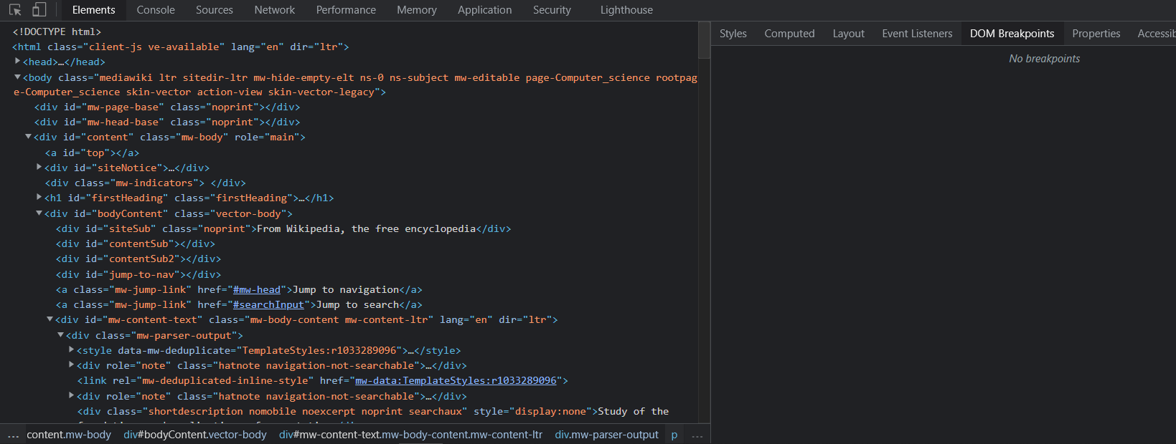

CSS editor –

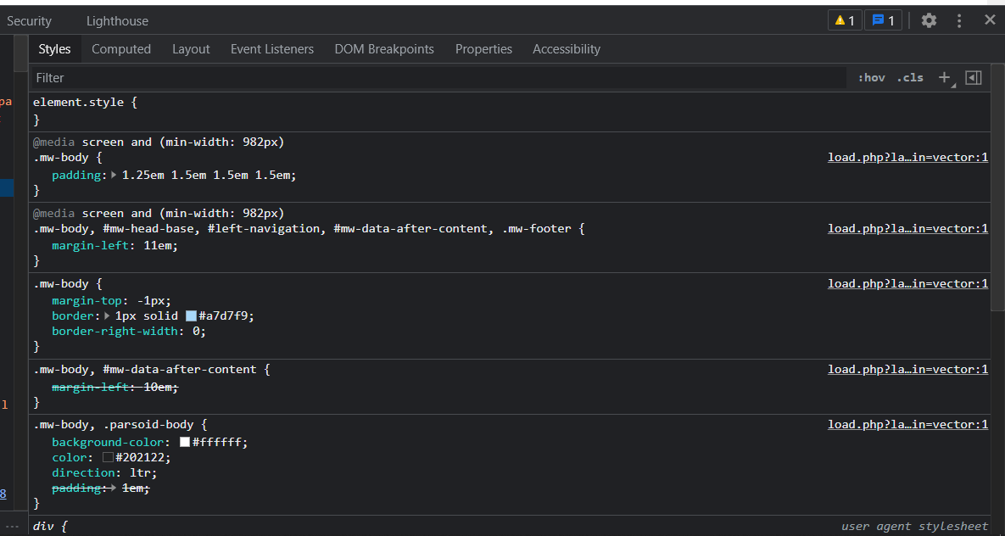

JavaScript [t Debugger -

