**Third Year B. Tech., Sem V 2021-22**

**Programming Lab 3**

**Assignment / Journal submission**

**PRN/ Roll No: 2019BTECS00113**

**Batch: T5**

**Title of assignment: To create a Node.js HTTP server and REPL Commands.**

**1. Create a separate workspace for your project using selected IDE.**

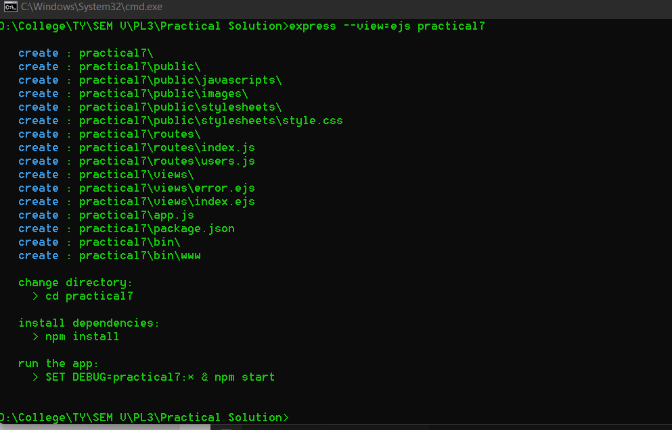

**2. Write a program to start a Node.js server on localhost and listens to the client requests on port number 3000.**

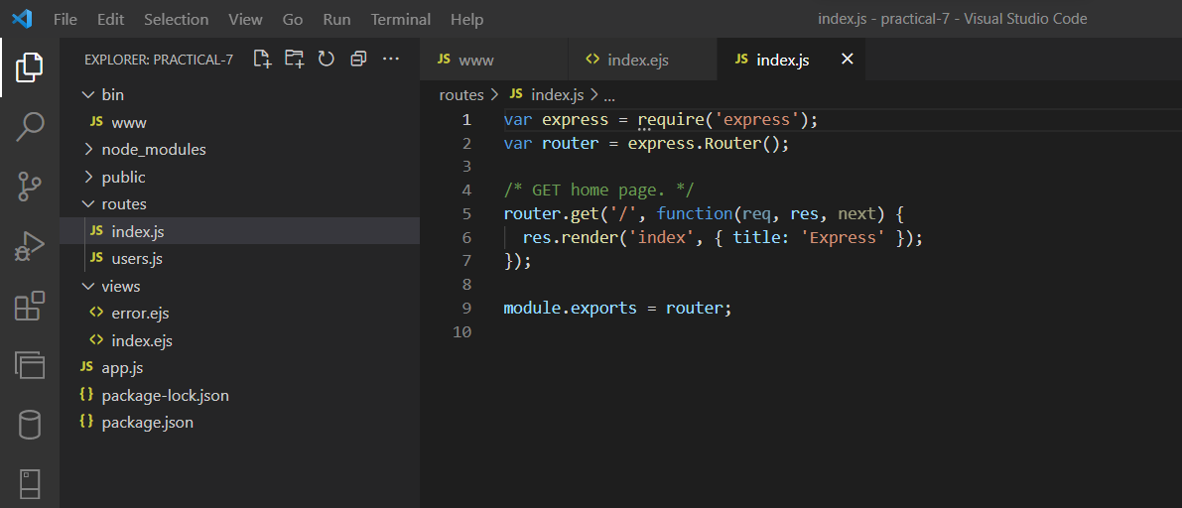

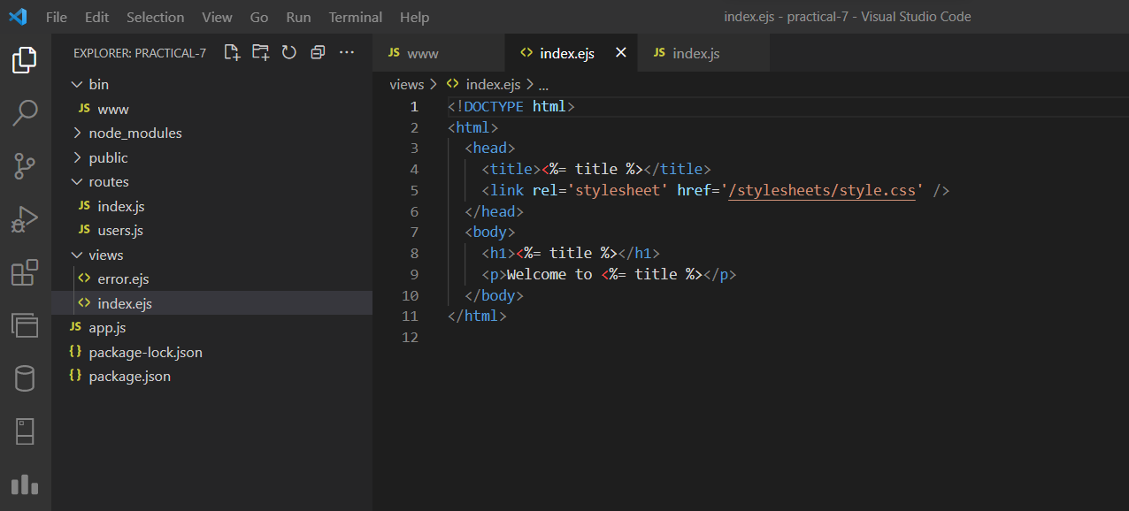

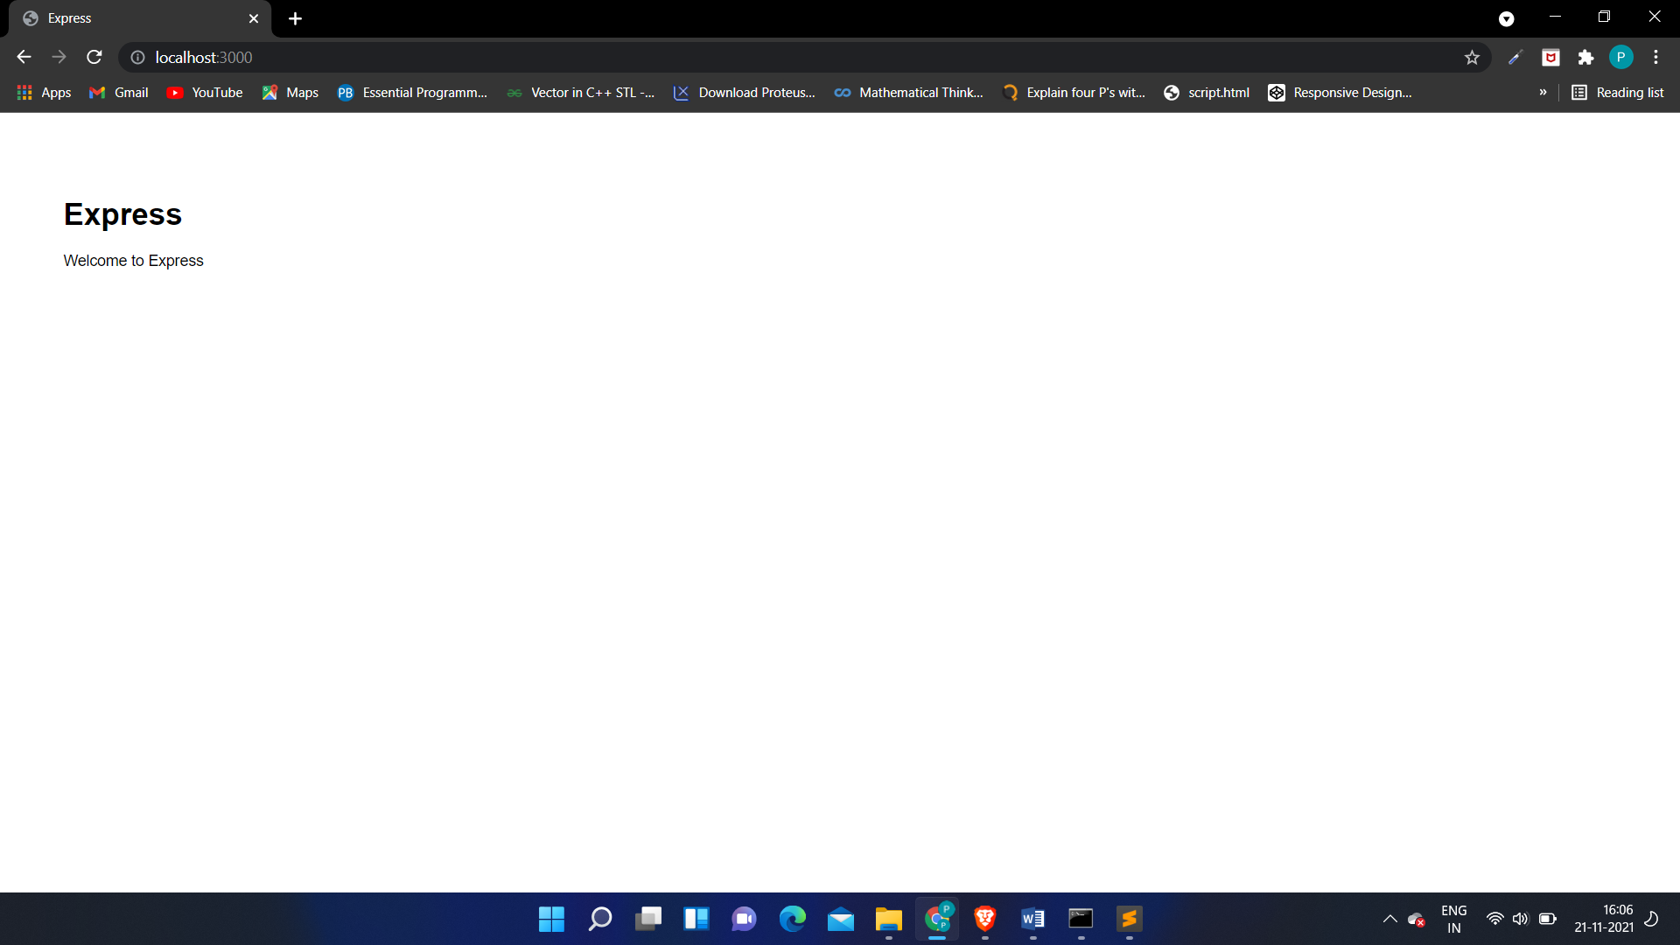

**3. Change the Node.js IP address and port number and start the server again.**

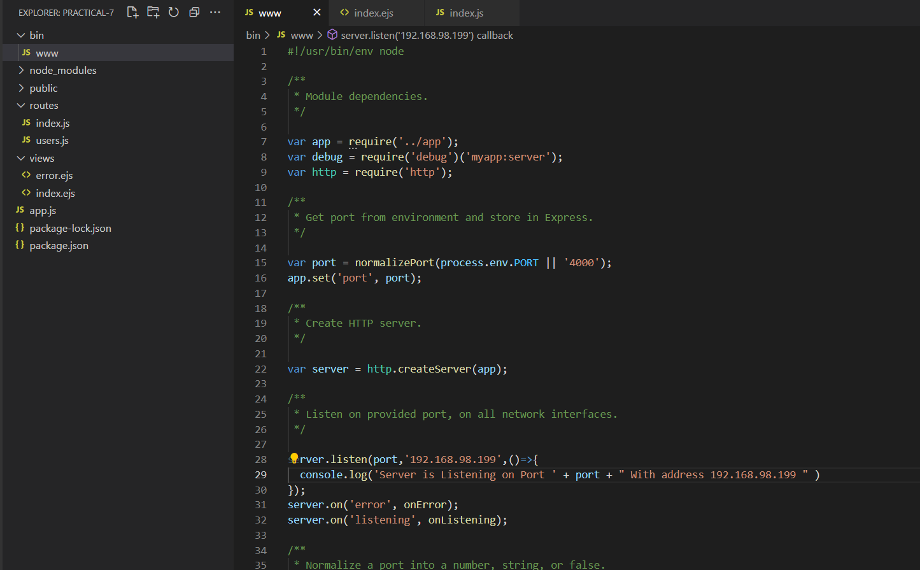

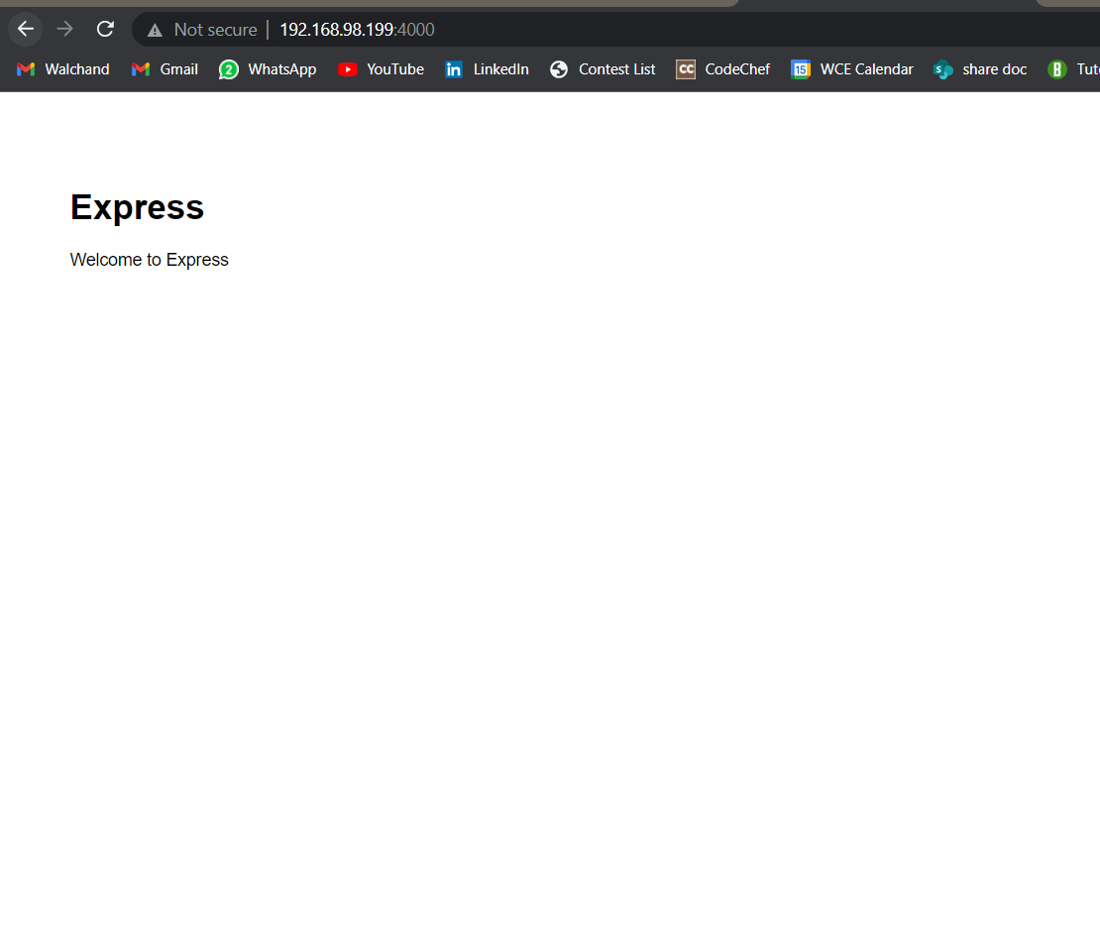

**Problem Statement 2:**

1. **Perform the fundamentals programming constructs such as operations, loops, variable assignments and printing their values using Node.js REPL environment.**

**2.Save the REPL session to a file and reload the REPL session.**

