**Third Year B. Tech., Sem V 2021-22**

**Programming Lab 3**

**Assignment / Journal submission**

**PRN/ Roll No: 2019BTECS00113**

**Batch: T5**

**assignment no 8: To use pre-built and user defined modules in Node.js Application**

**1. With the help of suitable examples use following Node.js pre-built modules in Node.js Application.**

**A. File System Module (fs)**

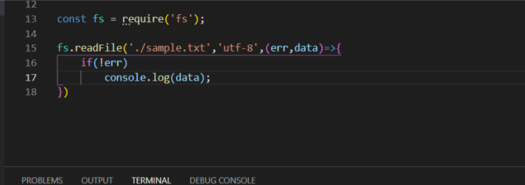

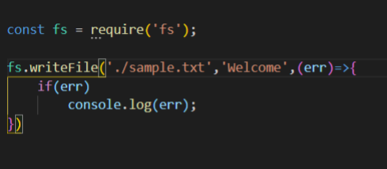

**Output ->**

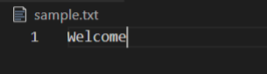

**B. Secure HTTP Module (https)**

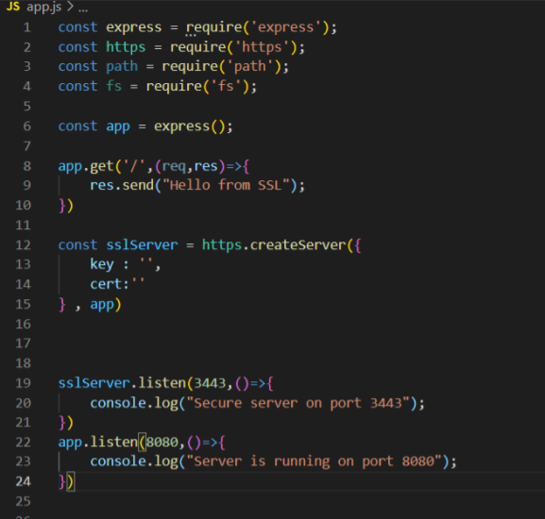

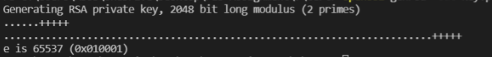

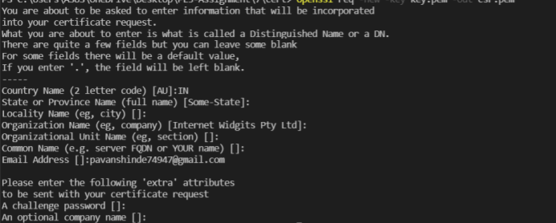



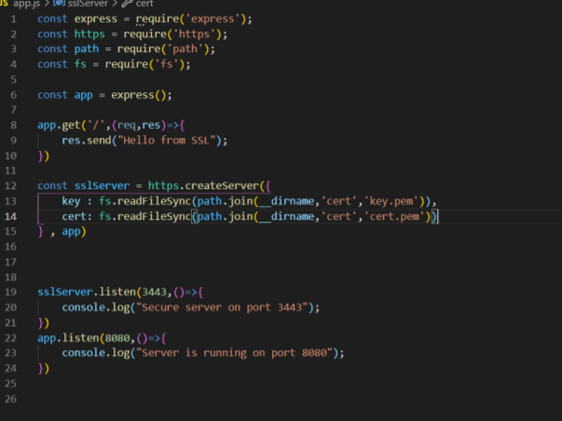

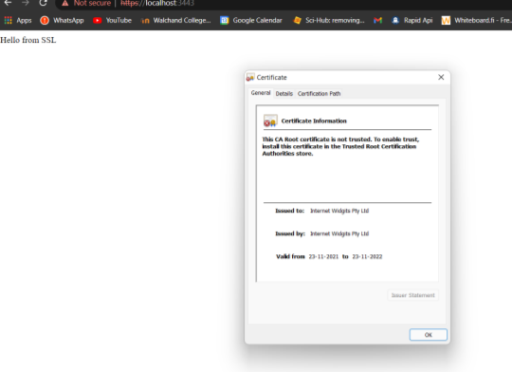

**C. Nodemailer Module (nod emailer)**

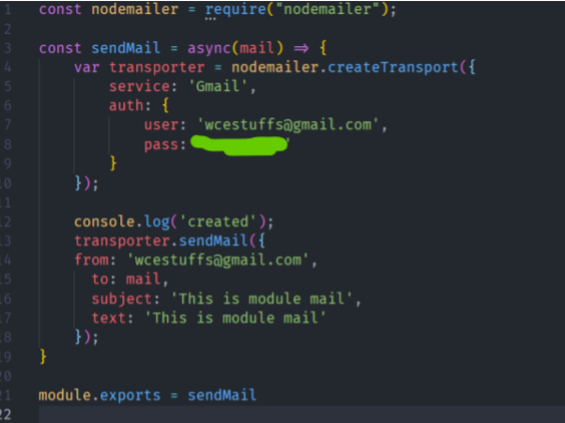

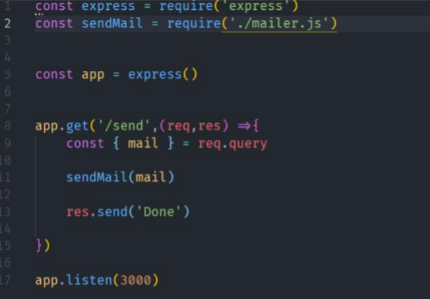

Email from http server -

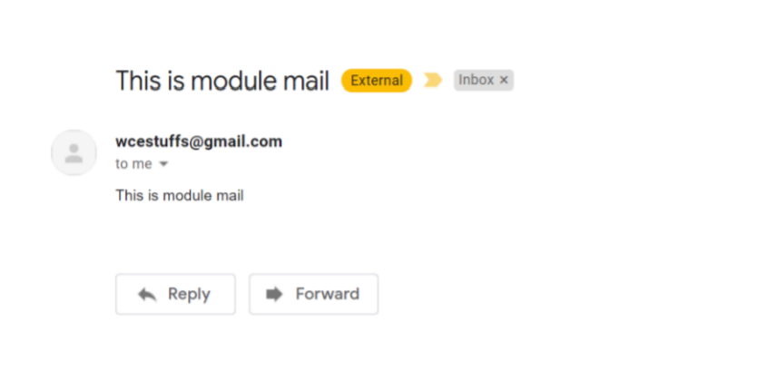

**2. Create a user defined module and use it in Node.js Application that uses HTTP server**



