**Walchand College of Engineering, Sangli**

**Department of Computer Science and Engineering**

**Third Year – Programming Laboratory-3 (2021-22)**

**PRN: 2019BTECS00113**

**NAME: SANKET RAJARAM MOTE**

**Practical No. 4: To install and configure a Web Server.**

**Problem Statement 1:**

1. **Install a web server on your machine. Run the server locally.**

**ANS:**

1. **Download –**

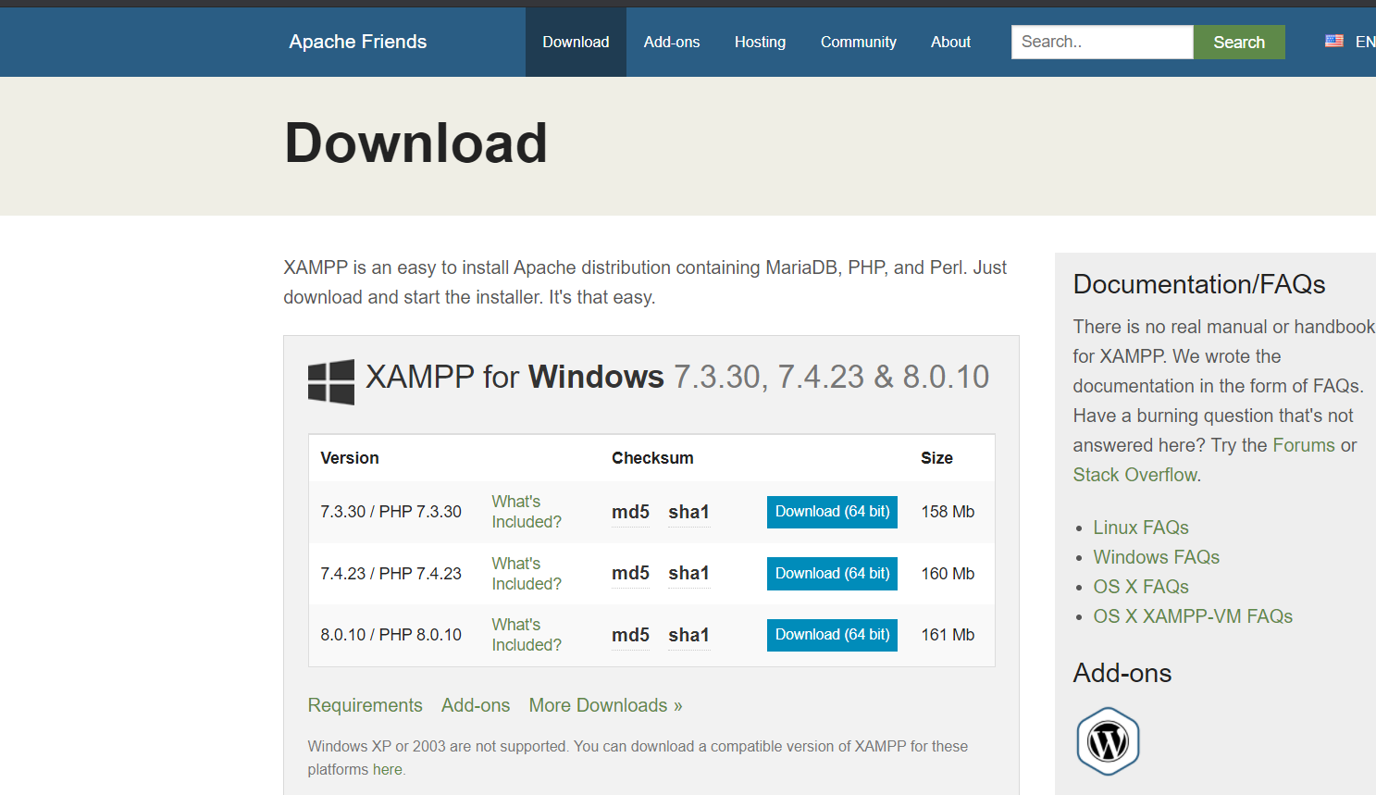

1. **Install –**

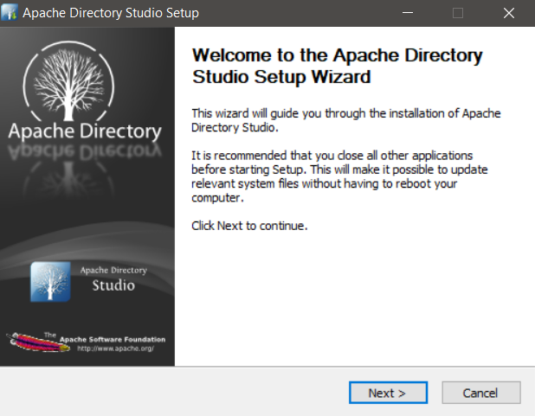

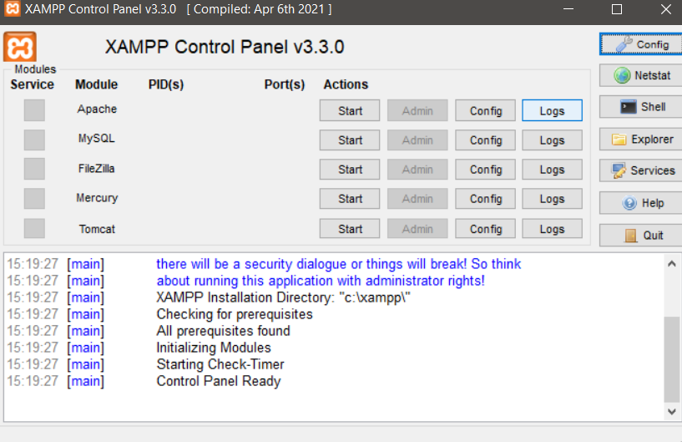

1. **Running Server –**

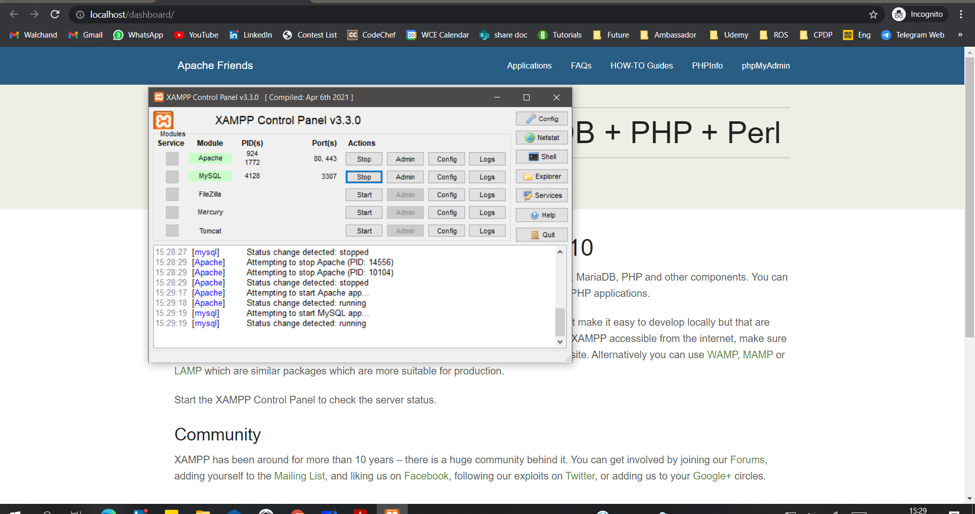

1. **Locate and study its configuration file.**

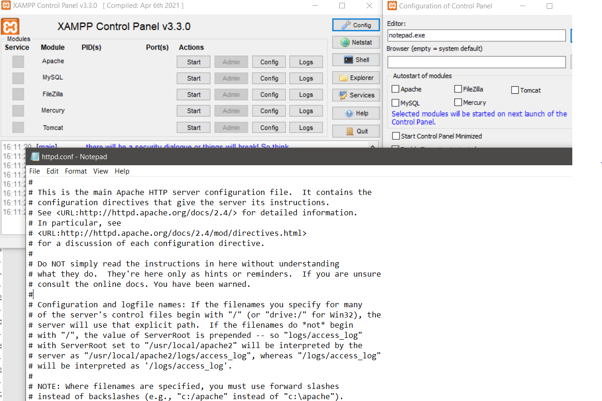

1. **Change the port number in the configuration file to any other valid port number. Rerun the server locally using newly assigned port number.**

**ANS:**

* 1. **Old port number –**

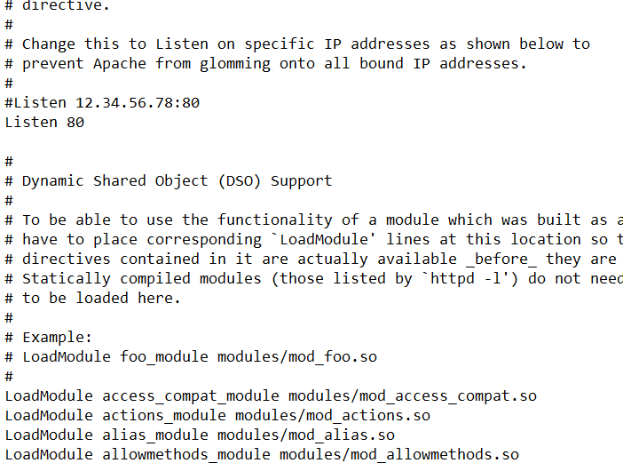

* 1. **New Port Number –**

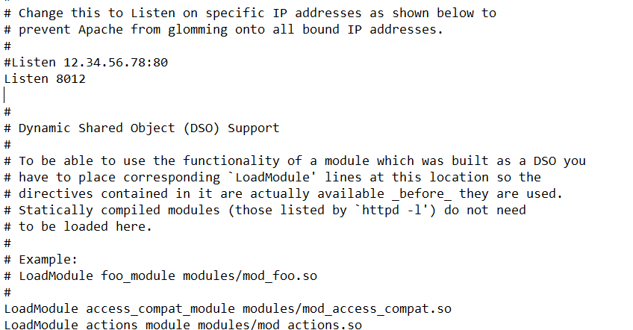

* 1. **Old SSL port –**

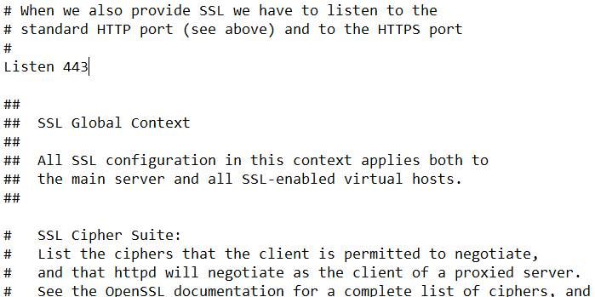

* 1. **New SSL port –**

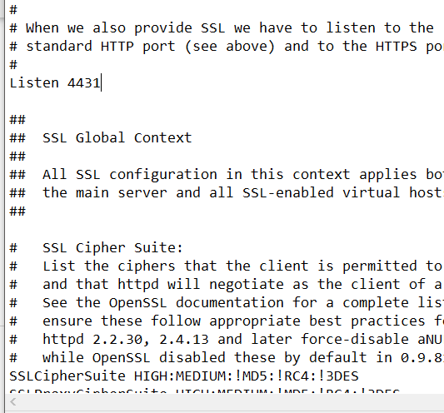

* 1. **Running server with new port number –**

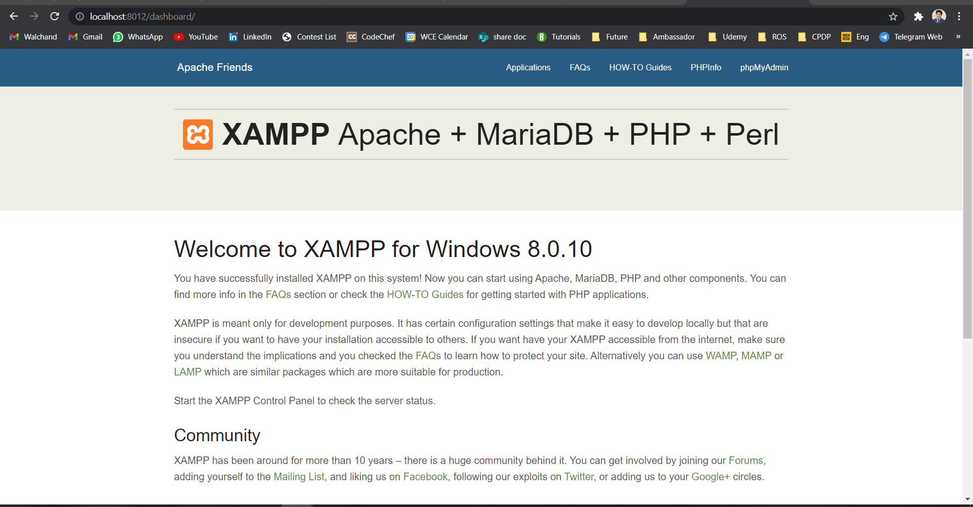

1. **Change the default IP address (127.0.0.1 or localhost) and port number of the server in the configuration file to any other valid IP address and port number. Re-run the server and access it in a network from another machine.**

.ANS:

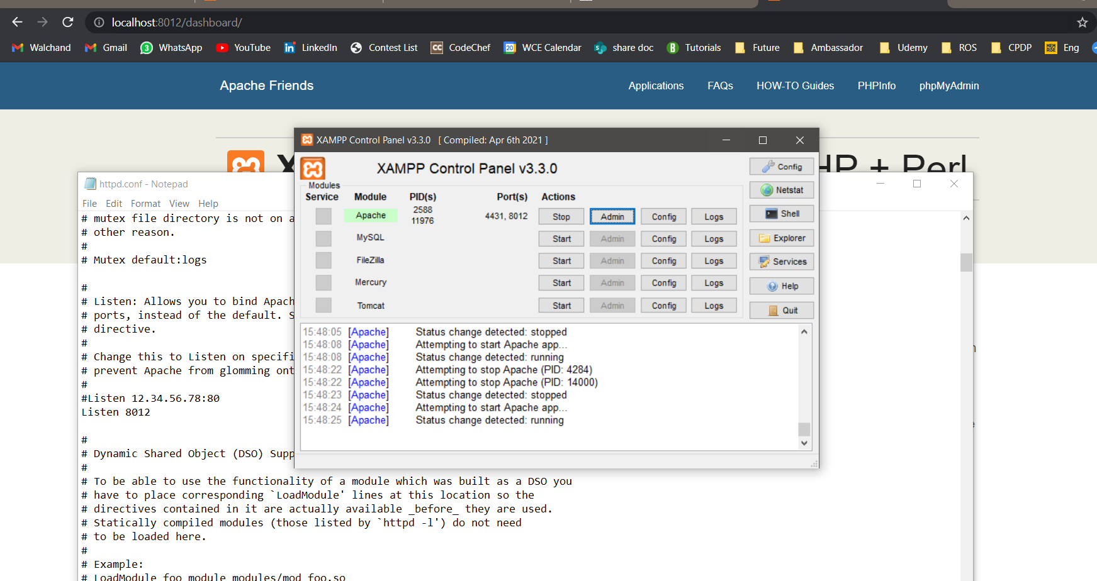

Running Server with Old IP address (localhost)

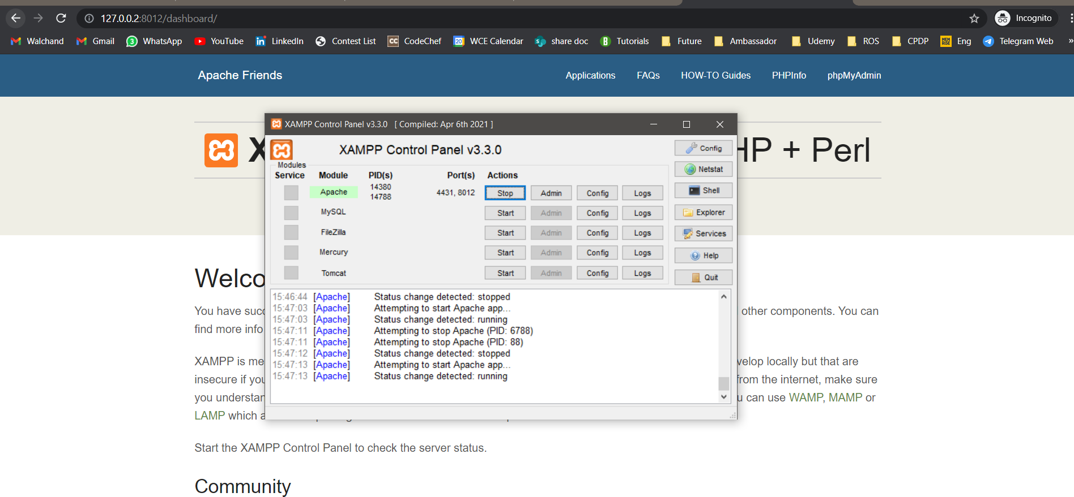

Running Server with New IP address (127.0.0.2 with port 8012)