Mid-Term Exam of Digital Communications
a.a. 2020-2021
Nov. 24, 2021

Exercise #1

The signal m(t) = 2 cos 20πt − cos 40πt is amplitude modulated using a carrier frequency fc of 600 kHz of amplitude is A=5.
(a) Sketch the spectrum of modulated signal. What is its bandwidth?
(c) The AM signal is passed through an ideal highpass filter with cutoff frequency 595 KHz (i.e., the filter passes all frequencies above 595 KHz, and cuts off all frequencies below 595 KHz). Find an explicit time domain expression for the in quadrature component of the filter output with respect to a 600 KHz frequency reference.
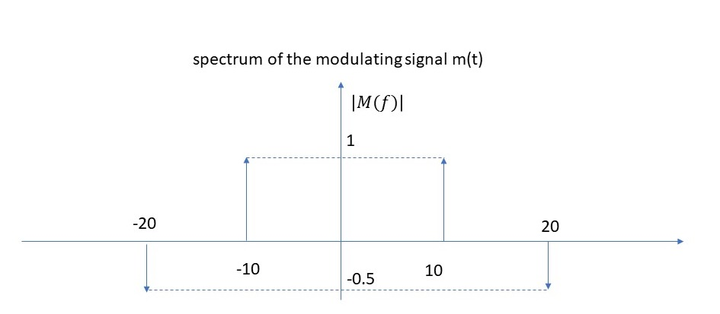

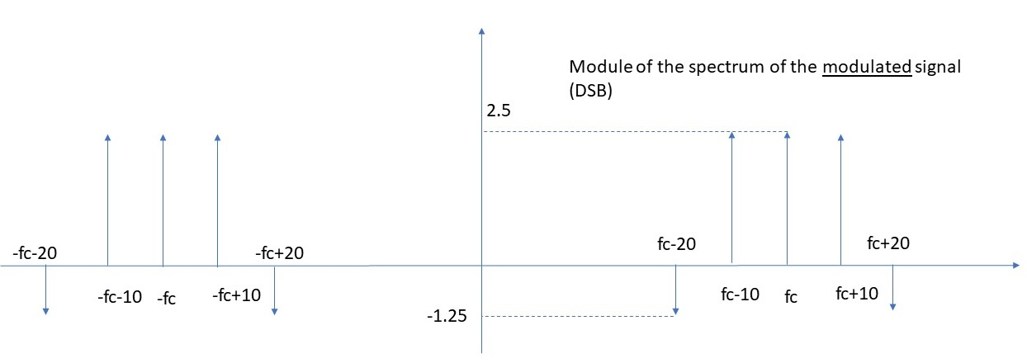
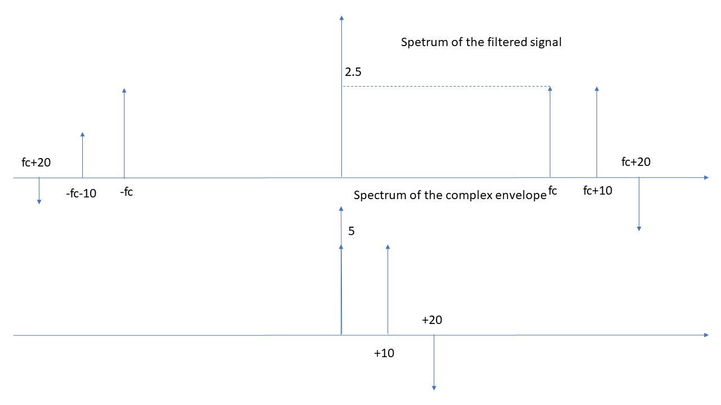
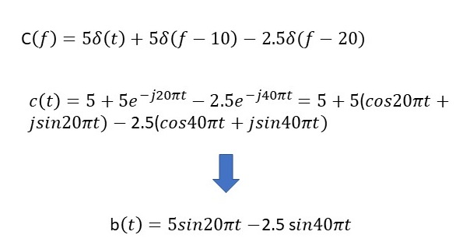

Exercise #2
We have to transmit a random process characterized by a bandwidth W=5kHz and an autocorrelation function given by 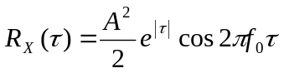.
- How many quantization levels are required to guarantee an SQNR3ea of at least 50dB?
- The signal is first coded using PCM and then transmitted over a channel of B=40kHz using an M-PAM modulation and using a roll-off- factor of alpha=1. Select the minimum order M of the modulation to guarantee transmission without ISI.
- Calculate the corresponding spectral efficiency
- In case I choose to transmit with a binary PPM modulation, what is the spectral efficiency of the system?
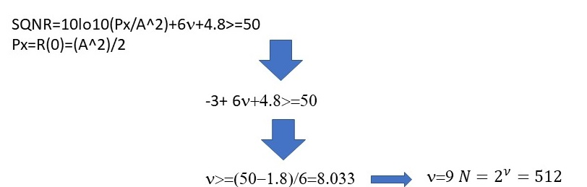
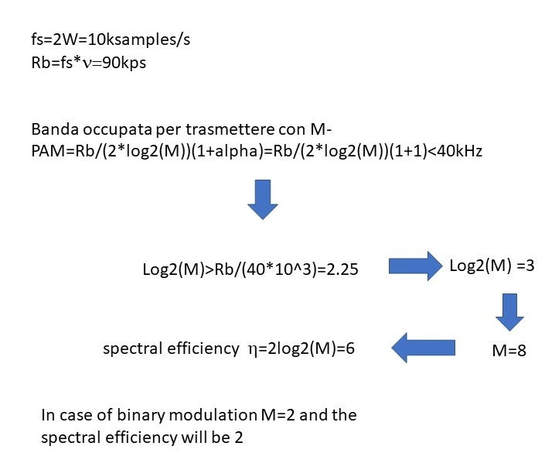

Exercise #3
The channel frequency response can be approximated by:

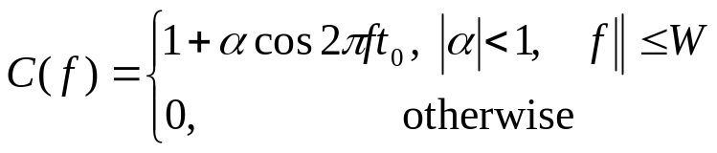

Where W=20MHz. Assume that you want to transmit over this channel a binary PAM signal with bit rate of 40Mbps. Assuming that the transmit filter is an ideal rectangular pulse in the frequency domain (width of 2W), design the receive filter R(f) in a way that there is no ISI.

Solution:
Binary PAM means M=2
Therefore, Rs=Rb/log2(2)=Rb=40Mbaud
Bmin=Rs/2=20MHz
Which is equals to the bandwidth of the channel. Therefore, the only possibility not to have ISI is that the pulse after the receiver filter is a sinc (rect on the frequency domain of width 2Bmin=2W)

So:
Assuming that T(f) is the frequency response of the transmit filter, which is a rect(f/2W)

T(f)*C(f)*R(f)=rect(f/2W)
rect(f/2W)*C(f)*R(f)=rect(f/2W)

hence

the frequency response of the receiver filter must verify this condition
R(f)=1/C(f)

