**/Exercise 1**

A digital communication system is designed using bandpass QPSK modulation with Graymapping. Due to a DC offset and phase error in the modulator, the constellation is translatedand rotated as shown in the figure below.





(a) Compute the average energy of the signals and sketch carefully the decision regions.

(b) Find the probability of a bit error *Pb* of this system and compare it with the bit error rate of a conventional QPSK with the same energy per bit Eb (i.e., indicate what is the increase in Eb/N0 that is needed to achieve the same performance in terms of bit error rate).

(c) If a demodulator for conventional QPSK is employed, what is the resulting value of *Pb*?

**Exercise 2**

Digital data are transmitted over a telephone line channel. Suppose that the telephone line is equalized over a 300-3700 Hz band and that the signal to noise ratio at the output (receiver end) is 15dB.

1. of the digital signaling techniques shown in the figure below, choose the one that will provide the largest bit rate for a Pe=10^(-3).
2. What is the maximum theoretical bit rate for this system with no ISI?
3. What is the maximum bit rate assuming a roll-off factor of 0.5?



**Exercise 3**

Digital data are transmitted over a telephone line channel. Suppose that the telephone line is equalized over a 300-3700 Hz band and that the signal to noise ratio at the output (receiver end) is 15dB.

1. of the digital signaling techniques shown in the figure below, choose the one that will provide the largest bit rate for a Pe=10^(-3).



1. What is the maximum theoretical bit rate for this system with no ISI?
2. What is the maximum bit rate assuming a roll-off factor of 0.5?

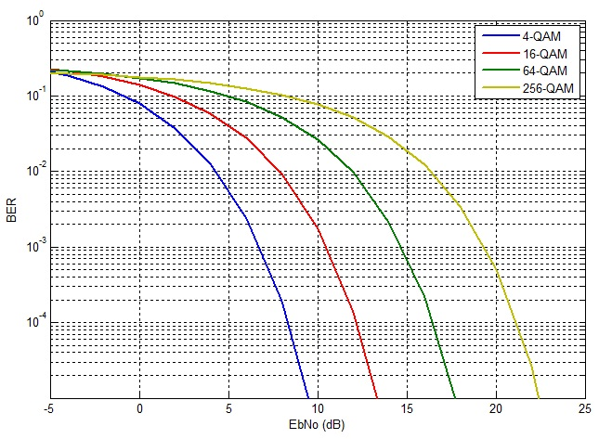**̣,,**



**iki**

**Exercise 4**

A binary modulation system uses quadrature modulation with the signal points shown in the figure below.

Transmission of equally likely bits takes place over an AWGN channel with power spectral density

*N*0*/*2.

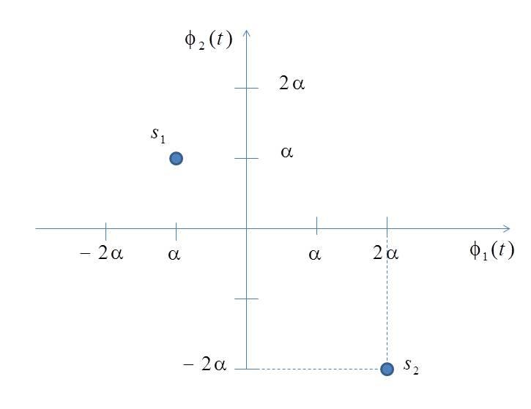



(a) Find the value of the constant *α* as a function of the average signal energy *E*.

(b) Sketch carefully the decision regions.

(c) Find the probability of a bit error in terms of *E/N*0 and the *Q*-function, and compare it with binary transmission using binary antipodal signaling.

**Exercise 5**

A voice signal in the range 3000 to 3300Hz is sampled at 8000 samples/s. We may transmit these samples directly as PAM pulses or we may first convert each sample to a PCM format and use binary (PCM) waveforms for transmission.

1. What is the minimum system bandwidth required for the detection of PAM with no ISI and with a filter roll-off characteristics of r=1;
2. Using the same roll-off, what is the minimum bandwidth required for the detection of binary (PCM) waveforms if the samples are quantized to eight levels?
3. Repeat (b) using 128 quantization levels.

**Exercise 6**

A 4 kHz bandpass channel will transmit data at a rate of 9600bit/s. If N0/2=10^(-10) W/Hz is the spectral density of the additive zero-mean Gaussian noise in the channel, design a QAM modulation and determine the average power per bit that achieves a bit error probability of 10^(-6). Use a pulse with a raised-cosine spectrum having a roll-off factor of at least 50%.

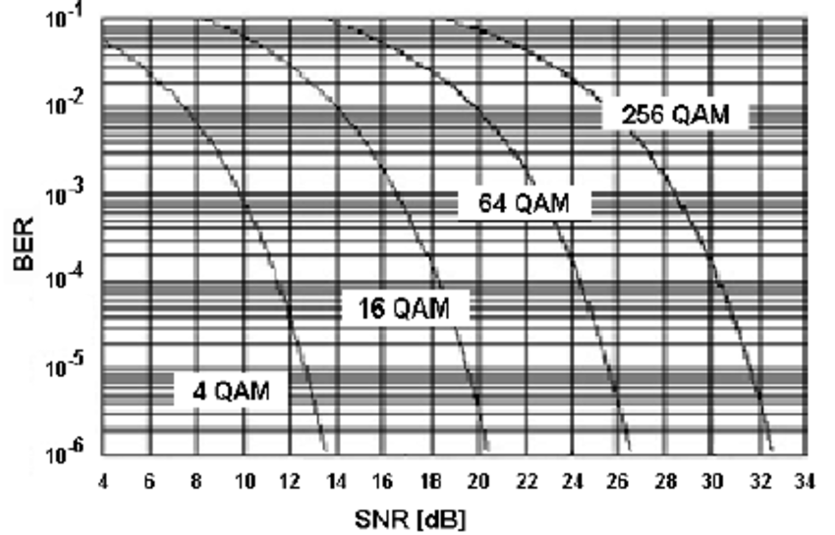



**Exercise 7**

Suppose the QPSK is used for transmitting over an AWGN with a power spectral density of 1/2N0=10^(-10) W/Hz. The transmitted signal energy is Es=(1/2)A^(2)T, where T is the symbol interval and A is the signal amplitude. Determine the signal amplitude to achieve an error probability of 10^(-6) when the data rate is: i) 10kbps; ii) 100kbps; iii) 1Mbps.

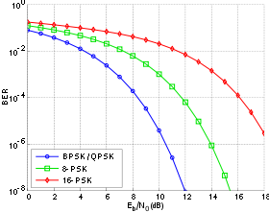



**Exercise 8**

A communication system is designed for binary data transmission over an ideal AWGN channel, with pulses of average energy equal to *Es* = *A*2*T/*4. This system is then applied to an optical link that has the feature that the variance of the AWGN process varies with the signal level. It is found that the sampled output of the matched filter *Y* is a Gaussian random variable with conditional PDF given by



In other words, the variance of *Y* equals *σ*2*Es* is the transmitted level is 0 and 2*σ*2*Es* if the

transmitted level is +1.

(a) Find the probability of a bit error for the optical link in terms of the energy-to-noise

power ratio, *Es/σ*2. Express your result in terms of the Gaussian *Q*-function.

(b) Give an expression to determine the threshold of the decision device used in an optimal

receiver for the optical link.