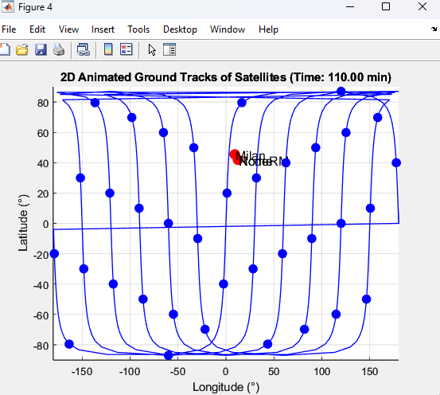

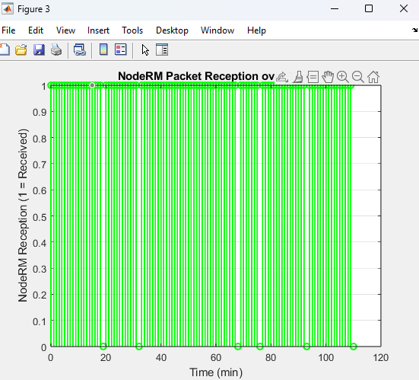

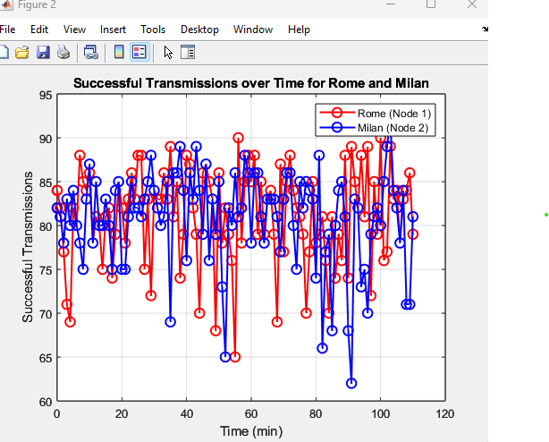

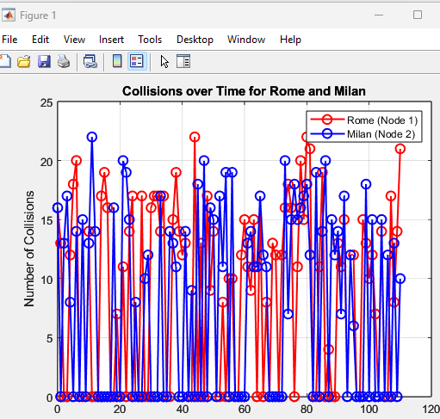

|  |  |
| --- | --- |
| **Protocol Used** | LR-FHSS (LoRaWAN) |

|  |  |
| --- | --- |
| **Packet Scheduling** | Random Poisson-based transmissions |

|  |  |
| --- | --- |
| **Frequency Hopping** | Yes (280 channels) |

|  |  |
| --- | --- |
| **Collision Handling** | Yes (100ms threshold) |

|  |  |
| --- | --- |
| **Error Correction** | Yes (FEC via Success Threshold) |

|  |  |
| --- | --- |
| **Relay to NodeRM** | Yes (if common satellite) |

|  |  |
| --- | --- |
| **Decoding at NodeRM** | Based on SNR & fragment availability |

|  |  |
| --- | --- |
| **Visualization** | Excel logs + Graphs + Animation |