**What’s Happening-Android app for Event Management**

Submitted in partial fulfillment of the requirements

of the degree of

Bachelor of Engineering

by

Abhijeet Gite, Roll No.12102A0026

Sanket Nawle, Roll No.12102A0035

Shruti Sadalge, Roll No.12102A0036

Under the Guidance of

Prof. Amit Dhanwani

Department of Computer Engineering

Vidyalankar Institute of Technology, Wadala (E), Mumbai

2014-2015

**Project Report Approval for Bachelor of Engineering**

This Project Report entitled ***What’s Happening*** is approved for the degree of ***Bachelor of Engineering in Computer Engineering.***

Examiners

1. _______________
2. _______________

Supervisors/ Guides

1. _______________
2. _______________

Head of Department

1. _______________

Principal

1. _______________

Date:

Place:

**Declaration**

We declare that this written submission represents our ideas in our own words and where others' ideas or words have been included, we have adequately cited and referenced the original sources. We also declare that we have adhered to all principles of academic honesty and integrity and have not misrepresented or fabricated or falsified any idea/data/fact/source in our submission. We understand that any violation of the above will be cause for disciplinary action by the Institute and can also evoke penal action from the sources which have thus not been properly cited or from whom proper permission has not been taken when needed.

|  |  |  |  |
| --- | --- | --- | --- |
|  | Name of student | Roll No. | Signature |
| 1. | Abhijeet Gite | 12102A0026 |  |
| 2. | Sanket Nawle | 12102A0035 |  |
| 3. | Shruti Sadalge | 12102A0036 |  |

Date:

i

**ABSTRACT**

There has been an enthralling increase in the usage of smart phones since their invention. These smart phones are going to be the next generation open operating systems. It is very easy for the consumers to search for applications which will suffice their needs. The openness of these new environments leads to new applications and markets and enables greater integration. This paper presents a concept of an application which will help users to be aware of all the important things happening around them. The users will be notified about the events which are significant to them in their day to day life. It will consists of functions like alarm and news (customized). By using this application, the users can connect to other people by sending them requests and can also block people they don’t want to connect with. The users will have the feature to invite other people to their events and reply to their invitations as well. Users can also enjoy a feature called area-wise notification to get to know about the events which will be happening around them by tapping their smart phones on NFC tags. This application will also facilitate the users to keep track of all their events using reminders and connect those reminders to Google calendar in order to increase the availability and reliability.

**Keywords**– Alarm, News, Invitations, Area-wise notifications, NFC

ii

**ACKNOWLEDGEMENT**

The success of any project depends largely on the encouragement and guidance of many people. We take this opportunity to express our gratitude towards the people who have helped us and supported us throughout our project.

We are grateful to our project guide **Prof. Amit Dhanwani** for his continuous support and valuable inputs towards our project, from its inception until its completion. He has not only supported and guided us but also motivated us which has built our belief in achieving our goals with success.

We would also like to extend our deepest gratitude to all the other faculty members who offered us their help. The advice and ideas given by them truly provided a fillip in making our project more usable and significant.

The employees and staff at Vidyalankar Institute of Technology gave us their kind support and help. We would like to thank them as well.

We wish to thank our parents for their support and their interest in our work that inspired, encouraged and supported us in all possible ways. And last but not the least we wish to thank our friends who motivated us and helped us, enabling us to make this project a success

iii

**Table of Contents**

|  |  |  |
| --- | --- | --- |
| **Sr. No.** | **Topic Name** | **Page No.** |
| 1. | Project overview | 1 |
| 2. | Introduction & Motivation  a)Theory behind the project concept  b) Problem definition  c) Need for project | 2 |
| 3. | Analysis a) Software development  b) Flow of project  1. Preliminary survey  2. Feasibility study  3. Cost analysis  4. Process model  5. Data flow diagrams  c) UML diagrams  d) Technologies used  1. Hardware & software requirements  2. Introduction to programming model | 9 |
| 4. | Project time & Task distribution   1. Timeline chart | 27 |
| 5. | Implementation | 31 |
| 6. | Test cases   1. GUI 2. Test cases | 33 |
| 7. | Conclusion & future scope | 40 |

iv

**1. PROJECT OVERVIEW**

There has been an enthralling increase in the usage of smart phones since their invention. These smart phones are going to be the next generation open operating systems. It is very easy for the consumers to search for applications which will suffice their needs.

The openness of these new environments leads to new applications and markets and enables greater integration. The application will help users to be aware of all the important things happening around them. The users will be notified about the events which are significant to them in their day to day life.

It will consists of functions like alarm and news (customized).By using this application, the users can connect to other people by sending them requests and can also block people they don’t want to connect with. The users will have the feature invite other people to their events and reply to their invitations as well. Users can also enjoy a feature called area-wise notification to get to know about the events which will be happening around them by tapping their smart phones on NFC tags. This application will also facilitate the users to keep track of all their events using reminders and connect those reminders to Google calendar in order to increase the availability and reliability.

1

1. **Introduction and Motivation**

**2.1 Theory behind the project:**

Our main objective behind this project is to let the users of our application know everything that is happening around him. In order to do that we have exploited various functionalities of android operating system to fit our needs. This chapter explains the core concepts which together constitute the theory underlying the project concept and implementation.

The concepts involved are as follows:

**2.1.1 Android OS architecture:**

Android OS consists of four main layers kernel, libraries, applications framework and applications.

**Kernel Layer**

The whole Android OS is built on top of the Linux 2.6 Kernel with some further   architectural changes made by Google.  It is this Linux that interacts with the hardware and contains all the essential hardware drivers. Linux was chosen since it has a proven track record in desktop systems and in many cases doesn’t require drivers to be rewritten. Linux provides such things as virtual memory, networking, drivers, and power management.

**Native libraries layer**

The native libraries layer provides Android with the capabilities for its core features. Android is shipped with SGL which acts as the primary 2D graphics renderer. Its counterpart is OpenGL ES which provides 3D graphics support. Android comes packed with SQLite which takes care of most data storage. The WebKit web rendering engine is also shipped with Android and has been tailored to render web pages for smaller screen sizes. Dalvik virtual machine which is a part of this layer. The Dalvik virtual machine is a bytecode interpreter which is highly optimized

2

for executing on the mobile platform. The bytecodes are converted Java binaries that are very quick and efficient to run on smaller processors. The core libraries are written in Java and provide much of the core classes which would normally be available in a Java virtual machine.

**Applications framework Layer**

The applications framework provides all of the major APIs that the applications will use including things like sharing data, accessing the telephony system, and receiving notifications. This layer and the layer above it are written completely in Java.

**Applications layer**

This is the top layer in Android architecture. This layer contains software written by the Android team as well as any third-party software that is installed on the device. Even the most core features such as the phone and the contacts application reside in this layer. Any third party developer can access this layer, as an effect of which any events of core android apps can be handled by third party applications(like phone ringing).

Android provides the services expected in a modern operating system such as virtual memory, multiprogramming, and threads all on a mobile platform. Many of Android’s services are a result of including the Linux kernel. As well Android team has added the telephony stack.

**2.1.2 NFC**

Near Field Communication (NFC) is a set of short-range wireless technologies, typically requiring a distance of 4cm or less to initiate a connection. NFC allows you to share small payloads of data between an NFC tag and an Android-powered device, or between two Android-powered devices.

Tags can range in complexity. Simple tags offer just read and write semantics, sometimes with one-time-programmable areas to make the card read-only. More complex tags offer math operations, and have cryptographic hardware to authenticate access to a sector. The most

3

sophisticated tags contain operating environments, allowing complex interactions with code executing on the tag. The data stored in the tag can also be written in a variety of formats, but many of the Android framework APIs are based around a NFC Forum standard called NDEF (NFC Data Exchange Format).

Android-powered devices with NFC simultaneously support three main modes of operation:

1. **Reader/writer mode**, allowing the NFC device to read and/or write passive NFC tags and stickers.
2. **P2P mode**, allowing the NFC device to exchange data with other NFC peers; this operation mode is used by Android Beam.
3. **Card emulation mode**, allowing the NFC device itself to act as an NFC card. The emulated NFC card can then be accessed by an external NFC reader, such as an NFC point-of-sale terminal. Android-powered devices are usually looking for NFC tags when the screen is unlocked, unless NFC is disabled in the device's Settings menu. When an Android-powered device discovers an NFC tag, the desired behavior is to have the most appropriate activity handle the intent without asking the user what application to use. Because devices scan NFC tags at a very short range, it is likely that making users manually select an activity would force them to move the device away from the tag and break the connection.

To help you with this goal, Android provides a special tag dispatch system that analyzes scanned NFC tags, parses them, and tries to locate applications that are interested in the scanned data. It does this by:

1. Parsing the NFC tag and figuring out the MIME type or a URI that identifies the data payload in the tag.
2. Encapsulating the MIME type or URI and the payload into an intent. These first two steps are described in How NFC tags are mapped to MIME types and URIs.
3. Starts an activity based on the intent. This is described in How NFC Tags are Dispatched to Applications.

4

**2.1.3 Notification:**

A notification is a message you can display to the user outside of your application's normal UI. When you tell the system to issue a notification, it first appears as an icon in the **notification area**. To see the details of the notification, the user opens the **notification drawer**. Both the notification area and the notification drawer are system-controlled areas that the user can view at any time. Android **Toast** class provides a handy way to show users alerts but problem is that these alerts are not persistent which means alert flashes on the screen for a few seconds and then disappears.

When you need to issue a notification multiple times for the same type of event, you should avoid making a completely new notification. Instead, you should consider updating a previous notification, either by changing some of its values or by adding to it, or both.

For example, Gmail notifies the user that new emails have arrived by increasing its count of unread messages and by adding a summary of each email to the notification. This is called "stacking" the notification; it's described in more detail in the Notifications Design guide.

If you wish, you can set the priority of a notification. The priority acts as a hint to the device UI about how the notification should be displayed.

Although they're optional, you should add at least one action to your notification. An action allows users to go directly from the notification to an Activity in your application, where they can look at one or more events or do further work.

A notification can provide multiple actions. You should always define the action that's triggered when the user clicks the notification; usually this action opens an Activity in your application. You can also add buttons to the notification that perform additional actions such as snoozing an alarm or responding immediately to a text message

5

**2.1.4 TCP connection :**

The Transmission Control Protocol provides a communication service at an intermediate level between an application program and the Internet Protocol. It provides host-to-host connectivity at the Transport Layer of the Internet model. An application does not need to know the particular mechanisms for sending data via a link to another host, such as the required packet fragmentation on the transmission medium. At the transport layer, the protocol handles all handshaking.

At the lower levels of the protocol stack, due to network congestion, traffic load balancing, or other unpredictable network behavior, IP packets may be lost, duplicated, or delivered out of order. TCP detects these problems, requests retransmission of lost data, rearranges out-of-order data, and even helps minimize network congestion to reduce the occurrence of the other problems. If the data still remains undelivered, its source is notified of this failure. Once the TCP receiver has reassembled the sequence of [octets](https://en.wikipedia.org/wiki/Octet_(computing)) originally transmitted, it passes them to the receiving application. Thus, TCP abstracts the application's communication from the underlying networking details.

TCP is a reliable stream delivery service that guarantees that all bytes received will be identical with bytes sent and in the correct order. Since packet transfer over many networks is not reliable, a technique known as positive acknowledgment with retransmission is used to guarantee reliability of packet transfers. This fundamental technique requires the receiver to respond with an acknowledgment message as it receives the data. The sender keeps a record of each packet it sends. The sender also maintains a timer from when the packet was sent, and retransmits a packet if the timer expires before the message has been acknowledged.

**2.2 Problem Definition:**

Now a days in this fast paced world people who have a busy schedule, have to juggle between work and personal life sometimes find it difficult to track the events happening in their life.

6

This number is quite high especially in metropolitan cities like Mumbai since in such cities, the life is fast paced and a lot of things are happening simultaneously and new events keep on emerging in the spur of a moment.

Therefore through What’s Happening, our android application we will help users to create and manage events more efficiently by providing the following features:

1. **Alarm:**

To know what is happening around you, you need to be awake first! This app will give you the flexibility of having three alarm settings.

1. **News:**

You will receive all the important news you should be aware of. You can customize the news according to your interests

1. **Connect with people:**

You can connect with people by sending them requests. Once, you can receive the updates from those people. You also have the feature to unfollow someone but still remain connected. You won’t receive their updates automatically. But, you can see them by going to their profile manually.

1. **Public post:**

You will have the privilege to post an event you want to conduct and send it to particular people or group. On receiving the notification, you just have the option to set a reminder or just ignore it. You also have the feature to make a contact trustworthy, i.e., if you receive any update from him, it will directly get added to your reminders.

1. **Invitation:**

The users also have a facility to send an invite to specific people or a group as a whole. On the receiving side, you will get a notification regarding the invitation. At this point, you can not only set a reminder, but also send a feedback to the sender suggesting you would be attending the event or not.

7

1. **Area wise notification:**

This feature would make use of NFC tags. By using this app, you have the ability to retrieve data stored in an NFC tag by just touching your phone against it. After receiving that data, you can understand the event which is going to happen in that area and hence, set a reminder accordingly.

Use the Bluetooth feature to receive events or notifications in a closed range (10-15 meters).

**2.3 Need for the project:**

The idea behind this project is that we, as regular customers should be able to efficiently create and manage the various important events happening in our lives. Thus, the main objectives associated with this project are as follows:

* To help the people to wake up on time so that they don’t miss any event
* Provide a facility to get updates regarding their interests through news
* To help people to stay connected to others
* Facilitate people to create various events and inform others about them as well
* Facilitate people to receive event updates from the connected people
* To help people to set a reminder of any event of their choice
* To get the knowledge regarding the event happening in a particular area

8

1. **Analysis and Design**

**3.1 Software Development:**

In incremental model the whole requirement is divided into various builds. Multiple development cycles take place here, making the life cycle a “multi-waterfall” cycle.  Cycles are divided up into smaller, more easily managed modules.  Each module passes through the requirements, design, implementation and testing phases. A working version of software is produced during the first module, so you have working software early on during the software life cycle. Each subsequent release of the module adds function to the previous release. The process continues till the complete system is achieved.

For example:

[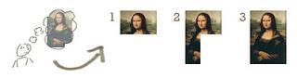](http://istqbexamcertification.com/wp-content/uploads/2012/01/Incremental-model_11.jpg)

In the diagram above when we work **incrementally** we are adding piece by piece but expect that each piece is fully finished. Thus keep on adding the pieces until it’s complete. As in the image above a person has thought of the application. Then he started building it and in the first iteration the first module of the application or product is totally ready and can be demoed to the customers. Likewise in the second iteration the other module is ready and integrated with the first module. Similarly, in the third iteration the whole product is ready and integrated. Hence, the product got ready step by step.

**9**

**Diagram of Incremental model:**

[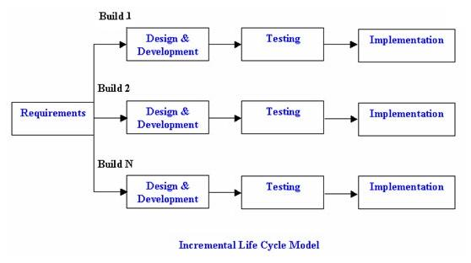](http://istqbexamcertification.com/wp-content/uploads/2012/01/Incremental_model.jpg)

**Advantages of Incremental model:**

* Generates working software quickly and early during the software life cycle.
* This model is more flexible – less costly to change scope and requirements.
* It is easier to test and debug during a smaller iteration.
* In this model customer can respond to each built.
* Lowers initial delivery cost.
* Easier to manage risk because risky pieces are identified and handled during it’d iteration.

**Disadvantages of Incremental model:**

* Needs good planning and design.
* Needs a clear and complete definition of the whole system before it can be broken down and built incrementally.
* Total cost is higher than waterfall.

10

**When to use the Incremental model:**

* This model can be used when the requirements of the complete system are clearly defined and understood.
* Major requirements must be defined; however, some details can evolve with time.
* There is a need to get a product to the market early.
* A new technology is being used
* Resources with needed skill set are not available
* There are some high risk features and goals.

**3.2 Flow of project:**

**3.2.1 Preliminary Survey:**

This chapter describes the details about the research regarding the various components that together constitute the projects. These components that include the datasets, tools etc are involved in the development of the entire project.

The components are listed as follows:

**NFC:**

Near Field Communication (NFC) is a set of short-range wireless technologies, typically requiring a distance of 4cm or less to initiate a connection. NFC allows you to share small payloads of data

**Reader/writer mode**, allowing the NFC device to read and/or write passive NFC tags and stickers.

11

**NOTIFICATION:**

A notification is a message you can display to the user outside of your application's normal UI. When you tell the system to issue a notification, it first appears as an icon in the **notification area**. To see the details of the notification, the user opens the **notification drawer**. Both the notification area and the notification drawer are system-controlled areas that the user can view at any time. Android **Toast** class provides a handy way to show users alerts but problem is that these alerts are not persistent which means alert flashes on the screen for a few seconds and then disappears.

**TCP Connection :**

The Transmission Control Protocol provides a communication service at an intermediate level between an application program and the Internet Protocol. It provides host-to-host connectivity at the Transport Layer of the Internet model. An application does not need to know the particular mechanisms for sending data via a link to another host, such as the required packet fragmentation on the transmission medium.

TCP is a reliable stream delivery service that guarantees that all bytes received will be identical with bytes sent and in the correct order. Since packet transfer over many networks is not reliable, a technique known as positive acknowledgment with retransmission is used to guarantee reliability of packet transfers. This fundamental technique requires the receiver to respond with an acknowledgment message as it receives the data. The sender keeps a record of each packet it sends. The sender also maintains a timer from when the packet was sent, and retransmits a packet if the timer expires before the message has been acknowledged.

**Programming tools:**

The programming language used for the purpose of development of this project is Java. This is because of the following reasons:

12

* Android apps are written in the Java programming language. The Android SDK tools compile your code—along with any data and resource files—into an APK: an *Android package*, which is an archive file with an .apk suffix.
* **Java** is a general-purpose computer programming language that is concurrent, class-based, object-oriented, and specifically designed to have as few implementation dependencies as possible. It is intended to let application developers "write once, run anywhere" (WORA), meaning that compiled Java code can run on all platforms that support Java without the need for recompilation.

**3.2.2 Feasibility Study:**

A feasibility study aims to objectively and rationally uncover the strengths and weaknesses of an existing business or proposed venture, opportunities and threats present in the environment, the resources required to carry through, and ultimately the prospects for success. A feasibility study evaluates the project's potential for success; therefore, perceived objectivity is an important factor in the credibility of the study for potential investors and lending institutions. What’s Happening?! is proposed for users so that they are aware of all the events happening in their life and it also helps in organizing these events in a much better way.

**Technical Feasibility:**

Technically our application is feasible because the development software used to develop is available and each module can be coded in sdk. Only one additional hardware is required that is the NFC tag, which are available at a very cheap price.

**Operational Feasibility:**

It is feasible for users as it will be simple and easy to understand and implement. The app would be user friendly and it will work step by step making the understanding easy. The user interface will be simple and the admin will maintain the database time to time.

13

**Economic Feasibility:**

The various softwares which will be used in making the app are available for low cost. This makes it feasible for the developers to make a good app at feasible price.

**Legal Feasibility:**

As now days many people use apps for wrong work, the app would be approved and authenticated when published so it doesn’t get illegal. Many apps are not registered and it can affect the user using it. What’s Happening would be legal making it reliable and safe to use.

**3.2.3 Cost Analysis:**

It is an analysis of the expected balance of benefits and costs, including an account of foregone alternatives and the [*status quo*](https://en.wikipedia.org/wiki/Status_quo). CBA helps predict whether the benefits of a policy outweigh its costs, and by how much relative to other alternatives (i.e. one can rank alternate policies in terms of the cost–benefit ratio) Cost Analysis of What’s Happening with security would include the cost of the database server required to store the details of the user and events. For that database needs to be purchased and kept updating the same. We also need a NFC Tag for the NFC Feature to work but it is available at a quite cheap price. To develop the App, we will be using Android Studio, which is an open source development kit available to us for free on the internet. Hence we will incur low or no Software costs.In case of getting the App on Google PlayStore, certain costs will be incurred. Alongwith that, if the App needs to be publicized, then also some cost will be added. Apart from this, we will not have any hardware costs in order to develop this App.

14

**3.2.4 Process Model:**

**INCREMENTAL MODEL**

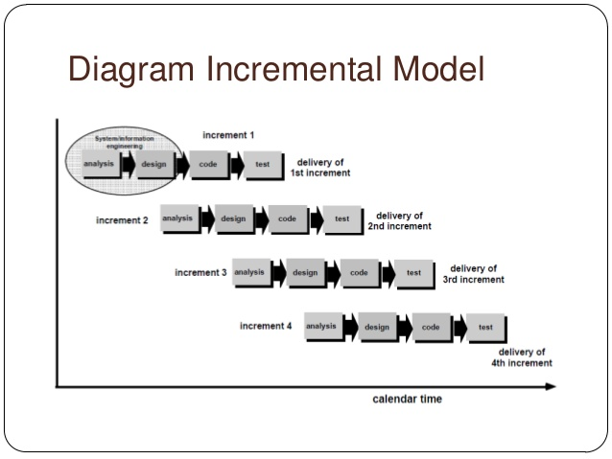

Incremental model is used in our project as our application consists of various features which can be divided into individual models so that they can be managed easily .Each module passes through the requirements, design, implementation and testing phase. A working version of software is produced during the first module, so you have working software early on during the software life cycle. Each subsequent release of the module adds function to the previous release. The process continues till the complete system is achieved.

Advantages of Incremental model are:-

* Generates working software quickly and early during the software life cycle.
* This model is more flexible – less costly to change scope and requirements.
* It is easier to test and debug during a smaller iteration.
* In this model customer can respond to each built.

15

* Lowers initial delivery cost.
* Easier to manage risk because risky pieces are identified and handled during each iteration.

**3.2.4.1 Data flow diagram**

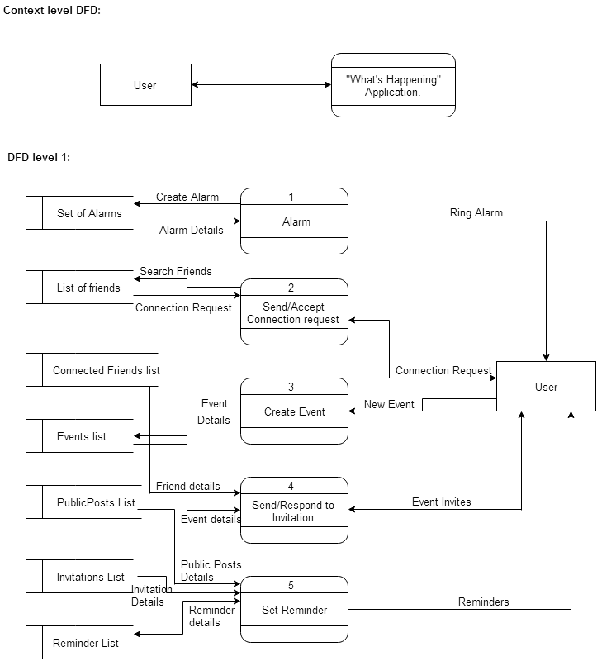

16

* 1. **UML diagrams:**

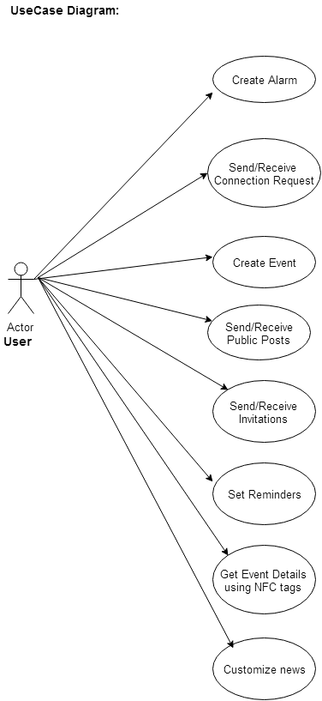

17

**Component diagram:**

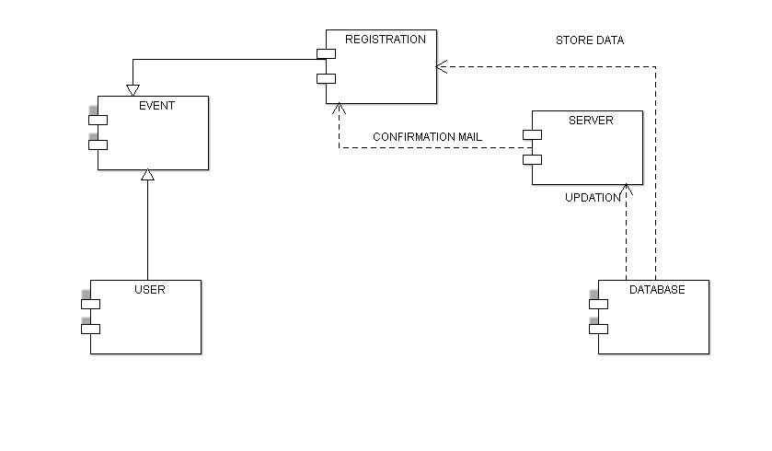

**Deployment diagram:**

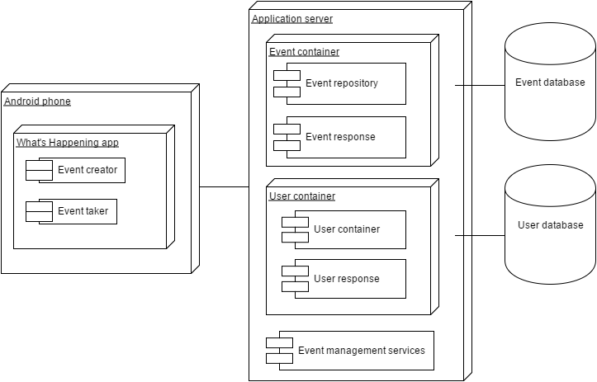

18

**Sequence diagram:**

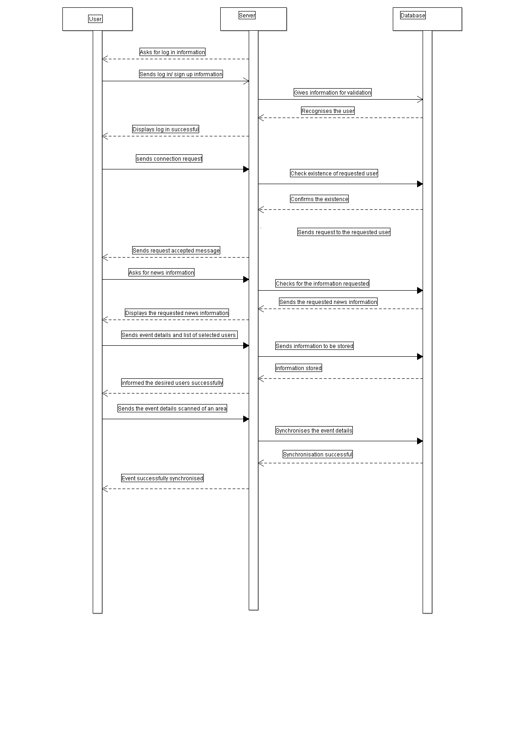

19

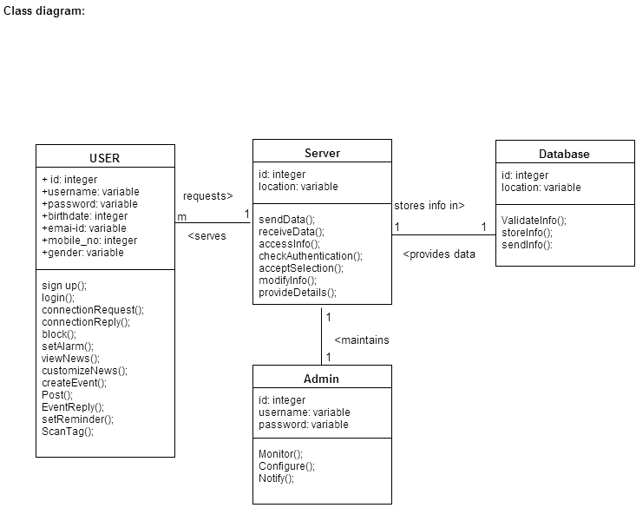

20

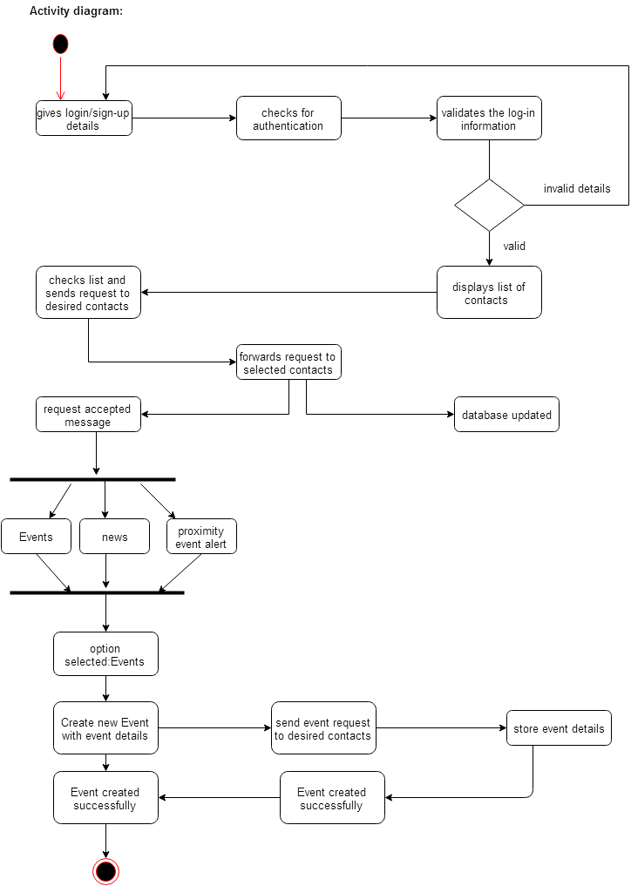

21

**3.4 Technologies used:**

**3.4.1 Hardware and Software Requirements:**

This project will be implemented using client-server architecture.

Following are some of the requirements:-

**Server Side:-**

**Hardware Requirements:-**

* Device: Smart Phone supporting Android OS
* RAM memory: 512 mb
* Processor: 1 Ghz

**Software requirements:**

* Operating system: Android 4.0 + version (Jelly Bean)
* Connectivity: WI-FI
* Bluetooth compatible
* NFC compatible
* Installation file: apk ( Android Application Package File) file

**Client Side:-**

**Hardware Requirements:-**

* Device:-Smart Phone Supporting Android OS
* RAM Memory:-512Mb
* Processor:-1GHz

22

**Software Requirements:-**

* Operating System:- Android 4.0 + version

(Jelly Bean)

* Connectivity:-WI-FI
* Bluetooth compatible
* NFC compatible
* Installation File:- apk (Android Application

Package File)file.

**3.4.2 Introduction to Programming Tools:**

**Android Studio**

**The Android operating system**

*Android* is an operating system based on the Linux kernel. The project responsible for developing the Android system is called the *Android Open Source Project* (AOSP) and is lead by Google.

The Android system supports background processing, provides a rich user interface library, supports 2-D and 3-D graphics using the OpenGL-ES (short OpenGL) standard and grants access to the file system as well as an embedded SQLite database.

An Android application typically consists of different visual and non visual components and can reuse components of other applications.

### Android platform components

The Android system is a full software stack, which is typically divided into the four areas as depicted in the following graphic.

23

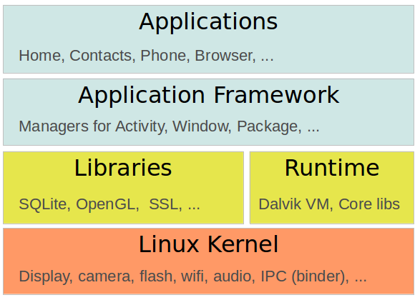

The levels can be described as:

* Applications - The Android Open Source Project contains several default application, like the Browser, Camera, Gallery, Music, Phone and more.
* Application framework - An API which allows high-level interactions with the Android system from Android applications.
* Libraries and runtime - The libraries for many common functions (e.g.: graphic rendering, data storage, web browsing, etc.) of the Application Framework and the Dalvik runtime, as well as the core Java libraries for running Android applications.
* Linux kernel - Communication layer for the underlying hardware.

24

The Linux kernel, the libraries and the runtime are encapsulated by the application framework. The Android application developer typically works with the two layers on top to create new Android applications.

## Android Studio Features

Android studio is based on IntelliJ IDEA, which does all the functionality that Eclipse with ADT plug-in do, with lot more additional features. The initial version of android studio offers

1. Gradle-based build support.
2. Android-specific refactoring and quick fixes
3. Lint tools to catch performance, usability, version compatibility and other problems
4. ProGuard and app-signing capabilities
5. Template-based wizards to create common Android designs and components.
6. **A rich layout editor:** it allows you to drag-and-drop UI components, preview layouts on multiple screen configurations. Preview appears instantly as you change in the layout editor. You can choose a language, and can see the preview of layout with that locale.
7. **Rich Color Preview editor:** While adding colors as a resource, and we can see the color preview at the left hand side of the editor.
8. **Deep Code Analysis:** If you point to a line and it gives detailed explanation about an exception based on the annotation added. And you can also know which constants are allowed for which API. It also has the powerful code completion. You can also inspect code in whole project, InteliJ lists all Lint errors during code inspection.

25

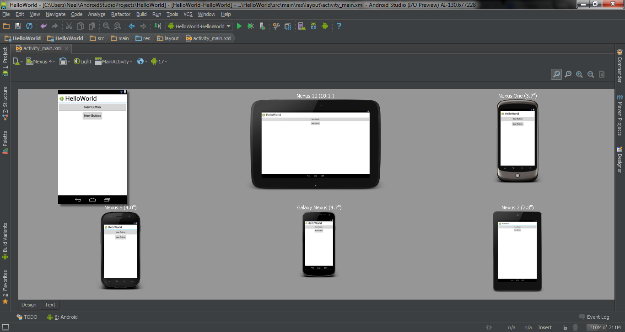

26

1. **ProjectTime & Task Distribution**

**4.1 Timeline chart:**

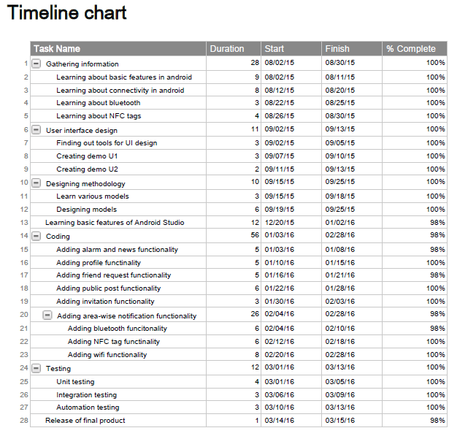

27

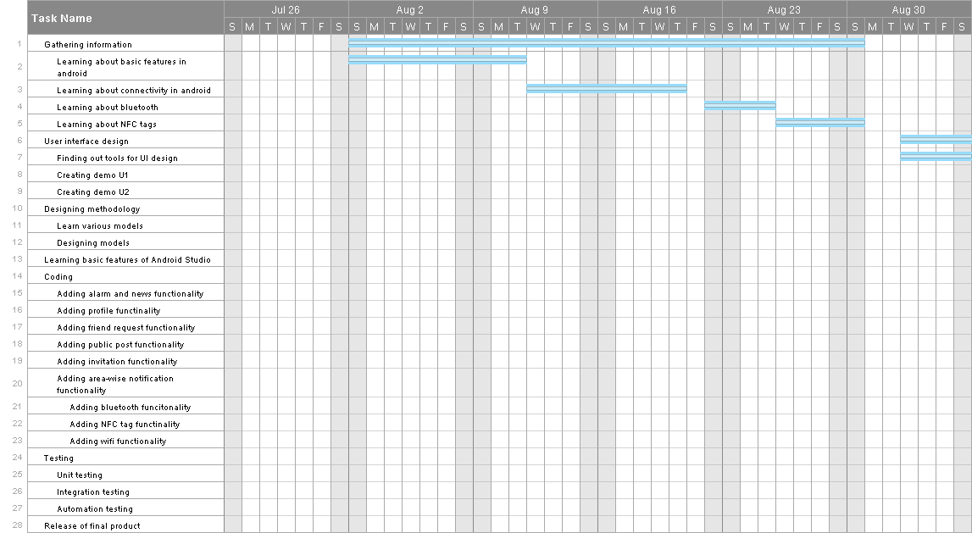

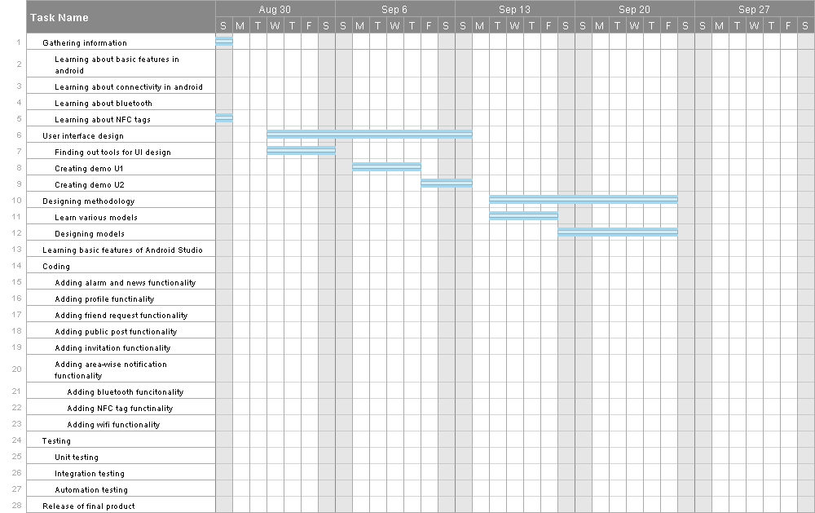

28

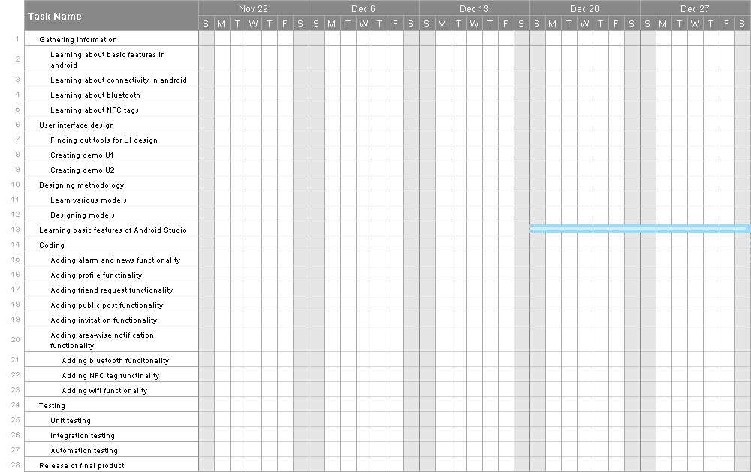

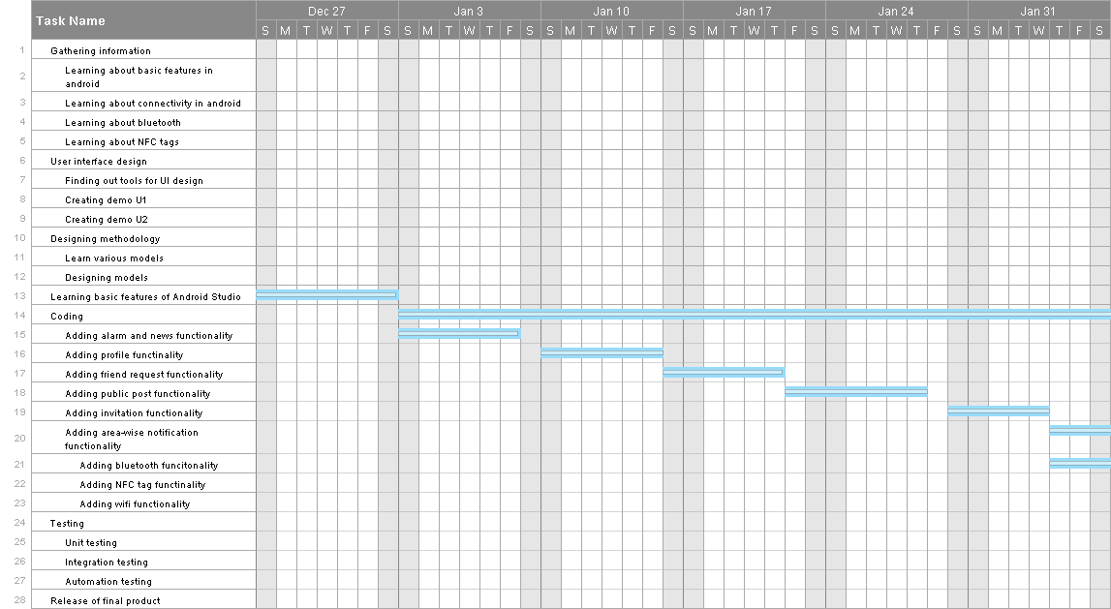

29

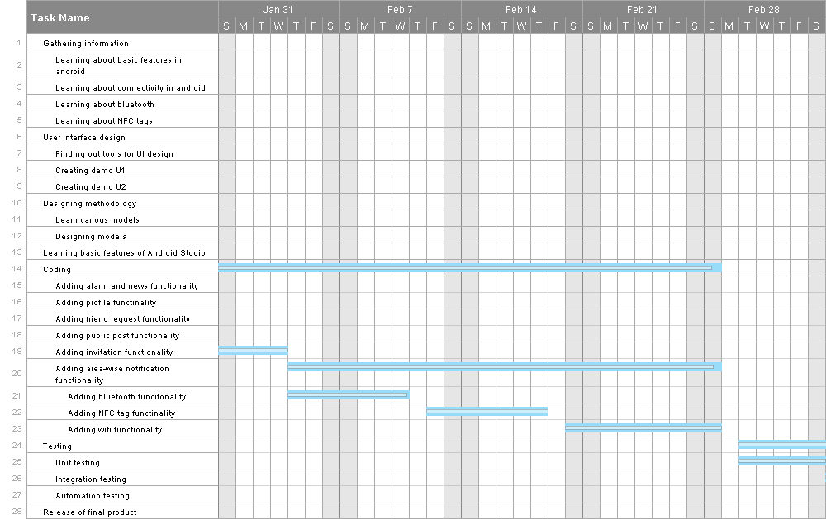

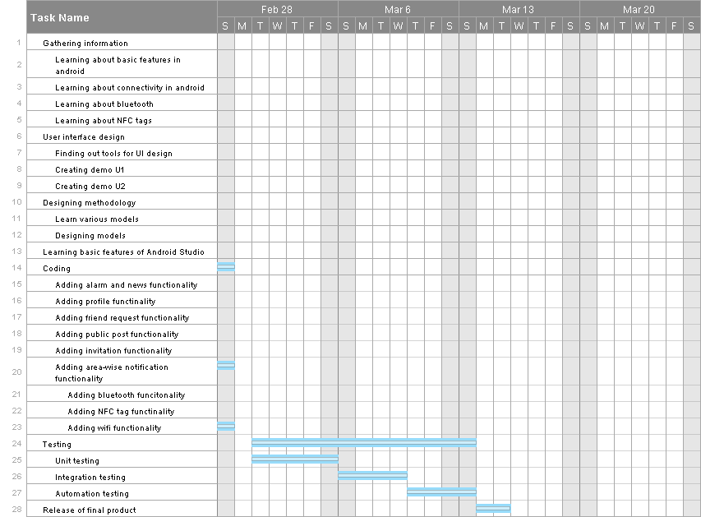

30

**5. Implementation**

* **Identifying the need of creating our android application:**

We identified the need that many people have trouble knowing about the things which are happening around them, especially when they are in an unknown surrounding. People need to approach other people to get information they need. As a result, it is very much likely that they may miss out some important events or may need to visit the places personally to check whether there is anything important happening in that area. In order to help the users to obtain all the information they need, we have incorporated the area-wise notification feature. Moreover, the users can feel free to send all the information they get to their friends using public post and invitation. Also, the news feature can come handy to know about the worldly happenings.

* **Learning basic functionalities of Android Studio:**

In order to create our application, it was imperative that we need to use an IDE for android platform. Since Android Studio was the latest IDE available with lots of features to exploit and having a better control over the coding, we decided to choose it as the IDE. We gathered the information about using Android Studio from a variety of sources like Youtube, Android Developers website, Stack Overflow, etc.

* **Connectivity between Android and Database:**

Since our application needs to store data regarding the users and various events, we needed to use a database. We decided to keep the database online, i.e., we used a web server called ‘Hostinger.in’ to store our database so that the data will always be available to the users. Now, in order to connect the android application to the database we used the concept of JSON object to pass the parameters to PHP files which then manipulate the database accordingly.

31

* **NFC tag:**

Near Field Communication (NFC) is a set of short-range wireless technologies, typically requiring a distance of 4cm or less to initiate a connection. NFC allows you to share small payloads of data between an NFC tag and an Android-powered device, or between two Android-powered devices. NFC tag in our application is mainly used for the purpose of reading and writing strings on it. It also helps to replace paper since it is rewritable.

* **GUI design:**

GUI design is one of the most important aspects when it comes to making the application user friendly. We discussed various formats of representing the features in the application so that the GUI looks attractive and interactive to the user. Also, we needed to see to it that the user can easily navigate through the entire application. As a result, we tried to keep the GUI as consistent as possible. We have meticulously used the color combination in our application so that it becomes easy for the user to know which activity/feature he is currently using in the application.

* **Feedback:**

In order to improve the interface of the application and consider the needs of the users, we took feedback from several people asking them about their opinion about the application and also for the suggestions which could help us improve our application.

32

**6. Test Cases**

**6.1 Graphical User Interface:**

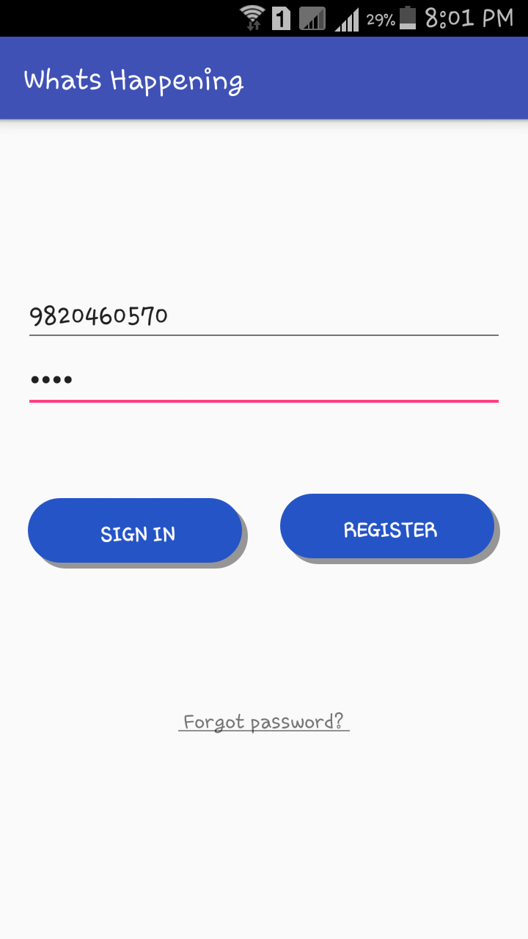 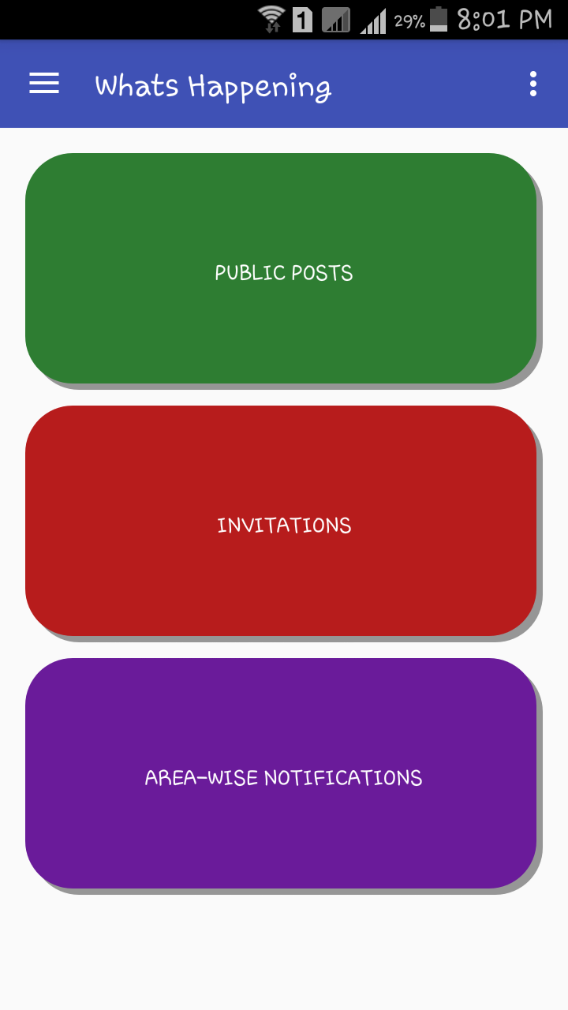

33

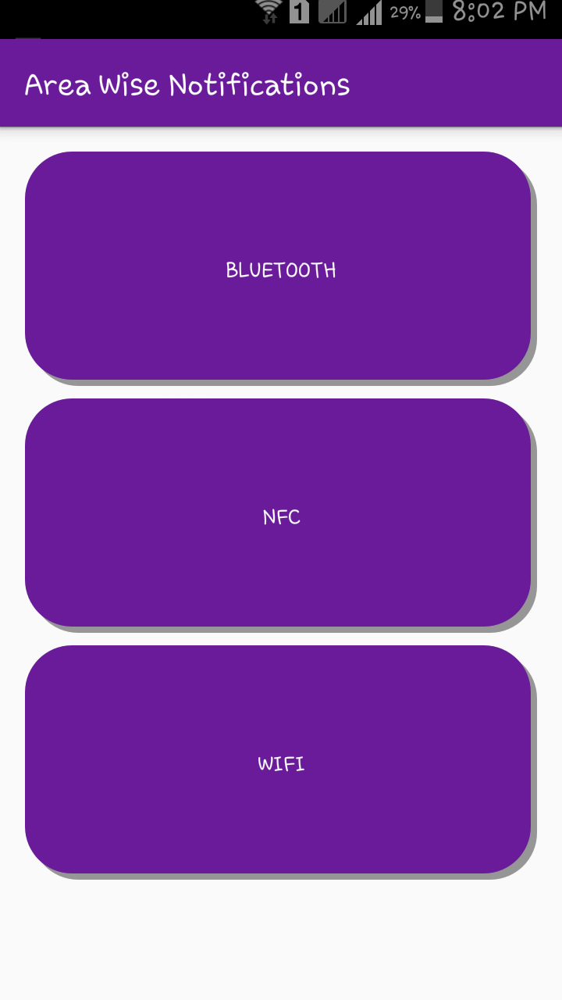 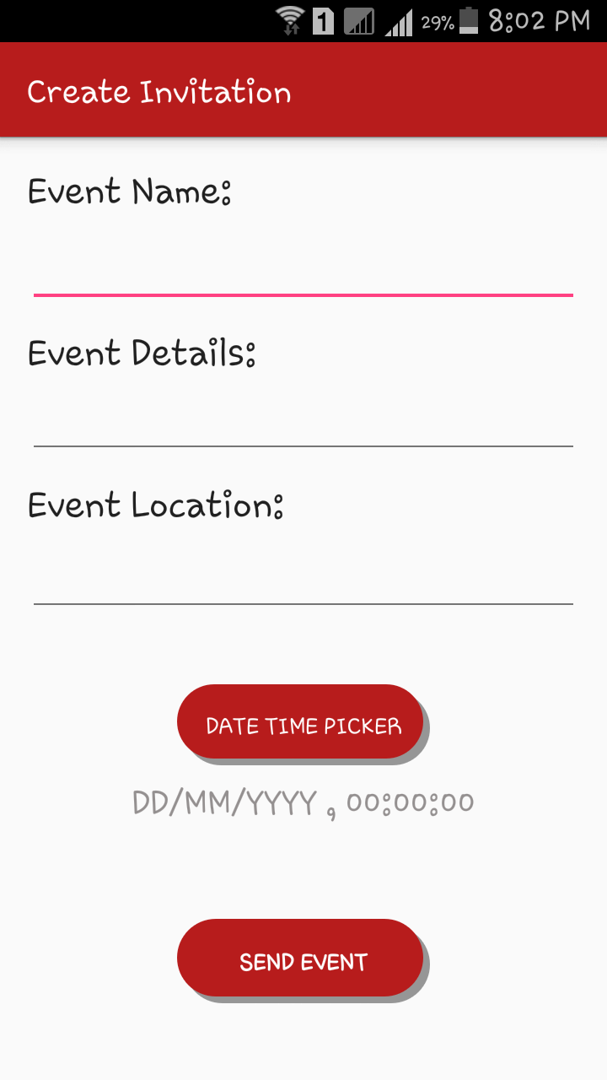

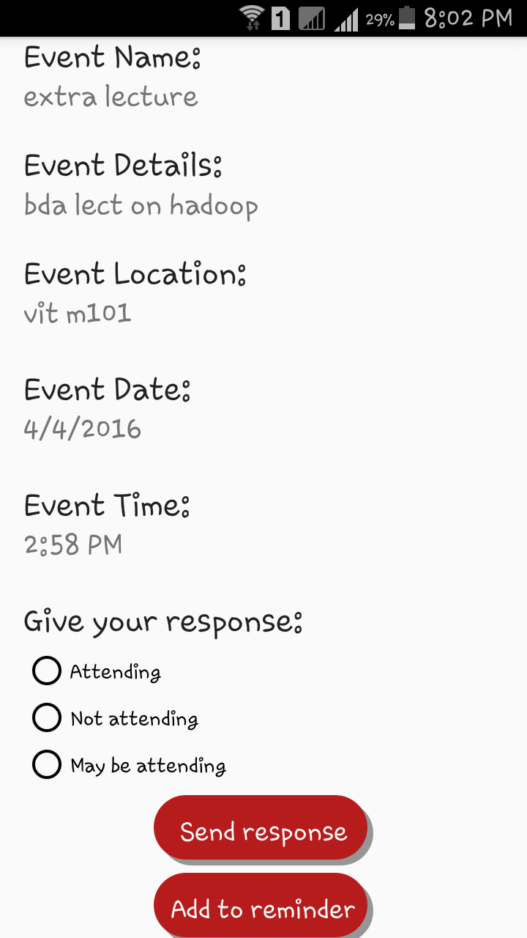

34

**6.2 Test Cases:**

Android is the largest operating system in the world. At the same time, Android is fragmented. There are tons of devices and Android versions that the app must be compatible with therefore we performed the following tests:

**1) Unit testing:**

These are specific to a particular unit. The basic functionality of the unit is to be understood based on the requirements and the design documents. Generally design document will provide a lot of information about the functionality of the unit.

For our application, if the user enters valid email id and username values, let us assume that design document says that the system must display the user details and should insert the email id and username in the given field. If user enters invalid user id system will display appropriate error message and will not store it in database.

**2) Functionality Testing** -The below are some of checks that performed.

* Verified there are no invalid redirects.
* Checked all the validations on each field.
* Wrong inputs to perform negative testing.
* Verified the workflow of the system.
* Verified the data integrity.

3) **Usability testing -**To verify how the application is easy to use with.

* Tested the navigation and controls.
* Content checking.

35

* Checked for user intuition.

4) **Interface testing -**Performed to verify the interface and the dataflow from one system to other.

5) **Compatibility testing-**Compatibility testing is performed based on the context of the application.

* Bluetooth compatibility
* Operating system compatibility
* Compatible to various devices like NFC tags.

6) **Performance testing -**Performed to verify the server response time and throughput under various load conditions.

* **Load testing -**It is the simplest form of testing conducted to understand the behaviour of the system under a specific load. Load testing will result in measuring important business critical transactions and load on the database, application server, etc. are also monitored.
* **Stress testing -**It is performed to find the upper limit capacity of the system and also to determine how the system performs if the current load goes well above the expected maximum.
* **Soak testing -**Soak Testing also known as endurance testing, is performed to determine the system parameters under continuous expected load. During soak tests the parameters such as memory utilization is monitored to detect memory leaks or other performance issues. The main aim is to discover the system's performance under sustained use.
* **Spike testing -**Spike testing is performed by increasing the number of users suddenly by a very large amount and measuring the performance of the system. The main aim is to determine whether the system will be able to sustain the work load.

36

* **Security testing -**Performed to verify if the application is secured on web as data theft and unauthorized access are more common issues and below are some of the techniques to verify the security level of the system.
  + Injection
  + Broken Authentication and Session Management
  + Cross-Site Scripting (XSS)
  + Insecure Direct Object References
  + Security Misconfiguration
  + Sensitive Data Exposure
  + Missing Function Level Access Control
  + Using Components with Known Vulnerabilities
  + Invalidated Redirects and Forwards

37

**8) Validation testing:**

|  |  |  |  |  |  |
| --- | --- | --- | --- | --- | --- |
| Test case no | Test Case | Description | Expected  results | Actual results | status |
| 1 | User login | The user is authenticated with the respected username and password | The user is logged in successfully only if the login details provided by the user are correct | As per the expected results | **PASS** |
| 2 | User connection to server | The user connects to the server using the specific channel assigned to the user, user id of the client and the IP address of the user | User connects successfully to the server provided username provided is correct else user is not connected to server. | As per the expected results | **PASS** |
| 3 | User side encryption | The password entered by the client are stored in encrypted format in the databases | The password entered by the user are stored in encrypted format and encryption is applied to each and every password | As per the expected results | **PASS** |
| 4 | Registration form | The registration form for the new user is validated by checking all the details like first name, last name, email address, phone number are filled. If any of these violated then error message is shown | If all the mandatory fields are filled properly then the new user is registered and entry is made into database | As per the expected results | **PASS** |
| 5 | Users account | While creating users account, uploading profile picture and filling up the user details are checked. If there is any error in it then error message is shown | Users profile pictures are uploaded only if the size mentioned matches with photo’s size, otherwise photo not accepted and message is shown. | As per the expected results | **PASS** |
| 6 | Accessing modules | After logging in, users’ friends, events and profile are shown. | Validation must be done properly | As per the expected results | **PASS** |

**9) Alpha and Beta testing:**

After all the above mentioned tests, we took reviews from our colleagues. Some of the views are stated below.

* “The application is very useful for any user or store who wants to connect to their customers. We also get to connect with our friends and tell them about the various events happening. It’s amazing.”

- Vaibhav Pathak

* “The features of this application are easy to understand. Any ordinary person can use this application in a very efficient way.”

- Manjiri Acharekar

39

**7. Conclusion & Future Scope**

Our primary objective behind this project was to help the people who have a busy schedule and sometimes find it difficult to track the events happening in their life as lot of events are happening simultaneously in this fast paced world and new events keep on emerging on the spur of a moment.

Thus we designed and implemented an android application which helps us efficiently to create and manage the various important events happening around in our life.

We needed to learn different concepts and techniques quickly and apply them in the system. The project also provided a chance for us to accumulate experience in software development using Android. This project experience has greatly enriched our knowledge and sharpened our technical skills and critical thinking.

Even though we created an application to help people create and manage events, a lot improvements and enhancements are however possible in the future as follows:

* **Wifi** : Server side implementation can also be done if proper authentication process can be implemented so that the user can not only receive the broadcasts but also create them.
* **Bluetooth**: Currently we are sending only text messages through the Bluetooth feature but an improvement can be made to send files through Bluetooth. Also a security measure can be developed to receive the files so that the security of the user is not compromised. Currently, the list of all the messages acquired via bluetooth cannot be seen. So, that privilege can also be added.
* **Block** feature can be added to give more control to the user over his connections and improve his privacy.
* **Location:** Instead of manually entering the Event Location an improvement can be made to display the event on Google Maps and by using the GPS feature the user will automatically be notified when he comes at location of the event.
* **News feed :** A news feed feature can be applied where the user can get to know all the (public post/invitation) events he created at a time.

40

**Appendix A: User Manual**

1. Launch the application from the menu folder in the mobile device
2. Select a feature from the home screen of the application
3. Select any option provided in the navigational bar provided on the home screen.

 

41

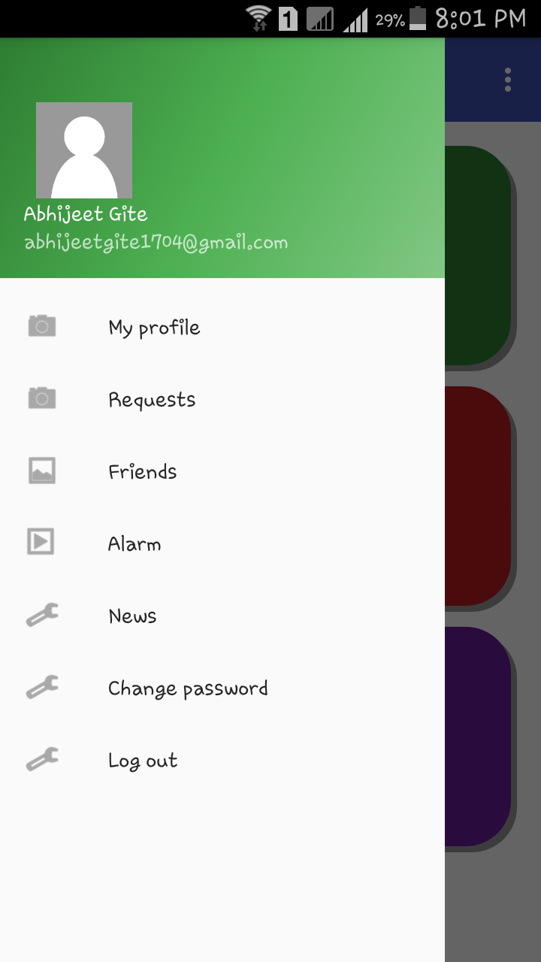

42

**Appendix B: Classes and external libraries:**

We needed to import the following libraries and classes/packages for our project :

* **android.app.ProgressDialog** : Creates a ProgressDialog with a horizontal progress bar
* **android.content.Intent** : Selecting a particular person to view would result in a new intent
* **android.util.Log** : Priority constant for the println method
* **android.widget.Toast** : A toast is a view containing a quick little message for the user. The toast class helps you create and show those.
* **com.android.volley** : Volley is a library that makes networking for Android apps easier
* **org.json** : JSON is a light-weight, language independent, data interchange format.
* **android.app.AlarmManager** : These allow you to schedule your application to be run at some point in the future
* **android.media** : Add video, audio, and photo capabilities to your app with Android's robust APIs
* **android.view** : The Android framework provides a set of base classes and XML tags to help you create a view that meets all of these requirements.
* **android.widget** : The widget package contains (mostly visual) UI elements to use on your Application screen
* **android.bluetooth** : The Android platform includes support for the Bluetooth network stack, which allows a device to wirelessly exchange data with other Bluetooth devices.
* **android.graphics** : Make your apps look and perform their best using Android's powerful graphics features
* **com.mcxiaoke.volley:library:1.0.19** : Volley is a network library from Android source code.
* **com.squareup.picasso:picasso:2.5.2** : A powerful image downloading and caching library for Android.
* **com.github.siyamed:android-shape-imageview:0.9+@aar** : Custom shaped android imageview components

43

**Appendix C: Input and Output Test Cases**

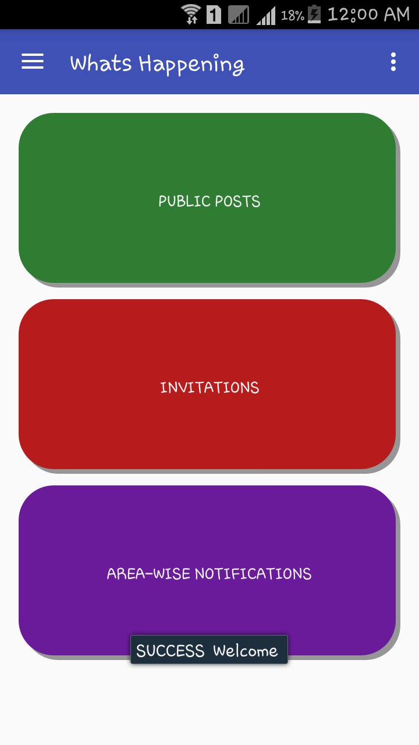 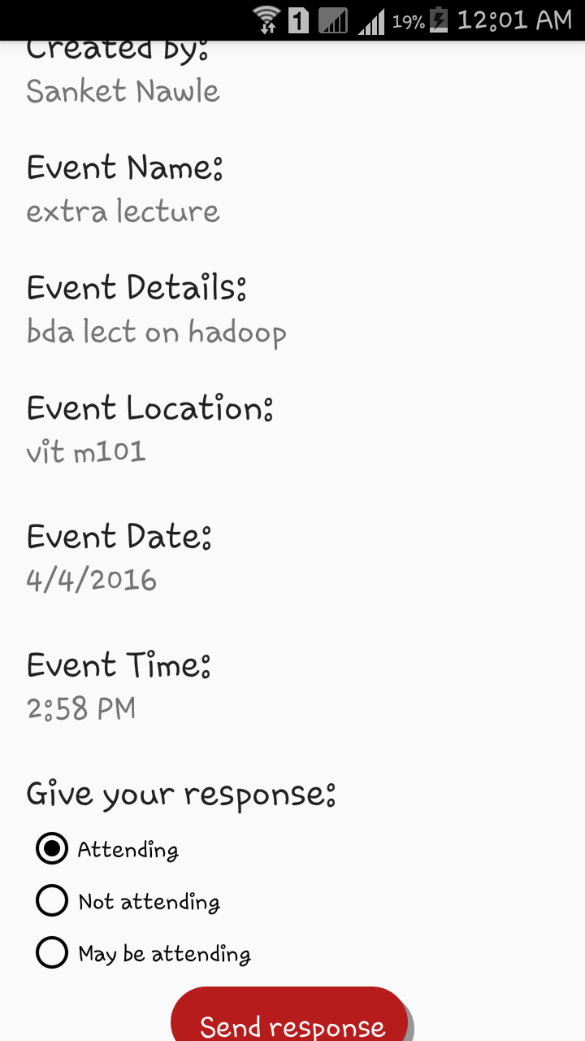

44

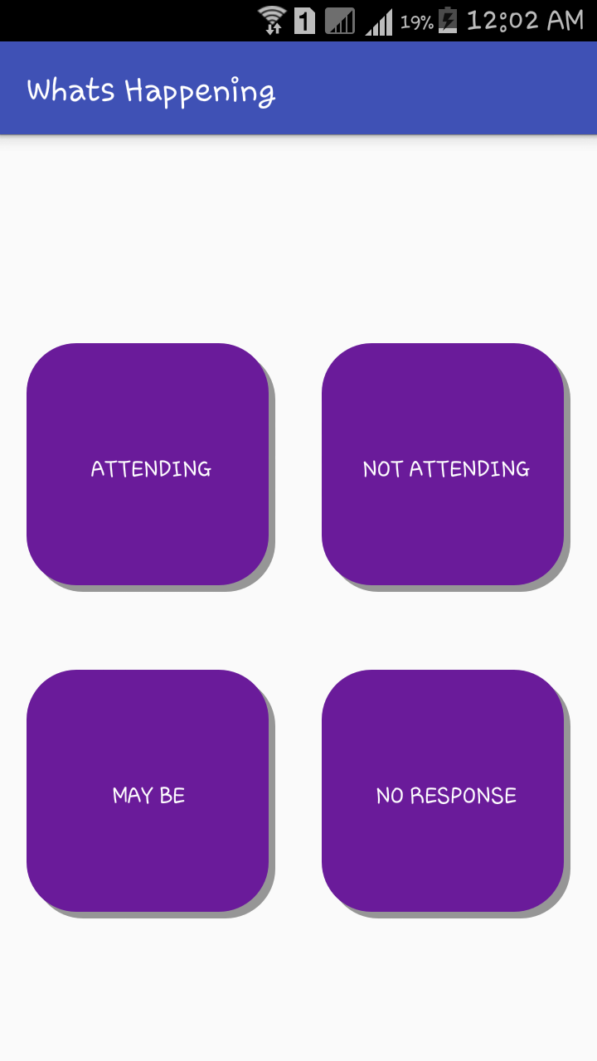 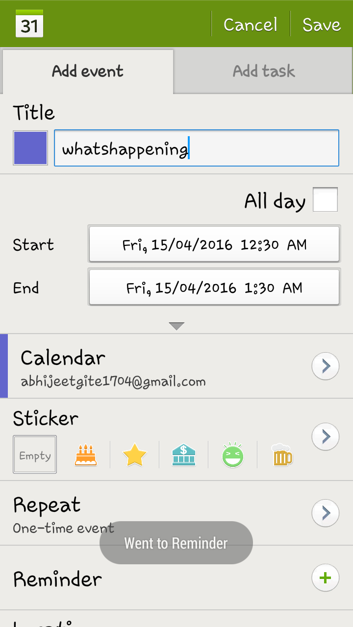

45

**Publications and Poster Presentations**

[1] “Author names: Abhijeet Gite, Sanket Nawle, Shruti Sadalge, Amit Dhanwani”, “Project title: What’s Happening”, “Conference name: “First National Research Symposium on RACEM-2015”, “Date: December, 2015”

[2] “Author names: Abhijeet Gite, Sanket Nawle, Shruti Sadalge, Amit Dhanwani”, “Project title: What’s Happening”, “Conference name: “ 2nd National level Technical Paper Presentation in UCoE”, “Date: November,2015”

[3] “Author names: Abhijeet Gite, Sanket Nawle, Shruti Sadalge, Amit Dhanwani”, “Project title: What’s Happening”, “Conference name: “ Tantra Vihar 2016”, “Date: April, 2016”

46

**Bibliography**

[1]<http://rts.lab.asu.edu/web_438/project_final/CSE_598_Android_Architecture_Binder.pdf>

[2] <http://www.compiletimeerror.com/2012/12/blog-post.html#.VfgXBxGqpBc>

[3] <https://developer.android.com/guide/topics/connectivity/nfc/index.html>

[4] <https://developer.android.com/guide/topics/connectivity/nfc/nfc.htm>

[5]<http://trendblog.net/creative-and-useful-ways-to-use-nfc-tags-with-your-smartphone/>

[6] <http://developer.android.com/guide/topics/ui/notifiers/notifications.html>

[7] <http://www.tutorialspoint.com/android/android_notifications.htm>

[8] <https://en.wikipedia.org/wiki/Transmission_Control_Protocol>

[9] <http://searchnetworking.techtarget.com/definition/TCP>

47