Discovery and Development of a Pharma drug for Treatment of Diabetic Retinopathy

Ross Kopelman

DIABETIC RETINOPATHY

According to the Center for Disease Control (CDC), diabetes mellitus (DM) is estimated to affect approximately 24 million Americans, with about a third of diabetic individuals presenting with diabetic retinopathy and 4.1 percent presenting with severe vision-threatening issues after age 40 [1]. Diabetic retinopathy (DR) is one of the leading causes of blindness in the United States, affecting more than 5.3 million Americans over the average age of 18 making up approximately 2.5% of the U.S. population.

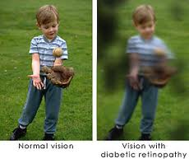
Figure 1: Regular Eye Vs. Diabetic Eye [2]
Furthermore according to the World Health Organization, there are currently 285 million people worldwide with diabetes mellitus and there is a projected to be a 35 percent increase in the number of people afflicted with diabetes by 2030 [3]. Early annual or biannual screenings are recommended to help identify those populations at greatest risk and offer them medical and surgical therapies that can prevent visual impairment [4].

An ocular examination offers a unique opportunity to directly examine retinal blood vessels in order to assess the progression of diabetic vascular disease. Therefore, the early detection of diabetic retinopathy can be achieved with close monitoring of the condition. Multiple epidemiologic studies and randomized clinical trials have demonstrated the value of therapeutic interventions to prevent progression of diabetic retinopathy [5]. Such interventions include improved systemic control of hyperglycemia, hypertension, and hyperlipidemia, laser photocoagulation, and surgical vitrectomy. Furthermore, evidence based studies suggest that early intervention and strict control of hyperglycemia can reduce the risk of macular edema and diminish the incidence of moderate to severe DR. [1]
Characteristic Features:

Diabetic retinopathy (DR) is an eye condition that affects individuals with either type I or type II diabetes, which leads to visual problems and potential blindness. Because of the tendency of diabetic patients to develop swollen leaky retinal vessels as well as neovascularization, which may lead to visual loss, diabetics are encouraged to have their eyes checked regularly [6]. The World Health Organization (WHO) estimates that after 15 years of diabetic mellitus, approximately 2% of people afflicted become blind, while 10% develop severe visual impairment [7].
Market:
The diabetic retinopathy pharmaceutical market is said to grow 8 fold to 700 million annually by 2020 [8]. This increase in the demand for pharmaceuticals for diabetic retinopathy is largely driven by a 3 million more people who will have diabetic retinopathy by 2020 [9].
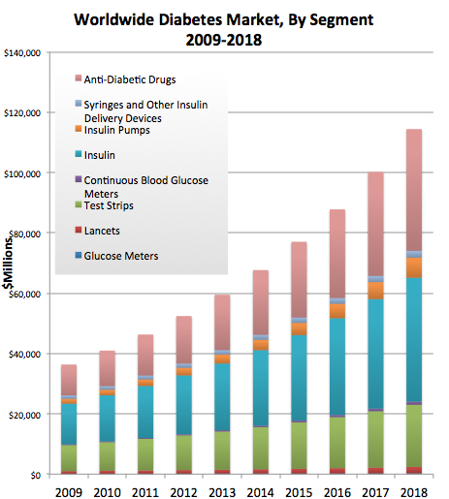
Figure 2: Diabetes Market Worldwide [10]

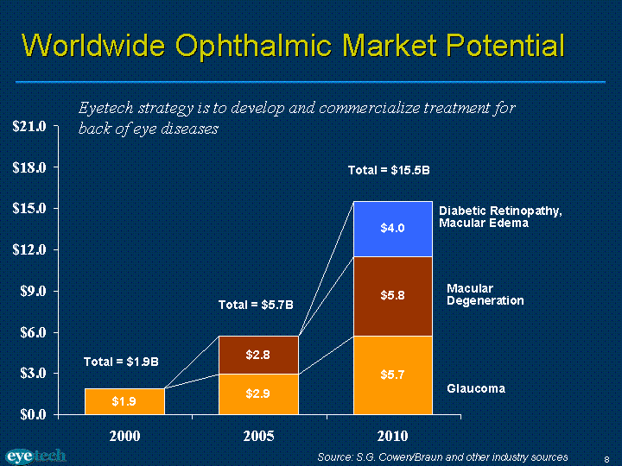
Figure 3: Diabetic Retinopathy Market Size [11]
TREATMENT

There are two main categories for treating Diabetic Retinopathy. The following are:

- Non-pharmacologic: This is involves utilizing photocoagulation to reduce the number of red blood vessels that are located at the back of the retina.
- Pharmacologic: This involves treating many of the secondary issues of treating diabetic retinopathy in order to halt the progression of the diseases which involve maintaining blood glucose, blood pressure, formation of triglycerides to name a few.

Drug | Route of administration | Dosage | Mechanism of Action | Side Effects
Triamcinolone | Intravitreal injection | 13 mg ^{[12]} | Inhibition of arachidonic acid thereby controlling biosynthesis of prostaglandins and leukotrienes. [13] | Eye pain, eye tearing, vision changes
Avastin (bevacizumab) | Intravitreal injection | 1.25mg ^{[14]} | Anti-VEGF antibodies and antibody fragments to shrink new red blood vessel growth | Eye inflammation
Lucentis (ranibizumab) | Intravitreal injection | 0.3-0.5mg ^{[15]} | Inhibits VEGF factor A | Eye inflammation
Fenofribrate [16] | Oral | 200 mg (once daily) | Lowers plasma triglycerides | Gallstones, liver problems, weakness of muscles
Candesartan | Oral | 16mg (once daily) ^{[17]} | Blocks the binding of angiotensin II to AT1. ^{[13]} | Fatal births if used with pregnant woman
Table 1. Drugs currently used to treat diabetic retinopathy. Pharma drugs include drug name, route of administration, dosage, mechanism of action, mechanism of action, and side effects..

Discussion of the Current Drugs:

The progression to diabetic retinopathy is a serious concern for diabetic patients. Currently there are no pharmaceuticals that target the condition head on. Rather the current drugs on the market address diabetic retinopathy through targeting blood glucose issues and blood pressure in the hope that if those conditions can be managed then the progression of the disease will slow down [18]. Current approaches to treat the condition and prevent the worsening of vision lose involve utilizing laser treatment (photocoagulation) to remove retinal vessels that have the potential to leak. Utilizing ant—vascular endothetial growth factor is an attempt to shrink the size of new red blood vessels that appear due to progression of diabetic retinopathy but still there is a strong need for an FDA approached drug that goes directly at the biochemical issue that leads to the progression of diabetic retinopathy. The other approaches are not guaranteed fixes all that the current methodology accomplishes is a quick fix to help alleviate the rate of progression for patients to get diabetic retinopathy.

MEDICAL NEED

According to the Center for Disease Control (CDC), diabetes mellitus affects approximately 24 million Americans with approximately one third of these patients presenting with diabetic retinopathy and 4 percent presenting with severe vision threatening retinopathy after the age of forty. Diabetic retinopathy is one of the leading causes of blindness in the United States, affecting more than 5.3 million Americans over the age of 18. In addition there are currently an estimated 285 million people worldwide who have diabetes mellitus and there will be a projected 35 % increase in the number of patients with the disease by 2030.

Currently the therapeutic options include laser therapy, surgery, tight control of serum glucose levels and the experimental use of vascular endothelial growth factor (VEGF) inhibitors as a means to limit the proliferation of new blood vessels that can precipitate visually threatening sequel in diabetic patients. Most of these therapies target retinal changes after they occur. Normally glutathione is an anti-oxidant that prevents vascular leakage and vascular occlusions. However in diabetic retinopathy there is an up-regulation of aldose reductase, which prevents glutathione production. No pharmaceuticals agents currently available target the inhibition of aldose reductase pathway.

Medical Hypothesis:
My target is Aldose Reductase. Aldose reductase is the first enzyme in the polyol pathway that is important for glucose metabolism.

Mechanism
The Polyol pathway is a biochemical mechanism for results in diabetic retinopathy. Glucose is able to diffuse into and out of the cell. Sorbitol is what gets stuck in the cell as a result of glucose being converted by aldose reductase. Aldose reductase requires NADPH.

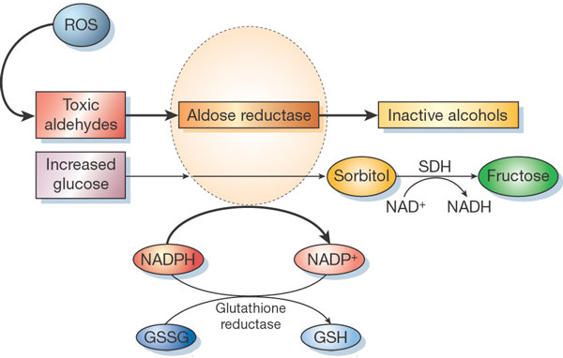
Figure 4: The mechanism of the polyol pathway [19]

The sorbitol then gets converted with the help of sorbitol dehydrogenase into fructose as you can see in Figure 1which will then eventually be converted into the glycolysis cycle. The sorbitol dehydrogenase requires NAD to function properly.

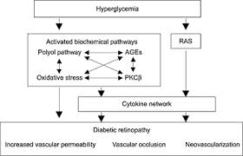
Figure 5: The mechanism of the polyol pathway with increase in glucose blood levels [20]

In diabetes where there is an increase in blood glucose the cells will try and uptake some of that glucose to help level out and attempt to normalize those glucose levels. With the increase in glucose levels it will result in sorbitol levels increasing thereby trapping some of that glucose in the cell in an attempt to lower the blood glucose levels. Sorbitol will be osmotically active and will not cross the cell membrane therefore an osmotic gradient will increase within the cell. Increased sorbitol levels will result in advanced glycosylated end products (AGE) [21]. As sorbitol increases it results in the depletion of NADPH.

NADPH normally helps to reduce glutathione to the usable form where it can act as an anti-oxidant, however now that the NADPH levels have decreased there ultimately now will be a reduction in the anti-oxidants available. In Figure 2 we can see that the result is an increase in oxidative stress and reactive oxygen species (ROS) that cannot be neutralized. With an increase in oxidative stress the result is increased vascular permeability and occlusions. Both of which are major pathophysiology components of diabetic retinopathy.

The focus is to biosynthesize an inhibitor that will bind to aldose reductase. By targeting aldose reductase with an inhibitor, it will result in the inhibition of the polyol pathway, which will prevent the buildup of sorbitol in the cells. Ultimately normal levels of NADPH are maintained so that glutathione is readily available to act as an antioxidant. This will prevent an increase in ROS and decrease oxidative stress. By preventing this oxidative stress it will be possible to prevent the emergence of diabetic retinopathy. The approach of utilizing a molecular antagonist to inhibit a key enzyme (aldose reductase) is addressing a fundamental biochemical defect that leads to vascular leakage and occulsions two primary events in early diabetic retinopathy and the eventual progression of the retinopathy to more threatening stages. Therefore if we can pharmacologically inhibit this pathway we maybe able to prevent the progression of the disease to a visually threatening stage.

LEAD COMPOUND:

The lead compound being used is SNK-860, which is an aldose reductase inhibitor. Fiderastat is potentially a good compound to help prevent and treat diabetic retinopathy. The inhibitor is utilized in order suppress sorbitol accumulation in peripheral nerve by inhibiting aldose reductase in the polyol pathway. [23]

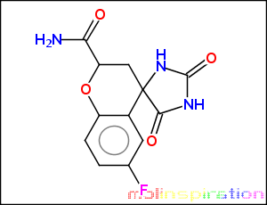
Figure 6: Lead Compound [23]

Chemical properties:

Molecular Weight = 279.227 Da
LogP = -0.418
N+O = 7
H Donors = 4

TARGET ASSAY:
The main motive of this assay is to determine the binding affinity of my inhibitor (drug), thereby, preventing the accumulation of sorbitol in the cells.
There are two assays selected, which are:

Assay | Protocol
Fluorometric Enzyme Assay | In this method, the drug molecule is linked with a fluorescent dye that will show fluorescence on absorbing light of a different wavelength. Thus drug interacts with the target enzyme inhibiting its function. Assay: more the inhibition more the fluorescence.
Enzyme-Linked Immunosorbent Assay | This is a competitive immunoassay where the change in signal reading is considered/measured. This is caused by the binding activity of the enzyme and the drug which changes the conformation of the enzyme, further restricting the enzyme to bind to the Ab. Therefore the single read goes down
Table 2: Different types of target assays

Out of these two, the one, which I will be selecting as the target assay, will be ELISA (Enzyme-Linked Immunosorbent Assay).

ELISA Assay: ^{[24]}
Principle:
In this Assay, Antibody is first immobilized to the plastic surface and then the Antigen (Enzyme), binds to the antibody. Then, Secondary Ab conjugated with enzyme binds to the antigen, thereby, making a Sandwich and gives colored product on addition of colorless substrate. Thus, when my inhibitor drug binds to Ab’s, concentration of enzyme (Antigen) decreases in the solution.

Experiment:
Immunoplates were coated with purified antibodies diluted in carbonate buffer at room temperature for 2 hours. Plates are washed three times with washing solution and blocked with blocking buffer for 30 min at room temperature. Then, Antigen solution (Aldose reductase) diluted with blocking buffer were placed in each well and incubated with constant agitation. Then, after washing it again three times, add secondary antibody conjugated with Alkaline Phosphatase in blocking buffer and incubate for 2 hours at room temperature. Later, the Antigen-Antibody complex formed was detected by adding substrate solution. Hydrolysis of the substrate was measured at 405nm with plate reader at the time when the highest O.D. reading in the plate reached 1.0-1.5. Addition of inhibitor diluted with blocking buffer will lead to decrease in the O.D. reading of the plate.
Diagrammatic Representation:

D
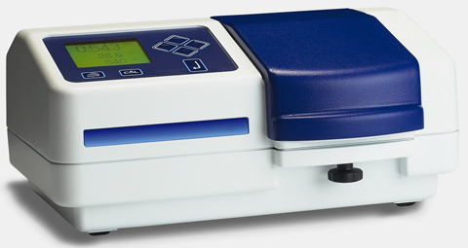
Spectrophotometer

Figure 7: ELISA Assay

Result:

A standard curve is observed when purified antigen, which is aldose reductase is added to the solution. When inhibitor is added to the solution in range of ng/ml, it gradually decreases the concentration of aldose redutase in the solution, thereby, confirming its binding to the antibodies.
Results are demonstrated below:

Inhibitor Concentration (ng/ml) | O.D.
0 | 1.121
10 | 0.982
20 | 0.826
30 | 0.695
40 | 0.600
Table 3: Readings interpreting O.D. for respective concentration of drug.

Figure 8: Graph representing the binding of drug with inhibitor.

Conclusion:
This assay is most effective to use as drug-binding assay. This assay is ideal to measure the OD levels. In order to execute it, there is a need to create a recombinant aldose reductase. One method is to utilize a barulovirus system to raise the antibodies. Best antibody to utilize is ARAB because of its high sensitivity and specificity for aldose reductase in comparison to other antibodies that have been attempted for this purpose.

DESIGNING AN NCE:

The compound, which I selected as a lead, is a very good aldose reductase inhibitor. It prevents the binding of glucose with aldose reductase, thus, preventing sorbitol production and hence, diabetic retinopathy progression.
The general chemical structure of the lead is shown in Fig1, with R1 and R2 as side groups attached.

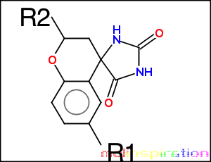
Figure 9: General Structure [22]

Compound | Structure
Lead
NCE 1 | 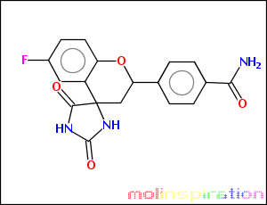
NCE 2 | 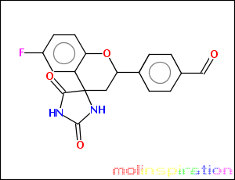
NCE 3 | 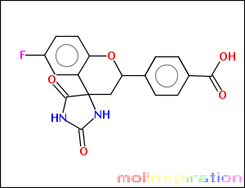
NCE 4 | 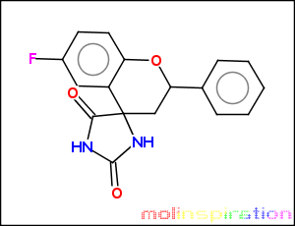
NCE 5 | 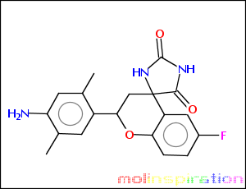
Table4. Chemical Structures of compounds [22]

Compound | R1 | R2 | LogP | Molecular Weight | Target Assay (Ki)
Lead | 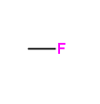 | 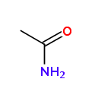 | -0.488 | 293.254 Da | 210
NCE 1 |  | 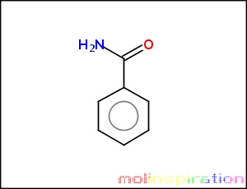 | 1.264 | 355.325 Da | 183
NCE 2 |  | 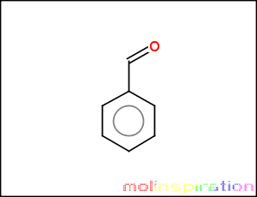 | 2.235 | 340.31 Da | 97
NCE 3 |  | 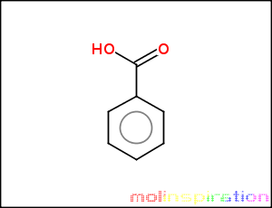 | 2.356 | 356.309 Da | 152
NCE 4 |  | 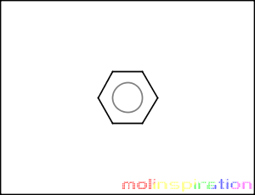 | 2.445 | 312.30 Da | 52
NCE 5 |  | 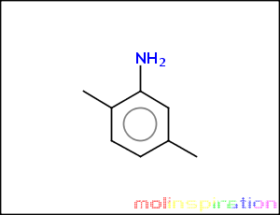 | 2.682 | 355.369 Da | 11
Table5- Side groups attached, LogP, Molecular Weight of compounds and target assay. [22]
ACTIVE SITE MODEL:
The compound Fideristat was picked as the primary lead because it is a very good aldose reductase inhibitor. Below in table 1 there are new chemical entities, which have been designed to help enhance the potency of their effects as inhibitors on aldose reductase. The new chemical entities engineered attempt to better follow the “rule of four” and in some cases result in greater optimization than original lead to increase affinity to the receptor, specificity for the receptor, efficacy of the compound, and the ADME profile. For the new features for the engineered lead refer to table 1 and table 2. And notice the changes to the molecular structure in table 2.
It is important to examining the active site of aldose reductase closer in figure X to better understand its overall form and function. The aldose reductase enzyme is a single polypeptide composed of 315 AAs. The active site is located in a large and deep crevice in the C-terminal end, which happens to be the region containing the least conserved residues. There is three distinct binding pockets in the active site as seen in Figure 10. The anion - binding pocket composed of Tyr48, His110, Trp20, and Trp111 side chains. The second is a hydrophobic pocket, known as specificity pocket, and lined by the residues Leu300, Cys298, Cys303, Trp111, Cys303, and Phe122 and the third is another hydrophobic pocket formed by the residues Trp20, Trp111, Phe122, and Trp219. [25]

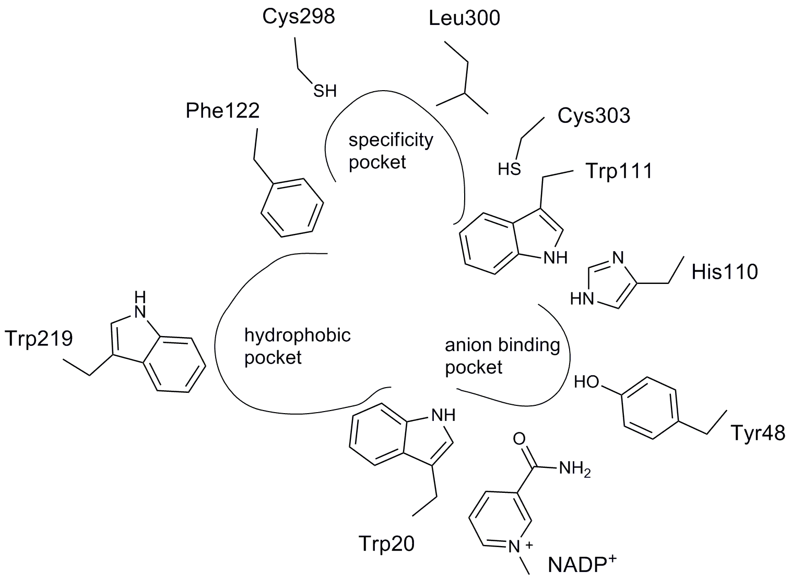
Figure 10: Active Site of Target [25]

Interaction of inhibitor in the Actice site:
There are two side groups R1 and R2 in NCE 5, which contain Fluorine and amino group in their binding sites. R1 binds with cysteine residue in the specificity pocket and R2 binds in the hydrophobic pocket and there is binding in the anion-binding pocket with ketone group in the NCE 5.

Figure 11: Interaction of amino acids with drug in active site of target.

PHARMACOLOGICAL PROFILING:
In pharmacological profiling, different assays are performed to know the potency, binding and different properties of NCE.
Some of the Assays performed include Binding Assay, Activity Assay, CYP inhibition Assay, hERG Assay and UGT assay.

CYP Inhibition Assay: ^{[26]}
CYP2D6 is the marker enzyme, whose inhibition is critical for a drug, which enters the body.
In this assay, a fluorescent marker substrate dextromethorphan is incubated at low concentration with HL microsomes and NADPH. CYP2D6 exclusively demethylates dextromethorphan to dextrophan (fluorescent metabolite). Since, both dextromethorphan and dextorphan are both fluorescent at same excitation and emission wavelengths, thus, HPLC is used for their separation and analyzed fluorimetry.

hERG Inhibition Assay: ^{[27]}
Cells present in plastic culture dishes were transferred to the stage of an inverted phase contrast microscope and continuously superfused with HEPES-buffered saline. Experiments were performed at different temperatures either ambient or near physiological. The onset and steady state block of hERG K current at room temperature were evaluated using a pulse pattern with fixed amplitudes from holding potential of -80mV. There was a solution exchange, which was completed in 30s and the exposure time of every cell to different concentration of drug was limited to 10minutes.

UGT Assay: ^{[28]}
UGT1A6 is an important UGT isoform known to catalyze the glucuronidation of planar and short aromatic molecules, including drugs such as acet- aminophen and potential carcinogens chemically related to hydroxy- lated polycyclic aryl hydrocarbons. In humans, it is expressed in liver, kidney, brain, lung, and intestine.
In this assay, incubation mixtures containing buffer and UDPGA are taken. Alamethicin is also included in HLM incubations. Incubations are performed in the water bath for 20-60mins and addition of acetonitrile leads to its termination. After that, centrifugation is carried out and supernatants are dried down and reconstitutedwith water. Standard curves were generated using using purified serotonin glucuronide.

Activity Assay: ^{[29]}
Principle:
The purpose of this assay is to measure the activity of drug in the target molecule, once it binds to the target. The assay used is based on the principle that when cells containing target binds the drug; it measures the decrease in the concentration of target molecule.

Experiment:
Aldose reductase from A7r5 cells was determined by using method of Wermuth and von Wartburg. Cells were harvested by trypinsisation and resuspended in ice-cold assay buffer. After this, sonication and centrifugation is required, than supernatants were kept on ice and assayed within 2 hours. For assay, samples were incubated with lithium sulfate and NADPH. NADPH oxidation is monitored after addition of glyceraldehyde and Inhibitor. Activity is monitored by absorbance at 340nm using spectrophotometer.

Results:
Different concentration of inhibitor was added to measure its activity. The concentration range used was from 0 to 2$μM$ and the activity was measured in O.D. But, the graph represented will show percentage inhibition with increase of concentration.

Inhibitor Concentration $(μM)$ | Percentage Activity of AR (%)
0 | 100
0.2 | 90
0.5 | 72
1.0 | 50
1.5 | 30
2.0 | 10
Table 5: Readings interpreting % activity for respective concentration of drug.

Figure 12: Graph representing the inhibiting activity of drug with inhibitor.

Conclusion:
Aldose Reductase (AR) enzyme, which is NADPH-dependent carbonyl reductase, is particularly susceptible to oxidative denaturation in vitro and in vivo. The results suggest that when the concentration of drug is increased, it reduces the activity of Aldose reductase in the cells.
This assay is done to check the ability of my drug to inhibit Aldose reductase activity.

Table 7: Representation of activity assay, CYP inhibition, hERG inhibition, UGT inhibition and target assay.
Compound | Activity  Assay  IC₅₀ (nM) | CYP inhibition  IC₅₀ (nM) | hERG  Assay  IC₅₀ $n$M | UGT  Inhibition  IC₅₀ $n$M | Target Assay  Ki nM
Lead | 90 | 145 | 214 | 16.1 | 210
NCE 1 | 48 | 50 | 183 | 11.2 | 183
NCE 2 | 20 | 153 | 200 | 5.3 | 97
NCE 3 | 63 | 100 | 80 | 10.7 | 152
NCE 4 | 125 | 168 | 130 | 2.1 | 52
NCE 5 | 6.3 | 280 | 310 | 7.2 | 11

Conclusions:

According to the SAR and pharmacologic profiling, NCE 5 is the most potent NCE for my target plus it follows Lipinski rule of 4.
- Molecular Weight: 355.369 Da
- LogP: 2.682 suggest that it is neither hydrophilic nor hydrophobic.
- Its IC₅₀ is 6.3nM provides the evidence that it has a very good inhibiting activity.
- Its pharmacologic profiling suggests that it is not a CYP and hERG inhibitor.

References:
- Davis MD, Fisher MR, Gangnon RE (1998) Risk factors for high-risk proliferative diabetic retinopathy and severe visual loss: Early Treatment Diabetic Retinopathy. Invest Ophthalmolology & Visual Science 39, 233-252.
- “Diabetic Retinopathy.” St. Luke’s Cataract & Laser Institute. (2012). Web. 19 January 2014. <http://www.stlukeseye.com/conditions/DiabeticRetinopathy.html>.
- Kohner EM, Stratton IM, Aldington SJ, et al. Relationship between the severity of retinopathy and progression to photocoagulation in patients with Type 2 diabetes mellitus in the UKPDS (UKPDS 52). Diabet Med 2001;18:178-84.
- Cost-Utility Analysis of Screening Intervals for Diabetic Retinopathy in Patients With Type 2 Diabetes Mellitus Sandeep Vijan, MD, MS; Timothy P. Hofer, MD, MS; Rodney A. Hayward, MD JAMA. 2000;283(7):889-896. doi:10.1001/jama.283.7.889.
- Writing Team for the Diabetes Control and Complications Trial/Epidemiology of Diabetes Interventions and Complications Research Group. Effect of intensive therapy on the microvascular complications of type 1 diabetes mellitus. JAMA 2002;287:2563-9.
- Klein, E., Moss, Klein. (October 1987)Management of Diabetic Retinopathy. Diabetes Care, Vol. 10 No.5, 633-638.
- [WHO] World Health Organization. Diabetes estimates and projections. WHO, 2008. Available at www.who.int/mediacentre/factsheets/fs312/en/index.html (last accessed June 2, 2009).)
- Comfort, C. (2011) The Diabetic Retinopathy Drug Market Will Expand Nearly Eight-Fold to $700 Million by 2020. Decision Resources. http://decisionresources.com/News-and-Events/Press-Releases/Diabetic-Retinopathy-121911
- Clare, S. (2013) EpiCast Report Diabetic Retinopathy – Epidemiology Forecast to 2022. PR Newswire. http://www.prnewswire.com/news-releases/epicast-report-diabetic-retinopathy---epidemiology-forecast-to-2022-237957811.html
- Driscoll, P. (2011) Diabetes Management Trends. Mediligence.http://blog.mediligence.com/category/stem-cell/page/3/
- Driscoll, P. (2011) Diabetes Management Trends. Mediligence.http://blog.mediligence.com/category/stem-cell/page/3/
- Spandau, U., Derse, M., Schmitz Valckenberg, P., Papoulis, C., & Jonas, J. (2005). Dosage dependency of intravitreal triamcinolone acetonide as treatment for diabetic macular oedema. British journal of opthalmology , 89 (8), 999-1003.
- http://www.drugbank.ca
- Avery, R., Pearlman, J., Pieramici, D., Rabena, M., Castellarin, A., Nasir, M., et al. (2006). Intravitreal bevacizumab (Avastin) in the treatment of proliferative diabetic retinopathy. Ophthalmology , 113 (10), 1695.e1-15.
- http://www.fda.gov/newsevents/newsroom/pressannouncements/ucm315130.htm
- http://emedicine.medscape.com/article/1225122-medication
- Rosing, K., Christensen, P., Hansen, B., Carstensen, B., & Parving, H.-H. (2003). Optimal Dose of Candesartan for Renoprotection in Type 2 Diabetic Patients With Nephropathy A double-blind randomized cross-over study. Diabetes Care , 26 (1), 150-155.
- Leal, E., Santiago, A., & Ambrosio, A. (2005). Old and new drug targets in diabetic retinopathy: from biochemical changes to inflammation and neurodegeneration. Current Drug Targets CNS Neurology Disorders , 4 (4), 421-434.
- Brownie, M. (2001). Biochemistry and Molecular Cell Biology of Diabetic Complications. Nature , 414, 813-820
- Funatsu, H., & Yamashita, H. (2002). Pathophysiology of Diabetic Retinopathy. Drugs news perspect , 15 (10), 633.
- M Lorenzi (2007) The polyol pathway as a mechanism for diabetic retinopathy: attractive, elusive, and resilient. Experimental Diabetes Research. Volume 2007, 61038
- http://molinspiration.com
- Anna Ramunna et. al. (2012). Progresses in the pursuit of aldose reductase inhibitors: The structure-based lead optimization step . European Journal of Medicinal Chemistry , 51, 216-226.
- Nishimura et. al. (1993). Quantitative Determination of Human Aldose Reductase by Enzyme-Linked Immunosorbent Assay Immunoassay of Human Aldose Reductase. Biochemical pharmacology , 46 (1), 21-28.
- Zhu, C. (2013). Aldose Reductase Inhibitors as Potential Therapeutic Drugs of Diabetic Complications . 17-46.
- Palamanda, J., Favreu, L., Lin, C. C., & Nomeir, A. A. (1998). Validation of a rapid microtiter plate assay to conduct cytochrome P450 2D6 enzyme inhibition studies. DDT , 3, 466-470.

- Kirsch, G. (2004). Variability in the measurement of hERG potassium channel inhibition: Effects of temperature and stimulus pattern . Journal of Pharmacological and Toxicological Methods , 50, 93-101.
- Krishnaswamy, S., Duan, S., Moltke, L. L., & Greenblat, D. (2003). Validation of Serotonin of (5-hydrotryptamine) as an in vitro substrate probe for human UDP-Glucuronosyltransferase (UGT) 1A6. Drug Metabolism and Disposition, 31(1).
- Kubiseski, T., Hyndman, D. J., Morjana, N., & Flynn, G. (1992). Studies on Pig Muscle Aldose Reductase. Kinectic Mechanism and Evidence for a slow conformational change upon coenzyme binding. The Journal of Biological Chemistry , 267 (10), 6510-6517.

