Discovery and Development of a Pharma drug for Treatment of Diabetic Retinopathy

Ross Kopelman

**Diabetic Retinopathy**

According to the Center for Disease Control (CDC), diabetes mellitus (DM) is estimated to affect approximately 24 million Americans, with about a third of diabetic individuals presenting with diabetic retinopathy and 4.1 percent presenting with severe vision-threatening issues after age 40.[1] Diabetic retinopathy (DR) is one of the leading causes of blindness in the United States, affecting more than 5.3 million Americans over the average age of 18 making up approximately 2.5% of the U.S. population.

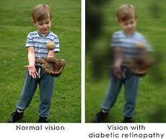

Figure : Regular Eye Vs. Diabetic Eye[2]

Furthermore according to the World Health Organization, there are currently 285 million people worldwide with diabetes mellitus and there is a projected to be a 35 percent increase in the number of people afflicted with diabetes by 2030.[3] Early annual or biannual screenings are recommended to help identify those populations at greatest risk and offer them medical and surgical therapies that can prevent visual impairment.[4]

An ocular examination offers a unique opportunity to directly examine retinal blood vessels in order to assess the progression of diabetic vascular disease. Therefore, the early detection of diabetic retinopathy can be achievedwith close monitoring of the condition.Multiple epidemiologic studies and randomized clinical trials have demonstrated the value of therapeutic interventions to prevent progression of diabetic retinopathy.[5]Such interventions includes improved systemic control of hyperglycemia, hypertension, and hyperlipidemia, laser photocoagulation, and surgical vitrectomy. Furthermore, evidence based studies suggest that early intervention and strict control of hyperglycemia can reduce the risk of macular edema and diminish the incidence of moderate to severe DR.

**Characteristic Features of Diabetic Retinopathy**

Diabetic retinopathy (DR) is an eye condition that affects individuals with either type 1 or type 2 diabetes, leading to visual problems and potential blindness. Because of the tendency of diabetic patients to develop swollen leaky retinal vessels as well as neovascularization which may lead to visual loss, diabetics are encouraged to have their eyes checked regularly.[6] The World Health Organization (WHO) estimates that after 15 years of diabetic mellitus, approximately 2% of people afflicted become blind, while 10% develop severe visual impairment.[7]

**Market**

The diabetic retinopathy pharmaceutical market is said to grow 8 fold to 700 million annually by 2020.[8] This increase in the demand for pharmaceuticals for diabetic retinopathy is largely driven by a 3 million more people who will have diabetic retinopathy by 2020.[9]

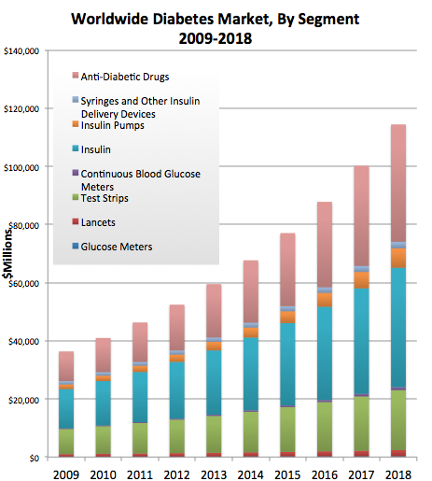Figure : Diabetes Market Worldwide[10]

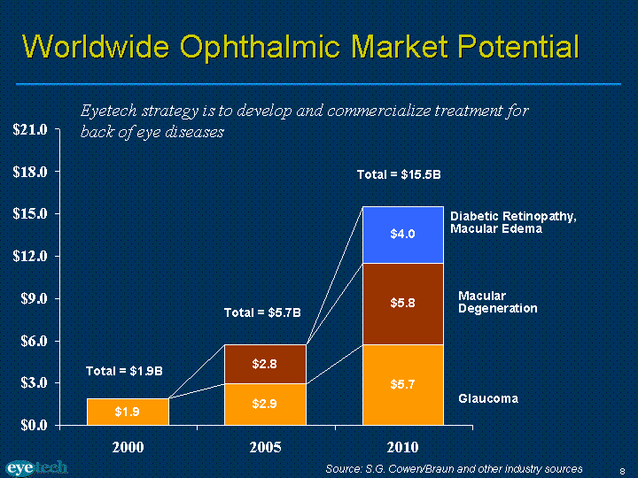Figure : Diabetic Retinopathy Market Size[11]

**TREATMENT**

There are two main categories for treating Diabetic Retinopathy. The following are:

* Non-pharmacologic: This is involves utilizing photocoagulation to reduce the number of red blood vessels that are located at the back of the retina.
* Pharmacologic: This involves treating many of the secondary issues of treating diabetic retinopathy in order to halt the progression of the diseases which involve maintaining blood glucose, blood pressure, formation of triglycerides to name a few.

|  |  |  |  |  |
| --- | --- | --- | --- | --- |
| Drug | Route of administration | Dosage | Mechanism of Action | Side Effects |
| Triamcinolone | Intravitreal injection | 13 mg[12] | Inhibition of arachidonic acid thereby controlling biosynthesis of prostaglandins and leukotrienes[13] | Eye pain, eye tearing, vision changes |
| Avastin (bevacizumab) | Intravitreal injection | 1.25mg[14] | Anti-VEGF antibodies and antibody fragments to shrink new red blood vessel growth | Eye inflammation |
| Lucentis (ranibizumab) | Intravitreal injection | 0.3-0.5mg[15] | Inhibits VEGF factor A | Eye inflammation |
| Fenofribrate[16] | Oral | 200 mg (once daily) | Lowers plasma triglycerides | Gallstones, liver problems, weakness of muscles |
| Candesartan | Oral | 16mg (once daily)[17] | Blocks the binding of angiotensin II to AT1[18] | Fatal births if used with pregnant woman |

Table 1. Drugs currently used to treat diabetic retinopathy. Pharma drugs include drug name, route of administration, dosage, mechanism of action, mechanism of action, and side effects..

**Discussion of the Current Drugs:**

The progression to diabetic retinopathy is a serious concern for diabetic patients. Currently there are no pharmaceuticals that target the condition head on. Rather the current drugs on the market address diabetic retinopathy through targeting blood glucose issues and blood pressure in the hope that if those conditions can be managed then the progression of the disease will slow down.[19] Current approaches to treat the condition and prevent the worsening of vision lose involve utilizing laser treatment (photocoagulation) to remove retinal vessels that have the potential to leak. Utilizing ant—vascular endothetial growth factor is an attempt to shrink the size of new red blood vessels that appear due to progression of diabetic retinopathy but still there is a strong need for an FDA approached drug that goes directly at the biochemical issue that leads to the progression of diabetic retinopathy. The other approaches are not guaranteed fixes all that the current methodology accomplishes is a quick fix to help alleviate the rate of progression for patients to get diabetic retinopathy.

**MEDICAL NEED**

### According to the Center for Disease Control (CDC), diabetes mellitus affects approximately 24 million Americans with approximately one third of these patients presenting with diabetic retinopathy and 4 percent presenting with severe vision threatening retinopathy after the age of forty. Diabetic retinopathy is one of the leading causes of blindness in the United States, affecting more than 5.3 million Americans over the age of 18. In addition there are currently an estimated 285 million people worldwide who have diabetes mellitus and there will be a projected 35 % increase in the number of patients with the disease by 2030.

### Currently the therapeutic options include laser therapy, surgery, tight control of serum glucose levels and the experimental use of vascular endothelial growth factor (VEGF) inhibitors as a means to limit the proliferation of new blood vessels that can precipitate visually threatening sequel in diabetic patients. Most of these therapies target retinal changes after they occur. Normally glutathione is an anti-oxidant that prevents vascular leakage and vascular occlusions. However in diabetic retinopathy there is an up-regulation of aldose reductase which prevents glutathione production.  No pharmaceuticals agents currently available target the inhibition of aldose reductase pathway. [[ii]](https://mail.google.com/mail/u/1/#144e28d2e61c8365__edn2)

### [Investigative Ophthalmology & Visual Science](http://www.iovs.org/)

**Medical Hypothesis:**

**My target is Aldose Reductase.** Aldose reductase is the first enzyme in the polyol pathway that is important for glucose metabolism.

**Mechanism**

The Polyol pathway is a biochemical mechanism for results in diabetic retinopathy. Glucose is able to diffuse into and out of the cell. Sorbitol is what gets stuck in the cell as a result of glucose being converted by aldose reductase. Aldose reductase requires NADPH.

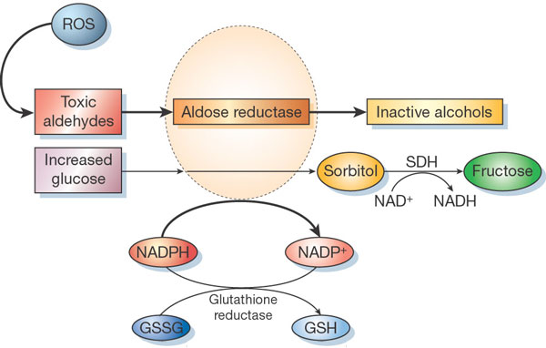

Figure : The mechanism of the polyol pathway [20]

The sorbitol then gets converted with the help of sorbitol dehydrogenase into fructose as you can see in Figure 1which will then eventually be converted into the glycolysis cycle. The sorbitol dehydrogenase requires NAD to function properly.

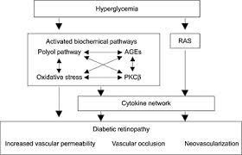

Figure : The mechanism of the polyol pathway with increase in glucose blood levels[21]

In diabetes where there is an increase in blood glucose the cells will try and uptake some of that glucose to help level out and attempt to normalize those glucose levels. With the increase in glucose levels it will result in sorbitol levels increasing thereby trapping some of that glucose in the cell in an attempt to lower the blood glucose levels. Sorbitol will be osmotically active and will not cross the cell membrane therefore an osmotic gradient will increase within the cell. Increased sorbitol levels will result in advanced glycosylated end products (AGE).[22] As sorbitol increases it results in a depletion in NADPH.

NADPH normally helps to reduce glutathione to the usable form where it can act as an anti-oxidant, however now that the NADPH levels have decreased there ultimately now will be a reduction in the anti-oxidants available. In Figure 2 we can see that the result is an increase in oxidative stress and reactive oxygen species (ROS) that cannot be neutralized. With an increase in oxidative stress the result is increased vascular permeability and occlusions. Both of which are major pathophysiology components of diabetic retinopathy.

The focus is to biosynthesize a molecular antagonist that will bind to aldose reductase. By targeting aldose reductase with a molecular antagonist it will result in the inhibition of the polyol pathway which will prevent the buildup of sorbitol in the cells. Ultimately normal levels of NADPH are maintained so that glutathione is readily available to act as an antioxidant. This will prevent an increase in ROS and decrease oxidative stress. By preventing this oxidative stress it will be possible to prevent the emergence of diabetic retinopathy. The approach of utilizing a molecular antagonist to inhibit a key enzyme (aldose reductase) is a addressing a fundamental biochemical defect that leads to vascular leakage and occulsions two primary events in early diabetic retinopathy and the eventual progression of the retinopathy to more threatening stages. Therefore if we can pharmacologically inhibit this pathway we maybe able to prevent the progression of the disease to a visually threatening stage.

Last name, First name. "Article Title." *Website Title.* Publisher of Website, Day Month Year article was published. Web. Day Month Year article was accessed. <URL>.

**Reference:**

1. Davis, M., Fisher, R., Gangnon, E. (1998) Risk factors for high-risk proliferative diabetic retinopathy and severe visual loss: Early Treatment Diabetic Retinopathy. Invest Ophthalmolology & Visual Science 39, 233-252.
2. “Diabetic Retinopathy.” St. Luke’s Cataract & Laser Institute. (2012).Web. 19 January 2014. <http://www.stlukeseye.com/conditions/DiabeticRetinopathy.html>.
3. Kohner, E., Stratton I., Aldington, S. (2001) Relationship between the severity of retinopathy and progression to photocoagulation in patients with Type 2 diabetes mellitus in the UKPDS (UKPDS 52). Diabet Med, 178-84.
4. Vijan, S., Peter, T., P. (2000) Cost-Utility Analysis of Screening Intervals for Diabetic Retinopathy in Patients With Type 2 Diabetes Mellitus.JAMA; 283(7): 889-896.
5. Bailey, C., Prato, D., Eddy, D,. Zinman, B. (2002) Writing Team for the Diabetes Control and Complications Trial/Epidemiology of Diabetes Interventions and Complications Research Group. Effect of intensive therapy on the microvascular complications of type 1 diabetes mellitus. JAMA;1309-1316.
6. Klein, S., Moss, E. (1987) Management of Diabetic Retinopathy. Diabetes Care, Vol. 10 No.5, 633-638.
7. **[WHO] World Health Organization. Diabetes estimates and projections. WHO, 2008. Available at www.who.int/mediacentre/factsheets/fs312/en/index.html (last accessed June 2, 2009).)**
8. <http://decisionresources.com/News-and-Events/Press-Releases/Diabetic-Retinopathy-121911>
9. http://www.prnewswire.com/news-releases/epicast-report-diabetic-retinopathy---epidemiology-forecast-to-2022-237957811.html
10. http://blog.mediligence.com/category/stem-cell/page/3/
11. http://www.sec.gov/Archives/edgar/containers/fix100/1115285/000095012305007819/y10261exv99w1.htm
12. <http://www.ncbi.nlm.nih.gov/pmc/articles/PMC1772791/>
13. http://www.drugbank.ca/drugs/DB00620
14. <http://www.ncbi.nlm.nih.gov/pubmed/17011951>
15. http://www.fda.gov/newsevents/newsroom/pressannouncements/ucm315130.htm
16. http://emedicine.medscape.com/article/1225122-medication
17. http://care.diabetesjournals.org/content/26/1/150.long
18. http://www.drugbank.ca/drugs/DB00796
19. <http://www.ncbi.nlm.nih.gov/pubmed/16101558>
20. <http://www.nature.com/nature/journal/v414/n6865/full/414813a.html>
21. http://journals.prous.com/journals/servlet/xmlxsl/pk_journals.xml_summary_pr?p_JournalId=3&p_RefId=349&p_IsPs=Y
22. M Lorenzi (2007) The polyol pathway as a mechanism for diabetic retinopathy: attractive, elusive, and resilient. *Experimental Diabetes Research*. Volume 2007, 61038

    Gabbay KH. The sorbitol pathway and the complications of diabetes. *The New England Journal of Medicine*. 1973;288(16):831–836.

    …………………

    Zhu, Changjin. (2013, January). Aldose Reductase Inhibitors as Potential Therapeutic Drugs of Diabetic Complications. Intech.

    Kim, Dooil. Hong Suk-In. Lee, Dae-Sil. (2006). Binding of Fidarestat Stereoisomer with Aldose Reductase. International Journal of Molecular Sciences, 519-536.

    Zhu, Changjin. (2013, January). Aldose Reductase Inhibitors as Potential Therapeutic Drugs of Diabetic Complications. Intech.

    www.molinspiron.com

    www.molinspiron.com

    www.molinspiron.com