Entrepreneurship Homework

Imran Ahmed, Alex Concepcion, Nasif Islam, MD Kabir, and Alex Lopez

11/10/14

The first question that was asked for the interview and the choices for it was:

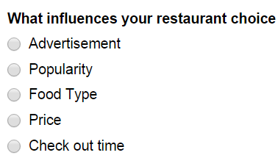

We asked this question to determine how most people decide on or pick which restaurant to eat at. The following shows the responses that we receive:

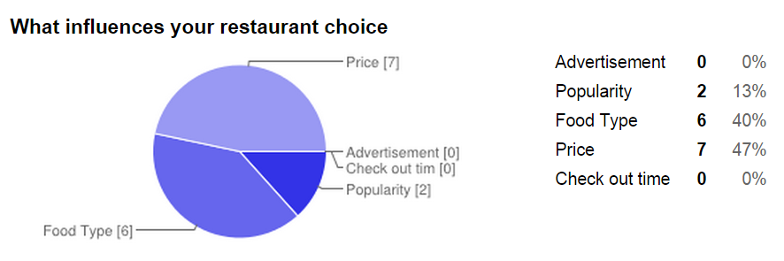

This result shows us that most people choose their food based on price. It also shows the strong influence of the type of food the restaurant provides and popularity of it. Although this disapproves the original hypothesis that advertisement influences people’s food choices, this data can still be utilized to generate the list of restaurants. The main two factor would be the pricing and the type of food.

The following shows the second asked for the interview:

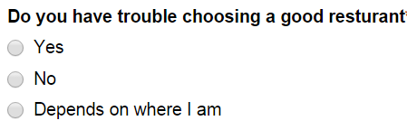

This question was asked to determine if people are having trouble. This was the summary of the responses we received:

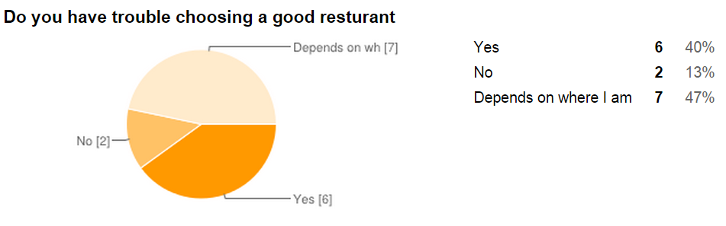

The responses shows that most people have trouble finding a good restaurant, especially if they were in an unfamiliar location. So the location of the people would be factored in as an essential data. The following shows the third and the fourth question:

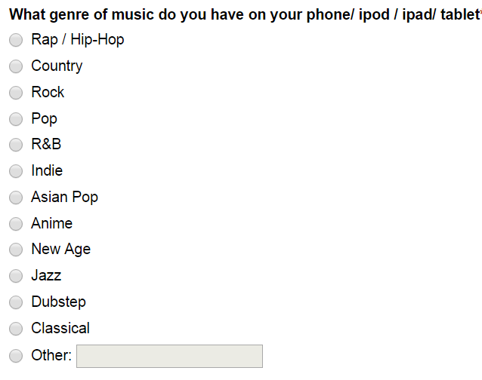

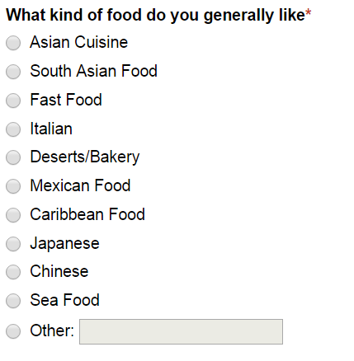

These questions were asked to see if there is a possibility of a correlation between people’s music and food taste. The responses for these questions were:

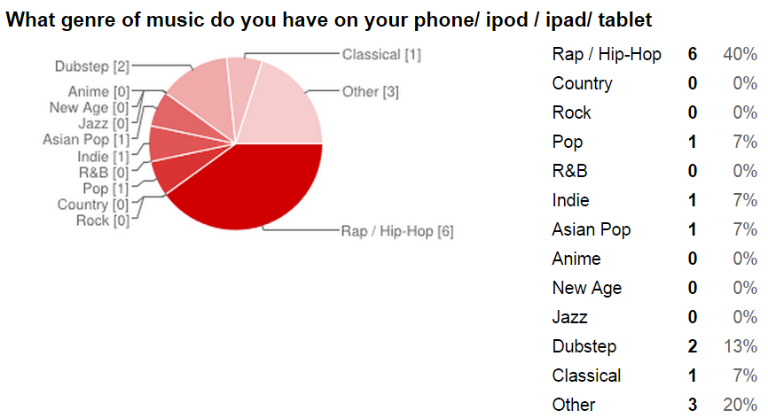

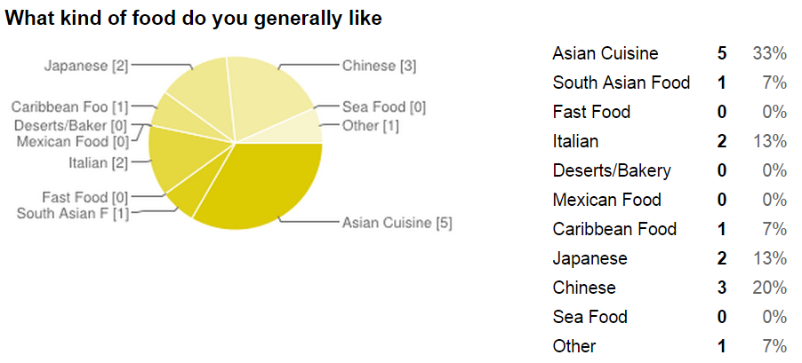

These responses show that most of the people that were interviewed generally listens to rap/hip-hop music and most people also generally like Asian cuisine. So this data shows us that there is somewhat of a correlation between music and food taste. The following shows the fifth and sixth question that was asked:

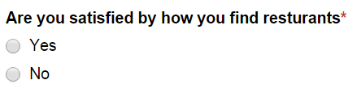

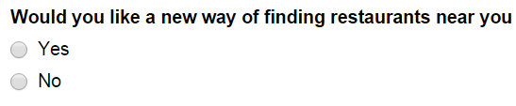

These questions were asked to determine the current state of how people feel about the method they use to choose their restaurant and if they are open to a new method, which is what our project is about. The following shows the responses we received for these final two questions we asked for the interview:

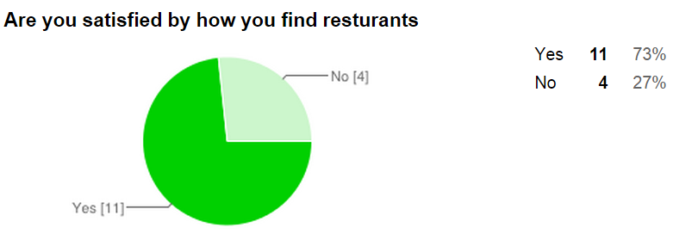

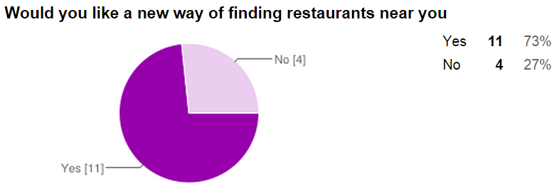

These data shows that people like their method for picking restaurant, which should be discouraging for our project. However, the results for the final question also shows that majority of the people are open to a new method for picking restaurant. The following table shows all the data for each question for each person:

|  |  |  |  |  |  |
| --- | --- | --- | --- | --- | --- |
| **What influences your restaurant choice** | **Do you have trouble choosing a good restaurant** | **What genre of music do you have on your phone/ iPod / iPad/ tablet** | **What kind of food do you generally like** | **Are you satisfied by how you find restaurants** | **Would you like a new way of finding restaurants near you** |
| Food Type | No | Asian Pop | Asian Cuisine | Yes | No |
| Price | Yes | Pop | Japanese | Yes | No |
| Food Type | No | Rap / Hip-Hop | Chinese | Yes | No |
| Price | Depends on where I am | Dubstep | South Asian Food | Yes | No |
| Food Type | Yes | Rap / Hip-Hop | Italian | No | Yes |
| Food Type | Depends on where I am | Rap / Hip-Hop | Asian Cuisine | Yes | Yes |
| Food Type | Depends on where I am | EDM | Italian | Yes | Yes |
| Popularity | Depends on where I am | Classical | Everything | Yes | Yes |
| Food Type | Depends on where I am | Rap / Hip-Hop | Chinese | No | Yes |
| Price | Depends on where I am | Rap / Hip-Hop | Asian Cuisine | No | Yes |
| Price | Yes | Indie Rock | Japanese | No | Yes |
| Popularity | Yes | Indie | Asian Cuisine | Yes | Yes |
| Price | Yes | Dubstep | Chinese | Yes | Yes |
| Price | Depends on where I am | Reggae | Caribbean Food | Yes | Yes |
| Price | Yes | Rap / Hip-Hop | Asian Cuisine | Yes | Yes |

Overall the interviewed helped us determine which factor to focus on for our app, such as the pricing, the location, and few others. This also showed us that there is some correlation between people’s food and music choice. From this we are moving forward with our idea, refining it farther using more responses.