Lab 03: Product Evaluation and Quality Improvement

EG1003 Section G1

Alexander Lopez-Matos

Lab Partner: Kevin

Date of Experiment: September 22, 2014

Date due: September 28, 2014

**Abstract**

The objective of this lab was to use important engineering principles to design and then improve a product. These principles are product evaluation and quality improvement. Product evaluation involves the process of testing a product with a particular set of standards in mind. Accuracy, precision, and cost are examples of standards a product could need. If the product is determined to not meet standards after product evaluation, the process of quality improvement is initiated. Quality improvement entails engineers testing the product and then using data from tests to make improvements to the product.

**Introduction**

Making improvements and innovations on products is an intrinsic part of engineering. When a company needs a certain product created, an internal or external team is expected to develop a product with the standards and needs of the company in mind. If a company creates a product that is sub-standard, they not only lose business from the company that originally hired them, the company also loses potential business in the future due to the reputation of developing terrible products.

While performing a product evaluation, the product is compared to a standard, which is essentially the bare minimum value that is acceptable of the product. The product is then tested to determine its average at a specific task, and that tasks accuracy and precision are then measured. The standard set in this lab is 80%.

Accuracy and precision are two different things in engineering. Accuracy is measured by how close the test is to the standard, and precision is how close the results are together. One of the best examples of the picture of the dart board in the EG manual. If a dart hits the middle, the result is considered accuracte, but if the other darts are scattered across the board, the results are imprecise. In engineering, we aim to have both accuracy and precision in the products that we create.

The concept of reverse engineering is also used in this lab. Reverse engineering is the process of dissesembling either hardware or software to determine its inner workings. This product can be used for a variety of reasons, including determining how a competitors product works and creating a similar product, finding a bug or a virus, or simply interacting with the product from your own.

**Procedure**

A robot was constructed by following a specific design given my TA's. Program with a five second forward move command was made using the mind storms lego software on a computer. Using the five second program, the robot was tested and its average was established. After the first test, the program was changed to run for four seconds and then more tests were performed. Once tests were completed with the original design, product evaluation and quality improvement were performed. The improved robot was put through the same testing process and then the results were observed and recorded.

**Data/Observations**

The original design was built with two wheels powered by individual motors and a peg on the opposing side to support the vehicle as shown in Figure 1. When the product was tested, the peg prevented the vehicle from moving at all in every test. Because the vehicle did not move, the first test was a complete failure and no data was collected.

**Figure 1 -** Original design

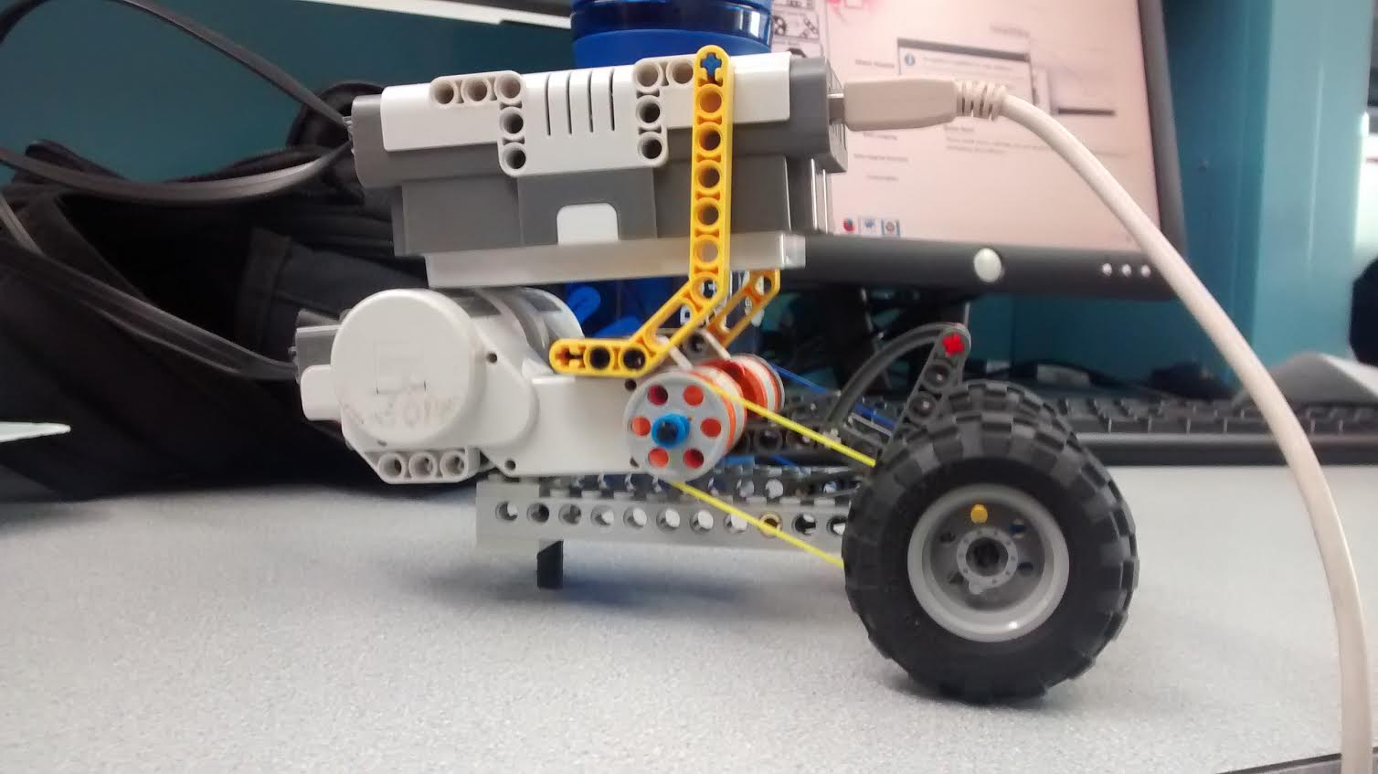

A vehicle that cannot do anything most definately does not meet standards, and has no measure of accuracy or precision. After the design was improved by adding a third wheel as shown in Figure 2, the vehicle actually moved and the accuracy and precision of distance and angle of deviation were measureable.

F**igure 2 -** Improved design

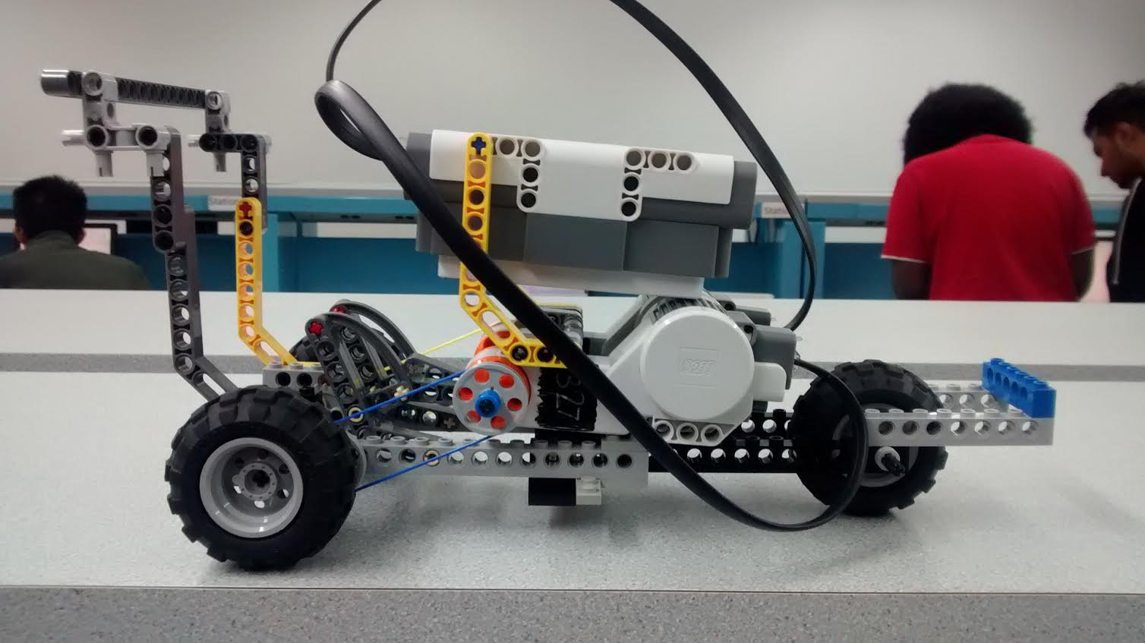

**Discussion/Conclusions**

Designs with greatest volume did the best in the competition. This could be because more air inside of the balloon was allowed to achieve an even larger volume and lower density because of the ideal gas law compared to smaller balloons. This greater volume and lower density directly allowed Archimedes principle to take effect because the balloon was displacing more air around itself, creating upward force.

Work Cited

"EG Manual" *EG1003*. N.p., n.d. Web. 28 Sept. 2014. (manual.eg.poly.edu/index.php/Main_Page)