Months of September and October Broad Product Development Requirements

* Yii Structural Development – Backend Framework + Full MVC
* School, Department, and Club UX Modifications

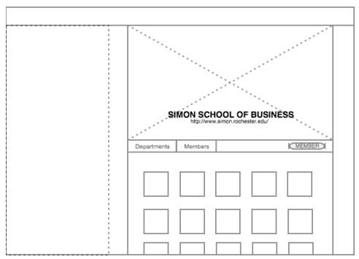 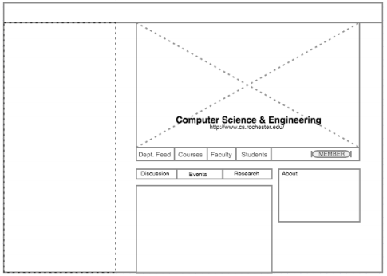

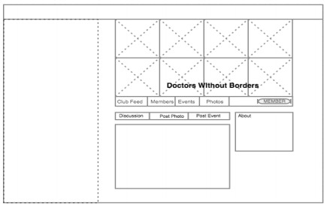

* iOS App Completed
* Search Page – Hierarchical (not string) Search and Autocomplete + New Search filters
* Event Posts
* New Add Event Form – Modular Component with Professor Added Features, different requirements in class and club contexts
* Notification System Redo – general and events
* Onboarding, tours, and Profile Page Progress Bar
* NLP Syllabus Algorithm
* Emails (weekly reminder, posts, email class, email club for administrators) + email group or group admin from the page itself
* Add different question types – mult choice and true/false + answer analytics
* Text formatting for posts and comments + LATEX add-on
* Calendar Redesign and New Requirements + import cal

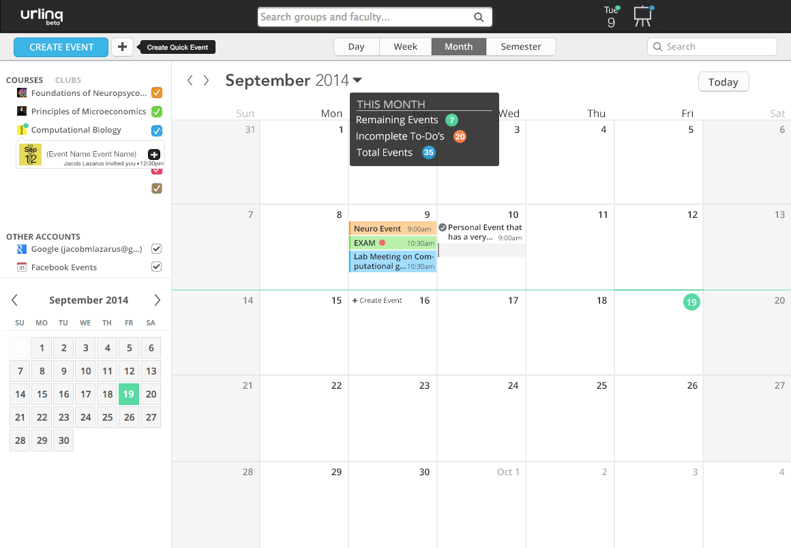

* Create UI/UX differences across the 3 faculty account types – researcher, administrator and professor
* Suggested People to Follow + Suggested Groups to Join (modular component)
* Non-Full Page refresh (main section refresh, top bar and left bar not refreshed)
* Version control through GIT and Local development on XAMPP/MAMP with only a few team leaders pushing to beta
* Weekly Patches
* Search Engine Optimization – make groups, profiles and departments Google searchable
* Great Product by November 1st to begin Beta Testing and Launch mid December