Lab 02: Hot Air Balloon

EG1003 Section G1

Alexander Lopez-Matos

Lab Partner: Adam, Kevin

Date of Experiment: September 15, 2014

Date due: September 21, 2014

**Abstract**

The objective of this lab was to construct a hot air balloon that held the most payload, floated the longest, and cost the least. In this lab, the Ideal Gas Law and Archimedes Principle were concepts used to understand how and why a hot air balloon stays afloat.

**Introduction**

The first hot air balloon was created by two Frenchman named Joseph-Michel and Jacques-Etienne. The men came up with the idea after watching embers levitate above a fire. Although the first hot air balloon was made to entertain the King of France, their range of uses has grown to recreation and advertising.

Different forms of balloons have spawned from the basic hot air balloon. Dirigibles are made from steel and have bags of gas, but these type of balloons are no longer in use because of the danger of using flammable gas inside of the bags. Blimps (like the famous Goodyear blimp) are giant helium balloons that have a control room on the bottom. These are primarily used for advertisement. Aerostats are another type of balloon that are primarily used for weather and location detection.

In this lab, two basic principles are used to allow for the understanding of why hot air balloons fly. The first principle is the Ideal Gas Law. The Ideal Gas Law states that as a gas is heated, the volume of that gas also increases while its density decreases. This law is formulized as PV = nRT where P is gas pressure, V is volume, T is absolute temperature (in Kelvin),n is the moles of gas, and R is the constant 0.0821 L * atm/mol * K

The second concept used in this lab is the Archimedes Principle. This principle states that when an object is inside of a body of liquid, an force is exerted upward equal to the amount of fluid that the object displaces. This is the same principle that allows boats to float. In the case of a hot air balloon, the ‘liquid’ is the surrounding air, so if the air inside of the balloon is heated, using the ideal has law, its volume will increase and its density will decrease, allowing the balloon to displace for air around it and create a greater upward force.

The ratio used to determine the winner of the hot air balloon competition is

(TimeAfloat/Cost) * Payload. Winning requires low cost, high time afloat, and high payload. The payload in the competition was the number of paperclips that the balloon could hold. Each balloon had three trials to get the best ratio.

**Procedure**

Sketch a design of the hot air balloon that fits into the volume limit 1m^3. Get sketch approved by the TA and collect required materials from design. Construct the hot air balloon with given materials. Six pieces of paper were carefully glued together into a rectangular prism shape, as shown in figure 1.

**Figure 1 -** Consctuction of the hot air balloon.



Once constructed, the hot air balloon was put to trial. The hot air balloon was placed over the heater and filled with hot air, prepping for flight as shown in Figure 2.

**Figure 2 -** Heating hot air balloon for flight

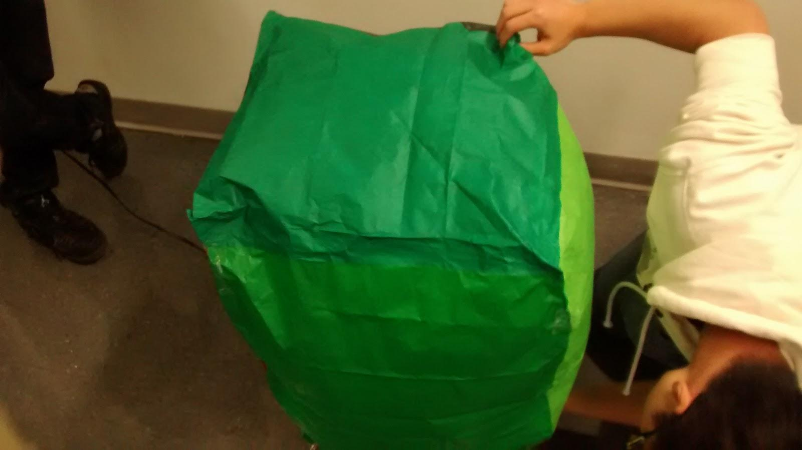

Results from the trials were recorded and compared to the other hot air balloons in the competition.

**Data/Observations**

Initial design for the hot air balloon involved two pieces of paper held together in an origami fashion. After seeing another groups similar construction fail, the design was changed by our group. A 6 paper rectangular prism is the design that our group ended up going for. The design one second place.

**Discussion/Conclusions**

Designs with greatest volume did the best in the competition. This could be because more air inside of the balloon was allowed to achieve an even larger volume and lower density because of the ideal gas law compared to smaller balloons. This greater volume and lower density directly allowed Archimedes principle to take effect because the balloon was displacing more air around itself, creating upward force.

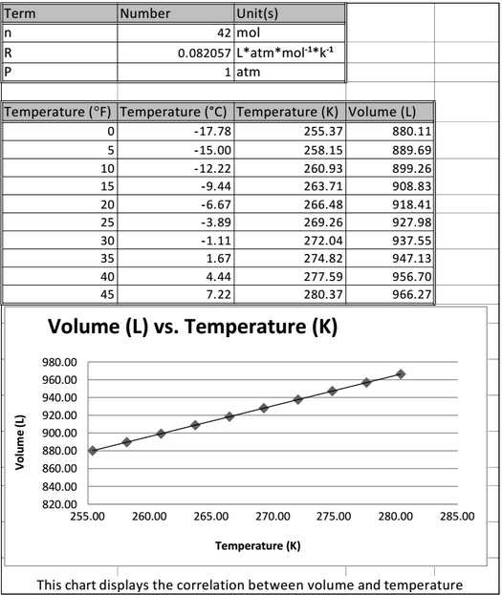

$$x=\frac{-b±\sqrt{b^{2}-4ac}}{2a}$$ Section G1

Mark Malia

Warlon Zeng

Alexander Lopez-Matos

**adroitcode@gmail.com**

101 Johnson Street, Brookyln NY 11201

702-293-2230

|  |  |  |  |  |  |
| --- | --- | --- | --- | --- | --- |
|  | **Monday** | **Tuesday** | **Wednesday** | **Thursday** | **Friday** |
| **8:00-8:30** |  |  |  |  |  |
| **8:30-9:00** | x |  |  |  |  |
| **9:00-9:30** | x |  |  |  |  |
| **9:30-10:00** | x |  |  |  |  |
| **10:00-10:30** | x |  |  |  |  |
| **10:30-11:00** | x |  |  |  |  |
| **11:00-11:30** | x |  |  |  | x |
| **11:30-12:00** | x |  |  |  | x |
| **12:00-12:30** | x |  | x |  | x |
| **12:30-1:00** | x |  | x |  | x |
| **1:00-1:30** | x |  | x |  | x |
| **1:30-2:00** | x |  | x |  |  |
| **2:00-2:30** | x |  | x |  |  |
| **2:30-3:00** | x | x | x | x |  |
| **3:00-3:30** | x | x | x | x | x |
| **3:30-4:00** | x | x | x | x | x |
| **4:00-4:30** | x | x | x | x | x |
| **4:30-5:00** | x |  |  |  | x |
| **5:00-5:30** | x |  |  |  |  |
| **5:30-6:00** |  |  |  |  |  |
| **6:00-6:30** |  |  |  |  |  |
| **6:30-7:00** |  |  |  |  |  |
| **7:00-7:30** |  |  |  |  |  |
| **7:30-8:00** |  |  |  |  |  |

