WORKSHEET-1

**DEEP LEARNING**

# Q1 to Q8 are MCQs with only one correct answer. Choose the correct option.

1. Which of the following can approximate any function universally (i.e. universal approximators)?
   1. Boosted Decision Trees B) Neural Networks

C) Kernel SVM D) All of the above

Answer: D) All of the above

1. In which of the following domains we cannot use neural networks?
   1. Image Processing B) Speech Processing

C) Fraud Detection D) None of the above

Answer: D) None of the above

1. Rearrange the following steps of a gradient descent algorithm in correct order of their occurrence?
2. Initialize random weight and bias
3. Repeat the process until you find the best weights of network
4. Change weights and biases for each neuron to reduce the error
5. Calculate error distances between the actual and the predicted value
6. Pass an input through the network and get values from output layer Choose the correct option:

A) iv – i – iii – v – ii B) v – i – iii – iv –ii

C) i – v – iv – iii – ii D) i – v – iii –iv –ii

Answer: C) i – v – iv – iii - ii

1. What is the full form of RNN?
   1. Recurrent Neural Network B) Recursive Neural Network

C) Redundant Neural Network D) Resurrection Neural Network

Answer: A) Recurrent Neural Network

1. What is plasticity in neural networks?
   1. input pattern keeps on changing B) input pattern has become static

C) output pattern keeps on changing D) output is static

Answer: A) input pattern keeps on changing

1. What is stability plasticity dilemma?
   1. system can neither be stable nor plastic
   2. static inputs & categorization can’t be handled
   3. dynamic inputs & categorization can’t be handled
   4. none of the above

Answer: C) dynamic inputs & categorization can’t be handled

1. Read the following statements:

**Statement 1**: It is possible to train a network well by initializing all the weights as 0

**Statement 2**: It is possible to train a network well by initializing biases as 0 Which of the statements given above is true, Choose the correct option?

* 1. Statement 1 is true while Statement 2 is false
  2. Statement 2 is true while statement 1 is false
  3. Both statements are true
  4. Both statements are false

Answer: B) Statement 2 is true while statement 1 is false

1. Which of the following architecture has feedback connections?
   1. Recurrent Neural network B) Convolutional Neural Network

C) Restricted Boltzmann Machine D) simple Artificial Neural Network

Answer: A) Recurrent Neural network

# Q9 and Q10 are MCQs with one or more correct answers. Choose all the correct options.

1. In training a neural network, you notice that the loss does not decrease in the few starting epochs. The reason behind it could be
   1. Learning Rate is low B) Regularisation parameter is high

C) Regularisation parameter is low D) Stuck at local minima

Answer: A) Learning Rate is low, B) Regularisation parameter is high, D) Stuck at local minima

1. Which of the following function(s) can be used to impart non – linearity in a neural network?
   1. Stochastic Gradient Descent B) Rectified Linear Unit

C) Convolution Function D) Sigmoid Function

Answer: B) Rectified Linear Unit, D) Sigmoid Function

# Q11 to Q15 are subjective answer type question. Answer them briefly.

1. What is Deep Learning?

Answer: Deep learning is a subset of machine learning that involves systems that think and learn like humans using artificial neural networks. The term ‘deep’ comes from the fact that you can have several layers of neural networks. In deep learning, the model consisting of neural networks will automatically determine which features to use (and which not to use). Therefore, in deep learning there is no need of feature engineering.

1. What is reinforcement learning?

Answer: Reinforcement learning is a machine learning training method based on rewarding desired behaviours and/or punishing undesired ones. In general, a reinforcement learning agent is able to perceive and interpret its environment, take actions and learn through trial and error. In trial phase the model assigns weights and biases to each node on the basis of feedback it achieved from the error. In error phase, if the error between desired and predicted result is decreased, a positive feedback is given otherwise a negative feedback is given to nodes.

1. What Are the Differences Between Machine Learning and Deep Learning?

Answer:

|  |  |
| --- | --- |
| **MACHINE LEARNING** | **DEEP LEARNING** |
| * Enables machines to take decisions on their own, based on past data * It needs only a small amount of data for training * Works well on the low-end system, so you don't need large machines * Most features need to be identified in advance and manually coded * The problem is divided into two parts and solved individually and then combined | * Enables machines to take decisions with the help of artificial neural networks * It needs a large amount of training data * Needs high-end machines because it requires a lot of computing power * The machine learns the features from the data it is provided * The problem is solved in an end-to-end manner |

1. What is a perceptron?

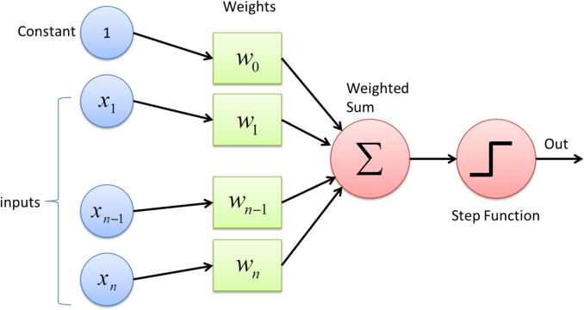 Answer: Perceptron is a linear classifier (binary). Also, it is used in supervised learning. It helps to classify the given input data. Perceptron can be seen as a single layered neural network. A perceptron takes inputs from n-nodes and assign weights to them respectively. Then it takes the weighted sum and adds a bias term to it. In final stage, it applies an activation function over it to give the final output. Pictorial representation of perceptron is as follows:

1. What’s the difference between AI and ML?

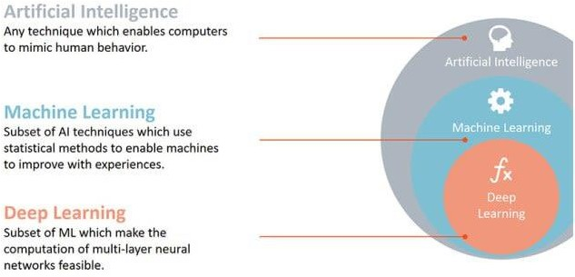Answer: AI and ML are closely related, but these terms aren’t interchangeable. ML actually falls under the umbrella of AI. It demands that machines carry out tasks in the same way that humans do. The current application of ML in AI is based around the idea that we should enable access to data so machines can observe and learn for themselves.