WORKSHEET-3

**SQL**

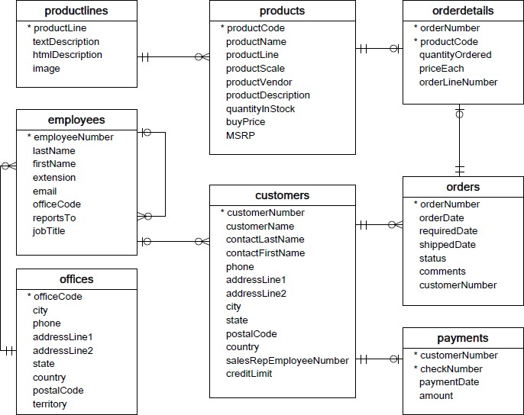**Refer the following ERD and answer all the questions in this worksheet. You have to write the queries using mysql for the required Operation.**

* **Customers**: stores customer’s data.
* **Products**: stores a list of scale model cars.
* **ProductLines**: stores a list of product line categories.
* **Orders**: stores sales orders placed by customers.
* **OrderDetails**: stores sales order line items for each sales order.
* **Payments**: stores payments made by customers based on their accounts.
* **Employees**: stores all employee information as well as the organization structure such as who reports to whom.
* **Offices**: stores sales office data.
  1. Write SQL query to create table **Customers.**

**Answer:**

CREATE TABLE ‘customers’ (‘customerNumber’ int(11) NOT NULL,

‘customerName’ varchar(50) NOT NULL,

‘contactLastName’ varchar(50) NOT NULL,

‘contactFirstName’ varchar(50) NOT NULL,

‘phone` varchar(50) NOT NULL,

‘addressLine1’ varchar(50) NOT NULL,

‘addressLine2’ varchar(50) DEFAULT NULL,

‘city’ varchar(50) NOT NULL,

‘state’ varchar(50) DEFAULT NULL,

‘postalCode’ varchar(15) DEFAULT NULL,

‘country’ varchar(50) NOT NULL,

‘salesRepEmployeeNumber’ int(11) DEFAULT NULL,

‘creditLimit’ decimal(10,2) DEFAULT NULL,

PRIMARY KEY (‘customerNumber’),

KEY ‘salesRepEmployeeNumber’ (‘salesRepEmployeeNumber’),

FOREIGN KEY (‘salesRepEmployeeNumber’)

REFERENCES ‘employees’ (‘employeeNumber’) );

* 1. Write SQL query to create table **Orders.**

**Answer:**

CREATE TABLE ‘orders’ (‘orderNumber’ int(11) NOT NULL,

‘orderDate’ date NOT NULL,

‘requiredDate’ date NOT NULL,

‘shippedDate’ date DEFAULT NULL,

‘status’ varchar(15) NOT NULL,

‘comments’ text,

‘customerNumber’ int(11) NOT NULL,

PRIMARY KEY (‘orderNumber’),

KEY ‘customerNumber` (`customerNumber’),

FOREIGN KEY (‘customerNumber’)

REFERENCES ‘customers’ (‘customerNumber’));

* 1. Write SQL query to show all the columns data from the **Orders** Table.

**Answer:** SELECT * FROM Orders;

* 1. Write SQL query to show all the comments from the **Orders** Table.

**Answer:** SELECT ‘comments’ FROM Orders;

* 1. Write a SQL query to show orderDate and Total number of orders placed on that date, from **Orders** table.

**Answer:** SELECT ‘orderDate’, count(‘orderNumber’) as ‘Total number of orders’ FROM Orders GROUP BY ‘orderDate’;

* 1. Write a SQL query to show employeNumber, lastName, firstName of all the employees from **employees** table.

**Answer:** SELECT ‘employeeNumber’ ,’lastName’ ,’firstName’ FROM Employees;

* 1. Write a SQL query to show all orderNumber, customerName of the person who placed the respective order.

**Answer:**

SELECT ‘orderNumber’ ,’customerName’

FROM Orders INNER JOIN customers

ON orders.’customerNumber’= customers.’customerNumber’;

* 1. Write a SQL query to show name of all the customers in one column and salerepemployee name in another column.

**Answer:**

SELECT ‘customerName’ , concat(‘firstName’,’lastName’)

FROM employees INNER JOIN customers

ON Employees.’employeeNumber’= customers.’salesRepEmployeeNumber’;

* 1. Write a SQL query to show Date in one column and total payment amount of the payments made on that date from the **payments** table.

**Answer:**

SELECT ‘paymentDate’ , sum(amount)

FROM payments

GROUP BY ‘paymentDate’;

* 1. Write a SQL query to show all the products productName, MSRP, productDescription from the **products** table.

**Answer:** SELECT ‘productName’,’MSRP’,’productDescription’ FROM products;

* 1. Write a SQL query to print the productName, productDescription of the most ordered product.

**Answer:**

SELECT ‘productName’,’productDescription’ FROM Products

INNER JOIN Orderdetails

ON Products.’productCode’ = Orderdetails.’productCode’

GROUP BY Products.’productCode’

ORDER BY Sum(‘quantityOrdered’) DESC

LIMIT 1;

* 1. Write a SQL query to print the city name where maximum number of orders were placed.

**Answer:**

SELECT ‘city’ FROM OrderDetails as a

INNER JOIN Orders as b

ON a.’orderNumber’= b.’orderNumber’

INNER JOIN Customers as c

ON b.’customerNumber’ = c.’customerNumber’

GROUP BY ‘city’

ORDER BY COUNT(a.’orderNumber’) DESC

LIMIT 1;

* 1. Write a SQL query to get the name of the state having maximum number of customers.

**Answer:**

SELECT ‘state’ FROM Customers

GROUP BY ‘state’

ORDER BY ‘customerNumber’

DESC LIMIT 1;

* 1. Write a SQL query to print the employee number in one column and Full name of the employee in the second column for all the employees.

**Answer:** SELECT ‘employeeNumber’, concat(‘firstName’,’lastName’) as ‘Full name’ FROM Employees;

* 1. Write a SQL query to print the orderNumber, customer Name and total amount paid by the customer for that order (quantityOrdered × priceEach).

**Answer:** SELECT ‘orderNumber’ , ‘quantityOrdere’`*’priceEach’ as ‘total amount paid’ FROM OrderDetails;