1. **ENGINE OVERHEATING IN RAILWAY POWER CAR**

Engine overheating occurs when the engine’s operating temperature exceeds its normal threshold, typically above **90–100°C** for diesel engines. If not addressed, it can lead to **engine seizure, head gasket failure**, or **total engine breakdown**. In railway power cars, this is a **critical issue** due to prolonged engine operation under heavy electrical or traction loads, especially in hot climates or during long hauls.

* **Causes of overheating**

| **Cause** | **Description** |
| --- | --- |
| **Coolant Leakage or Low Coolant Level** | Radiator leaks, loose hoses, or cracked reservoirs can reduce coolant quantity, impairing heat dissipation. |
| **Radiator Blockage or Scaling** | Mineral deposits (scaling) or dust/dirt clog the radiator fins, reducing airflow and heat exchange. |
| **Water Pump Failure** | A malfunctioning pump cannot circulate coolant effectively, leading to heat buildup. |
| **Thermostat Malfunction** | A stuck-closed thermostat restricts coolant flow, causing localized hot spots in the engine. |
| **Fan Failure (Radiator Fan or Belt-Driven)** | Mechanical or electrical fan failures reduce cooling at low speeds or during idling. |
| **Airlock in the Cooling System** | Trapped air prevents full coolant circulation, leading to localized boiling and hot zones. |
| **External Temperature and Load** | High ambient temperature and full generator load exacerbate heat generation. |
| **Improper Maintenance** | Use of poor-quality coolant, missed radiator cleaning cycles, or irregular servicing contributes to system failure. |

**Current Solutions and Mitigation Strategies**

1. **Regular Radiator Cleaning**
   * Using compressed air or water jet to clean radiator fins.
   * Chemical descaling every 6–12 months (especially in hard water regions).
2. **Coolant Quality Check**
   * Use of **anti-corrosive, temperature-stable coolants** (as per OEM spec).
   * Periodic topping up and replacement every 2 years or 1,000 engine hours.
3. **Water Pump and Fan Inspection**
   * Checking belt tension and bearing condition.
   * Fan clutch or motor functionality checks.
4. **Thermostat Testing**
   * Replacing thermostats showing sluggish or inconsistent response.
5. **Air Bleeding During Servicing**
   * Ensuring no air remains trapped during coolant filling (common after maintenance).
6. **Engine Room Ventilation Enhancement**
   * Improved airflow paths and exhaust routing to avoid heat buildup inside compartments.

* **Technology-Based Solutions**

1. **Real-Time Temperature Monitoring**
   * Engine control modules (ECM) continuously monitor coolant temperature.
   * Alerts sent to the driver or control center for early intervention.
2. **Automatic Engine Derating**
   * When overheating is detected, engine reduces power output to avoid damage.
3. **Remote Diagnostics**
   * Fault codes and sensor data sent to central maintenance hubs (common in modern fleets).
4. **Use of High-Efficiency Coolers**
   * Upgraded aluminum-core radiators with better heat exchange efficiency.
   * Dual-fan or electric-fan retrofits in older units.

**RECOMMENDED SOLUTION THAT CAN BE USED**

1. Hybrid Cooling Using Phase Change Materials (PCMs)

Install thermal energy-absorbing materials (PCMs) around the engine block or radiator. These materials absorb excess heat during peak engine temperatures and release it slowly when the engine cools down. PCMs are used in aerospace and data centers, but not yet in locomotives or power cars. It reduces thermal spikes and protects the engine from sudden overheating.

. *The mechanism of how PCM material works*

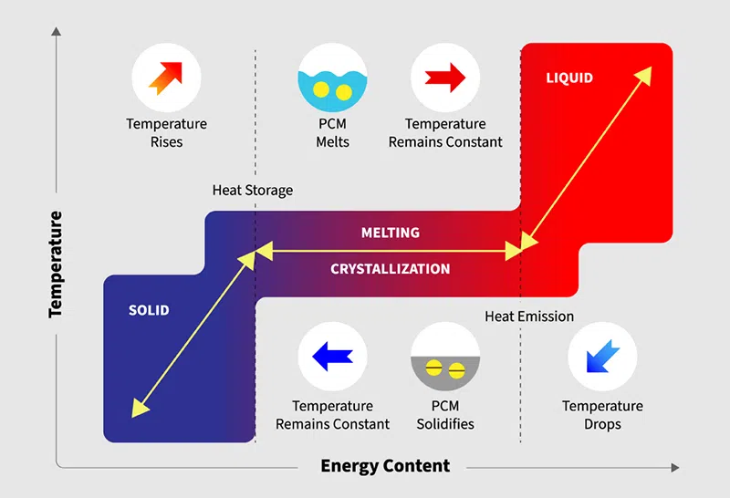

we have to integrate PCM packs near the exhaust manifolds or the coolant reservoirs.

1. Smart Self-Healing Coolant System

The Smart Self-Healing Coolant System is a very interesting idea that entails nano-engineered coolants capable of independently repairing small cracks or leaks in pipes or radiator linings. While such technology is still under development for automotive applications, it has not yet been implemented for railway uses, in that it is quite an innovative and futuristic proposal. The major advantage afforded by this system is the conservation of coolant that is lost through micro-leaks, which becomes particularly important for the maintenance of older fleets where these kinds of problems occur more frequently. The concept is still under research and could be further developed as a joint endeavor with a materials engineering institute.

For more information, you can refer to this link - [🔗link](https://www.researchgate.net/publication/349275524_Nano-Fluids_as_a_Coolant_for_Automotive_Engine_Radiators_Review_Study)

The technology is still in the development phase. Please review this research paper, you will get more insights.

1. Exhaust Heat Recovery for Supplemental Cooling

The concept involved integrating a thermoelectric generator or heat exchanger into the exhaust line in an attempt to convert waste heat into usable energy, which could then power an auxiliary cooling system, e.g., extra fans or coolant pumps. The interesting point about this concept is the very rare use of thermoelectric generators in non-electric railway investigations, despite their potential. The cooling of exhaust gases and enhancement of the engine's thermal efficiency constitute the main advantages of this concept. Environmental considerations include a reduction in fuel consumption to a minor degree in addition to making the whole operation greener and more sustainable.

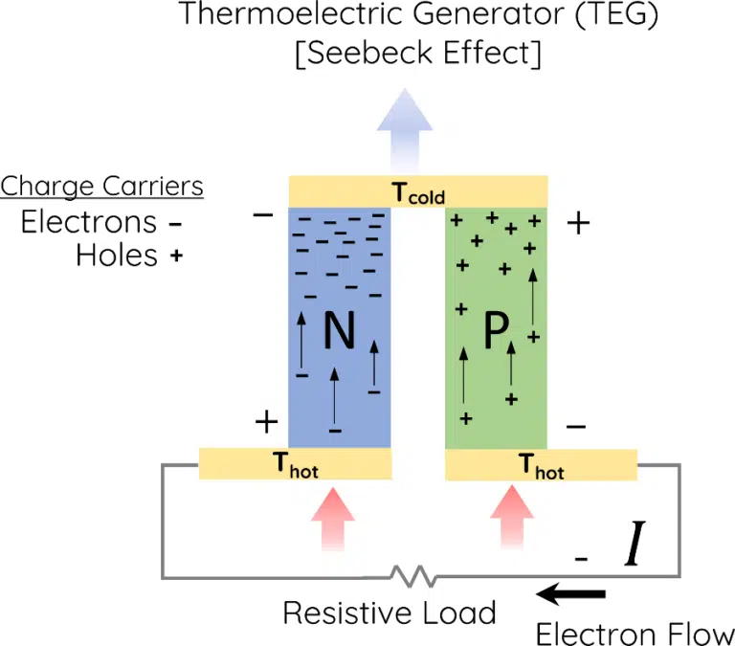

1. Use of CFD (Computational Fluid Dynamics)

A simulation method called computational fluid dynamics (CFD) is used to study heat transfer in mechanical systems and model the flow of fluids like coolant or air. It is perfect for resolving overheating problems in railway power cars because it enables engineers to see airflow, pressure drops, heat accumulation, and cooling efficiency in three dimensions.

Optimising airflow around engines and radiators is a common application of CFD. Heat dissipation can be hindered by inadequate flow or obstructions, and simulations can be used to redesign fan housings or ducts to improve airflow over hot components. In order to improve engine layouts or ventilation placements, CFD also detects thermal hotspots brought on by stagnant air.

Analysis of coolant flow is another important use. CFD supports design modifications by identifying flow inefficiencies brought on by bends, dead zones, or pump problems.

By simulating heat transfer across fins and recommending enhancements to geometry, materials, or fan support, it also aids in the refinement of radiator design. CFD can model the flow and radiation of exhaust gases to address exhaust heat problems, recommending insulation or thermal shields as ways to stop heat from recirculating into the engine bay.

Temperature maps, airflow vectors, coolant contours, and design optimisations for fan speed, radiator location, and vent placement are examples of typical outputs. ANSYS Fluent, Siemens Star CCM+, OpenFOAM, and SolidWorks Flow Simulation are popular CFD tools in this field.

*CFD simulation showing airflow velocity streamlines inside a railway power car engine compartment*.

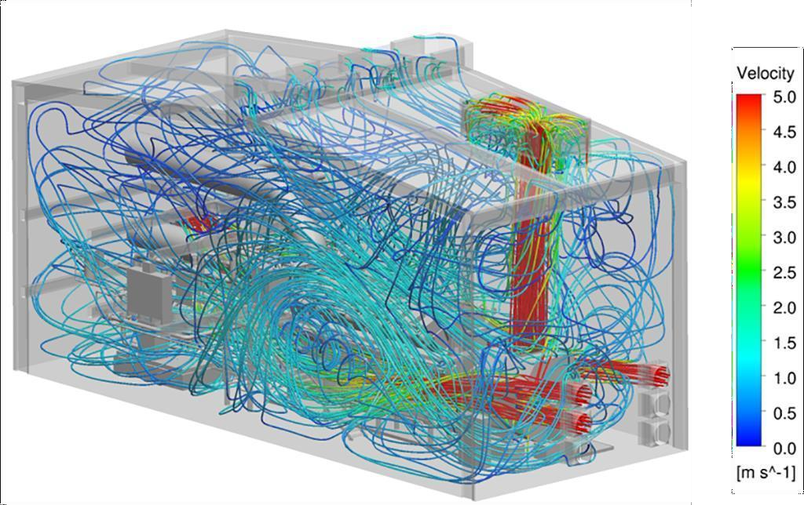

The color gradient represents airflow velocity from 0.0 m/s (blue) to 5.0 m/s (red). High-velocity zones are seen near cooling fans and ducts, while blue areas indicate low-flow regions that may lead to overheating. This analysis helps identify critical areas for improving ventilation design, optimizing component placement, and enhancing overall thermal management.

**2. WIRING FAULTS IN POWER CAR**

Important systems in power cars may be disrupted by wiring issues. Miscommunication or engine shutdown could result from an open or short wire in the ECU. Voltage problems may result from damaged generator wiring. Overheating may result from issues with the cooling fan or sensor wiring. Poor connections can prevent batteries from charging, and malfunctions in safety circuits may cause false trips or cause the circuits to not react when there is a real fault.

| **Type** | **Description** |
| --- | --- |
| Open Circuit | Broken wire or poor contact leads to no power delivery |
| Short Circuit | Current bypasses components, may cause fire or fuse blow |
| Ground Fault | Wire contacts chassis or earth, triggering failure |
| Corrosion or Loose Ends | Causes intermittent power or signal dropouts |
| Insulation Failure | Heat or rodents damage wire jackets, causing arcing |

Current Solutions Used

* Periodic inspection of control panels and wire harnesses
* Use of multi-core armored cables for critical circuits
* Cable routing in conduits or sealed trays
* Use of fire-retardant, temperature-rated insulation
* Vibration- and rodent-resistant sheathing
* Continuity and insulation resistance testing during maintenance
* Diagnostic systems with fault code memory (in modern power cars)

**RECOMMENDED SOLUTION THAT CAN BE USED**

1. Mobile TDR Cable Health Scanner

Time Domain Reflectometry (TDR) is used in this concept's portable diagnostic tool to identify wiring flaws like open circuits, short circuits, and insulation damage. A brief electrical pulse is sent through the wire to operate the tool. When a fault occurs, the pulse reflects back; the reflection time indicates the precise location and kind of the fault. Although TDR technology is widely used in the telecom and aviation sectors and is becoming more prevalent in electric vehicles, it is not yet widely used in the railway industry. It is simple for maintenance teams to learn and provides accurate, non-destructive testing without requiring insulation removal or component disassembly. It is more expensive than simple multimeters and needs to be calibrated for various wire types and lengths.

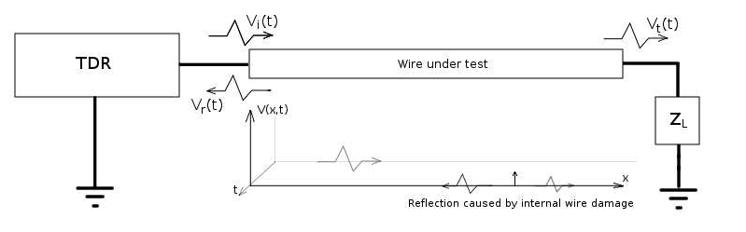

*Basic TDR setup diagram*

*TDR Calculations: Pulse vs. Step Technology*:

Pulse technology in Time Domain Reflectometry (TDR) involves sending a single electrical pulse through the wire and then disconnecting the transmitter to allow the receiver to detect reflections. This approach, while traditional, creates a dead zone—a short period during which faults close to the transmitter cannot be detected. Using a longer pulse increases the measurement range but also enlarges the dead zone, while shorter pulses reduce the dead zone but limit range and signal strength, resulting in a poorer signal-to-noise ratio and potentially incomplete test results.

In contrast, step technology, used in advanced tools like the VIAVI DSP TDR, sends a continuous signal while the receiver monitors reflections in real time, eliminating the dead zone entirely. This method enables full-length cable testing and benefits from higher signal energy, improving the signal-to-noise ratio. Additionally, digital averaging in step technology helps reduce interference, making it more reliable for precise and consistent fault detection*.*

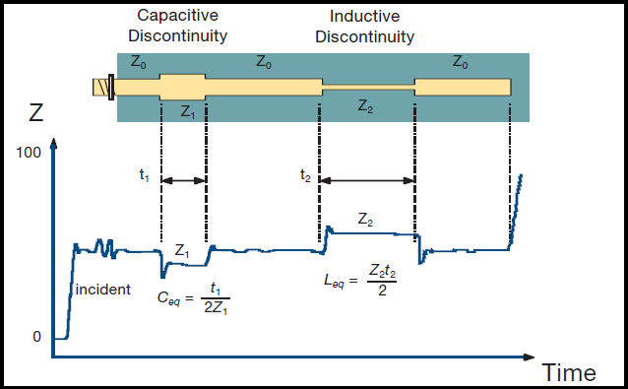

*Graphical response of TDR for impedance*

1. Self-Healing Insulation Material

The idea is to use cutting-edge polymer coatings that can automatically restore protective functionality by self-healing small cuts, abrasions, or cracks in wire insulation. Polymers containing microcapsules or reversible molecular bonds that activate in response to heat, air, or UV light are used to create these coatings. They successfully seal damage brought on by small mechanical impacts, vibration wear, and rodent bites. Reversible cross-linking silicone, polyurethane with healing agents, and graphene-polymer blends for increased durability are a few examples. Its ability to prevent shorts or arcing without immediate repair, particularly in difficult-to-reach areas, and the fact that it is a passive system that doesn't require any power or sensors are two of its main benefits. For cable sections that are run through conduits or under floors, this is perfect. For high-temperature settings, it can be combined with heat-activated curing.

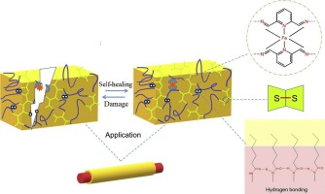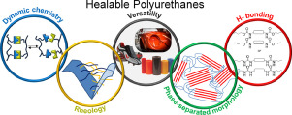

*Reversible cross-linking silicone*

1. Smart Wiring Harness with Embedded Sensors

In order to continuously monitor important electrical and physical parameters, this concept suggests integrating micro-sensors into or along crucial wiring harnesses. These sensors allow for the early detection of problems like overheating, short circuits, corrosion, or open circuits by monitoring temperature, voltage and current, resistance, and continuity in real time. A low-power embedded microcontroller is used to gather data, which is then sent to a central unit via wireless or the CAN bus. The system prevents complete failure by sending out early alerts if anomalous behaviour is found. This minimises unplanned breakdowns, lowers the risk of fire, and permits condition-based maintenance. Thin-film sensors or flexible printed circuits integrated into the cable jacket, with wireless data transfer via LoRa or ZigBee, and powered by the train's auxiliary battery or vibration energy could be used for implementation. Challenges include **higher initial costs** and the need for **rugged sensor designs** that can withstand railway vibration and thermal stress.

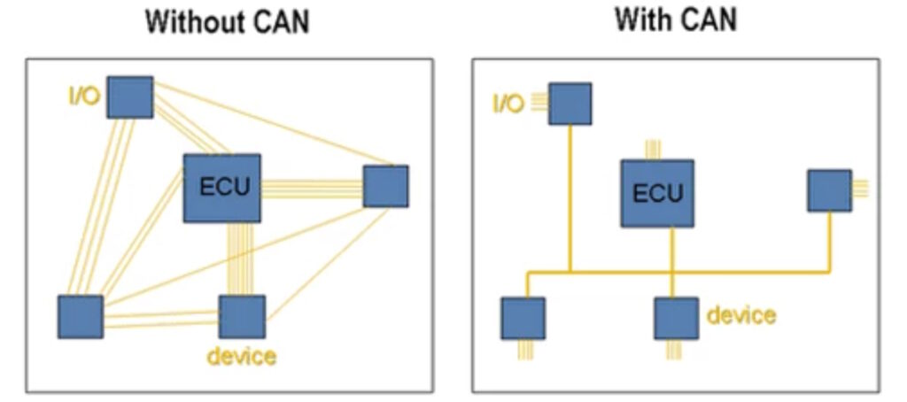

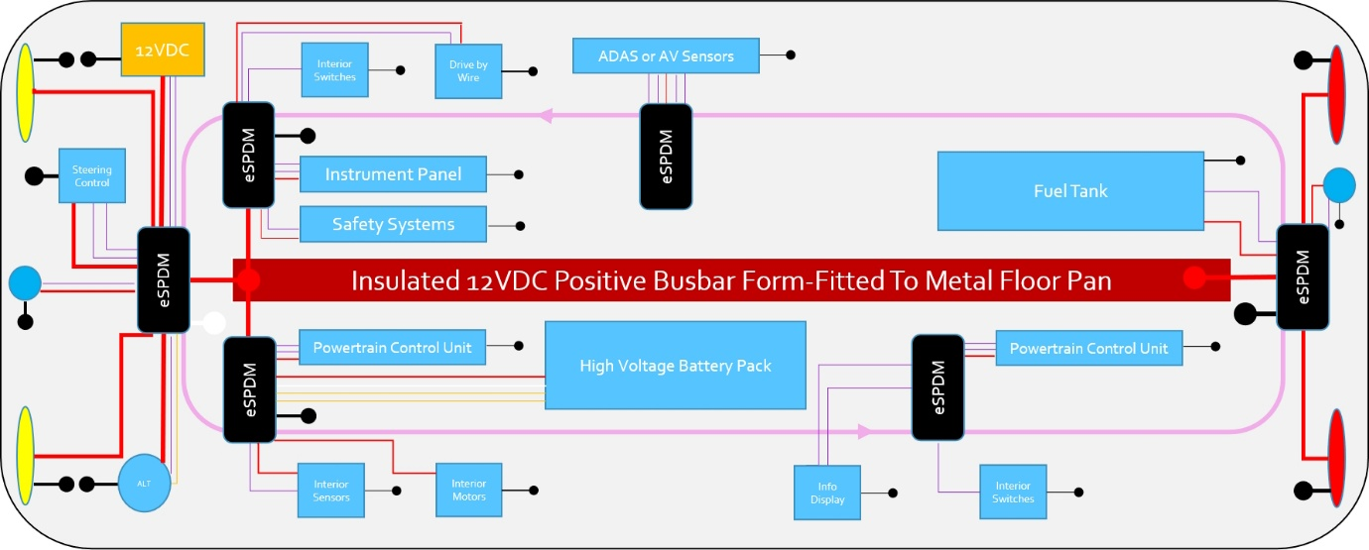

*Block diagram of a smart wiring harness showing the positions of the multiple output SDMs (black boxes).*

**Vibration-Induced Failures in Railway Power Cars**

The main causes of vibration in railway power cars are heavy-duty diesel engines, generator sets, and travel over uneven tracks. Over time, structural fatigue, electrical failures, and mechanical wear can result from unmanaged vibration. In terms of mechanics, it results in bolt loosening, engine or generator housing cracking, and increased bearing wear in fans, alternators, and pumps. Constant micro-movements in electrical systems compromise control panels, relays, and fuses by causing loose terminals, solder joint cracks, and wire fraying. Temperature, pressure, and speed sensors are particularly susceptible to vibration, which can result in erroneous readings and missed malfunctions or false alarms. Repeated exposure weakens the frame and chassis structurally, particularly at resonant points.

The main causes are worn engine mounts, frequently as a result of cracked or hardened rubber, shaft misalignment between the engine and alternator, and imbalance in rotating components such as generator rotors and engine flywheels. Long-term damage is exacerbated by vibration that is further amplified by resonance from structural design and irregularities in the track.

Current solutions that are used:

Anti-Vibration Mounts

* Rubber or elastomer mounts isolate engine/generator vibration from the car body.

Dynamic Balancing of Rotating Equipment

* Performed during engine/generator overhauls.

Rigid Frame Design

* Engine-generator sets are mounted on steel subframes to minimize transmission of vibration.

Maintenance-Based Solutions

* Periodic bolt torque checks
* Realignment of coupling shafts
* Replacement of worn-out dampers and mounts

**RECOMMENDED SOLUTION THAT CAN BE USED**

1.Smart Vibration Monitoring System

Critical parts like the engine block, generator casing, or control panel are equipped with MEMS vibration sensors, which continuously measure vibration in three axes (X, Y, Z). A microcontroller calculates metrics like Root Mean Square (RMS) or peak acceleration (measured in g or m/s2) by sampling the sensor data at regular intervals, usually every 50 to 100 milliseconds. An alert is generated and recorded for maintenance or additional diagnostics if the measured values surpass predetermined thresholds, which are established based on typical operating conditions.

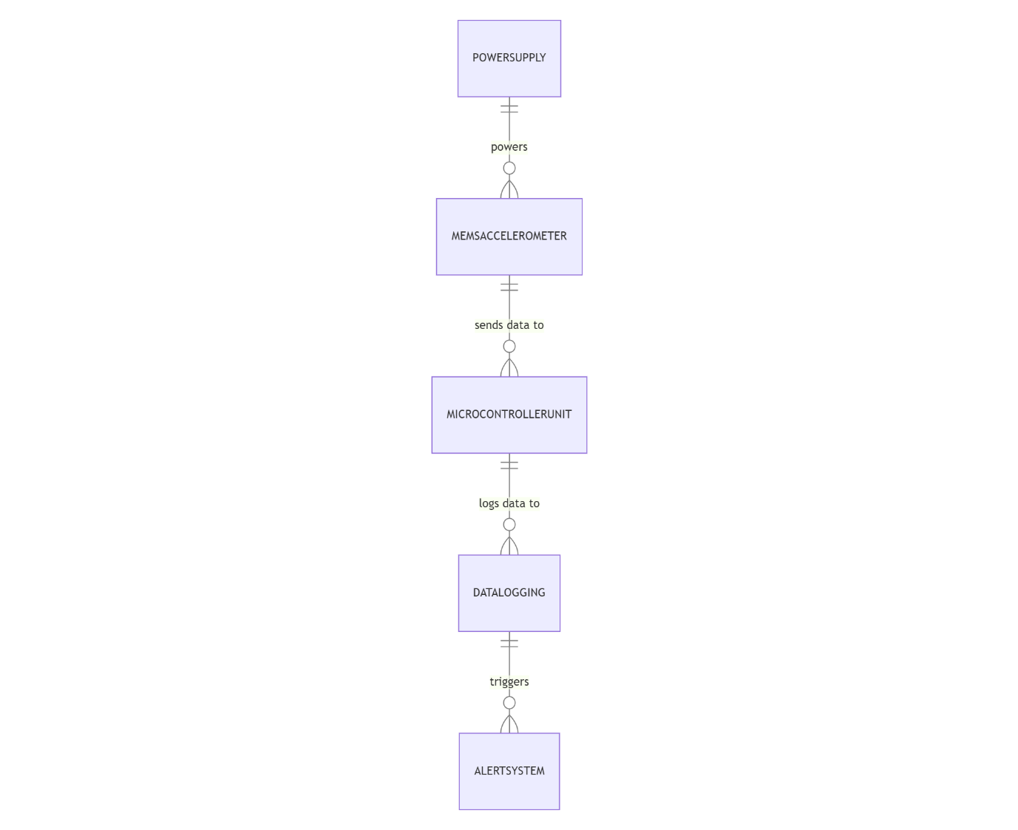

Threshold Example

Normal Vibration: ~0.5g RMS (idle engine)  
Warning Level: 1.5–2g  
Critical Level: >2.5g → Trigger maintenance alert

The system supports preventive maintenance by detecting vibration-related faults before they lead to critical failures, reducing downtime and repair costs. It is affordable, making it ideal even for older rolling stock without modern monitoring systems. The design is expandable, allowing the future addition of sensors for temperature, noise, or other parameters. Additionally, it is portable and can be easily mounted and tested across different power cars, enhancing its versatility for fleet-wide diagnostics.

**Cooling System Failures**

The cooling system of a railway power car includes several critical components: the radiator and radiator fan for heat dissipation, the water pump to circulate coolant, the thermostat to regulate coolant flow based on temperature, and the coolant reservoir, hoses, and piping for fluid containment and distribution. A coolant temperature sensor monitors system performance and feeds data to the control unit.

Several failure modes can affect cooling efficiency. These include radiator fan issues such as motor burnout or damaged blades, water pump malfunctions due to worn impellers or seal leaks, and coolant leaks caused by cracks in hoses, faulty clamps, or a damaged reservoir. Radiator clogging from dust, oil, or insect buildup can reduce heat transfer. Additionally, a thermostat stuck open or closed may disrupt temperature regulation, while air locks in the system can lead to poor coolant circulation and localized overheating.

Current Maintenance Practices:

Cooling system maintenance in railway power cars typically involves manual inspection of the radiator, hoses, and related components. Technicians perform periodic checks of coolant level and quality, along with scheduled coolant flushing and radiator cleaning to ensure optimal performance. Routine visual inspections are also carried out to check belt tension and detect any leaks from the water pump. Additionally, most systems are equipped with temperature alarms that trigger if the engine coolant temperature exceeds preset safety thresholds, prompting immediate intervention.

**RECOMMENDED SOLUTION THAT CAN BE USED**

**1.**Smart Coolant Flow Monitoring System

A flow sensor measures the coolant flow rate (in L/min) using a pulse output, while temperature sensors monitor coolant temperature before and after the radiator. A drop in flow rate below a set threshold may indicate an airlock or blockage. If the inlet temperature is high but the outlet temperature shows minimal drop, it suggests ineffective cooling, possibly due to a dirty radiator or fan malfunction. Key parameters to track include:

* Flow rate, typically between 10–30 L/min
* Temperature difference (ΔT = Tin – Tout), which should normally range from 8–15°C during operation
* If ΔT < 5°C, it signals poor heat transfer
* If flow rate = 0, it indicates a pump failure or major blockage

Components Needed: Flow sensor (YF-S201/turbine), 2× temperature sensors (DS18B20/PT100) – inlet & outlet, microcontroller (Arduino Uno/ESP32), optional OLED display or GSM/Wi-Fi module.

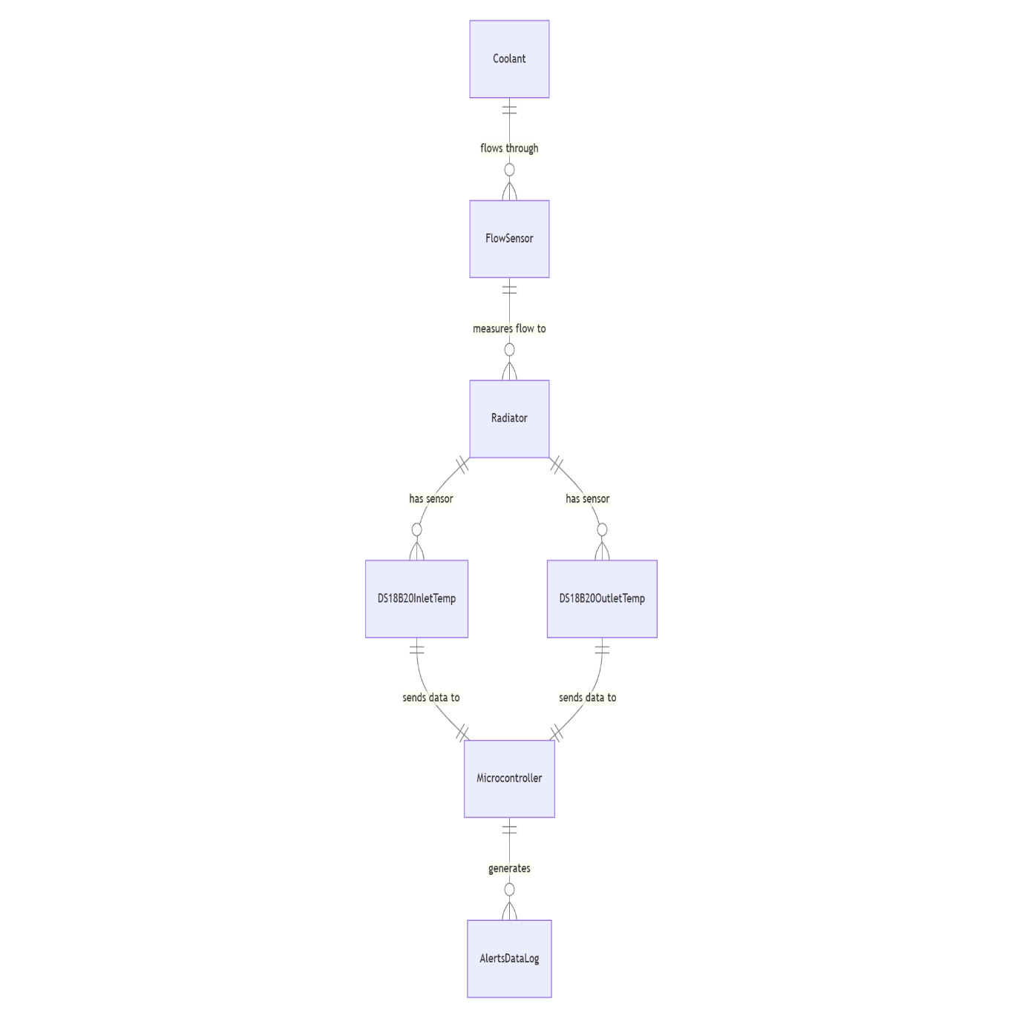

Demo Output & Alerts

Alert Conditions:

* Flow < 5 L/min → *"*LOW COOLANT FLOW*"*
* ΔT < 3°C → "COOLING INEFFECTIVE"

1. Predictive Radiator Fan Health Monitoring

**Components**: MEMS vibration sensor (ADXL335 / MPU-6050), microcontroller (ESP32 / Arduino), RPM sensor (optical / Hall effect), RTC module or timer, SD card or cloud logging system.

**Working Principle**: Vibration sensor mounted on fan housing; microcontroller records RMS acceleration. If vibration > threshold for extended time → possible bearing/blade issue. Combine with RPM data to detect imbalance. Use simple ML model for motor life prediction based on stress patterns.

Parameters:

* Vibration: >1.0 g RMS (Warning), >1.5 g RMS (Critical)
* RPM: 1000–3000 RPM
* Runtime: High vibration + long hours = increased wear

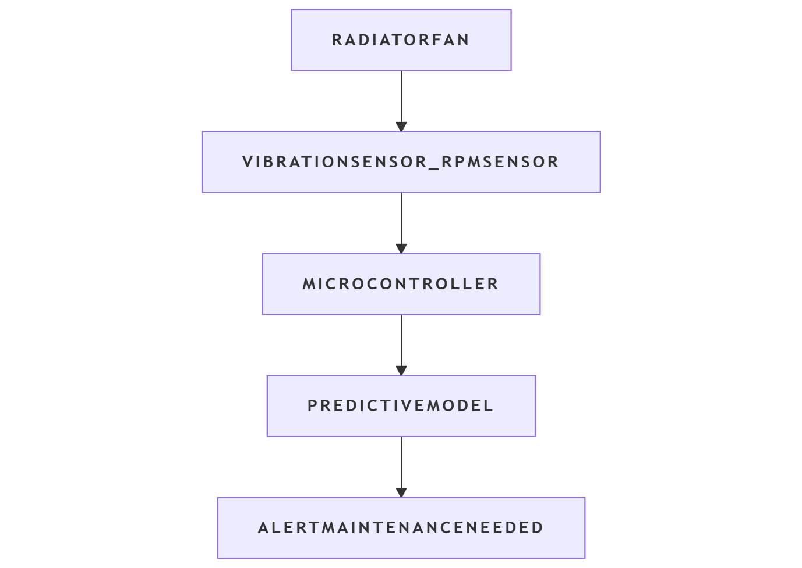

**Optional Predictive Model**

Train a model using historical vibration and runtime data:

* Input (X): {runtime hours, avg vibration, peak vibration}
* Output (y): {motor failure / no failure}

Can be implemented in Python using models like logistic regression or decision tree.

**Example Outputs:**

* *“*Fan Running Smoothly”
* *“*Vibration ↑ – Inspect Bearing”
* “Motor Health Score: 62% – Maintenance in 15 days”

**Fire-Related Risks**

Common fire hazards in railway power cars include diesel or oil leakage onto hot surfaces like exhaust pipes, and electrical short circuits or arcing in control panels. Overheating of generator windings or batteries, along with poor cable insulation or loose terminals, further increase the risk. Additionally, accumulated dust soaked in oil can act as a hidden fire load, igniting under high temperatures or electrical sparks.

Current Fire Safety Measures:

* Smoke and temperature sensors in engine compartment
* Manual or semi-automatic fire extinguishers (CO₂ or dry powder)
* Circuit breakers and fuses for overload protection
* Periodic wire harness inspections
* Fire retardant paint/coating on metal surfaces

**Recommended solutions that can be used**

1. Real-Time Thermal Imaging System

Objective

To monitor the engine bay or electrical cabinet of a railway power car using an infrared (IR) thermal camera system that can:

* Detect abnormal temperature rises (hotspots)
* Recognize early signs of overheating
* Automatically alert maintenance crews before fire hazards occur

This is a proactive, non-contact thermal safety solution designed to prevent thermal failures and fires.

2. Key Components

Hardware:

* IR Thermal Camera Module (e.g., FLIR Lepton, MLX90640, AMG8833)
* Microcontroller (ESP32, Raspberry Pi, NVIDIA Jetson Nano for ML)
* Power Supply (DC-DC converter, optional battery backup)
* Optional: Buzzer, GSM/LoRa module, relay for emergency shutdown

Software:

* Real-time thermal data acquisition via I²C/SPI
* Heatmap generation and anomaly detection
* Temperature threshold alert system
* (Optional) ML-based pattern recognition to identify high-risk areas

3. Working Principle

The IR thermal camera captures a 2D array of temperature data (e.g., 8×8, 32×24). If any pixel or region shows a critical temperature (e.g., >180°C or a sudden spike of >30°C), the system triggers an alert.  
It can log temperature data for trend analysis or send immediate alerts via GSM/Wi-Fi.

Example Alerts:

* “Cable Harness Temp: 205°C – Critical!”
* “Exhaust Flange Spike Detected: Check for Oil Leakage”
* “Battery Box Area > Threshold – Ventilation Required”

4. Use Case Zones in Power Car

* Engine Compartment: Monitor exhaust manifolds, turbochargers, fuel lines
* Electrical Cabinet: Detect overheating relays, transformers, terminals
* Battery Compartment: Identify lithium battery thermal runaway
* Generator Casing: Spot winding or housing hotspots