SHOPZY — TECHNOLOGY ARCHITECTURE
System Design & Engineering Specification | MP Online State Hackathon 2026
Hyperlocal Commerce, Real-time Geospatial Price Engine & Bhopal Tourism Integration
Platform: SHOPZY Web & API Platform | Domain: Hyperlocal Commerce & Tourism | Target Region: Bhopal & Madhya Pradesh
Architecture: 3-Tier Decoupled Monorepo | Tech Stack: React 18 + Node 22 + Mongo + Redis | Developer/Team: Sanket Raikwar (sanketraikwar12)

1. Executive Summary & Hackathon Problem Formulation
Local retail merchants and small businesses across Madhya Pradesh face existential pressure from centralized e-commerce aggregators that impose high commissions (15%–30%) and strip away local business identity. Simultaneously, residents and tourists in cities like Bhopal lack an authentic, transparent tool to discover verified neighbourhood shops, compare prices across physical stores in real-time, or connect local handicraft markets with tourism landmarks.
SHOPZY is an end-to-end, production-grade technology platform built specifically to address this challenge. It combines a high-speed geospatial search engine, an atomic multi-variant price comparison engine, verified shop onboarding, an AI-powered shopping assistant, and an integrated Bhopal Tourism Discovery portal. Engineered with clean architecture, zero-N+1 query denormalization, robust OWASP Top 10 security mitigations, and compliance with India's DPDP Act 2023, Shopzy provides an enterprise-ready digital backbone for MP's local economy.
📌 HACKATHON EVALUATION READY
Shopzy is architected to operate with ZERO required cloud infrastructure during evaluation: it auto-boots an in-memory MongoDB cluster loaded with 15 Bhopal tourist spots and local shops, while seamlessly supporting production deployment on Docker/Kubernetes with MongoDB Atlas and Redis.

2. High-Level 3-Tier System Architecture
The Shopzy architecture follows a decoupled 3-tier structure designed for low latency (<40ms search responses), high availability, and complete operational independence between layers:

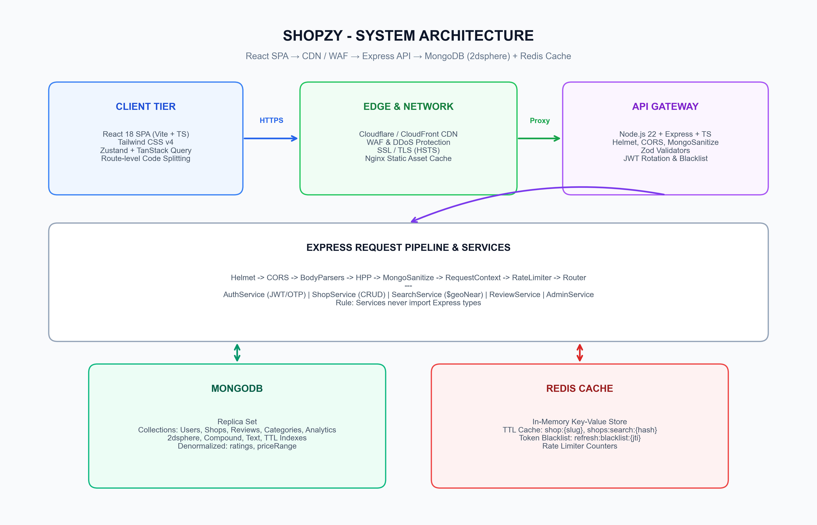
Figure 1: Shopzy End-to-End System Architecture (Client → Gateway → Services → Storage)
Tier | Technologies & Modules | Core Responsibilities & Capabilities
Presentation (Client) | React 18, Vite, TypeScript, Tailwind CSS v4, TanStack Query, Zustand, Lucide Icons | Client-side routing, optimistic caching, reactive UI, geolocation capture, interactive location picker, 101KB initial bundle.
Edge & Network | Nginx Reverse Proxy, Cloudflare CDN/WAF, SSL/TLS, Security Headers | TLS termination, gzip/brotli compression, static asset immutable caching, DDoS mitigation, reverse proxy pass to API.
Application & API Gateway | Node.js 22 LTS, Express, TypeScript, Zod, Helmet, MongoSanitize, JWT | RESTful API routes, request context tracing, authentication with token rotation, RBAC, domain services, rate limiting.
Data & Cache Storage | MongoDB 7.0 (Replica Set / Atlas), Redis In-Memory Cache | Geospatial 2dsphere indexing ($geoNear), document persistence, denormalized ratings, TTL search caching, token blacklist.

3. Geospatial Search & Real-Time Price Comparison Engine
A critical innovation in Shopzy is the geospatial search pipeline implemented in `services/search.service.ts`. Unlike naïve systems that store raw latitude/longitude floats and require full-table bounding-box scans, Shopzy leverages MongoDB's native 2dsphere index based on Google's S2 spherical geometry.
- Key Technical Mechanisms:
- Single-Pass Aggregation: Executes an atomic pipeline combining `$geoNear` (must be the first stage in the pipeline) with `$facet` for instantaneous categorization counts and price range distribution in a single database roundtrip.
- Zero-Join Denormalization: Average ratings, total reviews, and price range min/max are maintained directly on the `Shop` document during writes. Search queries execute with zero `$lookup` joins, keeping read latency at ~37ms cold and ~1ms cached.
- Dynamic Radius Clamping: Searches default to a 5 km radius but support fluid user expansion up to 50 km, applying spherical distance calculation in meters.
- Opening Hours Calculation: Complex schedule evaluation supports split-shifts, midnight crossing (e.g. 18:00 to 02:00), holiday overrides, and Asia/Kolkata timezone normalization.

4. Data Architecture, Schema & Entity Relationships
The data layer utilizes MongoDB collections structured with strong validation, compound indexes, and explicit relationship constraints:
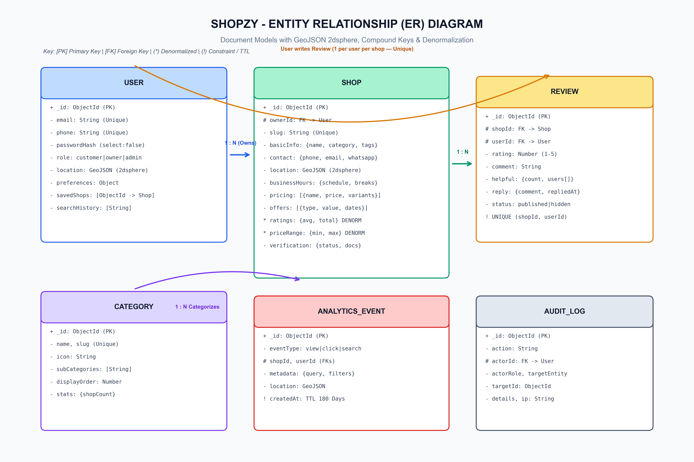
Figure 2: Shopzy Entity-Relationship Diagram (ERD) with GeoJSON, Indexes & Constraints
- Core Data Collections:
- Users Collection: Implements polymorphic roles (`customer`, `owner`, `admin`, `super_admin`), salted bcrypt password hashes (select: false), preferences, saved shops, and GeoJSON location.
- Shops Collection: Contains business metadata, category linkage, multi-variant pricing arrays, promotional offers, GeoJSON 2dsphere coordinates, business hours schedule, and verification status.
- Reviews Collection: Enforces strict unique compound indexing on `{ shopId: 1, userId: 1 }` ensuring one review per customer per shop, atomic rating recalculation hooks, and merchant reply threads.
- AnalyticsEvent Collection: High-velocity search and click logs featuring automatic 180-day TTL expiration (`createdAt` TTL index), preventing collection bloat.
- AuditLog Collection: Non-repudiable ledger recording administrative approvals, shop suspensions, and privilege changes with actor IP and timestamps.

5. Data Flow Diagrams (DFD Level 0 & Level 1)
To illustrate information movement and security boundaries across the system, DFD Level 0 (Context) and DFD Level 1 (Functional Decomposition) models are established:
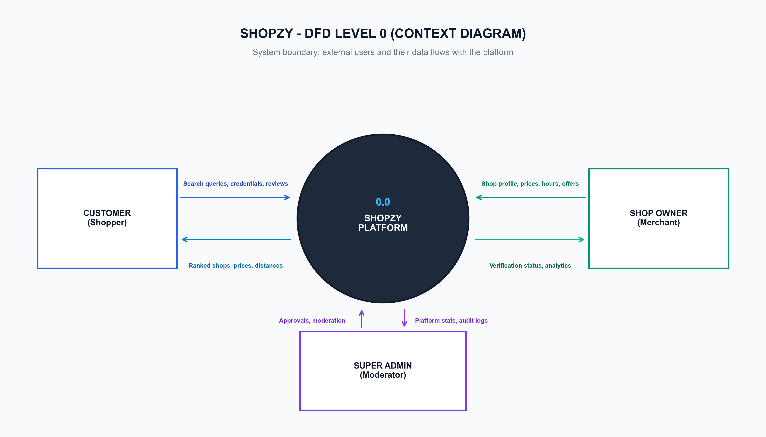
Figure 3: DFD Level 0 (Context Level Diagram) showing External Entities and Boundaries
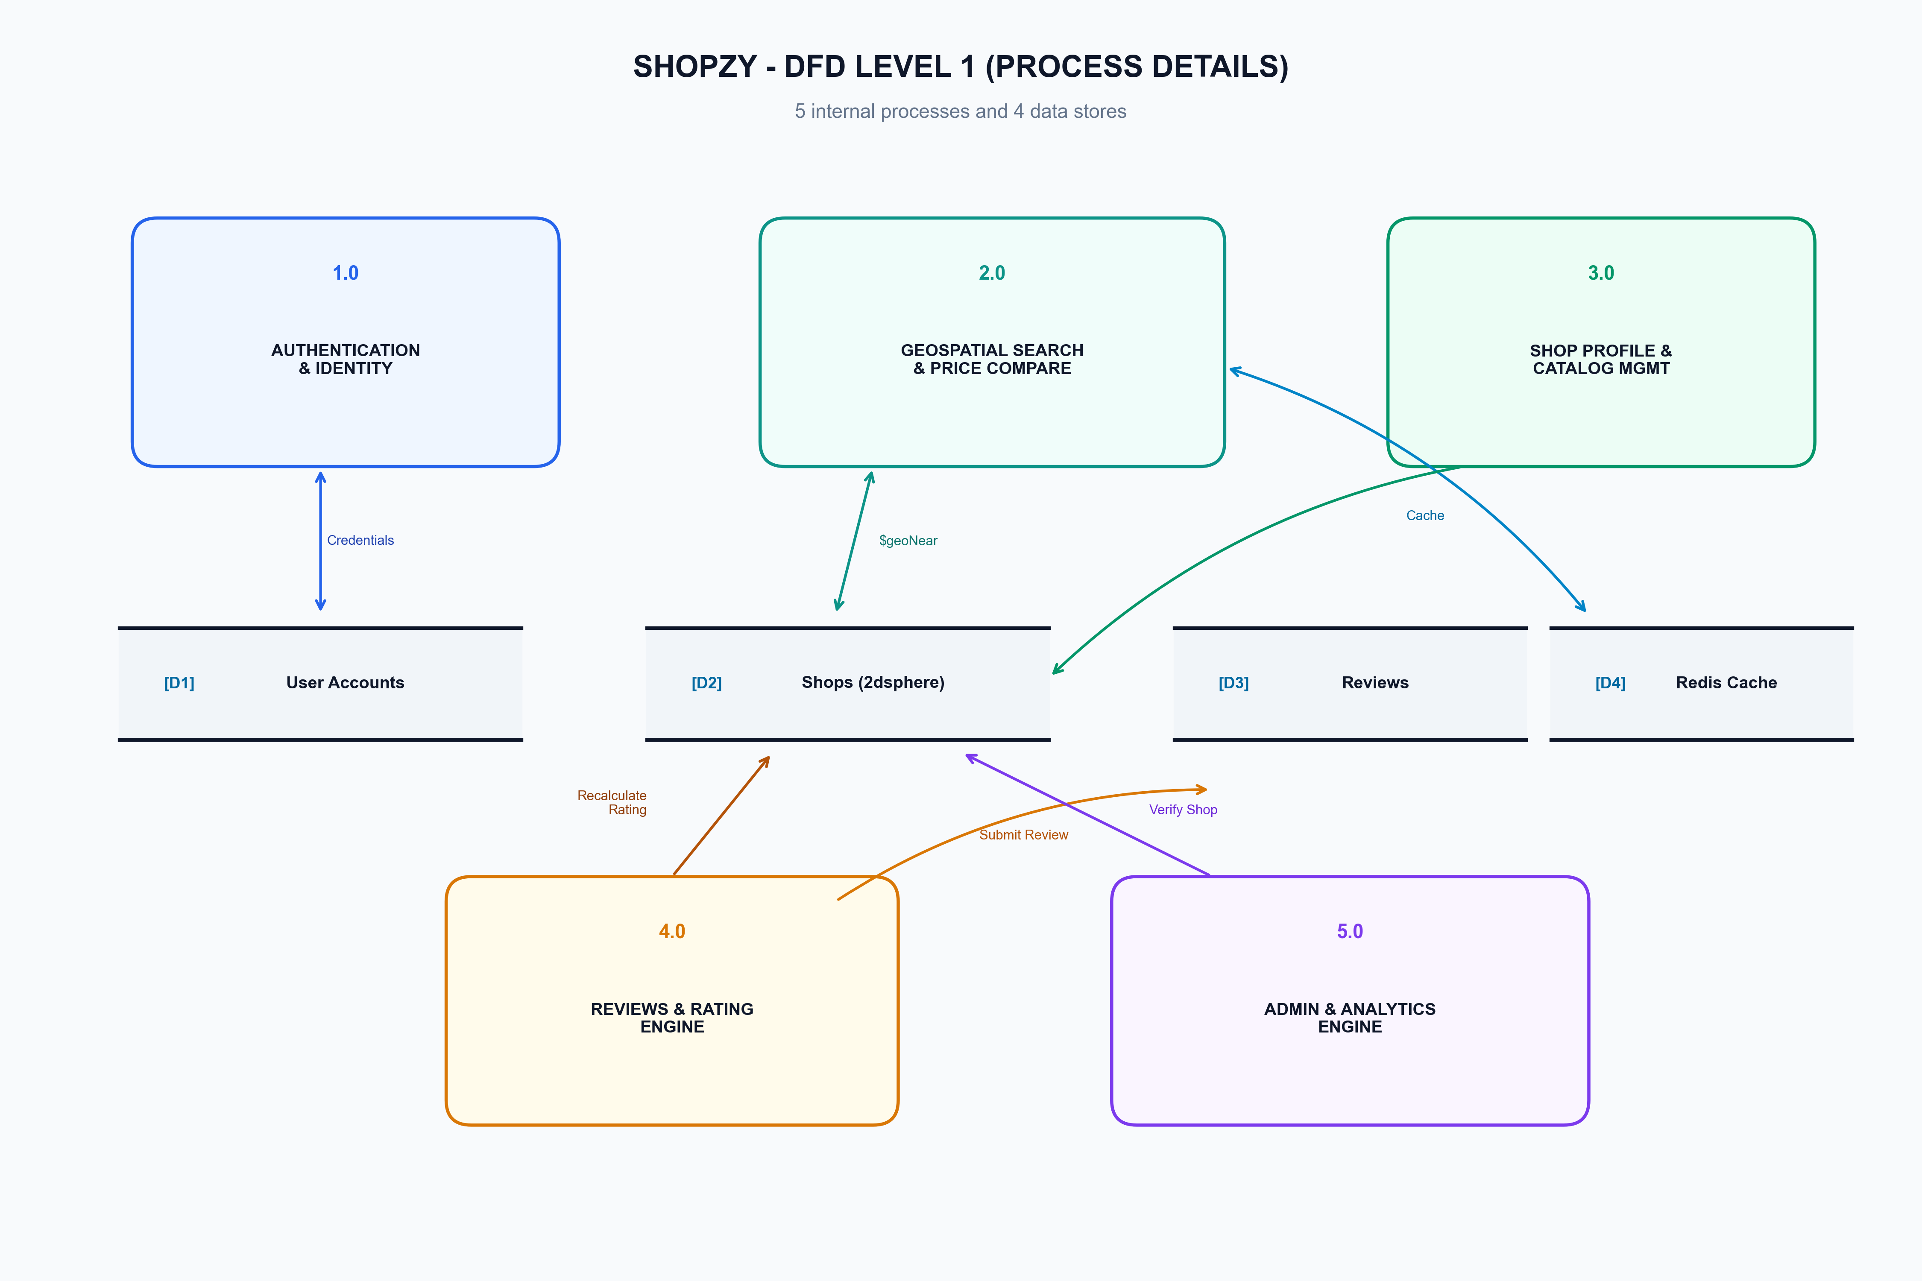
Figure 4: DFD Level 1 (Process Decomposition Diagram) showing 5 Core Processes and 4 Datastores

6. Madhya Pradesh & Bhopal Specific Innovations
Shopzy is purpose-built for the socio-economic context of Madhya Pradesh, specifically uniting tourist attraction footfall with local commerce:
- Bhopal Tourism Synergy: Integrates 15 iconic tourist landmarks (Upper Lake/Bada Talab, Van Vihar, Taj-ul-Masajid, Bhojpur Temple, Bhimbetka Rock Shelters, Tribal Museum, Manuabhan Tekri, Kerwa Dam, etc.) with surrounding local markets, handicrafts, and authentic dining (e.g. Chowk, New Market, Sagar Gaire).
- Shopzy AI Assistant: Integrates intelligent conversational assistance that parses user natural language queries ('Where can I find Chanderi sarees near Gohar Mahal under ₹2000?'), checks live shop inventories, and provides directions.
- MSME Empowerment: Zero-commission direct customer connection with one-tap WhatsApp chat and phone calling, bypassing predatory aggregator middle-men.

7. Enterprise Security, Threat Mitigation & DPDP Act Compliance
Security is implemented as a fundamental system invariant rather than an afterthought:
Security Vector | Threat Prevented | Implementation in Shopzy
Authentication & Replay | Token Hijacking & Credential Stuffing | Dual JWT architecture: 15-min Access Token + 7-day Refresh Token with unique `jti`. Stolen token replay automatically triggers blacklist revocation.
NoSQL Injection | Database Query Manipulation | Express MongoSanitize strips `$` and `.` operators from request bodies and query params; Zod enforces strict typed runtime validation.
Enumeration Resistance | Account Probing & Harvesting | Identical responses and timing for failed logins regardless of whether the email exists, preventing attacker reconnaissance.
Privilege Escalation | Unauthorized Role Updates | Mass assignment protection: controllers explicitly whitelist assignable fields. Requests sending `role: admin` are silently discarded.
DPDP Act 2023 Compliance | Regulatory Non-Compliance | Supports right to erasure (account deletion cascade), explicit consent logging, data minimization, and granular audit trails.

8. DevOps Pipeline, Containerization & Automated Testing
Shopzy ships with full container orchestration and comprehensive automated testing:
- Docker Multi-Stage Builds: API compiles TypeScript in an intermediate container and copies only `dist/` and production dependencies to a hardened `node:22-alpine` image running as non-root user `node` under `dumb-init` for graceful SIGTERM shutdown.
- Nginx Production Web Server: Serves production frontend with immutable caching for hashed chunks (`Cache-Control: max-age=31536000`), gzip compression, and client-side SPA routing fallback.
- 89 Passing Integration Tests: Runs Supertest against an actual in-memory MongoDB engine (`mongodb-memory-server`) verifying auth flows, geo-distance ranking, rate limits, review recalculations, and edge cases.

9. Hackathon Panel Viva & Evaluation Defense Cheat Sheet
Q1: Why did you use MongoDB 2dsphere indexing instead of PostgreSQL or standard float coordinates?
A standard B-tree index on latitude and longitude cannot perform radial distance filtering without scanning rectangular bounding boxes and performing expensive trigonometric post-filtering. MongoDB's 2dsphere index implements Google's S2 spherical geometry, projecting Earth onto a sphere divided into hierarchical cells. This allows `$geoNear` to traverse the index directly in distance order and stop at `maxDistance`, delivering instantaneous O(log N) radial searches with zero post-filtering.
Q2: How does your architecture avoid the N+1 query problem during high-traffic searches?
In traditional relational designs, displaying 20 shops with average ratings and price ranges requires either 20 separate review queries or complex multi-table joins. Shopzy employs an intentional denormalization strategy: when a review is submitted, a transactional hook recalculates and caches the average rating and review count directly onto the `Shop` document. Similarly, price ranges are maintained during product updates. As a result, search reads require exactly ZERO joins and execute in single-digit milliseconds.
Q3: What makes this solution uniquely impactful for Madhya Pradesh and Bhopal?
Centralized aggregators charge 20–30% commissions, destroying small retail margins, while tourists in MP often struggle to find authentic local goods outside commercial traps. Shopzy creates a direct bridge between tourist footfall (Bhopal's heritage landmarks) and local artisans/merchants with zero commissions, verified listings, one-click WhatsApp/Call connect, and an AI guide tailored to Bhopal's geography.

