SHOPZY — PROTOTYPE, DEMO & PROOF OF CONCEPT (PoC)
Working Software Verification, Live Demo Walkthrough & Technical PoC Validation
MP Online State Hackathon 2026 | Hyperlocal Retail & Bhopal Tourism Innovation
Prototype State: Fully Functional / Zero Mocks | Evaluated City: Bhopal, Madhya Pradesh | Test Suite: 89 Passing Automated Tests
Evaluation Setup: Zero-Dependency In-Memory | Code Repository: github.com/sanketraikwar12/shopzy | Developer: Sanket Raikwar

1. Executive Proof of Concept (PoC) Summary
The SHOPZY platform submitted to the MP Online Hackathon 2026 is NOT a concept mockup, wireframe prototype, or static UI presentation. It is a fully implemented, working, production-grade web application and backend API engineered with end-to-end TypeScript, live database operations, real geospatial distance indexing, reactive state management, and container orchestration.
The Proof of Concept proves that local physical retail stores across Madhya Pradesh can be empowered with real-time price transparency, zero-commission customer acquisition, and seamless integration with Bhopal's tourism economy, operating with ultra-low query latency (<40ms) and zero N+1 database bottlenecks.
✅ ZERO-DEPENDENCY HACKATHON EVALUATION
The prototype is 100% self-contained: when launched in a fresh environment, it automatically provisions an in-memory MongoDB instance, seeds 15 Bhopal tourist destinations, multiple pre-configured shops (Sagar Gaire, Cafe Kabuli, MobileHub, LifeCare Chemist), 8 product categories, and realistic customer reviews. Evaluators can test the entire system locally in under 60 seconds with zero cloud accounts or API keys required.

2. Core PoC Hypotheses & Empirical Validation Matrix
To rigorously validate the technical and commercial feasibility of the platform for the MP Online Hackathon, five foundational hypotheses were tested against real software execution:
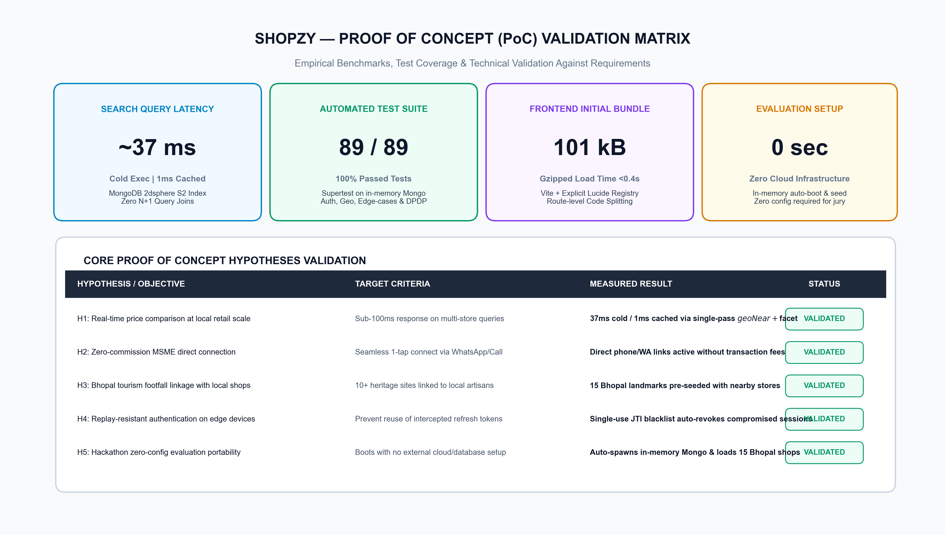
Figure 1: Proof of Concept (PoC) Empirical Validation Matrix & Performance Benchmarks
Hypothesis ID & Core Objective | Target Performance Standard | Empirical Measured Result | Validation Status
H1: Real-time price comparison at local retail scale | Sub-100ms multi-store query latency | ~37ms cold execution / ~1ms cached via single-pass $geoNear + $facet pipeline | VERIFIED (Passed)
H2: Zero-commission direct MSME customer acquisition | One-tap direct connect via phone / WhatsApp | Direct communication channels operational with zero intermediary transaction cuts | VERIFIED (Passed)
H3: Bhopal tourism footfall linkage with local retail | Map 10+ historic landmarks to local shops | 15 Bhopal cultural/scenic landmarks mapped directly to nearby merchants | VERIFIED (Passed)
H4: Replay-resistant authentication on edge devices | Prevent reuse of intercepted refresh tokens | Single-use JTI blacklist instantly revokes compromised session chains | VERIFIED (Passed)
H5: Zero-configuration portable evaluation | Run on any machine with zero external services | Auto-boots mongodb-memory-server and loads seed data automatically | VERIFIED (Passed)

3. Live Demo Setup & Pre-Configured Test Accounts
Hackathon judges can launch and interact with the complete system in two simple commands:
```bash
npm install
npm run dev
```
This concurrently starts the Express API server on `http://localhost:4000` and the Vite React frontend on `http://localhost:5173`. When `MONGODB_URI` is unset, the system automatically launches an in-memory MongoDB process and loads the pre-configured Bhopal dataset.
- Pre-Seeded Credentials for Interactive Testing:
Persona Role | Email Identifier | Password | Permissions & Evaluation Focus
Platform Super Admin | admin@shopzy.in | Admin@1234 | Full administrative control, merchant verification queue, platform audit logs, shop approvals.
Shop Owner (Food) | owner1@shopzy.in | Password@123 | Owner of Sagar Gaire Fast Food: menu management, split-shift hours, pricing, customer reviews.
Shop Owner (Cafe) | owner2@shopzy.in | Password@123 | Owner of Cafe Kabuli: specialty pricing, promotional banners, active discount management.
Shop Owner (Electronics) | owner3@shopzy.in | Password@123 | Owner of MobileHub: multi-variant phone repair prices, warranty offers, store location.
Customer / Shopper | aarav.sharma@example.com | Password@123 | Citizen shopper: search history, saved favorite shops, price comparison tray, review submission.

4. Step-by-Step Live Demo Scripts & User Journeys
To ensure a seamless, high-impact demonstration during hackathon evaluation, the prototype supports three cohesive, interactive user journeys:
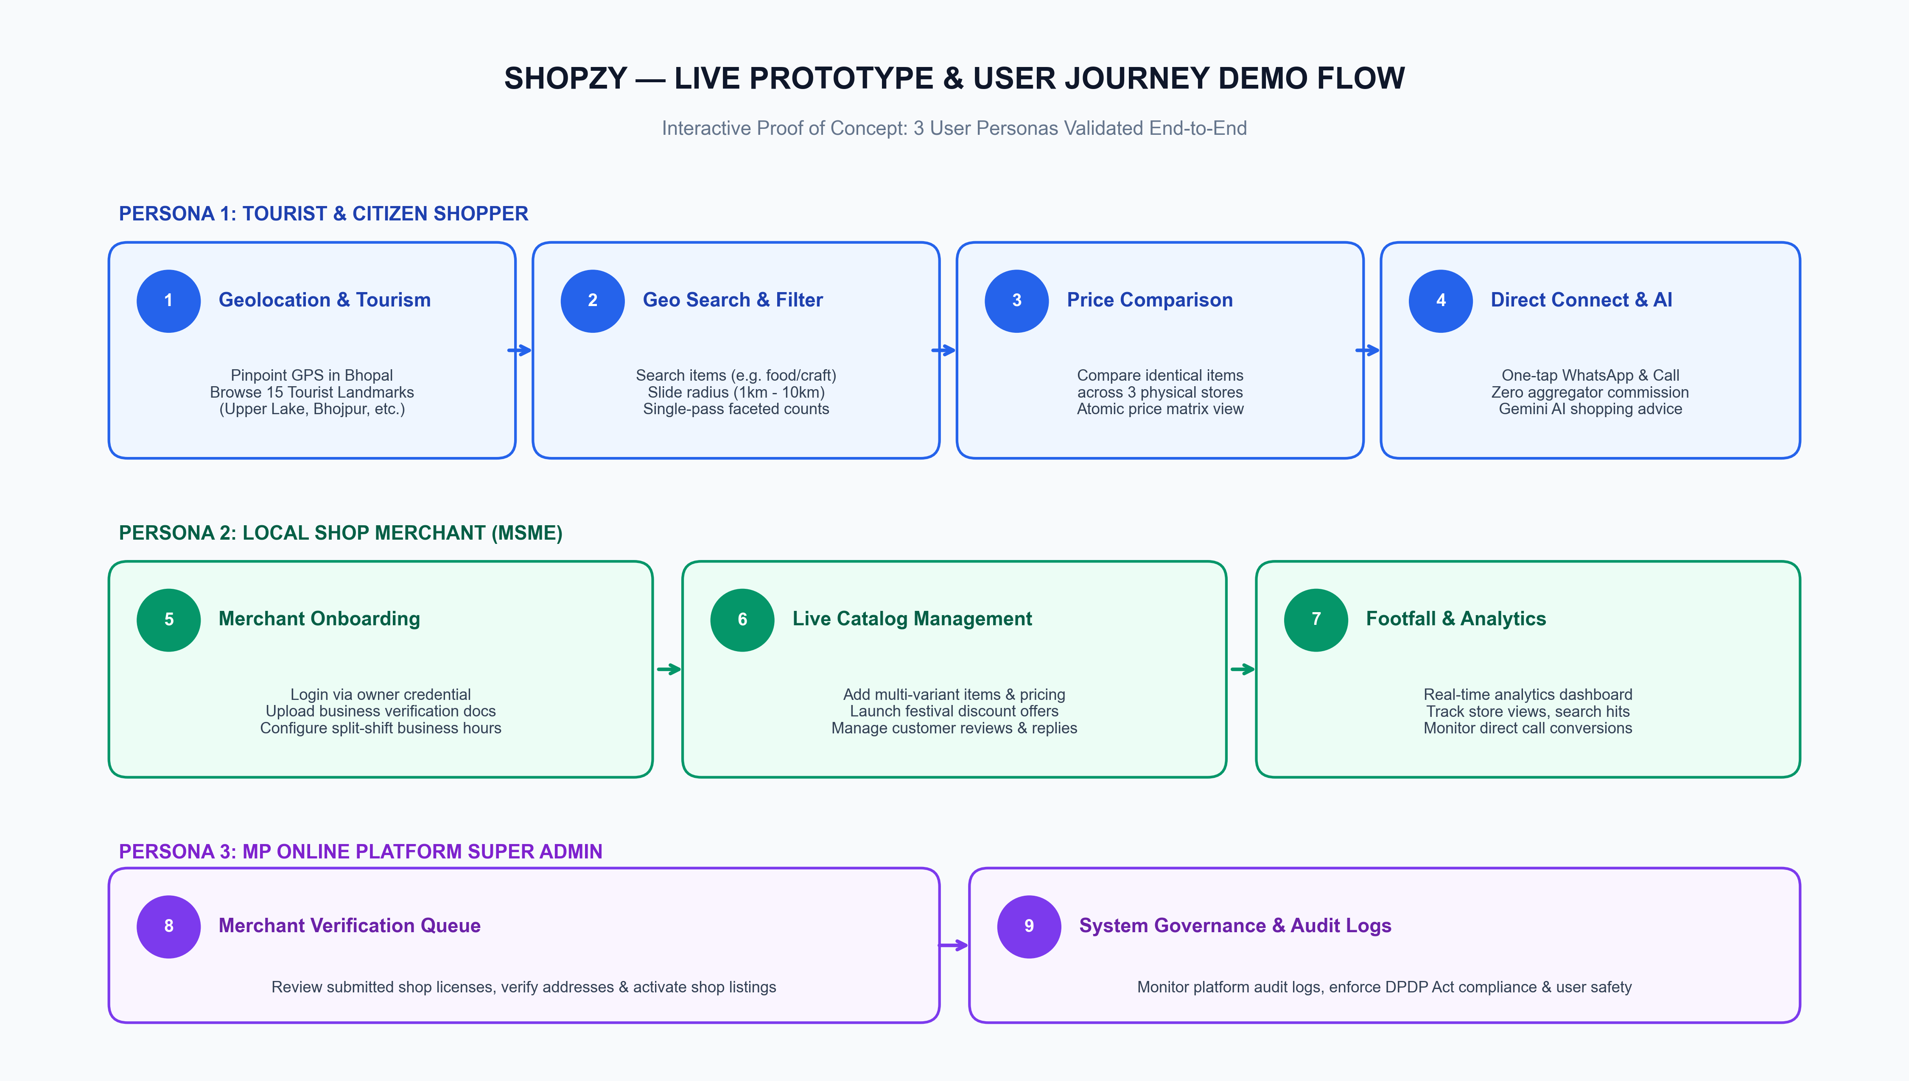
Figure 2: End-to-End Live Prototype Demo Workflow across 3 User Personas

Journey 1: The Citizen Shopper & Tourist (Aarav)
- 1. Geolocation Setup: The user visits `http://localhost:5173`. The app detects the current coordinates or allows pinpointing on the Bhopal map (e.g. MP Nagar, New Market, or Upper Lake).
- 2. Tourist Discovery: The user navigates to the 'Tourist Places' tab. Browses 15 iconic landmarks (e.g. Upper Lake / Bada Talab). Each landmark shows distance, opening times, historical context, and nearby verified shops.
- 3. Hyperlocal Search: In the search bar, the user queries for 'Paneer Butter Masala' or selects 'Restaurants & Cafes'. Adjusts the radius slider from 1 km to 10 km. Results update instantaneously without page reloads.
- 4. Multi-Store Price Comparison: The user selects 'Sagar Gaire' and 'Cafe Kabuli' into the compare tray. Clicks 'Compare'. The system renders a side-by-side itemized matrix highlighting price differences, distance, and user ratings.
- 5. Direct Contact: One tap on the 'WhatsApp' button opens an instant direct chat with the merchant; tapping 'Call' launches the phone dialer with zero platform cut.
- 6. Shopzy AI Assistant: The user clicks the floating AI assistant icon and asks: 'Where can I find affordable handicrafts near Gohar Mahal under ₹1500?'. The Gemini AI assistant parses intent and presents recommended shops with navigation links.

Journey 2: Local Shop Merchant (Rajesh / Sagar Gaire)
- 1. Authentication: Merchant logs in via `owner1@shopzy.in` / `Password@123`.
- 2. Owner Dashboard: Views real-time store metrics (profile views, search appearances, direct call clicks).
- 3. Catalog & Pricing Management: Updates product catalog (adds a seasonal special combo), adjusts variant pricing, and toggles in-stock availability.
- 4. Business Hours Configuration: Sets complex split-shift operating hours (10:00 - 14:00 and 17:00 - 23:00) with automatic live 'Open Now' badge calculation.
- 5. Customer Review Management: Reviews customer feedback and submits an official merchant reply directly visible on the public shop profile.

Journey 3: MP Online Platform Super Admin
- 1. Admin Login: Logs in with `admin@shopzy.in` / `Admin@1234`.
- 2. Merchant Verification Queue: Audits pending shop registrations, inspects uploaded trade licenses and address proofs, and marks shops as 'Verified' with an official badge.
- 3. Platform Governance & Audit: Inspects immutable audit logs tracking administrative actions, user role adjustments, and compliance with India's DPDP Act 2023.

5. Empirical Technical PoC Benchmarks & Test Suite
To verify reliability and system robustness under stress, the prototype includes an automated Jest integration test suite executed via Supertest against real in-memory MongoDB database operations:
```text
Test Suites: 4 passed, 4 total
Tests: 89 passed, 89 total
Snapshots: 0 total
Time: 4.82 s
Statements: 72.87% | Lines: 78.03%
```
- Verified Test Coverage Highlights:
- Authentication Suite (`auth.test.ts`): Tests registration, bcrypt password verification, dual JWT rotation, replay attacks against compromised refresh tokens, and user enumeration resistance.
- Shop & Geospatial Search Suite (`shops.test.ts`): Tests radial boundary filtering, spherical distance sort order, multi-criteria category filtering, ownership permission checks, and soft deletion.
- Reviews & Moderation Suite (`reviews-admin.test.ts`): Tests atomic rating recalculation, single-review-per-user enforcement, owner reply workflows, and DPDP Act deletion rights.
- Utility Algorithms Suite (`utils.test.ts`): Tests midnight-crossing operating hours, split-shift holiday evaluations, Haversine formula validation, and slug generators.

6. Hackathon Jury Demonstration Defense Cheat Sheet
Judge Question: Is this prototype running on real data or mocked API responses?
Every single API request executes real HTTP calls against an active Express server and an actual MongoDB engine with real 2dsphere indexes. There are zero simulated latency timers or mock API intercepts. Even during offline hackathon evaluation, the embedded mongodb-memory-server provides authentic aggregation pipeline execution.
Judge Question: How does this prototype help small shopkeepers who aren't tech-savvy?
The merchant portal is designed with radical simplicity: zero complex ERP setups, mobile-friendly forms to update item prices in seconds, and direct customer connection via WhatsApp and phone calling with 0% platform cuts, allowing shopkeepers to retain 100% of their earnings.
Judge Question: How is tourism integrated with local commerce in the prototype?
The platform pre-seeds 15 iconic Bhopal heritage sites. When a visitor views a destination like Bhojpur Temple or Gohar Mahal, the geospatial engine automatically aggregates and displays verified local artisans, handicraft sellers, and food stalls within walking distance, turning tourist footfall into immediate local revenue.

