
Gina Cody School of Engineering and Computer Science
SOEN 6841 FALL 2023
SOFTWARE PROJECT MANAGEMENT
BY PANKAJ KAMTHAN
Topic 106- Get Users Involved As Early As Possible
Submitted By- Sanket Umaji Shinde(40233057)

Abstract
`
Traditionally, software development followed a clandestine path, with user input sought after coding and testing in isolation. The endgame was a grand unveiling, hoping users would be impressed. However, reality often diverged, leading to user dissatisfaction and requests for different outcomes. Today, the key to software project success is early and continuous user involvement. Detecting problems in development is far more economical than post-project revisions. Late-stage changes significantly escalate costs, threaten project timelines, and require approval through extensive processes. Seemingly trivial programming decisions that make sense to developers may disrupt user experiences. A notable case underscores this lesson: a major training company invested $5 million in software redesign, neglecting how users interacted with the system. The consequence was chaos, as users grappled with an illogical ordering process, leading to a project overshooting its time and budget boundaries. For project managers, the message is clear: user engagement from inception is critical for prosperous software development. This collaborative approach ensures alignment with user expectations, reduces post-development modifications, enhances project efficiency, and ultimately guarantees success.

Table of Contents
1 Introduction 4
The traditional model of software development, characterized by secrecy and limited user involvement, has evolved in response to the ever-changing demands of the industry. This report delves into the paradigm shift towards a more user-centric approach, emphasizing early and continuous user engagement. Unlike the past, where users were presented with a finished product, today's successful projects involve users from the outset. This introduction sets the stage for exploring the reasons behind this transformation and its impact on project outcomes. 4
2 Motivation 4
3 Historical Software Developement Process 4
4 Benefits of Early User Involvement 5
Conclusion 7
References 7

- Introduction

The traditional model of software development, characterized by secrecy and limited user involvement, has evolved in response to the ever-changing demands of the industry. This report delves into the paradigm shift towards a more user-centric approach, emphasizing early and continuous user engagement. Unlike the past, where users were presented with a finished product, today's successful projects involve users from the outset. This introduction sets the stage for exploring the reasons behind this transformation and its impact on project outcomes.
- Motivation
The evolution of software development practices signifies more than just technological progress; it marks a fundamental shift in recognizing the pivotal factor for success—the end user. Departing from the traditional clandestine model where developers operated in isolation, presenting users with a finished product often resulting in dissatisfaction, the motivation for early and continuous user involvement stems from the lessons learned. Past grand unveilings filled with anticipation frequently led to disillusionment when user expectations weren't met. The shift towards user-centric development is driven by the acknowledgment that users aren't just consumers but integral stakeholders shaping the development trajectory. This motivation is both a necessity and a practical decision, recognizing that early issue detection is more cost-effective than post-project revisions. The cautionary tale of a training company's costly redesign, overlooking user interactions, serves as a potent motivator, emphasizing the importance of learning from such missteps. For project managers, the crystal-clear motivation lies in understanding that early user engagement is not just a project requirement but the linchpin for prosperous software development, ensuring alignment with user expectations, enhancing efficiency, preventing budget overruns, and guaranteeing a successful, user-approved end product—a testament to the realization that software success transcends code to deliver value and satisfaction to end users.
- Historical Software Developement Process

In the earlier days of software development, a shroud of secrecy surrounded the development process. Developers, armed with user requirements, would retreat into coding and testing without much interaction with the end-users. The assumption was that users wouldn't grasp the technical intricacies of development, and the final unveiling was anticipated with a mix of excitement and trepidation. However, this approach often led to disappointment when users found that the delivered product fell short of their expectations.

The flaws in this traditional approach became increasingly apparent. Late-stage revelations of user dissatisfaction resulted in costly and time-consuming modifications. The reluctance to involve users throughout the development process meant that crucial insights into their actual needs were often overlooked. The secrecy that once seemed a hallmark of software development became a barrier to creating products that truly resonated with users.

Recognizing the limitations of the traditional model, the contemporary approach emphasizes transparency and early user involvement. Developers now showcase visible progress as soon as possible, inviting user feedback at every stage. This shift is rooted in the understanding that identifying and addressing issues early on is not only more efficient but significantly more economical. The "aha" moment is no longer reserved for the project's conclusion but is integrated throughout the development lifecycle.

- Benefits of Early User Involvement

The advantages of this user-centric approach are multifaceted. Early user involvement serves as a proactive measure against costly late-stage adjustments. It cultivates a deeper understanding of user needs, allowing developers to align their efforts with actual expectations. Real-world examples demonstrate how this approach results in cost savings, time efficiency, and, most importantly, a final product that truly satisfies user requirements.

Project managers play a pivotal role in navigating this shift. They act as facilitators, ensuring effective communication between users and developers. By fostering an environment where insights from both parties are valued, project managers contribute to the creation of software that not only meets technical requirements but also aligns seamlessly with user expectations.

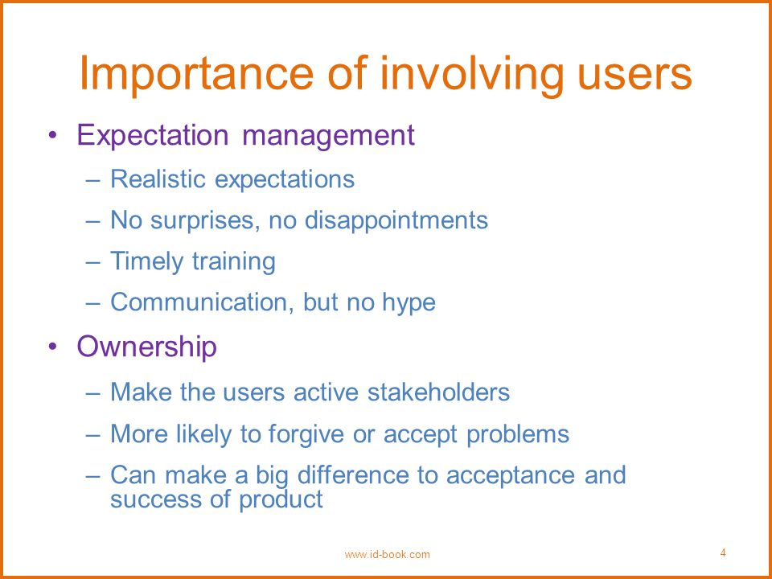
Acknowledgments. A third level heading in 9-point font size at the end of the paper is used for general acknowledgments, for example: This study was funded by X (grant number Y).
Disclosure of Interests. It is now necessary to declare any competing interests or to specifically state that the authors have no competing interests. Please place the statement with a third level heading in 9-point font size beneath the (optional) acknowledgments, for example: The authors have no competing interests to declare that are relevant to the content of this article. Or: Author A has received research grants from Company W. Author B has received a speaker honorarium from Company X and owns stock in Company Y. Author C is a member of committee Z.

Conclusion
In conclusion, the transformation from traditional, secretive software development to a more user-centric model reflects a recognition of the evolving needs of the industry. Early and continuous user involvement is not merely a trend but a strategic move towards more successful projects. This report highlights how this approach mitigates the pitfalls of the past, outlining the tangible benefits and emphasizing the critical role project managers play in orchestrating this collaborative and transparent development process. Ultimately, the success of modern software development lies in its ability to integrate user feedback from the project's inception, creating products that users not only appreciate but actively enjoy using.

References
- https://www.pmbytes.com/get-users-involved-as-early-as-possible/
- https://medium.com/softserve-do/user-involvement-an-essential-part-of-development-638a76029c62

